
Delphi Electronics & Safety
XSAL
Software Design Document
Prepared for customer-independent
Document: SDD-10017133-419
Prepared by: Jacek Roman
Date: 14-Sep-2007 Version: 00.1
Delphi Electronics & Safety, Technical Center Krakow
ul. Podgorki Tynieckie 2, 30-399 Krakow, Poland

Revision History

Version | Date | State | Author / Department | Change Description
00.1 | 14-Sep-2007 | Draft | Jacek Roman / Delphi E&S | Initial revision.
States of this document: draft, reviewed, approved, final
Table of Contents
1 Introduction 3
1.1 Purpose 3
1.2 Scope 3
1.3 Definitions, Acronyms and Abbreviations 3
1.4 References 3
1.5 Document Overview 3
1.6 Component Re-Use Status 4
1.7 Limitations 4
2 Design Considerations 5
2.1 Assumptions, Dependencies & Constraints 5
2.2 Conceptual Design Model 5
2.3 Integration Objectives 6
3 Design Details 6
3.1 Logical View 6
3.2 Component View 18
3.3 Deployment View 19
4 Interfaces 19
4.1 API 19
4.2 Configuration & Global Data 19
5 Memory Usage Objectives 20
6 Requirements Trace 21
7 Usage Guidelines 22
8 Test Objectives 22
9 Open Issues 22
10 Lessons Learned 22
11 Appendixes 22

Introduction
The neXt generation System Abstraction Layer (XSAL) is a library providing a subset of typical OS functionality. XSAL specification defines:
- Thread management and synchronization
- Real-Time memory management
- Asynchronous message passing
- Synchronous communication

Purpose
The purpose of this document is to describe the detailed design of the XSAL component. The document is intended to be used by software engineers that are responsible for development and maintenance of XSAL-based applications. The design is based on the requirements specified in the SRS document [1] and API [2].

Scope
XSAL is available in two API versions:
- Rich API targeted at high-end systems, in this document referred to as XSAL Full,
- Reduced API targeted at low-end systems in this document referred to as XSAL Light.

Since XSAL Light is a proper subset of XSAL Full, it is possible to run low-end software components on high-end systems.

Definitions, Acronyms and Abbreviations

Abbreviation | Explanation
API | Application Programming Interface
OS | Operating System
SRS | Software Requirements Specification
XSAL | neXt generation System Abstraction Layer
XSAL Full | XSAL, multi processes version
XSAL Light | XSAL, single process version

References

No. | Document Name | Location
 | XSAL Requirements Document | DOORS: /Roster_Number_10017133/SW/Documents/Internal Requirements/Application Processor/XSAL/SRS_10017133-419
 | XSAL API | Synergy CM: xsal/doc/XSAL_API.doc
 | XSAL interface “help” documents | Synergy CM: xsal/doc/XSAL.chm, xsal/doc/XSAL_Light.chm
 | XSAL test | Synergy CM: xsal/doc/XSAL_Test.chm
 | DebugTrace library documents | Synergy CM: DebugTrace/doc/*
 | Procman application documents | Synergy CM: rocessManager/doc/*

Document Overview
Chapter 1 provides a general introduction to XSAL and some remarks on document structure, re-use, references, acronyms, abbreviations, etc.

Chapter 2 provides a general description of the software component including its functionality and matters related to the overall system architecture and its design.

Chapter 3 details the design of both the static and dynamic structure of the component. Its objective is to provide the logic view, the component view and the deployment view onto the design of the software component.

Chapter 4 considers interfaces of the components. It lists all public available classes, objects, functions, structures, enumerations as well as data and configuration objectives.

Chapter 5 gives information on memory usage of the component.

Chapter 6 summarizes the implementation of the requirements.
Note: References to requirements are given in all chapters where appropriate.

Chapter 7 gives information on how to use the component.

Chapter 8 provides information on test objectives.

Chapter 9 gives list of open issues which are not yet finalized or requirements which are not covered by the component.

Chapter 10 will be filled at the end of the project to indicate issues which could not be solved, caused trouble and should be considered in the next project.

Chapter 11 adds additional information to the document.

Component Re-Use Status
XSAL has been derived from its previous version – SAL2 – which was used in the EHU4 project. XSAL implements lesson learns from SAL2 and adds new functionality.

Components in the project could have been re-used in different ways. Each component has its own re-use status. The possible re-use status values are shown in the list below:

Component re-use status | Explanation
unchanged | 1 to 1 copy of the module
configured | Configuration setting has changed only
extended | The building block was extended to fulfill the requirements of the program
derived | The component was copied, then modified.
new | A new component
Tool generated | The source of the component was generated by tools

In the component view for each package the re-use status is given as

Status (provider)

The provider is the name of e.g. another project or supplier which is the source of the component. If provider is not filled, by default it is defined to be developed internally.

Limitations
N/A

Design Considerations
This chapter provides a general description of the component’s design, including the reasons and alternatives for the chosen design which is described in detail in chapter 3. It also describes the role of the component in the system architecture.

Assumptions, Dependencies & Constraints
The document describes the design of both versions of XSAL: XSAL Full and XSAL Light. If it is not specified explicitly, then the description concerns both versions. If any issue concerns only some specific version, then it will be marked with: XSAL Full or XSAL Light.

Conceptual Design Model
The architecture of XSAL is modular. It consists of a few components shown in the figure below:

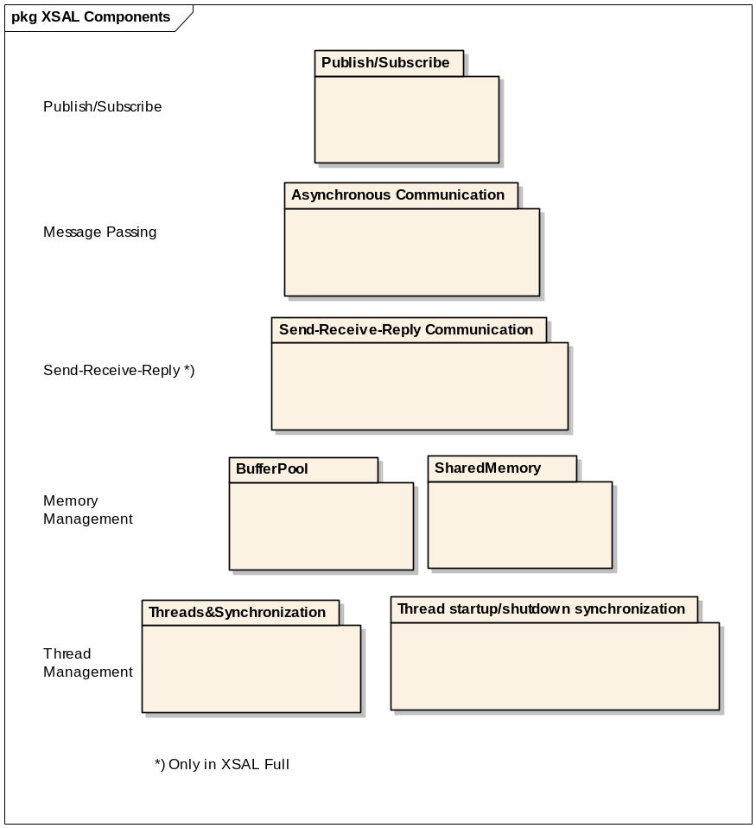
Figure 1: XSAL components

XSAL API covers the following functionality:

- Thread management – implements OS-independent creation of threads.
- Thread synchronization and mutual exclusion – provides thread synchronization and mutual exclusion primitives.
- Thread synchronization at startup/shutdown – provides a mechanism for synchronizing threads during startup and initialization as well as shutdown.
- Buffer pools – provide non-fragmenting, time-bounded memory allocation and de-allocation.
- Shared memory – provides facilities to create and access shared memory.
- Send-receive-reply communication – implements basic synchronous communication primitives. This feature is accessible in XSAL_Full only.
- Asynchronous communication – implements message queues and message passing.
- Timer management – implements timers.
- Publish/subscribe – provides facilities for sending and receiving messages according to the publish/subscribe paradigm.
- Application management – makes it possible to start up and initialize XSAL-based applications.

It is possible to use only the needed components, e.g. it’s possible to use only threads and mutexes.

Chapter 4.2 (Configuration & Global Data) describes how to configure which components will be used and describe their configuration parameters.

Integration Objectives
XSAL is use in various projects. Some of them are written in the C language, some in C++ and some in both C and C++. Moreover some projects require that all the components be compliant with the MISRA-C specification.

Because of the reasons stated above, XSAL is written in pure C. It doesn’t use compiler, machine or OS dependent data types like int, char. Instead it uses types like int32_t, char_t, uint8_t, etc. In some places it also defines and uses its own types, like SAL_Message_T, SAL_Thread_Id_T, etc.

Design Details

Logical View
Figure below shows the layered architecture of a typical system based on XSAL. Applications do not talk to the operating system directly, so only the XSAL layer is affected when the operating system changes.

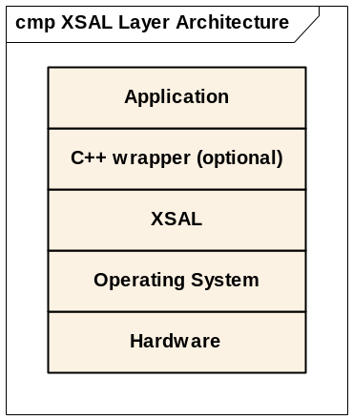
Figure 2: XSAL Layer Structure

In the XSAL approach, the system is composed of independent, concurrent components. Components communicate and co-operate toward a common goal. It could be a number of threads in single process (XSAL_Light) or number of processes with one or more threads (XSAL_Full).

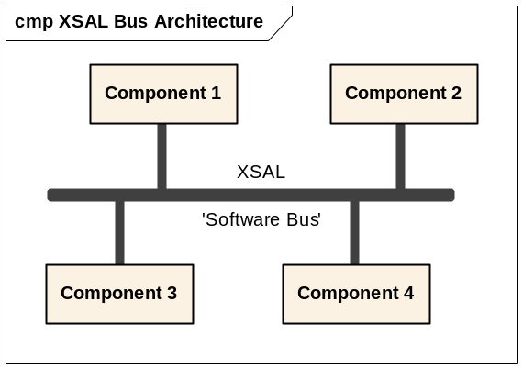
Figure 3: XSAL Bus Architecture

XSAL_Light Logical View
The logical view of XSAL_Light is shown in figure 3. All components in the figure are running in single process space. Each component is equivalent to a thread/task.

XSAL_Full Logical View
The previous sections describe the logical view of an XSAL-based system, especially the XSAL_Light version. Because XSAL_Full allows for communication between components located in different processes, then it has some additional functionality, called Naming Service. The architecture of an XSAL_Full-based system is shown in the figure below.

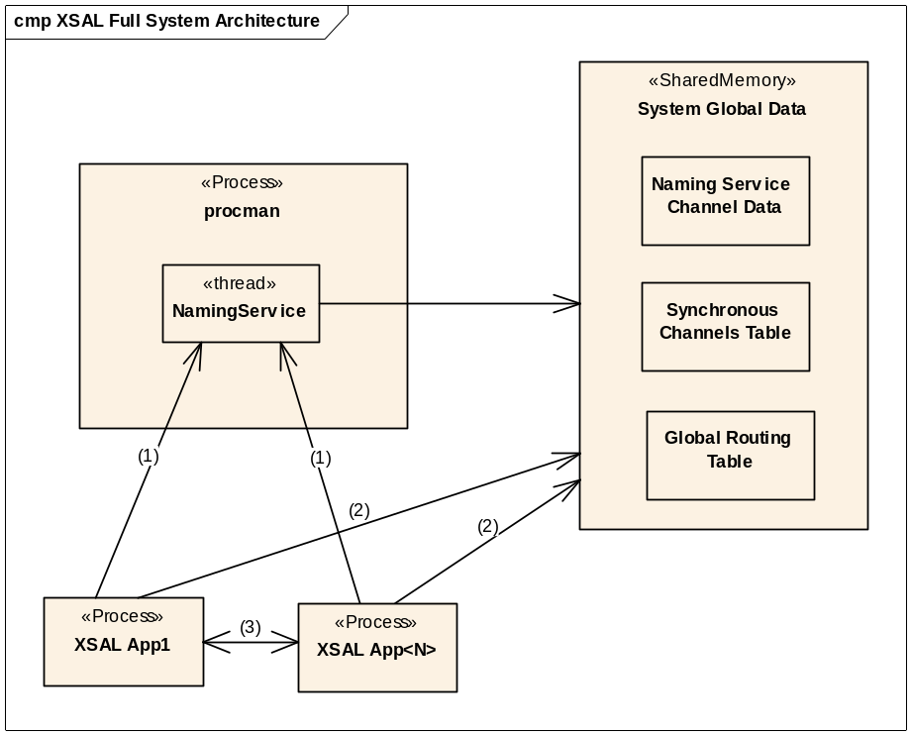
Figure 4: XSAL_Full Architecture

The picture shows some XSAL_Full processes (XSAL App1 and XSAL App2). Processes communicate with each other (3) and with NamingService (1) (which is a thread in the procman process). Additionally each XSAL Application has access (2) to global data in Shared Memory.

Digits in the figure denote groups of messages exchanged between components. The following messages belong to each group:

(1) Naming Service data and Subscription update messages:
SAL_NS_Bind_Channel(), SAL_NS_Resolve_Channel(), SAL_NS_Unbind_Channel(), SAL_NS_Get_Running_App_Ids(), SAL_NS_Subscribe(),SAL_NS_Unsubscribe(), SAL_NS_Unbind_App()
(2) System Global Data Tables accesses in READ ONLY mode (e.g. Routing Table): Channels Table, Global Routing Table
(3) Message passing between applpications: SAL_Send(), SAL_Publish()

Naming Service
One of the key components of the XSAL Full system is the Naming Service (NS). It is responsible for the management of:

- Channels Table
- Global Routing Table

Naming Service is a thread in the procman application. During initialization, the NS creates a communication channel which is used by XSAL_Full applications to send messages to the NS. In order to send messages to the NS, each XSAL_Full application has to create first the connections to the NS. Data which are necessary to create connection are stored by the NS in the Naming Service Channel Data in the Shared Memory.

Synchronous Channels Table
Synchronous Channels Table is use to store System Wide Synchronous Communication Channel data. Each channel in the NS is identified by two ids: Application ID and Port ID. Any application can register its own channel (calling SAL_NS_Bind_Channel()), un-register it (calling SAL_NS_Unbind_Channel()) and create a connection to a channel created by another application (SAL_NS_Resolve_Channel()).

Each XSAL_Full–based application creates one channel to receive asynchronous messages form remote applications. This channel is automatically registered in the NS with the calling Application ID and Port ID equal 0 (<AppId, 0>). Channel with Port ID equal 0 is sometimes called Router Thread Channel.

Global Routing Table
The second functionality of the Naming Service is to store subscription information: which applications are subscribed to which events. Subscription data are kept in the Global Routing Table (GRT). Logically, GRT it is two-dimensional table with SAL_MAX_EVENTS number of rows and SAL_MAX_APPS number of columns.

GRT[SAL_MAX_EVENTS][SAL_MAX_APPS];

Each row of the table contains a list of applications subscribed to a given event. If Application 5 is subscribed to event 7, then GRT[7][5] is equal 1, otherwise 0.

GRT is kept in the System Global Data in the Shared Memory. Applications have access to the GRT in two ways. When they are going to change any data in the GRT they send a synchronous event to the NamingService via NamingService Proxy API. If they only read GRT data they access the Shared Memory directly (via memory pointer).

Static Structure
The picture below shows the static structure of an XSAL application.

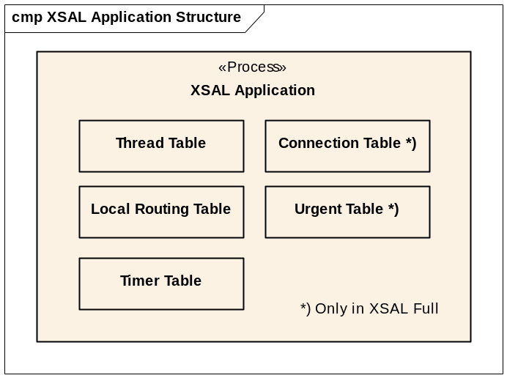
Figure 5: Static structure of the XSAL Application

Each XSAL application has the following internal data structures:
- Thread Table
- Local Routing Table (LRT)
- Timer Table

Additionally XSAL_Full applications have:
- Connection Table
- Urgent Table

Thread Table
The figure below shows the main attributes of the XSAL Thread structure.

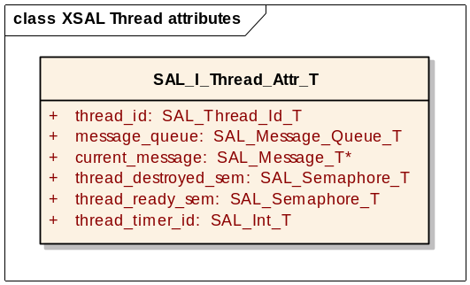
Figure 6: XSAL Thread structure

thread_id attribute
Each XSAL Thread has its own unique identifier – thread_id.
The thread Id value is from range [1, SAL_I_Max_Number_Of_Threads], where the SAL_I_Max_Number_Of_Threads parameter is defined by the user during runtime.

message_queue and current_message attributes
XSAL Threads communicate by asynchronous messages passing. Each thread has the message_queue attribute. Function SAL_Create_Queue creates the message queue in the calling thread. When a thread receives an event (by calling SAL_Receive()) from its own queue or from queue created in another thread in the same application (by calling SAL_Receive_From()), then a pointer to the received message is stored in the current_message attribute.

When a thread terminates, the message pointed to by current_message is returned to the queue from which the message was received (it is a possibility that the message was received from another thread’s queue) and the calling thread’s message queue is also destroyed (if it was created).

thread_ready_sem and thread_destroyed_sem attributes
XSAL allows synchronizing thread startup/shutdown. It is implemented by using two semaphores per thread: thread_ready_sem and thread_destroyed_sem. Every time when a thread is started, it signals its thread_ready_sem semaphore. When the thread is terminating itself, it signals its thread_destroyed_sem semaphore. When other threads in the application call SAL_Wait_Ready() or SAL_Wait_Destroy(), they wait for thread_ready_sem or thread_destroyed_sem respectively.

thread_timer_id attribute
Each XSAL thread may create timers. Attribute thread_timer_id points to the first timer ID from the list of all timers created by given thread. When a thread terminates, all its timers are also destroyed.

Local Routing Table (LRT)
LRT stores the information about which threads are subscribed to a given event. Logically, it is a two-dimensional table with SAL_MAX_EVENTS number of rows and Number_Of_Threads number of columns. Each row of the table contains a list of threads subscribed to a given event.

LRT[SAL_MAX_EVENTS][Number_Of_Threads];

SAL_MAX_EVENTS defines the number of events in the system and Number_Of_Threads defines the number of declared threads in the application.

Router Threads Connection Table
Router Threads Connection Table exists only in XSAL_Full. In XSAL_Light there is only one process and consequently there are no connections to other applications.

Router Threads Connection Table stores Connection ID’s to remote Router Threads. Connections to other Router Threads are established once, just before the first message is sent / published.

Router Thread Connections Table is logically defined as one-dimension table with SAL_MAX_APPS rows:

SAL_Connection_T Connection_Id[SAL_MAX_APPS];

SAL_MAX_APPS defines number of XSAL applications.

Behavior
The following sections describe the behavior of XSAL applications in the context of application initialization and message passing.

XSAL Application initialization
Depending on XSAL version, there are two scenarios of starting XSAL Application(s). In XSAL_Full, there is more then one application which shares some global data like Synchronous Channels Table and Global Routing Table, while in XSAL_Light there is only one application without any global data. Therefore the procedure of initialization is different in both versions.

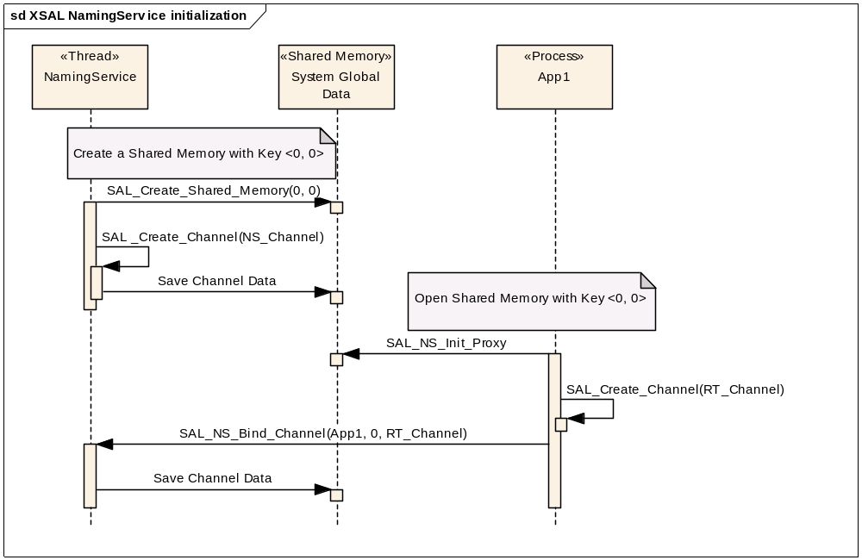
Figure 7: XSAL_Full system initialization

Figure 7 shows the sequence of initialization of the NamingService in XSAL_Full. It is done by the procman application which has to be started as the first process.

The NamingService thread (which is a part of the procman application) is started first and it creates Shared Memory with a globally known identifier (pair of numbers: <0, 0>). Next it creates a synchronous communication channel and stores its parameter in the Naming Service Channel Data in the Shared Memory. When the XSAL Application starts, it opens Shared Memory identified by identifier <0, 0>, reads Naming Service Channel Data and creates connections to the NamingService. It is done by function SAL_NS_Init_Proxy. After that, the XSAL Application creates its own Router Thread Communication Channel and binds it in the NamingService (using Naming Service Proxy created in the previous step).

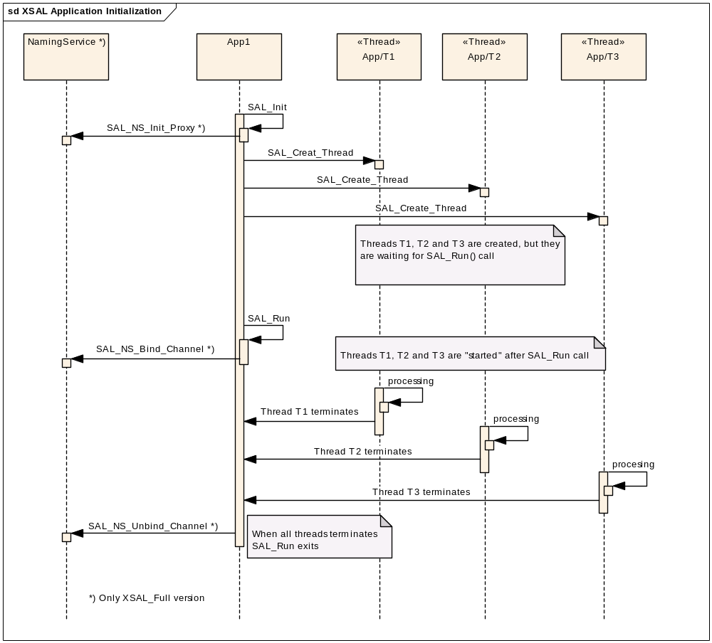
Figure 8: XSAL Application initialization

Figure 8 shows the process of XSAL Application initialization.

At the beginning, the SAL_Init function has to be called. It initializes all internal resources (e.g. thread table, mutexes, semaphores,…). In the XSAL_Full version it initializes the NamingServer Proxy. In the next step user threads (T1, T2 and T3) are created. Note that threads are initialized but they don’t execute their main function until SAL_Run is called.

SAL_Run is a blocking function. It starts the created threads and blocks itself until all XSAL threads terminate themselves or until the SAL_Exit function is called by any thread.

In XSAL_Full version, when SAL_Run is about to terminate, it unbinds the application’s Router Thread from the Naming Service.

Router Thread functionality
Each XSAL Application has at least one internal thread called Router Thread (RT). Functionality of the Router Thread depends on XSAL version. In XSAL_Full its main responsibility is to receive messages from remote applications and post them to the destination threads’ queues. Additionally, on QNX operating system, Router Thread processes timer events (see section “XSAL timers on QNX platform”). Moreover, in XSAL_Full version, Router Thread processes Debug Trace Console (DTC) events. Debug Trace Console is an application used to change Debug Trace parameters of any XSAL Application during runtime. It allows enabling/disabling debug statements, change group mask and verbosity level.

In XSAL_Light the functionality of the Router Thread is different. Because it is a single processes system Router Thread doesn’t process any remote messages. Its main responsibility is to manage XSAL Timers. Section “Timer management” describes it in detail.

Receiving messages
Functions SAL_Receive() and SAL_Receive_From() receive messages/events from a thread’s queue. Figure 9 shows the way how the messages are delivered to the queue, depending on whether they are sent from a thread of a local or remote process (XSAL_Full only). Messages sent between threads in the same process are copied directly to the receiver thread’s queue. When they are sent from a thread in a remote process, they are received by the Router Thread and copied to the receiver thread’s queue.

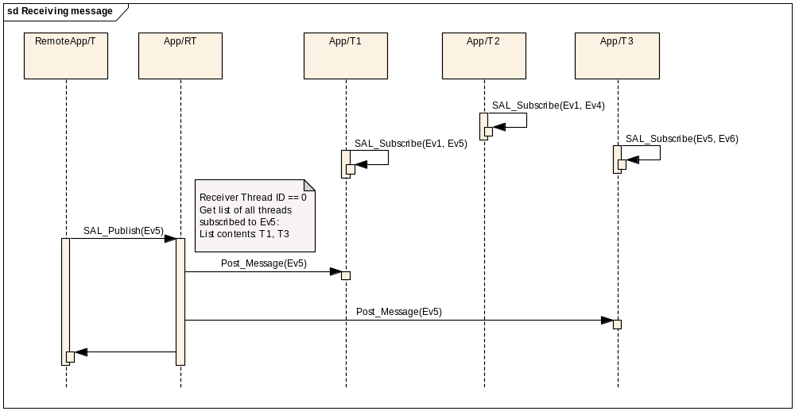
Figure 9: XSAL_Full message receiving

Figure 9 shows how the published events are delivered to its receivers.

Sending and publishing messages
XSAL has two functions sending messages – SAL_Send and SAL_Publish. SAL_Send uses direct channel naming – the Application ID and Port ID are specified. Function SAL_Publish uses indirect channel naming. It means that it doesn’t address any particular receiver.

To recognize if the message was send by SAL_Send() or SAL_Publish(), the Router Thread checks the value of the receiver_thread_id field in the message header. If the value is greater than 0 then it means that the message was sent to the given thread by SAL_Send(). When the value equals 0 then it means that the message was sent by SAL_Publish(). In this case, Router Thread checks in the Local Routing Table which threads are subscribed to the given event.

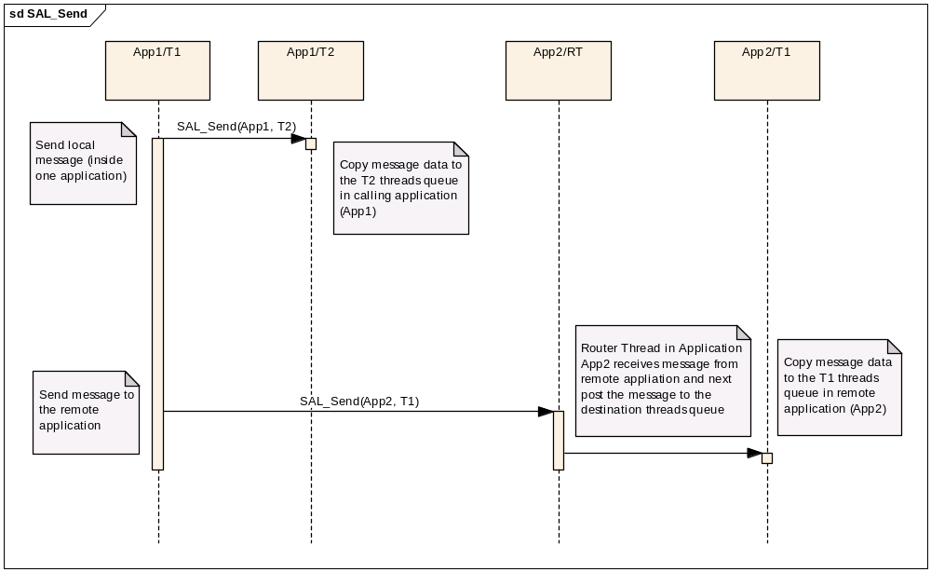
Figure 10: XSAL message sending

When a thread sends a message to thread(s) in a remote process, then it is first sent synchronously to the remote Router Thread. Then the Router Thread puts the message into the queue of the destination thread(s).

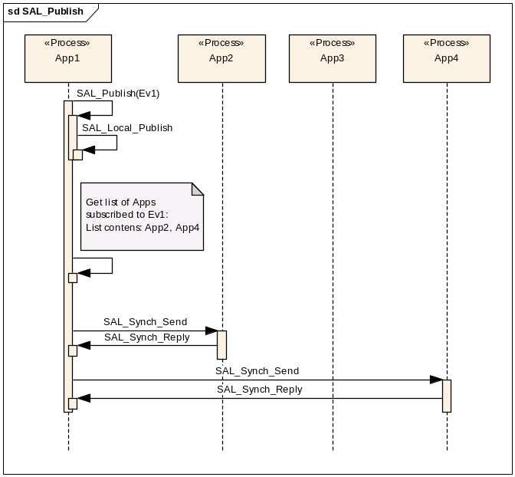
Figure 11: XSAL message publishing

Figure 11 shows how the published events are delivered to its receivers on the synchronous communications level.

Timer management
XSAL Timer events are delivered to the receiver thread’s queue on timer expiration. Thread which created the timer is the owner of the timer. The timer may be started, stopped and destroyed only by their owner. Because each timer belongs to one thread, threads don’t have to subscribe to timer events.

When a thread creates a timer, it may use “private events“. Private events are not declared in the global range in xsal_event_id.h file. Note that it is not possible do declare private events as urgent.

The figure below show the main attributes of the XSAL Timer structure.

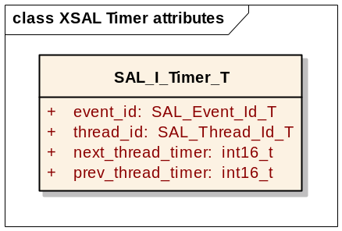
Figure 12: XSAL Timer attributes

Physically, all XSAL Timers are stored in a vector Timer Table. The size of the vector determines the maximum number of XSAL Timers which an application (all threads together) can have. The default value and the way how it can be changed is described in section “Configuration & Global Data”.

All timers created by a thread are logically grouped on the list by using two attributes: next_thread_timer and prev_thread_timer. Both attributes contain indexes to the next and the previous timer owned by a specific thread (or value -1 if there aren’t next/previous timers).

Besides some common attributes, implementations on different platforms can contain other, OS specific, attributes e.g. “current time value” decremented on each ‘timer tick.’

Implementation of the timers is strongly dependent on the underlying OS. Currently we can distinguish three different approaches depending on the OS: QNX, WIN32 and POSIX.

XSAL timers on the QNX platform
On QNX, XSAL Timers use QNX timers sending pulses. A QNX timer sends a pulse to a defined channel. The pulse carries two attributes: code (7 bits) and value (32 bits).
XSAL uses attribute code as the ID of the receiver thread and attribute value as the event ID.

In both XSAL versions (XSAL_Full and XSAL_Light) pulses from timer are received by the Router Thread. Every time when a pulse is received, the Router Thread checks the value of the attribute code. If it is grater than 0, it means that the pulse comes from an XSAL Timer. In this case the Router Thread post them to the message queue of the thread with a specific ID.

Pulses with the attribute value equal 0 are processes by the Router Thread. This allows terminating the Router Thread (and function SAL_Run) by sending a pulse with code 0 and an arbitrary status in the attribute value.

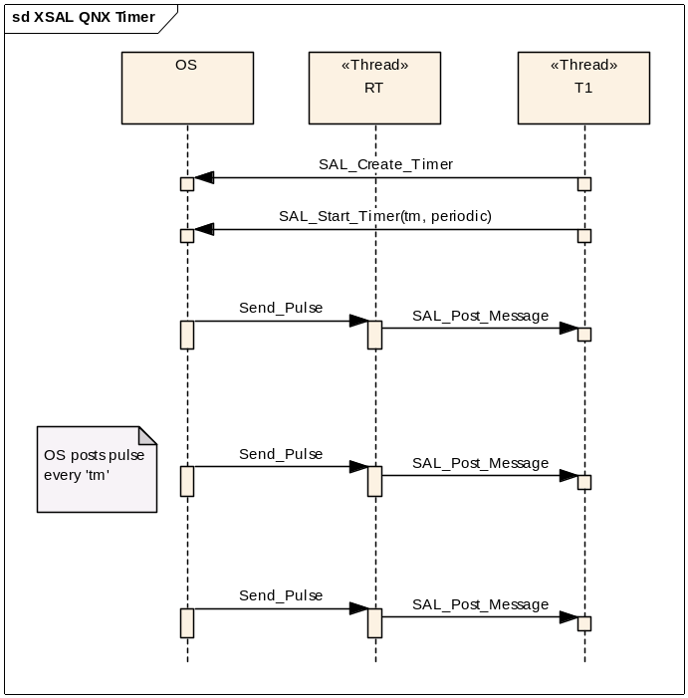
Figure 13: XSAL Timer on QNX System

XSAL timers on the Win32 platform
XSAL Timers on the WIN32 system uses the WM_TIMER event generated by the system.
The WT_TIMER event is sent every 10 ms to a dedicated thread (called TimerThread). When this event occurs, all counters (“current timer values”) of running XSAL Timers are updated. If any of them expires then the XSAL Timer event is posted to the receiver thread’s queue.

XSAL Timers implementation is slightly different depending on XSAL version. In XSAL_Light timer thread functionality is implemented in the Router Thread while in XSAL_Full a dedicated thread is created.

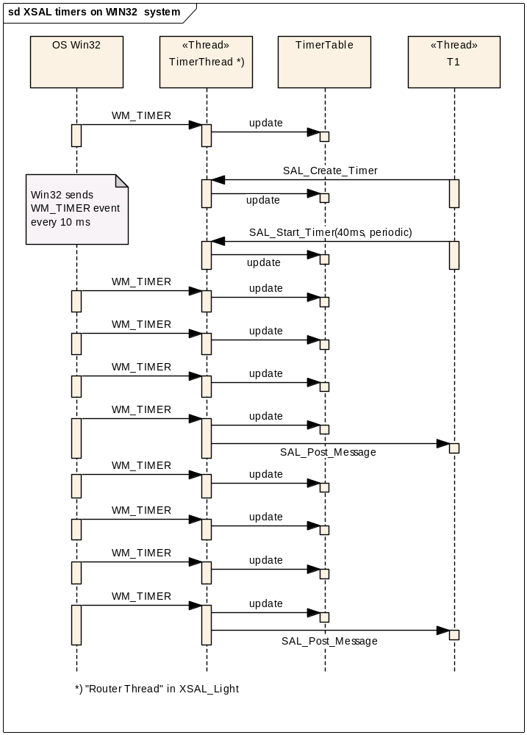
Figure 14: XSAL Timer on WIN32 System

XSAL timers using POSIX Signals
XSAL Timers on POSIX-based systems use signal SIGALRM. Similar to the Win32 solution, there is a dedicated thread. The thread waits for a signal which is sent every 10 ms. When the signal occurs then all counters (“current timer values”) of running XSAL Timers are updated. If any of them expires then the XSAL Timer event is posted to the receiver thread’s queue.

The implementation of XSAL Timers depends on XSAL version. In XSAL_Full there is a dedicated thread which catches signals and updates timer counters. In XSAL_Light timer thread functionality is implemented in the Router Thread.

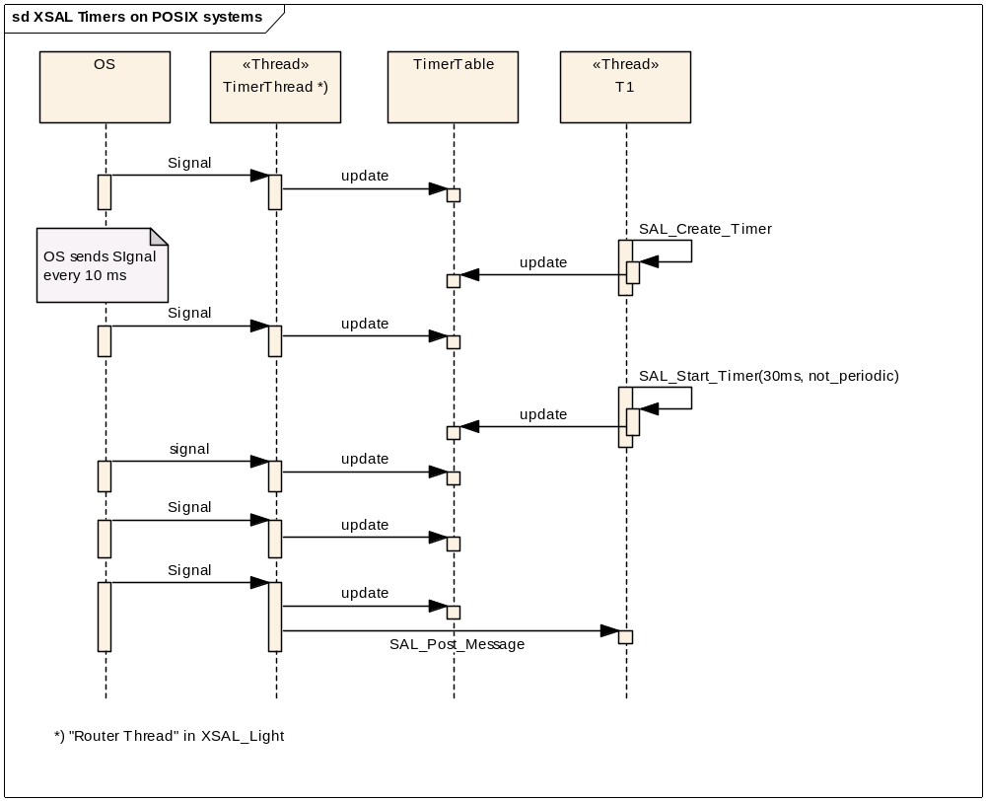

Component View
This view shows how the logical view and its classes and objects are build into actual entities of the software components.

Source Package Objects
List up source packages as well as any other artifact which is required to build the compiled objects.

Compiled Objects
List up libraries, executables, configuration files or any other software artifact which is delivered by the build process. Specify artifacts which are required by dependend components. Specify artifycts which are required at runtime.
The build process creates the XSAL library, and XSAL test applications. Depending on the version of XSAL that is compiled (XSAL Full or XSAL Light), XSAL or XSAL_Light library is built (libXSAL.a, libXSAL_Light.a).

Some XSAL implementations (e.g. on QNX, Linux or Win32) use the Debugtrace package internally. Therefore, when the XSAL Application is linked, the Debugtrace library also has to be linked.

Summary
Optional: list down all the components of the software component along with resource allocation and, if available, reference to detailed design document name and location (for traceability).

Component name | Allocated resource | Detailed design name and location

Deployment View
This view shows how to push the software into hardware. It focuses on giving details of how the software is deployed into that layer which is called hardware.

Interfaces

API
The XSAL Interface is described in document [3]. It is a chm help file generated from XSAL source files using doxygen and HTML Help Workshop tools.

Configuration & Global Data
The configuration of the XSAL component consists of:
- List of Application IDs – defined in file xsal_application_id.h. The file contains a list of IDs of all XSAL applications.
- List of Event IDs – defined in file xsal_event_id.h. The file contains a list of IDs of all XSAL public events.
- Set of macros with default values of some parameters – defined in file xsal_settings.h.

Configuration of the xsal_application_id.h file
The xsal_application_id.h file defines the IDs of all XSAL Applications in a specific project. Each project has to define its own version of this file.

Several data structures depend on the number of applications defined in this file. Therefore it is extremely important that every time that this file is changed, the XSAL library must be recompiled, and all applications (including procman) must be linked with the new XSAL lib.
This file may also be used in the XSAL_Light version to define the symbolic name of the application.

Configuration of the xsal_event_id.h file
The xsal_event_id.h file defines the IDs of all XSAL events in a specific project. Each project has to define its own version of this file.

Several data structures depend on the number of events defined in this file. Therefore it is extremely important that every time that this file is changed, the XSAL library must be recompiled and the application must be linked with the new XSAL library.

Configuration of the xsal_settings.h file

Macro XSAL_MAX_NUMBER_OF_TIMERS
The maximum number of timers that an application can have is defined by the macro XSAL_MAX_NUMBER_OF_TIMERS.

By default its value is set to 64. It can be changed during the compilation of the XSAL library by changing the value in the xsal_settings.h file or by passing the macro with a new value during compilation time (e.g. make <param> -DXSAL_MAX_NUMBER_OF_TIMERS=16). The new value of the parameter will apply to all XSAL Applications.

This value can also be changed dynamically by each application during application initialization, by calling the SAL_Init function:

SAL_Config config;
SAL_Get_Config(&config);
config.max_number_of_timers = 10;

SAL_Init(&config);

Macro XSAL_MAX_NUMBER_OF_BUFFER_POOLS
Maximum number of buffer pools that an application can have is defined be the macro XSAL_MAX_NUMBER_OF_BUFFER_POOLS.

By default its value is set to 32. It can be changed during the compilation of the XSAL library by changing the value in the xsal_settings.h file or by passing the macro with a new value during compilation time (e.g. make <param> -DXSAL_MAX_NUMBER_OF_BUFFER_POOLS =16). The new value of the parameter will apply to all XSAL Applications.

This value can also be changed dynamically by each application during application initialization, by calling the SAL_Init function:

SAL_Config config;
SAL_Get_Config(&config);
config.max_number_of_buffer_pools = 64;

SAL_Init(&config);

Macro SAL_THREAD_NAME_MAX_LENGTH
Macro SAL_Thread_NAME_MAX_LENGTH defines the length of the thread name (including the terminating string byte with the value 0). By default the thread name may have 8 characters:

#define SAL_THREAD_NAME_MAX_LENGTH (8+1)

Memory Usage Objectives
XSAL is a modular library compiled for various OS’s using various compilers. Depending on the project requirements it may be compiled using different compilation flags (e.g. optimized for speed or size), as a static or dynamic library (usually the size of a static library is smaller than the size of a dynamic one), and so on.

The table below shows the sizes of the XSAL library grouped by functional modules. The library was compiled as a static library for QNX 6.3.0, without Debug Traces using the gcc compiler version 3.3.5 for the SH4 microprocessor.

XSAL module | Code Size
Mutexes | 1.0 KB
Semaphores | 1.0 KB
RWLocks | 1.0 KB
BufferPools | 1.5KB
SharedMemory | 1.5 KB
Thread Management | 7.0 KB
Queue Management | 3.5 KB
Timers | 2.0 KB
Message Sending | 2.0 KB
Message Publishing | 2.0 KB
Urgent Messages *) | 1.0 KB
Queue Iterators *) | 1,5 KB
NS Proxy *) | 1,0 KB
NS Thread *) | 2.0 KB
Synchronous Communication *) | 1.5 KB
DTC | 0.5 KB
Sum of all components | ~30 KB

Requirements Trace
Requirements document in DOORS: /Roster_Number_10017133/SW Documents/Internal Requirements/Application Processor/XSAL

Requirement Id | Requirement | Implementing package::class
SRS-10017133-419-21 | XSAL shall be implemented on the following operating systems: QNX, Windows, uItron | N/A
SRS-10017133-419-22 | XSAL shall be written in the C language | N/A
SRS-10017133-419-23 | XSAL shall be available in two versions: XSAL and XSAL Light | N/A
SRS-10017133-419-26 | It shall be possible to create threads | Thread & Synchronization
SRS-10017133-419-27 | It shall be possible to synchronize threads and ensure mutual exclusion | Thread & Synchronization
SRS-10017133-419-32 | Threads shall be able to communicate via asynchronous message passing | Asynchronous Communication
SRS-10017133-419-33 | Threads shall be able to subscribe to and publish messages | Publish / Subscribe
SRS-10017133-419-34 | Threads shall to be able communicate via synchronous message passing | Send-Receive-Reply Communication
SRS-10017133-419-35 | It shall be possible to create timers | Asynchronous Communication
SRS-10017133-419-37 | It shall be possible to create non-fragmenting, time-bounded memory buffers | Buffer Pool

Usage Guidelines

Usage guidelines for the XSAL component are described in document [2].

Test Objectives

Test objectives for the XSAL component are described in document [4].

Open Issues

No. | Issue | Comments /  Proposed Solution | Person responsible | To be resolved by date
 | N/A | N/A | N/A | N/A
 | N/A | N/A | N/A | N/A

Lessons Learned

TBD

Appendixes

N/A

