Base Audio Software Architecture
S/W Detail Design XSAL Light for uITRON

Document: sdd_basa_xsal_light_uitron
Prepared by: Dan Carman
Date: September 18, 2007
Version: 0.2 Draft

Delphi E&S
Entertainment & Communications

Revision History

Version | Date | Author | Company/ Department | Change Description
0.1 Draft | 9-Feb-2007 | Dan Carman | Delphi E&S, Kokomo | Initial document
0.2 Draft | 18-Sept-2007 | Dan Carman | Delphi E&S, Kokomo | Updated format and general contents

TABLE OF CONTENTS
Revision History 2
TABLE OF CONTENTS 2
List of figures 3
1. Introduction 4
1.1 Purpose 4
1.2 Scope 4
1.3 Definitions, acronyms, and abbreviations 5
1.4 References 6
1.5 Overview 6
1.5.1 General uITRON Design Rules 6
2. Software structure and interfaces 7
2.1 Application 7
2.1.1 init_task 7
2.1.2 init_drv 7
2.1.3 Application_Initialization 7
2.1.4 SAL_Get_Config 7
2.1.5 SAL_Init 7
2.1.6 SAL_Run 7
2.2 Threads 7
2.2.1 Thread Creation 7
2.2.2 Thread uITRON attributes 7
2.2.3 XSAL extended thread attributes 8
2.2.4 Thread Sleep and Delay 8
2.2.5 Thread synchronization at startup 8
2.3 Mutexes 8
2.3.1 uITRON specific Data Types 9
2.4 Semaphores 9
2.4.1 uITRON specific Data Types 9
2.5 Timers 9
2.5.1 Timestamps 11
2.6 Memory Allocation 11
2.6.1 Pool Memory 11
2.6.2 General Memory Allocation 12
2.7 Message Passing 12
3. CALLOUTS 12
4. Dynamic behavior and algorithms 12
5. Restrictions 12
6. Resource consumption objectives 13
6.1 Memory usage 13
7. Test criteria 13
8. Open issues 13
9. Appendixes 14

List of figures
Figure 1 - Architecture of an uITRON XSAL Light system 4
Figure 2 - XSAL Thread calls with direct uITRON mappings 8
Figure 3 – XSAL Mutex Direct uITRON Call Mappings 8
Figure 4 – XSAL Semaphore Direct uITRON Call Mappings 9
Figure 5 – Individual Timer State Behavior 10
Figure 6 – Execution Individual Timer State Behavior 11
Figure 7 – XSAL Memory Pool Direct uITRON Call Mappings 12
Figure 8 – XSAL General Memory Allocation Direct uITRON Call Mappings 12

Introduction

Purpose
The document describes the design for the implementation of XSAL Light API for the uITRON OS. XSAL is the “next generation” System Abstraction Layer API. XSAL facilitates the implementation of operating system-independent applications, thus improving their portability.
XSAL is available in two API versions:
- Rich API targeted at high-end multi-process systems with protected memory (called XSAL API).
- Reduced API targeted at low-end mult-threaded systems without protected memory (called XSAL Light API).
Besides this implementation for uITRON, XSAL has been implemented on Windows, QNX, and Linux.

Scope
XSAL Light provides a standard interface layer between reusable S/W components and the underlying OS. For this design, the underlying OS is Renesas’ HI7000/4 Series uITRON.

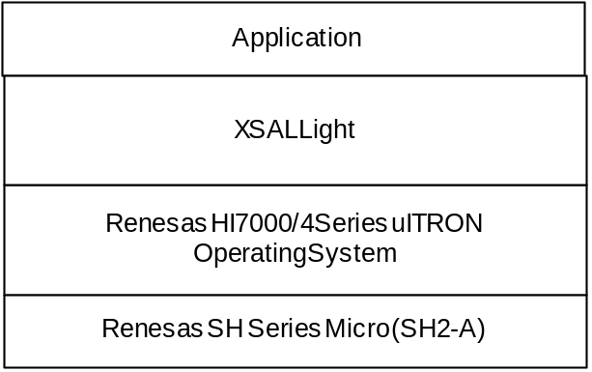
Figure 1 - Architecture of an uITRON XSAL Light system

XSAL Light API covers the following functionality:
- Application management – makes it possible to start up and initialize XSAL-based applications.
- Thread management – implements OS-independent creation of threads.
- Thread synchronization and mutual exclusion – provides thread synchronization and mutual exclusion primitives.
- Thread synchronization at startup – provides a mechanism for synchronizing threads during startup and initialization.
- Asynchronous communication – implements message queues and message passing.
- Publish/subscribe – provides facilities for sending and receiving messages according to the publish/subscribe paradigm.
- Timer management – implements timers and system clock.
- Buffer pools – provide non-fragmenting, time-bounded memory allocation and de-allocation.
- Memory Allocation – provide general purpose memory allocation / de-allocation.

  - Definitions, acronyms, and abbreviations
Abbreviation | Explanation
API | Application Programming Interface. Defines the interface to a software component for use by other software components.
BASA | Base Audio Software Architecture
callback | In BASA, the term “callback” is reserved for the specific case that a call is satisfied through a function pointer that can be modified dynamically at run time. This is different than a “callout”, which establishes a fixed relationship at program link time. Callbacks have the advantage of being dynamic, while having a RAM cost (for the function pointer). There is also an inherent risk that the function pointer might be corrupted. A callout sacrifices this dynamic capability and, at the same time, eliminates the RAM usage and associated corruption risk. For BASA, callouts are considered to be the preferred solution, since the dynamic behavior of a callback is seen as a rare need.
callout | A global symbol that is declared, but not defined (implemented), by the module that “owns” it. It must be defined (implemented) by some other module (which module is not specified) and the symbolic link must be satisfied at program link time. This provides a mechanism for configuring/customizing a module at link time. It has desirable coupling since the module defining (implementing) the callout can be changed without requiring modification of the component that declares the callout. Note that callouts can exist at both the public API level and at the implementation level of a component. AutoSAR uses the term “callback” for callouts. Because AutoSAR’s use of the term callback does not match that commonly used for the term, BASA chooses to use the common definition of “callback” and define the new term “callout”.
global symbol | Symbols that are visible throughout an entire C language program.
HMI | Human Machine Interface – the software that interfaces with the operator of the device, interpreting their input and displaying information to them.
Module Development Framework (MDF) | The MDF is the context in which a software component (module) is developed and tested. It is a Synergy Configuration Management (SCM) project that contains, as static subprojects, the API and implementation(s) of the software component. These same subprojects are statically included within the SCM projects created by programs that use the component; hence, in many respects, the MDF is like a program level SCM project.
N/A | Not Applicable.
Publish/Subscribe | A message passing system that decouples modules that publish information from those that subscribe to it. The publisher is unaware of what modules subscribe to the information or what their number is. Subscribers register at run time (dynamically) to receive the published information.
SoH | State of Health. The process of ensure that individual threads are active.
Synchronization | The process of providing exclusive access to a resource to independent threads of execution. Synchronization is require to prevent threads from accessing data while it is in the middle of being updated by another thread, etc.
Synergy Configuration Management (SCM) | The software tool from Telelogic used for global software configuration management by Delphi.
RTOS | Real Time Operating System – an operating system designed to handle timing requirements.
  - References
No. | Document Name | Date | Version | Location
 | Next Generation System Abstraction Layer User Manual | March 1, 2007 | n/a | SCM project - bb_xsal_api/doc/XSAL_API.doc
 | HI7000/4 Series uITRON User Manual | January 04, 2006 | 6.00 | O:\Data\IBS_Software\BASA\Renesas SH2 Tools\uItron_Users_Manual_rej10b0060_hi7000_4um.pdf
 | uITRON Application Note | January 12, 2005 | 3.00 | O:\Data\IBS_Software\BASA\Renesas SH2 Tools\uITRON_Application_Note_rej05b0364_hios.pdf
 | XSAL Light API Reference Guide |  | n/a | SCM project mdf_xsal_light/doc/ bb_xsal_light_api_REF.chm
 | XSAL Light SH2A Implementation Reference Guide |  | n/a | SCM project mdf_xsal_light/doc/ bb_xsal_uitron_sh2a_impl_REF.chm
 | XSAL Light SH2A Test Reference Guide |  | n/a | SCM project mdf_xsal_light/doc/ bb_xsal_uitron_sh2a_test_REF.chm
 | XSAL Software Design Document | September 14, 2007 | 00.1 | SCM project mdf_xsal_light/doc/ SDD_10017133_419.doc

Overview
The rest of this document will describe how each of the XSAL Light OS service classes are implemented on uITRON. This document will not describe the public APIs in detail. Those APIs are described in the reference documents and are assumed to be a requirement for this design.

General uITRON Design Rules

uITRON service calls have the general form of xxx_yyy where:

xxx : Abbreviated verb that shows kind of operation
cre : create, act : activate, snd : send, etc.

yyy : Abbreviated Target Object
tsk : task, mbx : mailbox, etc.

The Renesas implementation of uITRON 4.0 has mirrored many of the standard uITRON calls for use in interrupt context. These mirrored functions have a pre-appended i for “interrupt”, ixxx_yyy vs. xxx_yyy. For example, signal semaphore has the following two forms, isig_sem and sig_sem. Note, the sns_yyy functions can be called from all contexts. In this document it is assumed that, where the equivalent interrupt context function exist, the appropriate context check will be used to select between service call versions. Thus, service call mapping tables will omit listing of the interrupt forms.

xxx_yyy is only for the call from task-context.
ixxx_yyy is only for the call from non-task context. ‘i’ means “interrupt”.
txxx_yyy is same as xxx_yyy with timeout.

When available, only the timeout version of service call will be used.
It is assumed that all uITRON return values will be checked and asserts will be generated on all errors. The exception will be for E_TIMEOUT errors from SAL wait functions. In those cases, the function shall simply return unsuccessful (i.e., false).
Where possible XSAL Data types will be mapped directly to the equivalent types to minimize conversions. It is also assumed the mapping functions will appropriately repackage parameters from the XSAL calling format to that needed by uITRON.

Software structure and interfaces

Application
Need something here about uITRON configuration.

init_task
Only required pre-configured uITRON task is init_task. This thread starts up the system and eventually manages the SAL timers. Init_task initializes the system memory pool (SMP) which is used to allocate dynamic memory; the Renesas’ drivers via init_drv function; the I/O system; and ends with calling the project specific application initialization function. The application initialization function is not expected to return.

init_drv
The init_drv function first configures and startups the IOIF (I/O interface) sub-system. The IOIF manages all of the POSIX style device drivers. It directs calls to standard I/O functions (open, close, read, write, ioctl, etc..) to the proper device driver based on the file handle.
Init_drv also initializes any device drivers, not initialized by Base Driver Wrapper modules.

Application_Initialization
Application_Initialization is a project specific function used to configure and startup the actual application.

SAL_Get_Config

SAL_Init

SAL_Run

Threads
XSAL threads are managed with a combination of uITRON task functions and extended thread attribute structure. Thread related functions are implemented in three C files: xsal_create_thread, xsal_thread_uitron, and xsal_thread_attributes.

Thread Creation
Implemented in xsal_thread_create_uitron.c.

Thread uITRON attributes
XSAL thread uITRON attributes are managed by xsal_thread_uitron.

XSAL Light Service | uITRON Service
SAL_Get_Thread_Priority | get_pri
SAL_Set_Thread_Priority | chg_pri
SAL_Is_Thread_Alive | ref_tst
SAL_Get_Thread_Id | get_tid
Figure 2 - XSAL Thread calls with direct uITRON mappings

XSAL extended thread attributes
XSAL extended thread attributes are manage by xal_thread_attributes.c. The extended thread attributes contain the thread’s name, ready semaphore, message queue, and message pointer.

Thread Sleep and Delay

The XSAL sleep function, SAL_Sleep, is mapped directly to the uITRON dly_tsk service in xsal_sleep_uitron.c.
The XSAL delay function is implemented by polling a free running hardware timer.

Thread synchronization at startup
Implemented in xsal_ready_uitron.c. The extended thread attributes include a ready semaphore. A ready semaphore for each potential thread is created and initialized to 0 during SAL_Init. Therefore, the semaphores are valid before any thread is created. The SAL_Signal_Ready function increments the calling thread’s semaphore to 1.
The SAL_Wait_Ready function waits, in series, for the ready semaphore for each thread in it’s list. When it gets the semaphore, it reset the semaphore back to 1. The timeout is used for each individual wait, thus worst case total time to return may be equal to the number of threads being waited on times the timeout.

Mutexes
XSAL mutexes calls are directly mapped to the equivalent uITRON’s mutexes calls. The mutex functions are implemented in xsal_mutex_uitron.c
There is a behavioral difference in the uITRON mutexes from other XSAL systems. uITRON only supports ceiling priority for mutexes. The full XSAL systems, QNX, windows, etc., use priority inheritance. This will result in different relative priorities when a thread holds the mutex. With priority inheritance the holder’s priority only increases when a higher priority task is waiting on the same resource. With priority ceiling, the holder’s priority immediately increases to the ceiling level. Additionally, the application must set the ceiling to at least the priority of the highest priority using thread.

XSAL Light Service | uITRON Service
SAL_Create_Mutex | acre_mtx
SAL_Destroy_Mutex | del_mtx
SAL_Lock_Mutex_Timeout | tloc_mtx  ploc_mtx (when dispatch is disabled)
SAL_Try_Lock_Mutex | ploc_mtx
SAL_Unlock_Mutex | unl_mtx
Figure 3 – XSAL Mutex Direct uITRON Call Mappings

uITRON specific Data Types
SAL_Mutex_T holds the uITRON Mutex Object ID (int16_t).
SAL_Mutex_Attr_T is structure with single data field, ceiling_priority, which holds ceiling priority of mutex. The ceiling priority must be same or higher than all using tasks priorities. A NULL pointer will not accepted as a valid creation parameter.

Semaphores
XSAL semaphore calls are mapped to the equivalent uITRON’s semaphore calls. The XSAL semaphore calls are implemented in xsal_semaphore_uitron.c.

XSAL Light Service | uITRON Service
SAL_Create_Semaphore | acre_sem
SAL_Destroy_Semaphore | del_sem
SAL_Wait_Semaphore_Timeout | twai_sem
SAL_Try_Wait_Semaphore | pol_sem
SAL_Signal_Semaphore | sig_sem
Figure 4 – XSAL Semaphore Direct uITRON Call Mappings

uITRON specific Data Types
SAL_Semaphore_T holds the uITRON Semaphore Object ID (int16_t).
SAL_Semaphore_Attr_T is a structure with two data fields, initial_value and max_value.
The initial_value has the initial semaphore value after creation. In a producer / consumer use case, the initial value is usually 0. In a resource allocator use case, the initial value is usually the number of available items. The second parameter, which is not available on windows or QNX, sets an upper count limit. The system will generate an error if this value is exceeded.

Timers
There are no uITRON services that directly correspond to XSAL timers interface. Timers are implemented using a combination of a uITRON cyclic handler and a high priority thread acting on lists of timer structures.
Timers are implemented as structures of type sal_timer_T. The structure contain a double link list entry sub structure, a state variable, owning thread id, a timeout value, a period value, and a SAL message event ID.
Based on their state, a timer belongs to one of three double linked lists. The unused list contains timers that are not current owned by any thread. The stopped list contains all owned timers that are not current active (timers that have been stopped or one shots that have expired). The third list contains all of the active (running) timers waiting to time out. This list is sorted in order of time out. The first timer scheduled to expire will be at the head of the list. The timer with the longest time to expire will be at the tail. The following state chart show the transitions of the timer due to various API calls and timeout.

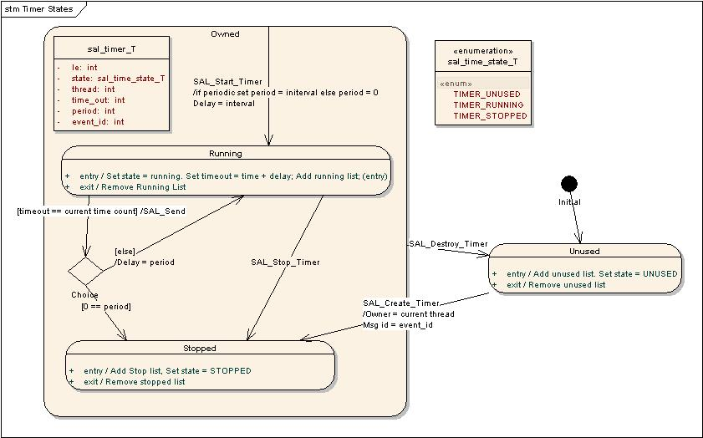
Figure 5 – Individual Timer State Behavior
The main behavior, that is not described in the individual timer state chart, is when a create timer call is received and there are no timers in the unused list. In this case, a block of timers is dynamically allocated from memory and added to the unused list (via the initial transistion). Thus only enough timers (rounded up to the block size), to meet peak requirement are allocated. Note, the allocated memory is never freed. Destroyed timers simply return to the unused list to be recycled on following Create timer request.
Figure 6 shows the operation used to check if any of the running timers have expired. A cyclic handler, which operates in an interrupt context, signals a semaphore every mS. The high priority thread waits on the semaphore. The task locks access the timer list and increments a time counter. It then checks the head of sorted list of running timers until either the list is empty or the head timer timeout value is not equal to the current time counter. If the head timer’s timeout matches the current time count, the timer thread sends the requested event ID to the timer’s owning thread. If the periodic value is zero, the timer is then stopped, else the period is added to the current timeout value and the timer in reinserted into the running list.
The use of sorting the running timers based on their expiration time minimizes the number of timers that are check every mS. Only the timers that are scheduled to expired plus 1 are processed regardless of the number of pending timers. Individual timers are only accessed when they are started, stopped, or expire (note, the running list is partially transversed any time a timer is started (or restarted periodically)).
The stopped and unused lists are unsorted and never transversed. Timers are always added to the end of the list. Unused timers are pulled from the head of the list. All operation that remove a timer from the stopped list, pass a pointer to the timer.

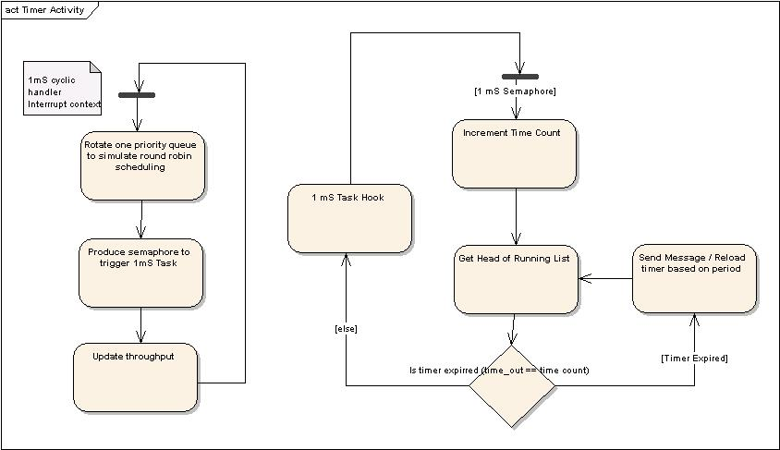
Figure 6 – Execution Individual Timer State Behavior

Timestamps
XSAL Light has added two functions for time stamping. The first is SAL_Clock which returns the number of mS (system ticks) since startup. The second function, SAL_Elapsed_Time, returns the elapsed time between the current SAL_Clock value and the passed parameter. It handles any timer wrap issues. These functions provides a convenient time stamp system that should be available on all BASA systems.
The full XSAL uses ftime to do timing measurements. There are few issues with using ftime. First, ftime is not available on many smaller OSes, which typically only have a system tick clock and not a full date / time. Second, is that ftime stores time in structure and multiple fields must be added to compute the net elapsed time.
Although similar, SAL_Clock differs from the C standard library function Clock. Clock returns program execution time. On low end OSes, these two functions typically return the same value. However, on some high-end OSes, Clock does not include time when all threads are blocked.
The uITRON implementation of SAL_Clock directly returns the uITRON’s get_tim value. This assumes that the system tick rate is 1.0 mS (a common BASA assumption). The Win32 implementation of SAL_Clock uses the ftime function. The first time SAL_Clock is called, it stores a base time. Sequential calls return the difference in milliseconds from the base time.

Memory Allocation

Pool Memory
The XSAL pool memory functions are mapped to uITRON fixed size memory pool services in
xsal_buf_uitron.c.
The XSAL Free buffer API does not indicate which pool to return the buffer to, which is required by the uITRON rel_mpf service. To track the pool ID, SAL_Create_Buffer_Pool allocates an extra 4 bytes (to preserve quad alignment) to the requested block size. The pool ID is stored at the returned address from pget_mpf and that address is incremented by 4 bytes before returning to the application. On SAL_Free_Buffer, the passed in address is decremented by 4 bytes to retrieve the associated pool ID and pass on to rel_mpf.
The uITRON feature to block a caller until a buffer is available is not used. SAL_Alloc_Buffer always returns immediately.
XSAL Light Service | uITRON Service
SAL_Create_Buffer_Pool | acre_mpf
SAL_Alloc_Buffer | pget_mpf
SAL_Free_Buffer | rel_mpf
Figure 7 – XSAL Memory Pool Direct uITRON Call Mappings

General Memory Allocation

The XSAL memory allocation / de-allocation functions are mapped to the equivalent System Memory Pool (SMP) functions.

XSAL Light Service | uITRON Service
SAL_Alloc | SMP_alloc
SAL_Free | SMP_free
Figure 8 – XSAL General Memory Allocation Direct uITRON Call Mappings

Message Passing
Message passing does not use any underlying uITRON communication primitives. It reuses the full XSAL messaging system with removal of the inter-process communications.

CALLOUTS
NEED TO DEFINE CALLOUTS USED BY XSAL LIGHT. What about dropped message handler?

Dynamic behavior and algorithms
Describe the communication going on between software units (using sequence diagrams, communication diagrams etc.).
Describe the state behavior of the units (using statecharts etc.).
Specify the key data-processing algorithms to be implemented (using activity diagrams etc.).
Describe the task cycle time or scheduling algorithm utilized.

The figures below show example diagrams used to specify dynamic behavior of software units and algorithms.

Restrictions

Mutexes cannot be used in interrupt context.
Messages cannot be sent from an interrupt context due to use of mutexes for the queue.

Resource consumption objectives
Specify memory usage needs for the component (including RAM, ROM, EPROM, Flash etc.). For instance:

Memory usage

Table 1 displays the memory usage for the XSAL Light modules on SH2A with 25 threads. This does not include the underlying uITRON implementation.

Module | Code | Constant | RAM
xsal_alloc_uitron | 20 | 0 | 0
xsal_app_uitron | 308 | 0 | 1
xsal_message_queue | 1408 | 0 | 0
xsal_msg_uitron | 228 | 0 | 0
xsal_mutex_uitron | 316 | 0 | 0
xsal_publish_subscribe | 580 | 0 | 78
xsal_queue | 136 | 0 | 0
xsal_ready_uitron | 316 | 0 | 0
xsal_search_message_queue | 192 | 0 | 0
xsal_semaphore_uitron | 292 | 0 | 0
xsal_sleep_uitron | 112 | 0 | 0
xsal_thread_attributes | 568 | 13 | 1706
xsal_thread_create_uitron | 320 | 0 | 0
xsal_thread_uitron | 216 | 0 | 4
xsal_timer_uitron | 1096 | 20 | 126
Total | 6108 | 33 | 1915

Table 1 Memory usage for SH2A XSAL Light

Specify the CPU load or execution time objectives. For instance:

Test criteria
Specify test criteria concerning:
- Dynamic behavior,
- Interfaces,
- Resource consumption.

Test criteria can include:
- Units, functions etc. that are critical for the functioning of system should be listed.
- Functions and sequence flow which requires extra focus while testing should be listed. (This will provide inputs to the testers to plan 100% code coverage for identified functions/component/algorithms)

No. | Unit, function, functionality, sequence of execution etc. | Testing inputs | Proposed code coverage

Open issues

No. | Issue | Comments / Proposed Solution | Person responsible | Issue to be resolved by date

Appendixes

uITRON Functions used by XSAL

Note, additional uITRON functions may be used directly by Renesas’ device drivers.

Task Management Functionss
 | iacre_tsk | Create Task and Assign Task ID Automatically (interrupt contex)
 | acre_tsk | Create Task and Assign Task ID Automatically
 | ista_tsk | Start Task (Start Code Specified) (interrupt contex)
 | sta_tsk | Start Task (Start Code Specified)
 | icre_tsk | Create Task Using Dynamic Stack (interrupt contex)
 | cre_tsk | Create Task Using Dynamic Stack
 | ichg_pri | Change Task Priority (interrupt contex)
 | chg_pri | Change Task Priority
 | iget_pri | Refer to Task Priority (interrupt contex)
 | get_pri | Refer to Task Priority
 | iref_tst | Refer to Task State (simple version) (interrupt contex)
 | ref_tst | Refer to Task State (simple version)
Task Synchronous Management Functions
 | dly_tsk | Delay Task
Task Exception Management Functions
 |  | Not Used
Synchronization and Communication Functions
Semaphore
 | acre_sem | Create Semaphore and Assign Semaphore ID Automatically
 | del_sem | Delete Semaphore
 | twai_sem | Wait on Semaphore with Timeout
 | ipol_sem | Poll Semaphore (interrupt contex)
 | pol_sem | Poll Semaphore
 | isig_sem | Return Semaphore Resource (interrupt contex)
 | sig_sem | Return Semaphore Resource
Event Flag
 |  | Not Used
Data Queue
 |  | Not Used
Mailbox
 |  | Not Used
Extended Synchronization and Communication Functions
Mutex
 | acre_mtx | Create Mutex and Assign Mutex ID Automatically
 | del_mtx | Delete Mutex
 | ploc_mtx | Poll and Lock Mutex Resource
 | tloc_mtx | Lock Mutex Resource with Timeout
 | unl_mtx | Unlock Mutex Resource
Message Buffer
 |  | Not Used
Memory Pool Management Functions
Fixed-Size Memory Pool
 | iacre_mpf | Create Fixed-Size Memory Pool and Assign Fixed-Size Memory Pool ID Automatically (interrupt contex)
 | acre_mpf | Create Fixed-Size Memory Pool and Assign Fixed-Size Memory Pool ID Automatically
 | ipget_mpf | Poll and Acquire Fixed-size Memory Block (interrupt contex)
 | pget_mpf | Poll and Acquire Fixed-size Memory Block
 | irel_mpf | Release Fixed-Size Memory Block (interrupt contex)
 | rel_mpf | Release Fixed-Size Memory Block
Variable-Size Memory Pool
 |  | Not Used
System Memory Pool Support
 | SMP_alloc | Allocate block of memory
 | SMP_free | Free block of memory
Time Management Functions
System Clock Management
 | iget_tim | Get System Clock (interrupt contex)
 | get_tim | Get System Clock
Cyclic Handler
 | acre_cyc | Create Cyclic Handler and Assign Cyclic Handler ID Automatically
Alarm Handler
 |  | Not Used
Overrun Handler
 |  | Not Used
System Status Management Functions
 | sns_ctx | Refer to Context
 | iget_tid | Refer to Task ID in RUNNING State (interrupt contex)
 | get_tid | Refer to Task ID in RUNNING State
 | ena_dsp | Enable Dispatch
 | dis_dsp | Disable Dispatch
 | sns_dsp | Refer to Dispatch-Disabled State

