Fig 2.7 screen shot

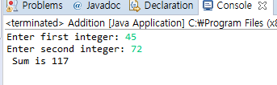

Fig 6.3 screen shot

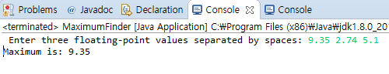

1. Menu Output

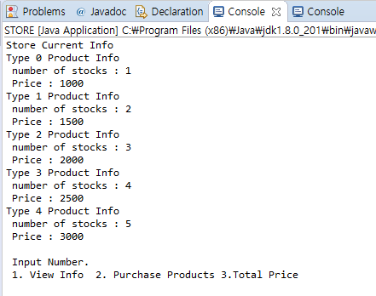

1. Purchase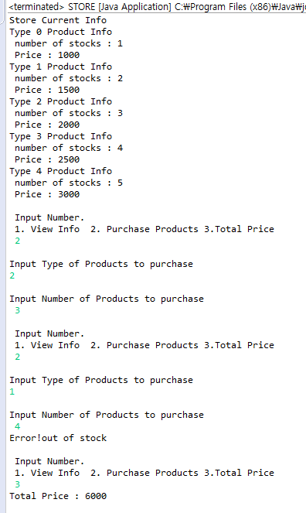
2. Error
3. 