# Run Pig On Eclipse From Windows

This article describes how to run pig java program on eclipse.

Step1. Import Pig lib jars (can be gotten from server :vm-45e5-3412,version:0.15.0)

Step2.import Hadoop configuration below files.(can be gotten from server/Hadoop/etc/Hadoop/)

core-site.xml&hdfs-site.xml&mapred-site.xml

Step3.code

Use pig java api coding.

Take an example:

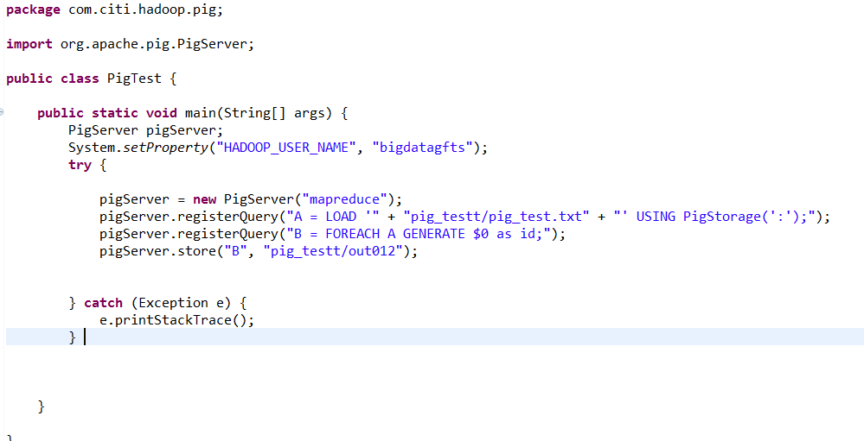

Step4.Check your result in server:

Command:hadoop dfs –ls pig_testtt/



Of course ,if you have pig script, you can directly run it through pigServer.registerScrip instead,just get pig’s api.