DiMA-PPI: Canonical State-Potential Learning for Consistent Protein Binding Mutation Prediction
Qi Liu¹, Xinyi Xu¹, Qian Cheng¹, Chen Wu¹, Lu Meng¹, Defu Yang², Xinbo Gao¹, and Xueli Chen^{1,2}
¹Xidian University, Xi’an, China
²Hangzhou Normal University, Hangzhou, China
Correspondence: xyxu@xidian.edu.cn; xbgao@mail.xidian.edu.cn; xlchen@xidian.edu.cn

Abstract
Predicting mutation-induced changes in protein–protein binding free energy supports variant interpretation and protein engineering. Independently predicted substitution effects can produce path-dependent estimates of the binding free-energy difference between the same protein variants. We propose DiMA-PPI, a multimodal graph neural network that enforces path consistency through shared state-potential learning. The model integrates sequence embeddings, structural representations and local atomic descriptors to estimate latent potentials for bound and isolated-chain states. Mutation effects are expressed as differences between the binding potentials of the initial and final variants. Canonical state reuse maintains a single numerical value for each represented state across all predictions. On S1129, comprising 1,129 substitutions from 111 complexes, DiMA-PPI achieves a Pearson correlation coefficient (PCC) of 0.757 and a root mean squared error (RMSE) of 1.542 kcal mol⁻¹. We further construct PPI-Path92, which contains 92 groups of same-site variants and 9,904 mutant-to-mutant comparisons whose targets are derived from measured effects relative to the wild type. On PPI-Path92, DiMA-PPI achieves an RMSE of 1.611 kcal mol⁻¹ and a mean discrepancy of $4.78×{10}^{−7}$ kcal mol⁻¹ between direct and multistep predictions. Experiments with fixed model parameters show that state reuse eliminates inconsistencies arising from independent stochastic evaluation and reduces redundant computation. These results support canonical state-potential learning for consistent prediction of binding changes across related protein variants.

Keywords:
Graph neural networks, state potentials, protein binding, path consistency.

Introduction
Predicting changes in protein–protein binding free energy following amino-acid substitution is a central task in variant interpretation and protein engineering. Established tools include FoldX [1], MutaBind2 [2], mCSM-PPI2 [3] and DDMut-PPI [4]. Graph neural networks and pretrained protein representations integrate structural and sequence information to estimate these effects [5, 6]. Evaluation on benchmarks such as SKEMPI [7] primarily measures accuracy for individual substitutions. Comparison of related variants additionally requires path consistency: for states $a$, $b$ and $c$ under the same modeled conditions, the predicted change from $a$ to $c$ should equal the sum of the changes from $a$ to $b$ and from $b$ to $c$. This relation couples predictions across substitutions.
Reverse-mutation augmentation and antisymmetric prediction address directional bias [8] by relating each substitution to its reverse. Global consistency additionally requires zero accumulated change around closed mutation cycles. Representing protein states as graph nodes and mutation effects as directed edges provides a unified formulation: edge values defined by node-potential differences sum to zero around every cycle, analogous to voltage differences around a circuit loop. Implementing this property requires identical numerical representations of shared states throughout structure preparation and inference.
StaB-ddG derives binding effects from folding scores [9], while DSSA-PPI uses residue-score differences under a shared conditioning context [6]. We introduce canonical state identity across structure preparation, feature extraction and inference to preserve potential differences throughout the prediction pipeline. DiMA-PPI learns a binding potential from each pair of bound and free representations and reuses canonical state values across mutation queries. We also construct PPI-Path92 from S1129 to evaluate compositional prediction and cycle consistency. Matched model comparisons assess the relationship between predictive accuracy and consistency, while experiments with fixed model parameters quantify the numerical and computational effects of state reuse.

Proposed Method
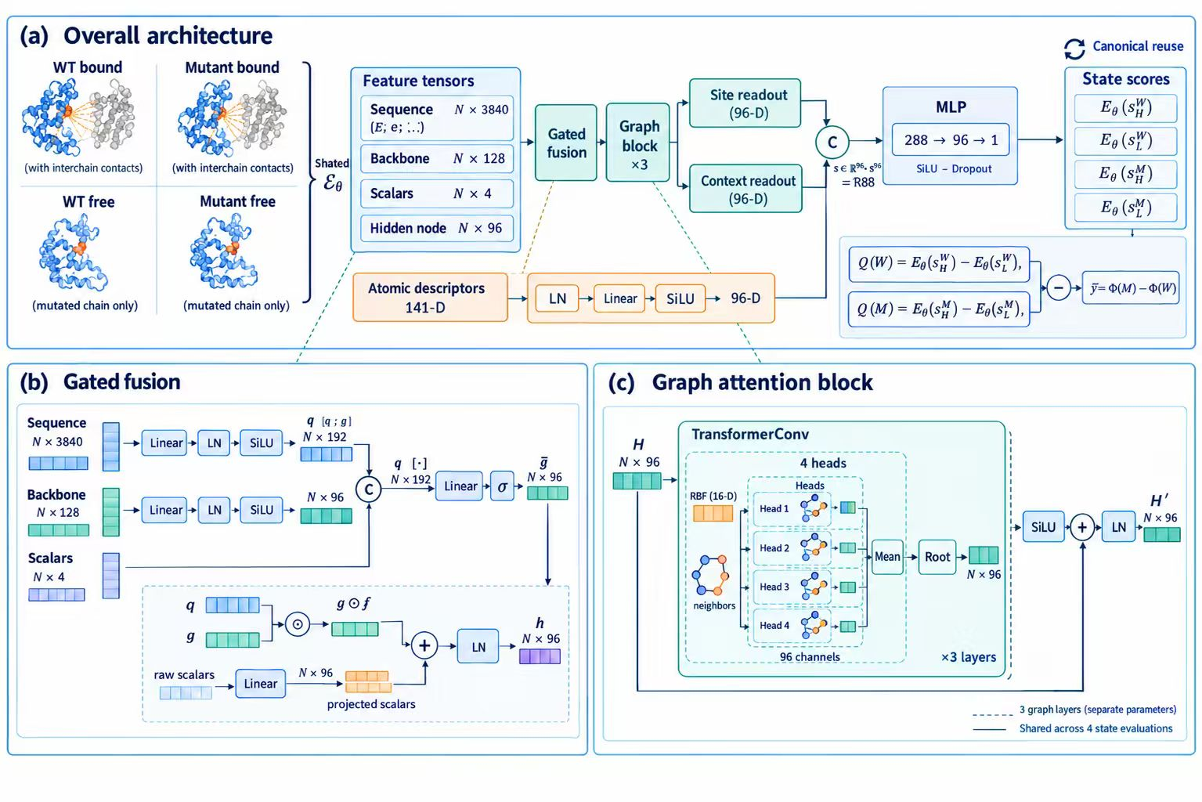
Fig. 1. DiMA-PPI architecture. (a) Four bound/free and WT/mutant states are evaluated by a shared network; differences of state scores yield the predicted mutation effect. (b) Gated fusion integrates sequence, backbone and scalar features. (c) Each graph block combines four-head TransformerConv, SiLU, a residual connection and LayerNorm. Three graph blocks are stacked with separate parameters. Site and context readouts are concatenated with projected atomic descriptors before the 288–96–1 scalar head. Canonical state scores are reused across edges.
Figure 1 summarizes the shared encoder, four-state output and canonical inference procedure.

Canonical Bound and Free States
For a fixed complex and substitution site, $S_{a}$ denotes the state with amino-acid identity $a$. Positive $y_{a→b}=ΔΔG_{a→b}$ follows the benchmark convention of stronger mutant binding. Each state has a bound context $S_{a}^{b}$ and an isolated-chain free context $S_{a}^{f}$, identified by
$$k(a,c)=(\text{complex},\text{chain},\text{PDB site},a,c), c∈\{b,f\}. \text{(1)}$$
Each key maps to one representation selected by source-row order, independently of labels and fold assignments. Repeated occurrences reuse identical sequence features, graph geometry, node masks and atomic descriptors, ensuring a consistent representation of shared intermediate states.
The reference-backbone graph contains residues within 20 Å of the site. Edges connect residues within 8 Å and sequential neighbors on each chain; 16 radial basis functions encode their distances. The bound encoder uses the complex graph. For the free context, cross-chain edges are removed and readout is restricted to the mutated chain. Four 141-dimensional descriptors encode wild-type/mutant and bound/free atomic environments. PyRosetta [10] locally repacks side chains within 8 Å in the bound structures and repacks the isolated mutated chain for the free contexts. Descriptors contain element-distance histograms, substituted-residue element counts, 18 residue-level Rosetta score terms and their local sums.

Shared Multimodal Graph Encoder
Each residue has an ESM-2 650M embedding $e_{i}^{a}∈R^{1280}$ [11], a ProteinMPNN reference-backbone feature $p_{i}∈R^{128}$ [12], and four scalars $s_{i}$ encoding chain membership, site membership and normalized site distance. The single-state sequence block is $u_{i}^{a}=[e_{i}^{a};e_{i}^{a};0]$, which represents a single sequence identity in both embedding blocks and fixes the difference block to zero. A learned gate integrates the sequence and structural features:
$$q_{i}=ϕ_{seq}(u_{i}^{a}), t_{i}=ϕ_{str}(p_{i}),$$
$$g_{i}=σ(W_{g}[q_{i};t_{i};s_{i}]+b_{g}),$$
$$h_{i}^{(0)}=\text{LN}(q_{i}+g_{i}⊙t_{i}+W_{s}s_{i}+b_{s}). \text{(2)}$$
The projections use linear layers, layer normalization and SiLU. Three TransformerConv layers with four averaged attention heads and hidden width 96 propagate messages over the context-specific edges:
$$H^{(ℓ+1)}=\text{LN}​\left[H^{(ℓ)}+SiLU({TConv}_{ℓ}(H^{(ℓ)},E_{c},R))\right]. \text{(3)}$$
Attention pooling produces separate representations of the substitution site and surrounding context, with weights proportional to $exp(w^{⊤}h_{i}^{(3)})$ within each node set. A shared scalar head maps these representations and the atomic descriptor to a state score:
$$E_{θ}(S_{a}^{c})={MLP}_{θ}([z_{site};z_{context};ϕ_{d}(d_{a}^{c})]), \text{(4)}$$
where $ϕ_{d}$ normalizes and projects the atomic descriptor to width 96. All four evaluations share encoder, projection and scalar-head weights.

Potential Differences and Numerical Identity
Define the latent binding potential and mutation prediction as
$$Φ_{θ}(a)=E_{θ}(S_{a}^{b})−E_{θ}(S_{a}^{f}), \text{(5)}$$
$${\hat{y}}_{a→b}=Φ_{θ}(b)−Φ_{θ}(a). \text{(6)}$$
For any path, intermediate potentials cancel:
$$\sum_{ℓ=0}^{L−1}{{\hat{y}}_{a_{ℓ}→a_{ℓ+1}}}=Φ_{θ}(a_{L})−Φ_{θ}(a_{0}). \text{(7)}$$
Equation (7) establishes antisymmetry, path independence and zero cycle sums. For an oriented node–edge incidence matrix $B$, the prediction vector is $B^{⊤}Φ$, a discrete potential-difference field with zero circulation. In comparison, pairwise antisymmetrization $[f(a,b)−f(b,a)]/2$ constrains the reversal relation.
Canonical inference preserves the state identity required by Eq. (7). With dropout disabled, each context score can be computed once per checkpoint and reused across all incident edges. For stochastic inference, the same state estimate is reused within each draw. Both procedures preserve cancellation to floating-point precision. Mutation-effect supervision determines potential differences; a common additive offset leaves every prediction invariant. The represented state space is defined by the complex, substitution site and structural context.

Optimization
The model is optimized using observed forward mutation effects. With the training-subset target standard deviation $σ_{y}$ and scaled four-state output ${\tilde{y}}_{θ}$, the objective is
L=1Nn​SmoothL10.5(yθ(an,bn)−yn/σy). (8)
Predictions are rescaled to physical units by multiplication with $σ_{y}$, with the additive offset fixed at zero. The objective consists solely of the forward-prediction loss; consistency is imposed by the output parameterization. AdamW uses learning rate $5×{10}^{−4}$, weight decay ${10}^{−4}$, batch size 8 and dropout 0.15. Training runs for up to 60 epochs with validation-MSE early stopping and patience 10.

Experiments and Results
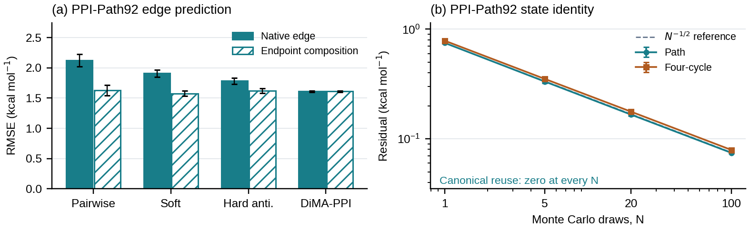
Fig. 2. Evaluation on PPI-Path92. (a) RMSE of native mutant-to-mutant predictions and composition of predicted WT effects, evaluated against differences of measured WT effects. Bars and error bars denote the mean and sample SD across five seeds. (b) Consistency residuals under independent state sampling with fixed StaB-ddG parameters. Canonical reuse yields zero measured residuals at all sample counts, as indicated below the curves.

Datasets and Evaluation Protocol
S1129. The public benchmark contains 1,129 single substitutions from 111 complexes following the two official exclusions from S1131. We use the five predefined complex-disjoint outer folds from the DSSA-PPI protocol [6], with test sizes 169, 142, 271, 252 and 295. Approximately one eighth of each outer training fold is reserved for validation using a seeded mutation-level split; complexes may therefore occur in both fitting and validation subsets. We report the mean and sample SD across seeds 42–46 after averaging per-fold metrics within each seed. PCC, Spearman correlation and RMSE measure linear association, rank agreement and error magnitude, respectively.
PPI-Path92. We construct the Protein–Protein Interaction Mutation Path Benchmark (PPI-Path92) from repeated-site measurements in S1129. Measurements are grouped by complex, chain, PDB site and WT residue. Sites with at least two distinct measured mutant variants are retained, with duplicate records resolved by selecting the earliest source row. The resulting benchmark contains 92 site panels from 27 complexes and 793 amino-acid states. For each ordered mutant pair, the target is
$$y_{b→c}^{derived}=y_{WT→c}−y_{WT→b}. \text{(9)}$$
PPI-Path92 contains 9,904 mutant-to-mutant comparisons with targets defined by Eq. (9). Native predictions evaluate each mutant pair directly; endpoint composition subtracts the corresponding predicted WT effects. Including WT edges, the state graphs contain 11,306 directed edges, supporting 5,653 reverse comparisons, 9,904 ordered paths, 31,922 triangles and 133,736 four-state cycles per seed. Each panel inherits the S1129 outer fold of its source complex, preserving complex-disjoint evaluation.
Matched controls share residue-graph inputs and training settings: an unconstrained pairwise regressor, reverse-label supervision, a soft reverse consistency penalty (weight 0.20), hard pairwise antisymmetry, and a shared potential without atomic state descriptors. Reverse and path residuals are $\left|{\hat{y}}_{a→b}+{\hat{y}}_{b→a}\right|$ and $\left|{\hat{y}}_{a→c}−{\hat{y}}_{a→b}−{\hat{y}}_{b→c}\right|$. Cycle residuals are absolute sums around the loop.

Comparison with Published Models and Ablation
Table I. S1129 predictive accuracy: mean $±$ sample SD across five repeats or seeds, each averaged over five folds. RMSE is in kcal mol⁻¹.
Model | PCC $↑$ | Spearman $↑$ | RMSE $↓$
Published-model comparison
DSSA-PPI [6] | $0.706±0.011$ | $0.508±0.017$ | $1.717±0.040$
DiMA-PPI (ours) | $0.757±0.009$ | $0.592±0.011$ | $1.542±0.023$
Matched controls and ablation
Pairwise | $0.570±0.020$ | $0.514±0.021$ | $2.112±0.047$
Reverse supervision | $0.756±0.009$ | $0.602±0.011$ | $1.565±0.039$
Soft consistency | $0.759±0.012$ | $0.608±0.014$ | $1.551±0.045$
Hard antisymmetry | $0.755±0.003$ | $0.594±0.009$ | $1.549±0.013$
No state descriptors | $0.750±0.004$ | $0.578±0.006$ | $1.588±0.025$
DSSA-PPI [6] is evaluated using five released repeats of fold-specific checkpoints, using the same S1129 observations and outer folds as DiMA-PPI and retaining its original pretraining and optimization procedures.
DiMA-PPI achieves PCC $0.757±0.009$, Spearman correlation $0.592±0.011$ and RMSE $1.542±0.023$ kcal mol⁻¹ (Table I). Relative to DSSA-PPI, DiMA-PPI increases mean PCC by 0.051 and Spearman correlation by 0.084, and reduces RMSE by 0.176 kcal mol⁻¹. Among matched controls, soft consistency achieves the highest mean PCC and Spearman correlation; DiMA-PPI achieves the lowest mean RMSE.
Removing state descriptors yields PCC 0.750, Spearman correlation 0.578 and RMSE 1.588. Paired uncertainty is estimated from five-seed ensemble predictions using 10,000 complex-bootstrap replicates within each fold. Including the descriptors increases ensemble PCC by 0.0098 (95% CI 0.0002–0.0206) and reduces RMSE by 0.0490 kcal mol⁻¹ (95% CI 0.0138–0.0779).

Path and Cycle Consistency on PPI-Path92
Table II. PPI-Path92 mean absolute consistency residuals (kcal mol⁻¹), averaged across five seeds.
Model | Reverse | Path | Triangle | Four-cycle
Pairwise | $2.260$ | $1.298$ | $3.283$ | $4.248$
Soft | $0.867$ | $0.879$ | $1.314$ | $1.652$
Hard anti. | $1.63×{10}^{−7}$ | $0.441$ | $0.305$ | $0.348$
DiMA-PPI | $2.20×{10}^{−7}$ | $4.78×{10}^{−7}$ | $3.08×{10}^{−7}$ | $3.68×{10}^{−7}$
Table II reports residuals for reversal, path composition and cycle closure. Hard antisymmetry achieves numerical precision for reversal, with mean path and four-cycle residuals of 0.441 and 0.348 kcal mol⁻¹. DiMA-PPI achieves mean residuals below $5×{10}^{−7}$ for all four relations. This evaluation recomputes scores from deterministic canonical inputs for each requested edge; the resulting residuals are consistent with floating-point arithmetic.

Compositional Prediction on PPI-Path92
On the 9,904 mutant-to-mutant edges defined by Eq. (9), native pairwise, soft, hard and DiMA-PPI predictors achieve PCC 0.354, 0.442, 0.502 and 0.547, and RMSE 2.128, 1.910, 1.783 and 1.611 kcal mol⁻¹, respectively (Fig. 2a). The paired bootstrap of five-seed ensemble predictions estimates an RMSE reduction of 0.167 (95% CI 0.016–0.466) relative to hard antisymmetry. The ensemble PCC gain is 0.049 (95% CI $−0.041$ to 0.175).
Composition of predicted WT effects yields RMSE 1.630, 1.578 and 1.622 for the pairwise, soft and hard controls, respectively. Endpoint composition therefore recovers much of the accuracy difference observed for native predictions; the composed soft control has the lowest mean RMSE. In DiMA-PPI, native prediction and endpoint composition are algebraically equivalent through the shared state potential.

Effect of Canonical State Reuse
We assess the effect of state reuse with 25 fixed StaB-ddG checkpoints covering five folds and five seeds. Independent and canonical inference use the same panels and nested Monte Carlo sample counts $N∈\{1,5,20,100\}$. Independent mean path error decreases from 0.751 to 0.074 kcal mol⁻¹, approximately following $N^{−1/2}$ (Fig. 2b). Reusing each state estimate across edges yields zero measured reverse, path and cycle residuals at every $N$. In the paired evaluation at $N=20$, canonical reuse preserves the WT-to-mutant estimates and their predictive metrics while enforcing closure across the state graph.
A computational evaluation using the seed-42 DiMA-PPI checkpoints covers 793 amino-acid states, 1,586 bound/free contexts and 11,306 directed edges in PPI-Path92. Independent edge evaluation requests 45,224 context scores; canonical reuse requires 1,586, a 28.5-fold reduction. On an Intel Core i7-12700KF with eight PyTorch CPU threads and batch size 32, model inference time decreases from 469.4 to 16.1 seconds, corresponding to a 29.1-fold speedup. Checkpoint/cache loading, graph assembly and disk I/O are performed outside the timed region. The mean and maximum absolute prediction differences between the two inference procedures are $1.10×{10}^{−7}$ and $1.67×{10}^{−6}$ kcal mol⁻¹, and reused scores give zero measured closure residuals.

Discussion and Conclusion
DiMA-PPI combines a shared four-state encoder with canonical state identity to produce globally consistent mutation predictions. It achieves PCC 0.757 on S1129 and RMSE 1.611 on the PPI-Path92 compositional benchmark, with path and cycle residuals at numerical precision. Fixed-weight experiments establish canonical scalar reuse as an effective way to preserve consistency and reduce repeated inference across state graphs.
Extensions to condition-aware states, conformational ensembles and multi-site mutation paths provide further directions for evaluation.

Acknowledgment
OpenAI Codex assisted with manuscript drafting, formatting and result-summary visualization.

References
[1] J. Schymkowitz, J. Borg, F. Stricher, R. Nys, F. Rousseau, and L. Serrano, “The FoldX web server: an online force field,” Nucleic Acids Research, vol. 33, no. suppl_2, pp. W382–W388, 2005.
[2] N. Zhang, Y. Chen, H. Lu, F. Zhao, R. Vera Alvarez, A. Goncearenco, A. R. Panchenko, and M. Li, “MutaBind2: Predicting the impacts of single and multiple mutations on protein–protein interactions,” iScience, vol. 23, no. 3, p. 100939, 2020.
[3] C. H. M. Rodrigues, Y. Myung, D. E. V. Pires, and D. B. Ascher, “mCSM-PPI2: predicting the effects of mutations on protein–protein interactions,” Nucleic Acids Research, vol. 47, no. W1, pp. W338–W344, 2019.
[4] Y. Zhou, Y. Myung, C. H. M. Rodrigues, and D. B. Ascher, “DDMut-PPI: predicting effects of mutations on protein–protein interactions using graph-based deep learning,” Nucleic Acids Research, vol. 52, no. W1, pp. W207–W214, 2024.
[5] X. Liu, Y. Luo, P. Li, S. Song, and J. Peng, “Deep geometric representations for modeling effects of mutations on protein–protein binding affinity,” PLoS Computational Biology, vol. 17, no. 8, p. e1009284, 2021.
[6] J. Wu, J. Sun, T. Liang, Y. Zhang, H. Zhang, T. Zhang, X. Feng, P. Gao, P. Xu, and J. Li, “DSSA-PPI: enhancing binding affinity change prediction upon protein mutations using disentangled structure–sequence aware attention,” Chemical Science, vol. 17, no. 7, pp. 3719–3732, 2026.
[7] J. Jankauskaitė, B. Jiménez-García, J. Dapkūnas, J. Fernández-Recio, and I. H. Moal, “SKEMPI 2.0: an updated benchmark of changes in protein–protein binding energy, kinetics and thermodynamics upon mutation,” Bioinformatics, vol. 35, no. 3, pp. 462–469, 2019.
[8] M. Tsishyn, F. Pucci, and M. Rooman, “Quantification of biases in predictions of protein–protein binding affinity changes upon mutations,” Briefings in Bioinformatics, vol. 25, no. 1, p. bbad491, 2024.
[9] A. Deng, K. D. Householder, F. Wu, K. C. Garcia, and B. L. Trippe, “Predicting mutational effects on protein binding from folding energy,” in Proceedings of the 42nd International Conference on Machine Learning, ser. Proceedings of Machine Learning Research, vol. 267, 2025, pp. 13 129–13 151. [Online]. Available: https://proceedings.mlr.press/v267/deng25d.html
[10] S. Chaudhury, S. Lyskov, and J. J. Gray, “PyRosetta: a script-based interface for implementing molecular modeling algorithms using Rosetta,” Bioinformatics, vol. 26, no. 5, pp. 689–691, 2010.
[11] Z. Lin, H. Akin, R. Rao et al., “Evolutionary-scale prediction of atomic-level protein structure with a language model,” Science, vol. 379, no. 6637, pp. 1123–1130, 2023.
[12] J. Dauparas, I. Anishchenko, N. Bennett et al., “Robust deep learning-based protein sequence design using ProteinMPNN,” Science, vol. 378, no. 6615, pp. 49–56, 2022.

