1.C 4.C 5.A 6.C 7.B 8.A 9.D 10.B 11.D 12.C 13.B 14.B 15.A

16.abd 17.bd 18.acd 19.abd 20.bc

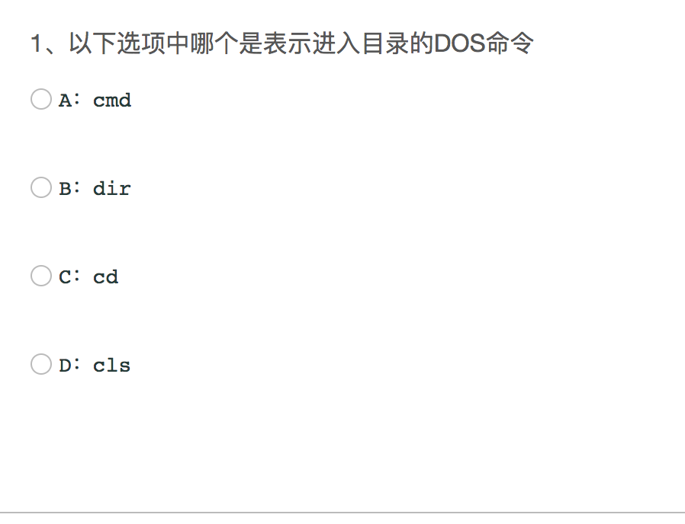

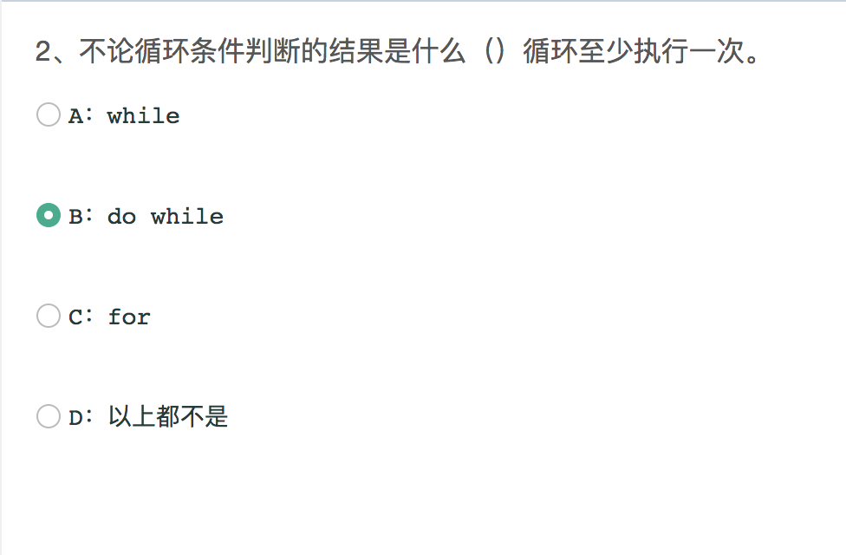

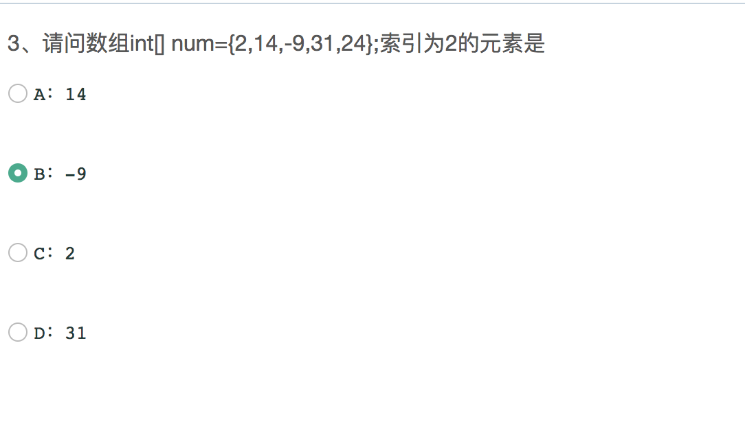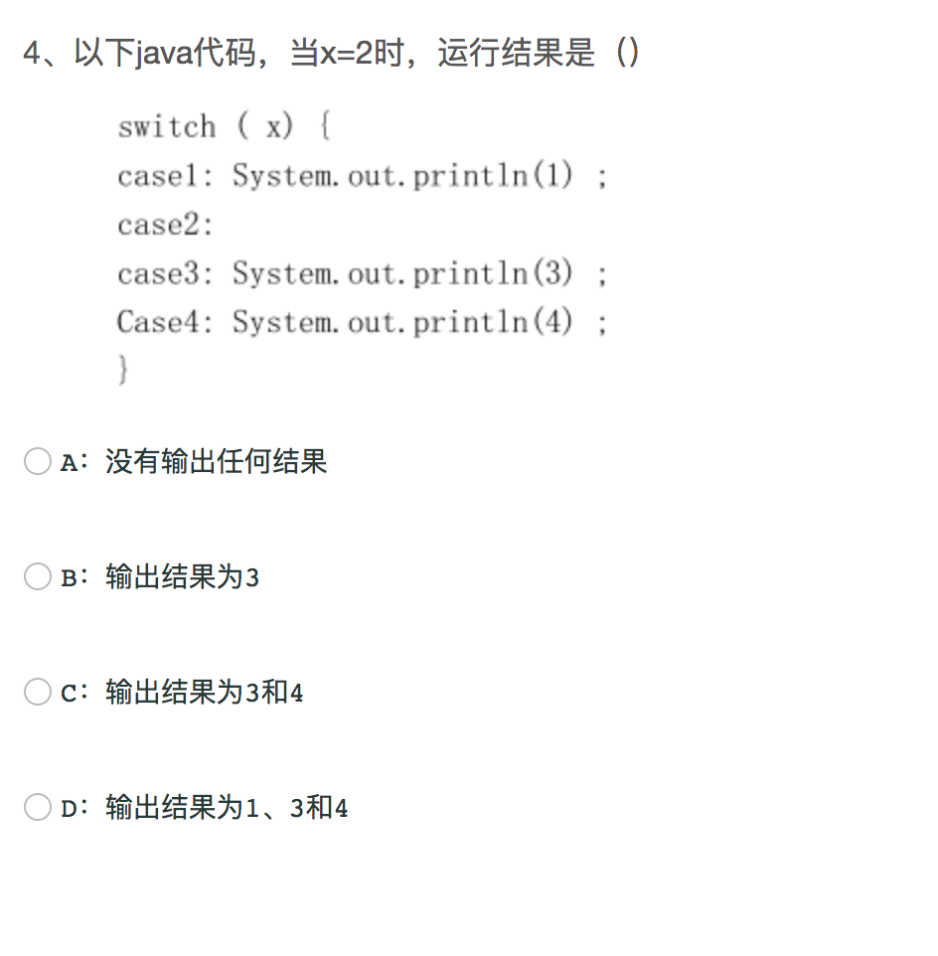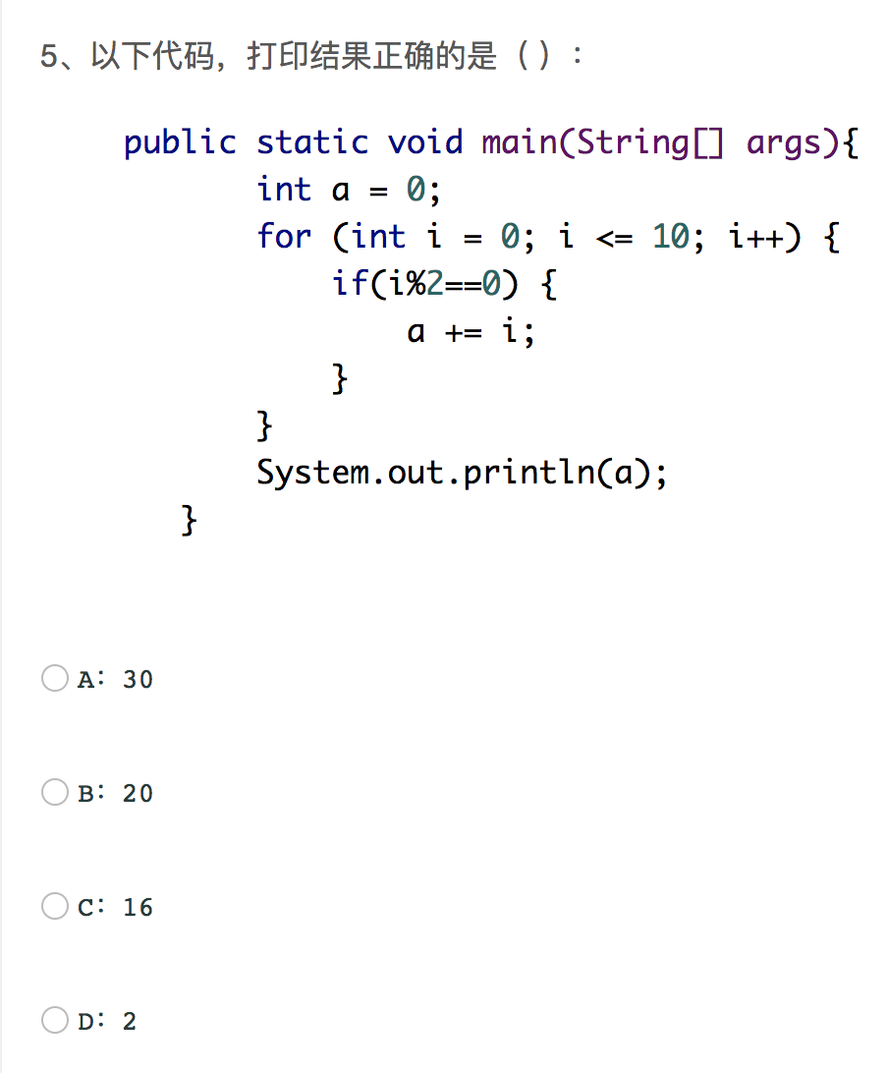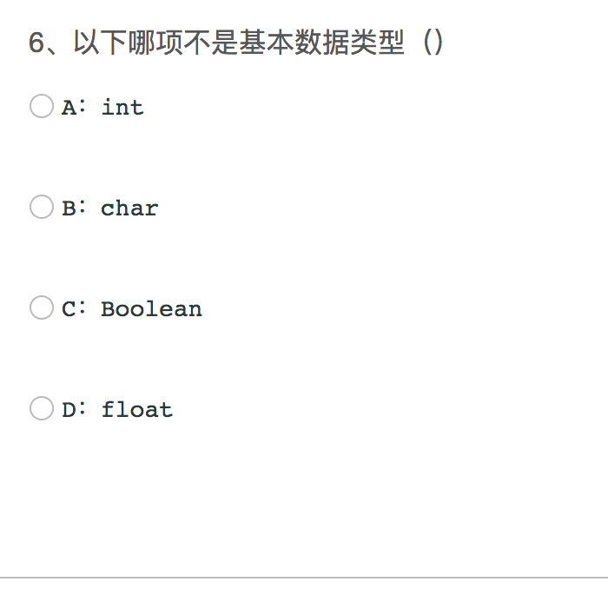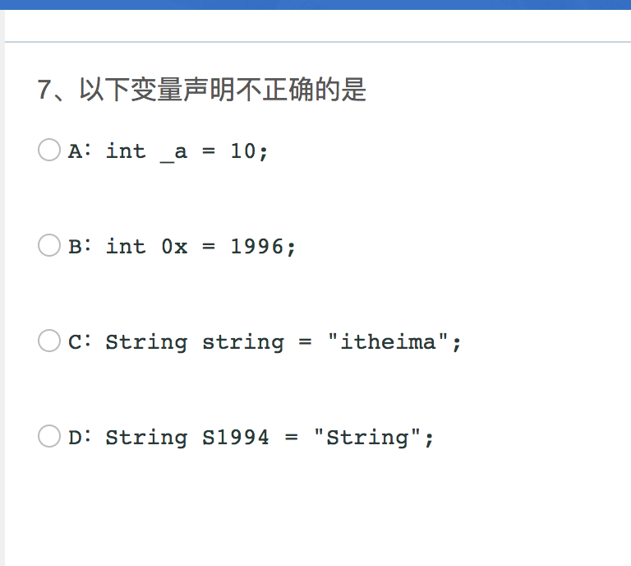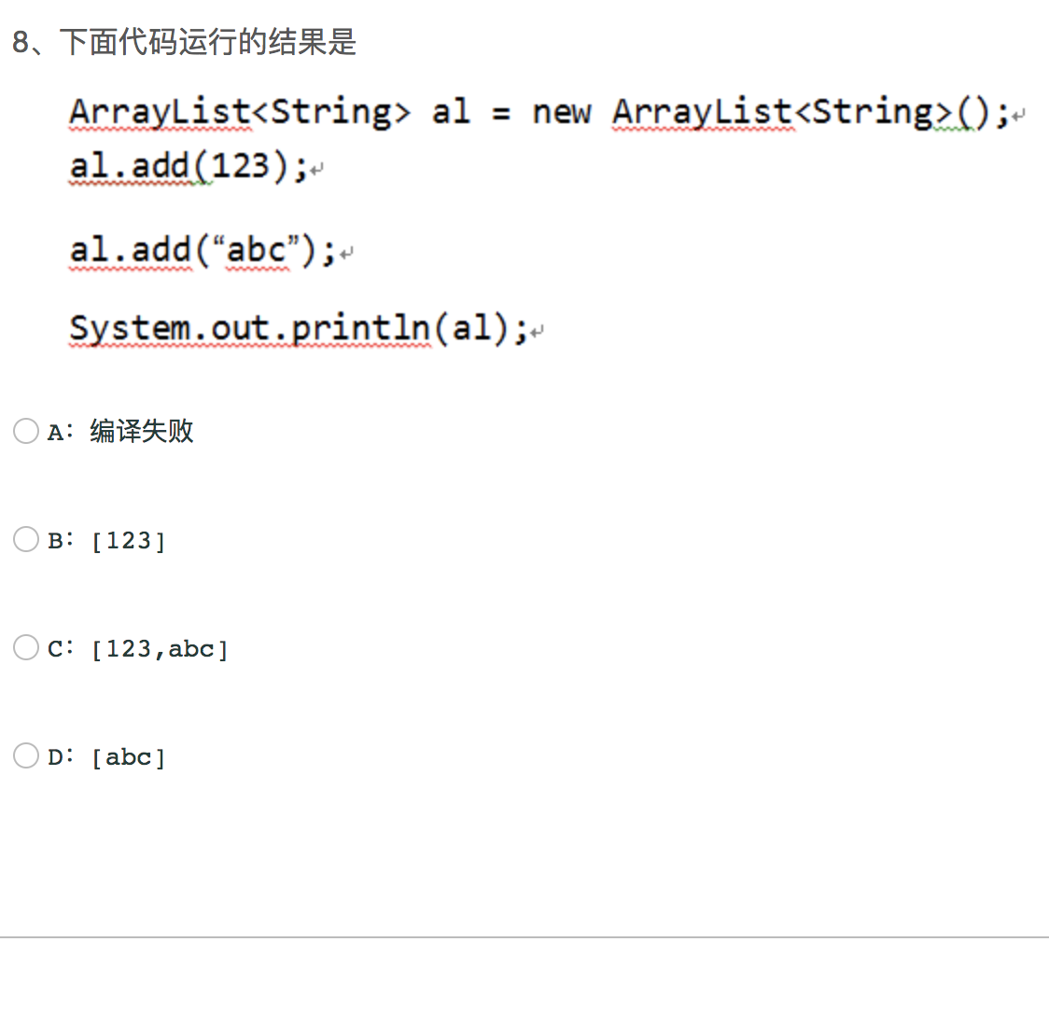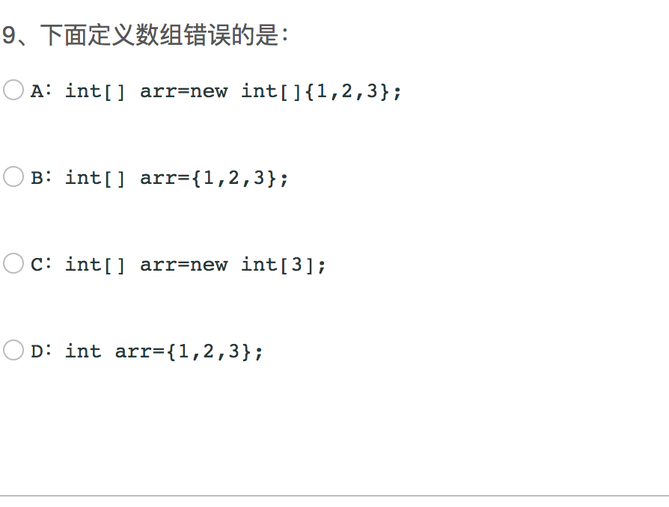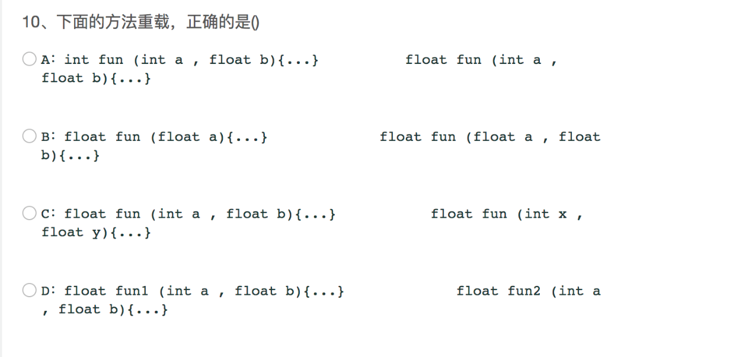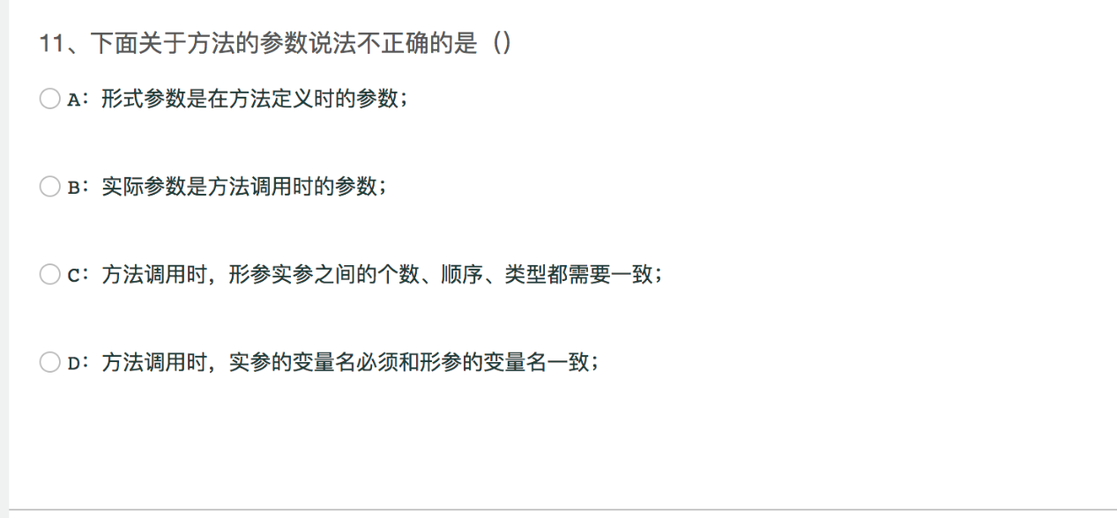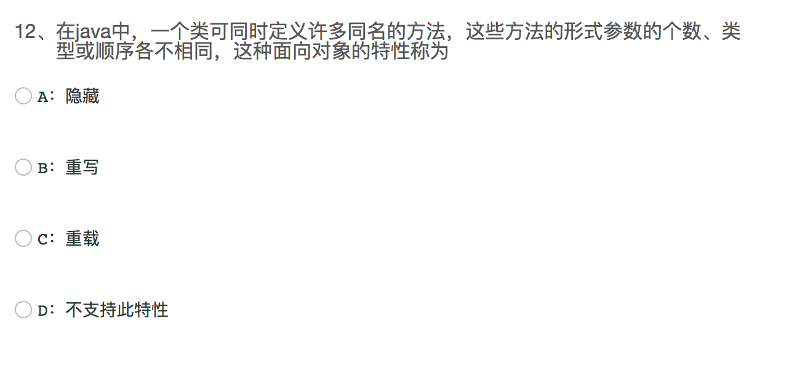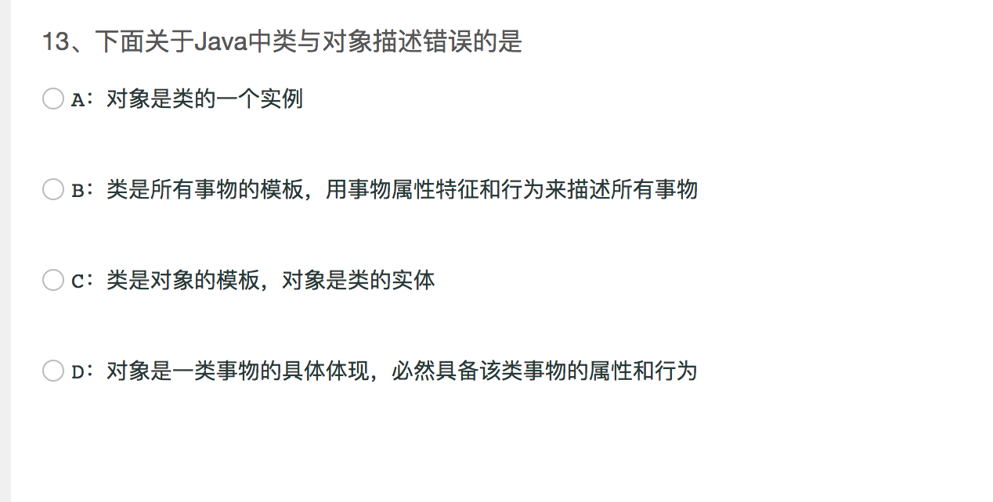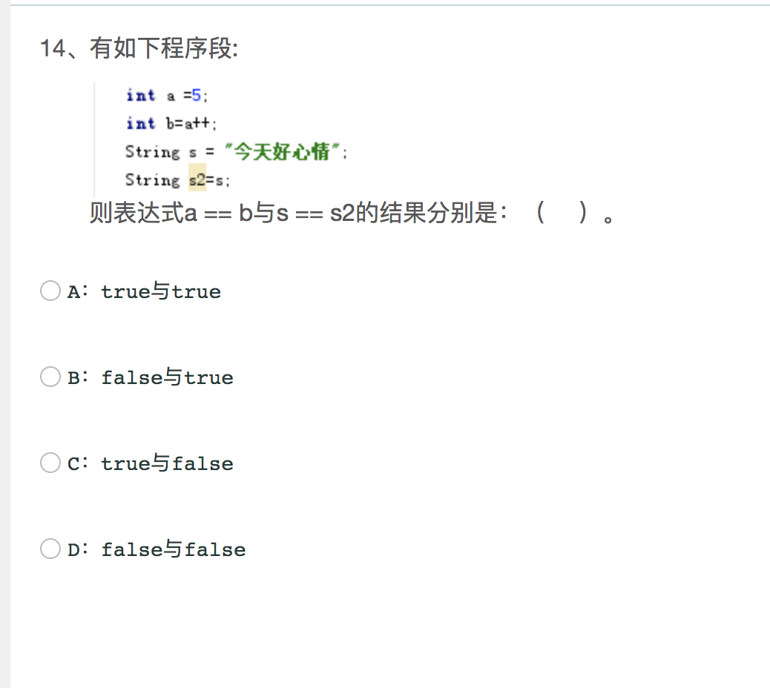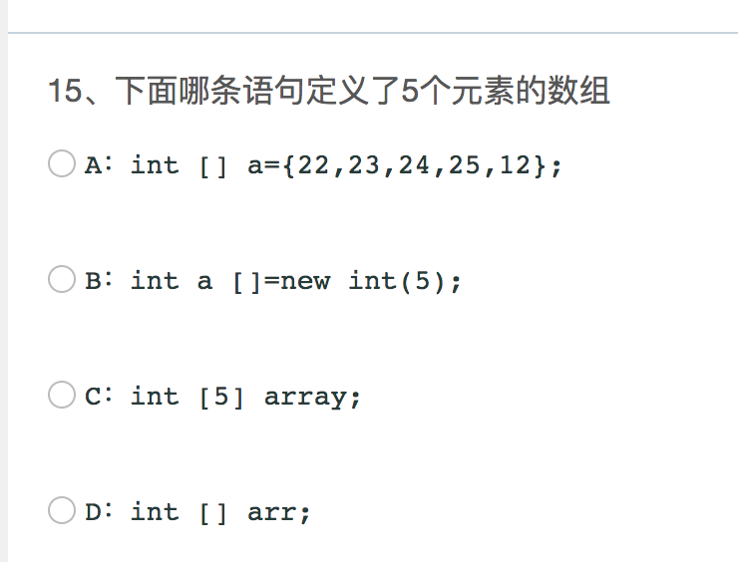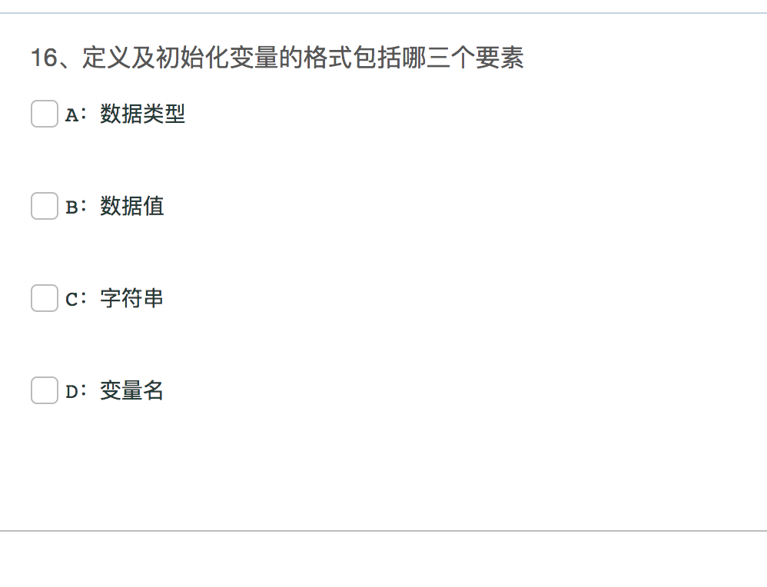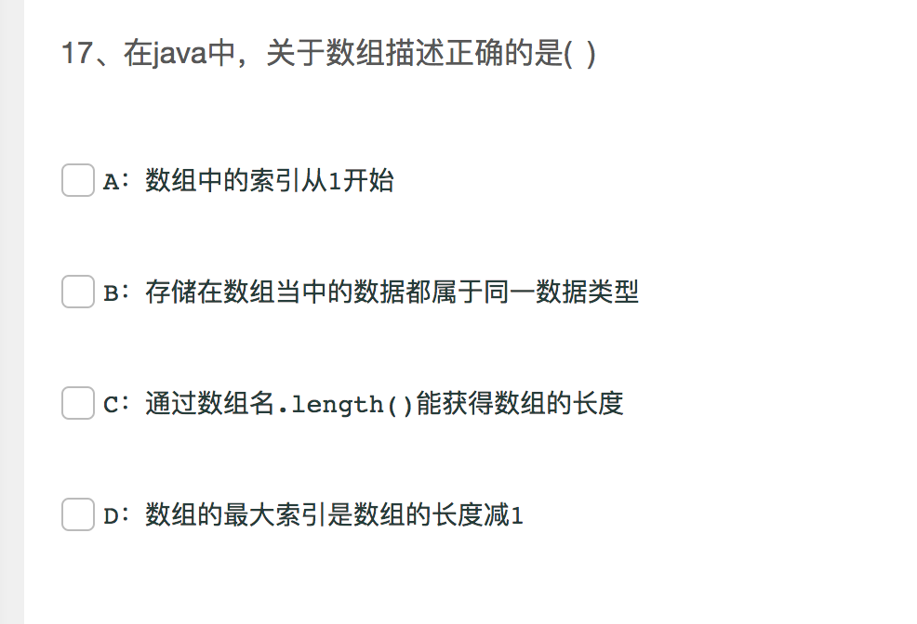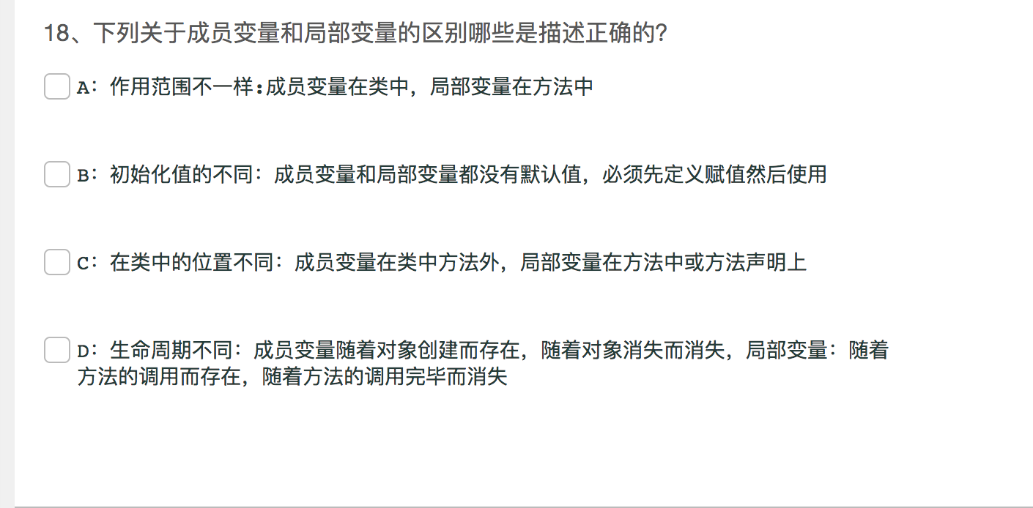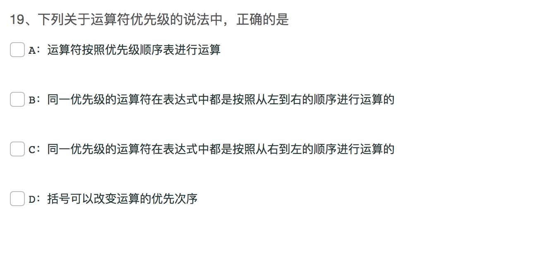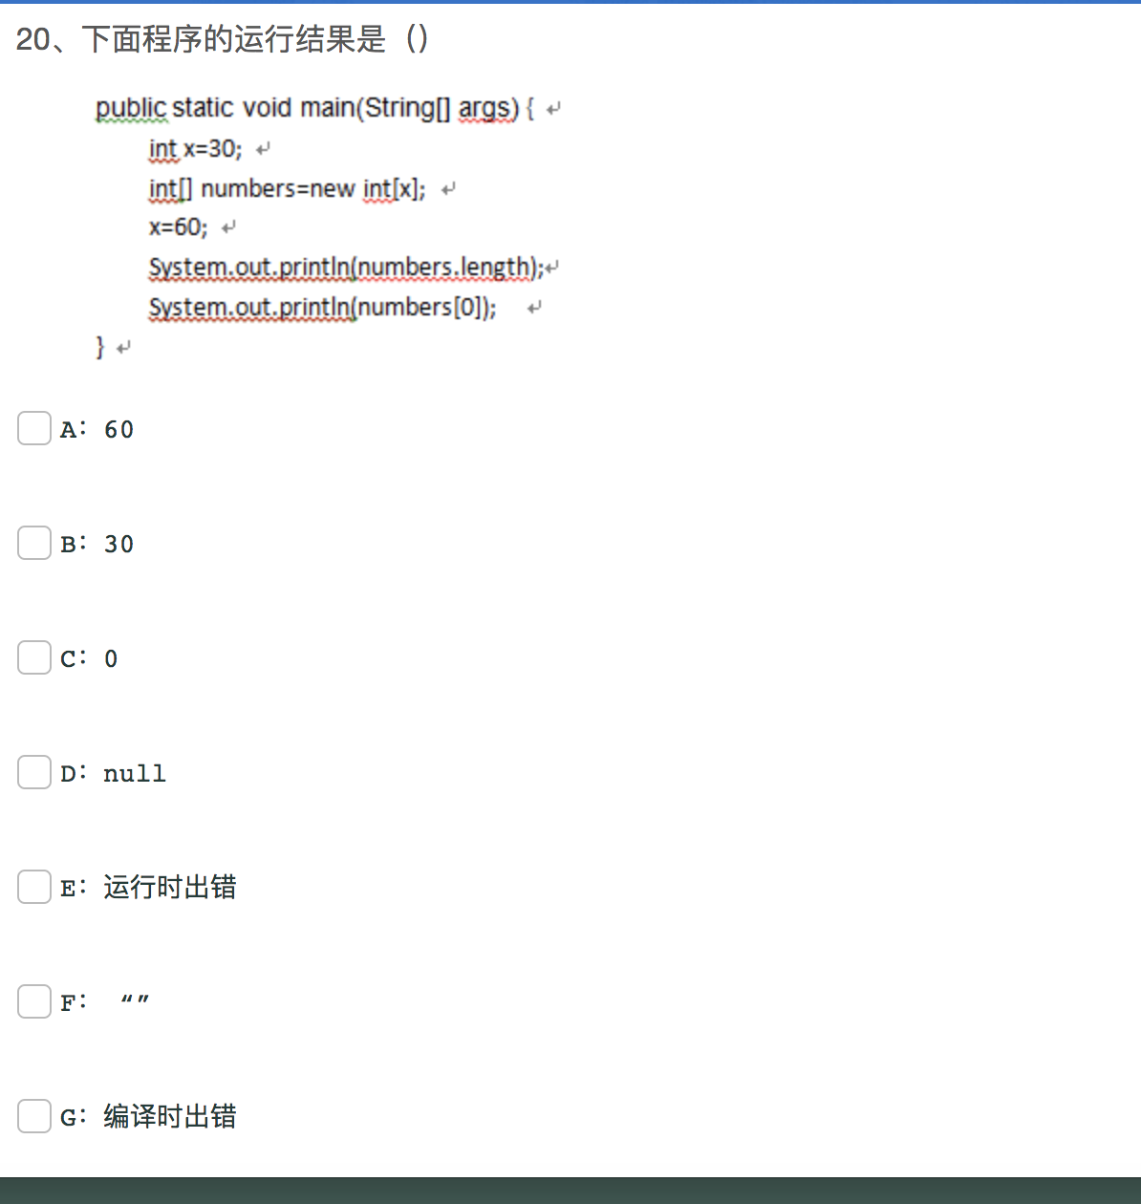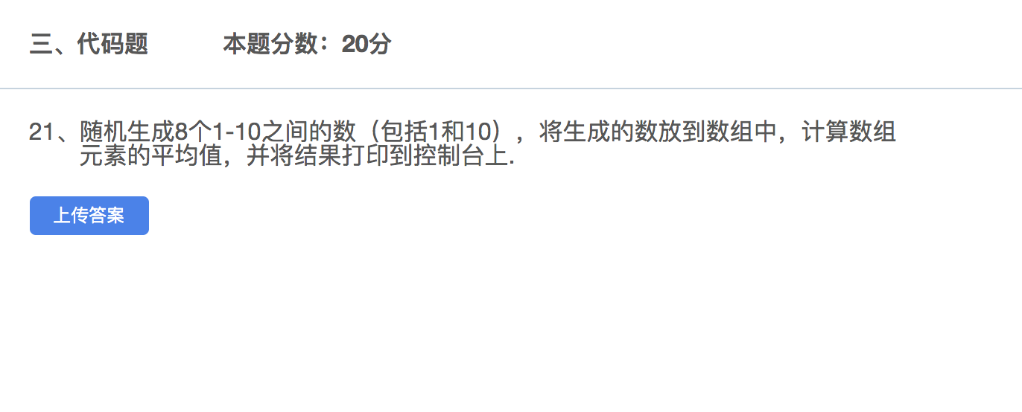

|  |
| --- |
| **package** com.itheima;  **import** java.util.Random;  **public class** Test11 {  **public static void** main(String[] args) {  */*  随机生成8个1-10的随机数存放到数组中。计算数组元素平均值  并打印   1.产生随机数范围在1-10，可以使用Random  2.利用for循环把每次生成的随机数放进数组  3.首先计算数组元素之和在除以数组的元素个数 就可以得到数据元素的平均值  4.输出结果  */* **int**[] arr = **new int**[8];  **int** sum = 0;  Random random = **new** Random();  *//利用for循环把每次生成的随机数放进数组* **for** (**int** i = 0; i < arr.**length**; i++) {  arr[i] = random.nextInt(11);  sum += arr[i];  }  System.***out***.println(sum / arr.**length**);   } } |

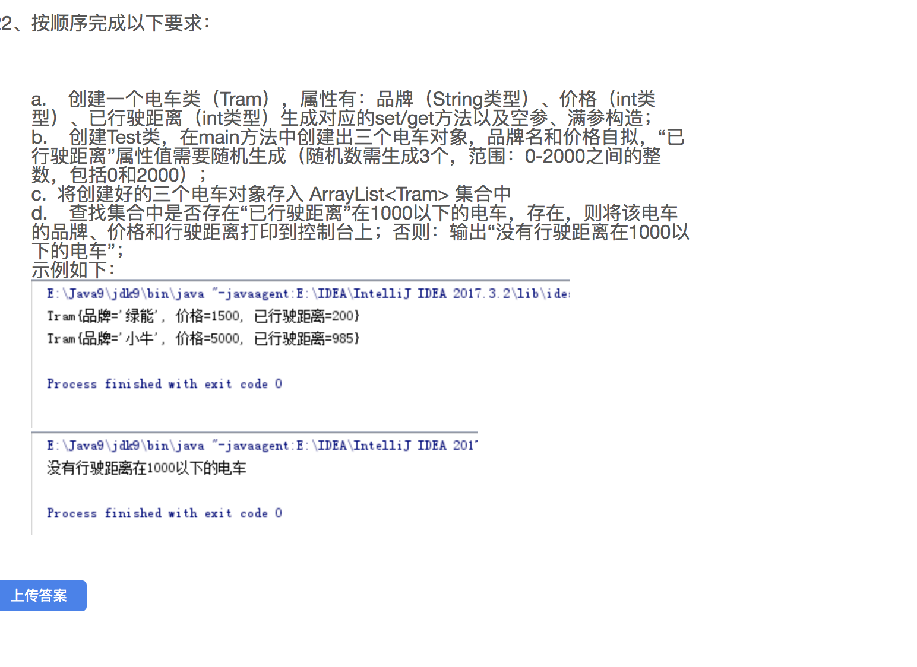

|  |
| --- |
| **package** com.itheima;  **public class** Tram {  **private** String **prand**;  **private int price**;  **private int juli**;   **public** Tram(String prand, **int** price, **int** juli) {  **this**.**prand** = prand;  **this**.**price** = price;  **this**.**juli** = juli;  }   **public** Tram() {  }   **public** String getPrand() {  **return prand**;  }   **public void** setPrand(String prand) {  **this**.**prand** = prand;  }   **public int** getPrice() {  **return price**;  }   **public void** setPrice(**int** price) {  **this**.**price** = price;  }   **public int** getJuli() {  **return juli**;  }   **public void** setJuli(**int** juli) {  **this**.**juli** = juli;  }   @Override  **public** String toString() {  **return "Tram{"** +  **"prand='"** + **prand** + **'\''** +  **", price="** + **price** +  **", juli="** + **juli** +  **'}'**;  }   }  **package** com.itheima;  **import** java.util.ArrayList; **import** java.util.Random;  **public class** TramTest {  **public static void** main(String[] args) {  Random random = **new** Random();  **int** l1 = random.nextInt(2001);  **int** l2 = random.nextInt(2001);  **int** l3 = random.nextInt(2001);  Tram tram1 = **new** Tram(**"奔驰"**,9999,l1);  Tram tram2 = **new** Tram(**"宝马"**,8999,l2);  Tram tram3 = **new** Tram(**"路虎"**,7999,l3);   ArrayList<Tram> list = **new** ArrayList<>();  list.add(tram1);  list.add(tram2);  list.add(tram3);   **for** (**int** i = 0; i < list.size(); i++) {  Tram tram = list.get(i);  **if**(tram.getJuli() < 1000){  System.***out***.println(tram);  **return**;  }  }  System.***out***.println(**"没有"**);  } } |