# 1 状态查看

## 基本状态查看

集群状态

|  |
| --- |
| get _cluster/health  get _cluster/state  get _cluster/settings  get _cluster/pending_tasks  注:  get _cluster/health查看分片状态  get _cluster/state查看nodes,metadata, indices信息 |

节点状态

|  |
| --- |
| get _cat/nodes?v  #查看ip|heap.percent|ram.percent |load_1m|load_5m|load_15m |node.role |master |name  get _nodes  get _nodes/stats  #这两条命令相同  #主要角色  "roles": [  "master",  "data",  "ingest"  ],  get _nodes/hot_threads  get _nodes/node-1/hot_threads  ::: {node-1}{BxHQfpeBRPq4CLOk61bOIQ}{-EzwOWxpTwyoekXMsssNIw}{192.168.11.73}{192.168.11.73:9300}  Hot threads at 2017-11-16T05:14:55.330Z, interval=500ms, busiestThreads=3, ignoreIdleThreads=true:  10.3% (51.3ms out of 500ms) cpu usage by thread 'elasticsearch[node-1][bulk][T#2]'  9/10 snapshots sharing following 2 elements  3.5% (17.5ms out of 500ms) cpu usage by thread 'elasticsearch[node-1][refresh][T#1]'  10/10 snapshots sharing following 2 elements |

索引状态

|  |
| --- |
| GET _cat/indices?v  GET _all?pretty  GET _all/_stats  #健康状态  GET _cluster/health?pretty&level=indices |

查看单个索引状态

|  |
| --- |
| get risklog-2017.11.10/_stats  get risklog-2017.11.10/_count  #查看mapping逻辑结构  get risklog-2017.11.10/_mapping  #查看物理结构  get risklog-2017.11.10/_search_shards  get risklog-2017.11.10/_segments |

分片状态

|  |
| --- |
| GET _cat/shards?help  GET_cat/shards?v&h=index,shard,state,docs,store,ip,unassigned.reason,unassigned.details |

## 1.2巡检脚本

健康状态

|  |
| --- |
| GET _cluster/health  GET _cluster/health?level=indices  GET _cluster/health?level=shards  GET _cluster/health?wait_for_status=green |

磁盘空间容量

|  |
| --- |
| GET _cat/allocation?help  GET _cat/allocation?v |

## 1.3分片恢复

### 1.3.1 待验证

logstash-2017.08.03/_recovery?human

logstash-2017.08.03/_recovery?human&pretty

logstash-2017.08.03/_stats?pretty

logstash-2017.08.03/_shard_stores?pretty

logstash-2017.08.03/_shard_stores?status=green&pretty

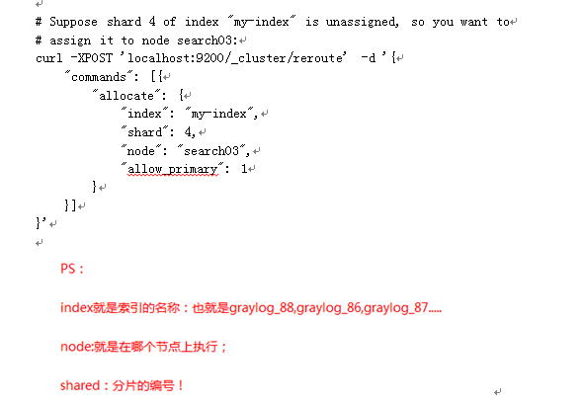

官网原话： 1、Allocate an unassigned shard to a node. Accepts the index and shard for index name and shard number, and node to allocate the shard to. It also accepts allow_primary flag to explicitly specify that it is allowed to explicitly allocate a primary shard (might result in data loss).

2、Warning：The allow_primary parameter will force a new empty primary shard to be allocatedwithout any data. If a node which has a copy of the original shard (including data) rejoins the cluster later on, that data will be deleted: the old shard copy will be replaced by the new live shard copy.

## 1.4 CAT api

|  |
| --- |
| GET _cat  GET /_cat/indices?help  GET _cat/indices?v&bytes=gb?v |