Wheat Rust Disease Identification Using Deep Learning

Ruiying Liu & Ziqing Cheng

1. Introduction

Wheat is one of the most important cultivated food crops across the globe. Wheat alone contributes ~ 205 of global human calorie intake (Singh J *et al*., 2022). Food and Agricultural Organization (FAO) reported that the wheat production was 781.1 million tonnes, ranking second after corn. However, wheat cultivation faces formidable challenges, and is attacked by over 100 different diseases caused by various pathogens and pests. Around 21.5% of wheat production is lost to these diseases annually (Singh J *et al*., 2022). The fungal disease affected by *Puccinia triticina*, commonly known as leaf rust or brown rust, is the most economically damaging disease of wheat, which occurs worldwide wherever wheat is grown (Chester, K. S., 1946).

Leaf rust primarily manifest as small, round pustules (formal name: uredinia) appear on the upper leaf surface (Figure 1). Uredinia are brown in color and generally circular in shape. The uredinia are often encircled by a yellow ring of chlorotic leaf tissue. Large area of uredinia growing on the leaves causes leaf yellowish, which affects photosynthesis, the source of power for plant growth, then reducing the yield. Uredinia harbor spores and facilitate the disease’s spread.

Figure 1 The symptoms of wheat leaf rust.

(Download from https://www.ars.usda.gov/ARSUserFiles/50620500/Cerealrusts/wlr_gnhse2.jpg)

Early diagnosis of leaf rust during the wheat growing season is crucial for minimizing its impact on wheat yield. However, traditional disease diagnostics have typically relied on farmers or experts visually inspecting the crops, which demands extensive knowledge and experience in disease identification. Furthermore, this manual approach is not only laborious but also constrained by time. Leaf rust symptoms typically manifest around 7 days after infection, with infected leaves beginning to deteriorate within 14 days. Additionally, secondary infections often accompany leaf rust, further complicating the identification of the specific pathogen responsible. This time constraint and complexity add significant challenges to manual diagnosis, particularly in large-scale farming operations.

The use of mobile devices, such as drones, and satellites for the regional and large-scale monitoring of wheat diseases has achieved significant progress. Due to the advantages of its rapid image acquisition, mobile devices are now widely utilized in disease identification. The use of mobile devices for image collection has replaced traditional manual field identification techniques, becoming the mainstream approach. However, manually reviewing these collected images by naked eyes and making diagnosis is also laborious.

Convolutional Neural Networks (CNNs) are widely utilized for image-based identification tasks due to their ability to automatically extract relevant features from images without manual intervention.

In summary, the objectives of this analysis include developing a CNN model which is capable of accurately identifying both diseased and healthy wheat leaves.

2. Data Collection and Preparation

The data for this analysis was generated by Arya and Singh (2020), and originally downloaded from https://data.mendeley.com/datasets/th422bg4yd/1. It was collected with an RGB camera from a wheat crop sown in the winter 2019 and harvested in 2020 at the Indian Agriculture Research Institute field and contains of 1159 images of wheat leaves total. Discriminating between leaf rust infections and other leaf discolorations poses a practical challenge. Given the limited dataset, preventing overfitting is of utmost importance. To address this, a third class, representing leaves with nitrogen deficiency, is introduced. Nitrogen deficiency characterized by paler green leaves with yellowing at the leaf tip. So, the data split into 3 categories: Control (healthy), Deficiency (Nitrogen deficient), Diseased (leaf rust infected) and the split ratio for train, validation and test is 70: 15: 15. The exact number of images for each is shown in Table 1.

Table 1 Number of images for 3 categories

|  |  |  |  |
| --- | --- | --- | --- |
|  | **Control** | **Deficiency** | **Diseased** |
| Train | 343 | 210 | 258 |
| Validation | 74 | 45 | 55 |
| Test | 74 | 45 | 55 |

Otsu's method, named after Nobuyuki Otsu, is popular image thresholding technique used in image processing (M. Sezgin & B. Sankur, 2004). It aims to automatically determine the optimal threshold value to separate pixels into two classes, foreground and background. The leaf images were acquired at the booting stage of a wheat crop. After the pictures were taken, the images were segmented from the background using Otsu-based masking (Figure 2).

Figure 2 Images in the data.

3. Model

3.1 Image processing

Using tensorflow.keras.preprocessing.image package, JPEG files are automatically converted from RGB grids of pixels into tensors that are rescaled to values between 0 and 1, a standard practice for neural networks. These images are then organized into batches of 32 tensors. Each image is resized to 150x150 pixels, maintaining consistency in input dimensions. Since the images are in color, individual tensors are created for the red, green, and blue color layers, resulting in 3 separate tensors for each input image. These resized images are fed into the model in batches of 32, constituting one step in the epoch. Consequently, this processing generates batches with a shape of (32, 150, 150, 3).

3.2 Support vector machine (SVM) model

Before constructing the CNN model, we first established an SVM model to gain insight into the general characteristics of the data and determine whether to proceed with using CNN. The model was set up as bellow:

svm_model = svm.SVC(kernel='linear')

By evaluating the accuracy of training dataset and validation dataset, which are 1.0 and 0.8735 respectively, we think this SVM model is overfitted since the accuracy of training dataset is higher than the accuracy of validation dataset.

Compared to SVMs, CNNs are generally more suitable for capturing highly nonlinear relationships in image data. To avoid of overfitting, we continue to construct a CNN model.

3.2 Initial CNN model

Figure 3 Model architecture of initial CNN model.

The architecture of our initial CNN model is shown as Figure 3. It is a very simple model, consisting with three convolutional layers, three pooling layers, one flatten layer and one dropout layer. The accuracy curve and loss curve are shown as Figure 4a and Figure 4b respectively.

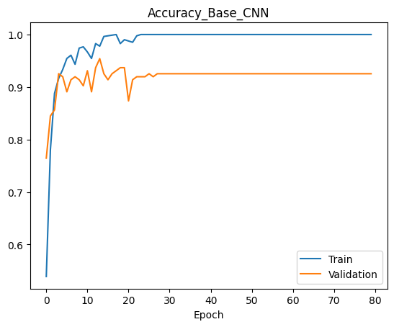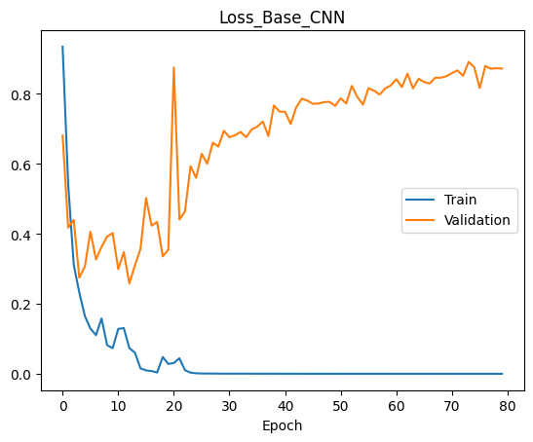

a

b

Figure 4 The accuracy curve (a) and loss curve (b) of initial CNN model.

Based on the curve shown above, the accuracy of validation is increased compared with SVM model, but validation accuracy curve is still below to the train accuracy curve. Additionally, as the loss curve of train approaching to 0, the loss curve of validation continues to increase, which suggesting that the initial CNN model still does not perform well in the validation dataset. Again, this model is also overfitted.

3.3 Model Improvement

The approaches to fix the overfitting contains: Increasing the size of dataset, image augmentation, regularization etc. Because we obtained the data from website, the way of increasing the size dataset is not realistic, and we already add one dropout layer in our model, so here we choose regularization and image augmentation to fix overfitting problems of our initial model.

3.3.1 Regularization

In the new model, we set up parameter kernel_regularizer=regularizers.l2(0.01)

and add into our initial model. The accuracy curve and loss curve are shown in Figure 5:

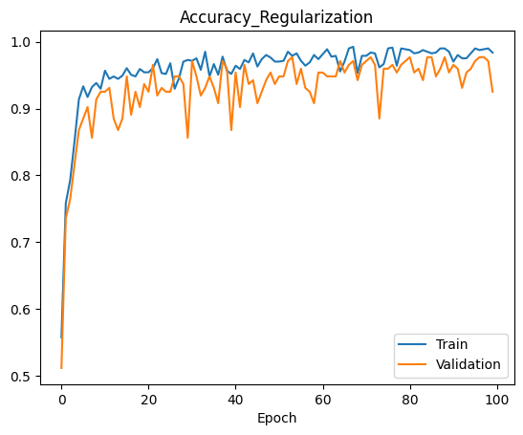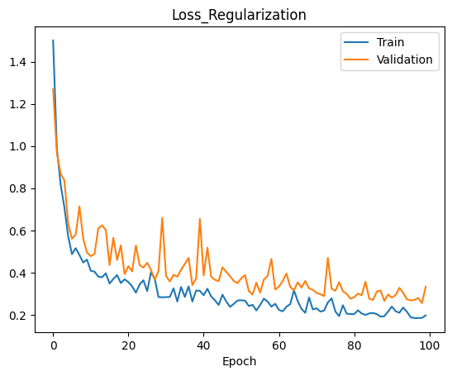

a

b

Figure 5 The accuracy curve (a) and loss curve (b) of CNN model with regularization.

3.3.2 Image augmentation

The image augmentation parameter is set up as follows:

rotation_range=20,

width_shift_range=0.2,

height_shift_range=0.2,

shear_range=0.2,

zoom_range=0.2,

horizontal_flip=True,

fill_mode='nearest'

The model used here is still the initial model.

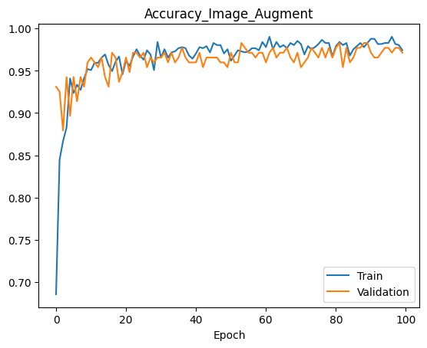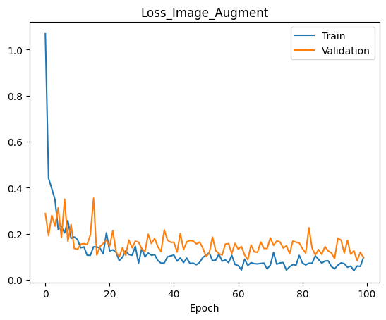

a

b

Figure 6 The accuracy curve (a) and loss curve (b) of CNN model with image augmentation.

Based on the curves of Figure 5 and Figure 6, both regularization and image augmentation improved the performance.

4. Conclusion

CNN model increases the accuracy on validation dataset compared with SVM model when the dataset size is not large. Adding regularization or image augmentation prevents the overfitting problem.

5. Citation

Arya, S., Singh, B. (2020), Wheat nitrogen deficiency and leaf rust image dataset, *Mendeley Data*, V1, doi: 10.17632/th422bg4yd.1

Chester, K.S. (1946). The nature and prevention of the cereal rusts as exemplified in the leaf rust of wheat. *In Chronica botanica*. Walthan, MA, USA. 269 pp.

Singh, J., Chhabra, B., Raza, A., Yang, S.H., Sandhu, K.S. (2023), Important wheat diseases in the US and their management in the 21st century. *Front Plant Science*. doi: 10.3389/fpls.2022.1010191.

Sezgin, M., Sankur, B. (2004). Survey over image thresholding techniques and quantitative performance evaluation. *Journal of Electronic Imaging*. 13 (1): 146–165.