
CMT202 Distributed and Cloud Computing
Student Number: c1749059

Part1:
In the part 1. We have built a distributed data storage system using pyro (Python Remote Objects). It implements allow their employees to access, store and update book information.

Environment:
- Ubuntu
- Python 3.0
- Pyro4

For running program, follow steps below:

Starting a name server:
Run a terminal and execute “python -m Pyro4.naming (or simply: pyro4-ns)”
result shown in this figure:
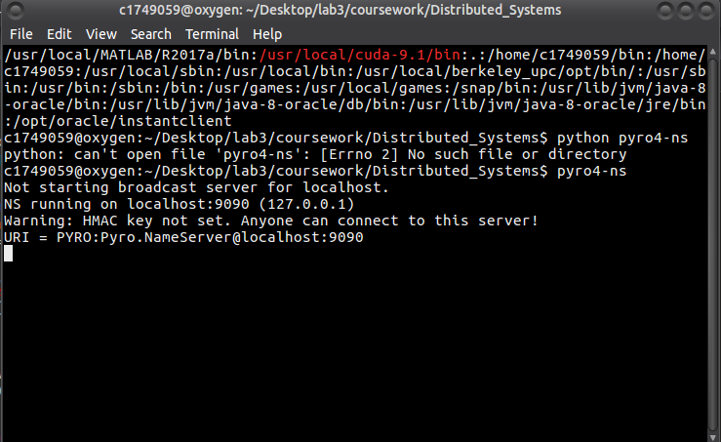

Running a warehouse Server:
Run new terminal in the same place and execute “Python warehouse.py”
Result shown in this figure:
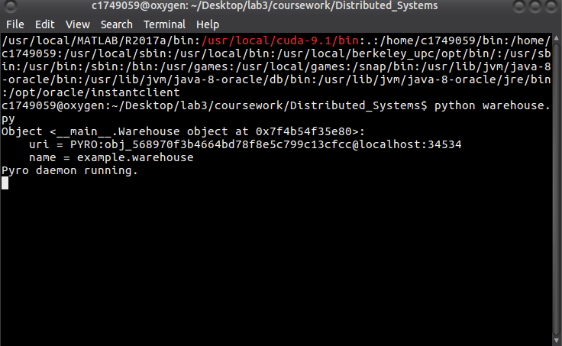

Running the programming:
Open another new terminal in the same place and execute “python read_csv.py”
Result shown in this figure:
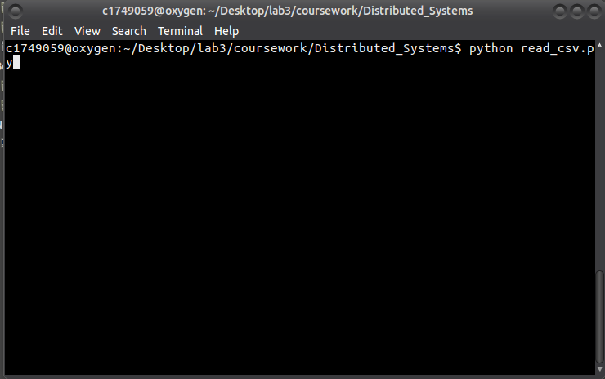

For result:
1. Display all six pieces of information relating to the set of books currently stored.
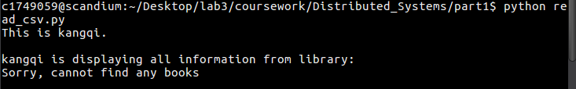
2. Add a book to the set of books currently stored; a newly added book should have a status of not on loan. The Book unique ID should be returned after completion of this task.
In warehouse:
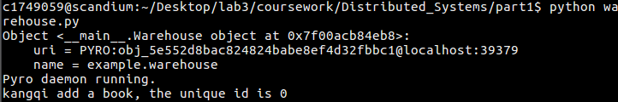
3. Display the subset of books currently stored which have a publication date within a specified inclusive year range (e.g. 2000-2010).

In warehouse:
4. Display the subset of books currently stored which have a specified ISBN.
In warehouse:
5. Set the status of all books with a specified ISBN to on loan.
In warehouse:
6. Set the status of all books with a specified ISBN to not on loan.
In warehouse:

Part2:
In this part we have created maper and reducer program that determine the maximum among all numbers in a CSV file.
Environment:
- Ubuntu
- Python 3.0
- Mrjob

For running program, follow steps below:

Run a terminal and execute “python max_mapreduce.py sample.csv”,
result shown in this figure:
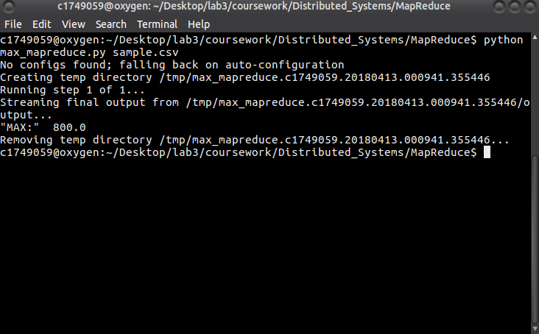

Part3:

Environment:
- Ubuntu
- Python 3.0
- Mrjob

For running program, follow steps below:

Run a terminal and execute “python mean_mapreduce.py sample.csv”
result shown in this figure:
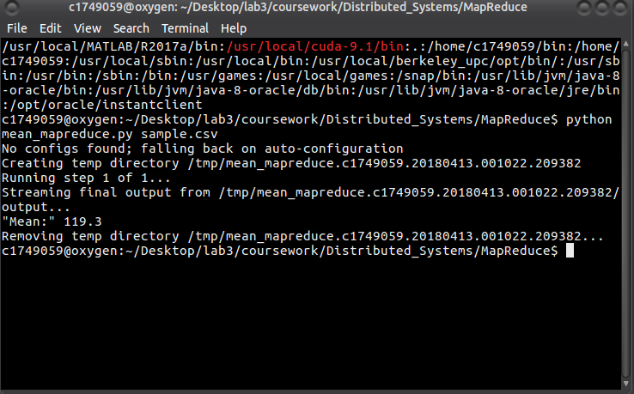

Part4:

Environment:
Ubuntu
Python 3.0
Mrjob

For running program, follow steps below:
Run a terminal and execute “python URL_mapreduce.py url.txt”
result shown in this figure:
