Plane element program

This program uses MATLAB appdesgner to calculate the plane triangular element, four node isoparametric element and their hybrid elements.

Plan_ Calculation. mlapp - Calculation interface

Tri_ Quad. M - triangle and four node isoparametric element calculation program

Input_ Data - input structure data

Output_ Data - output result data

This program is used for calculating plane problems, including triangular element,

four node isoparametric element and hybrid element

This program is only used for learning and communication.

Please do not use it for business without permission.

Please indicate the source for reprint

Written by Jia Xu & Ruoxi Liu - 04/13/2022

Contact: liuroci@163.com

The program calculation is divided into the following steps:

1. Open the program

Double click the MATLAB software folder to open the program_ Calculation. Mlapp opens the program interface.

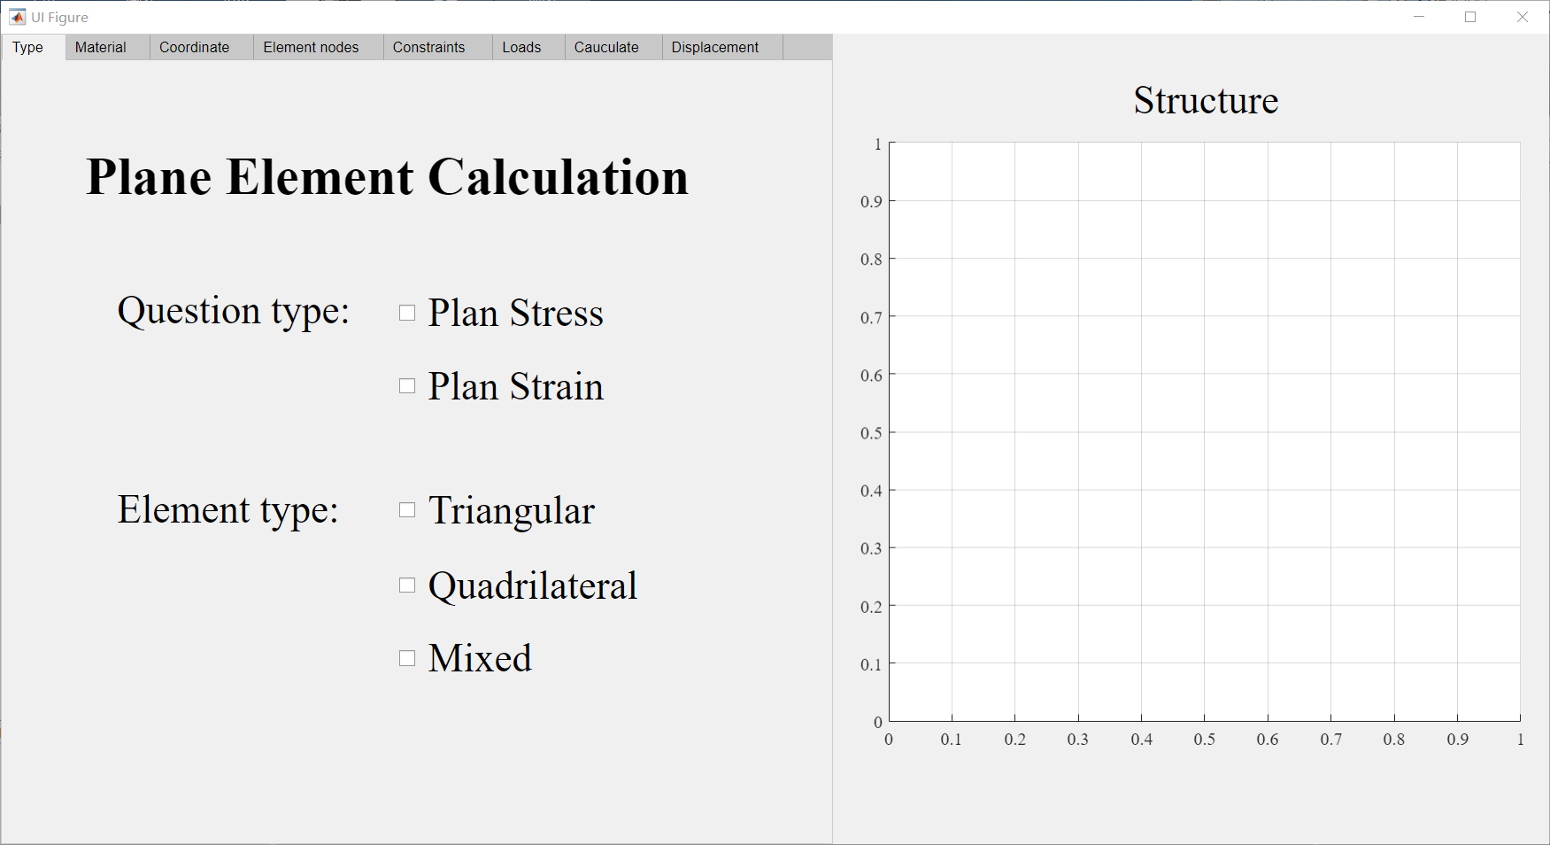

2. Data input

2.1 Problem type and element type

Select the plane strain problem or plane stress problem in question type, element type, select the type of calculation unit (triangle, four node, mixed cell)

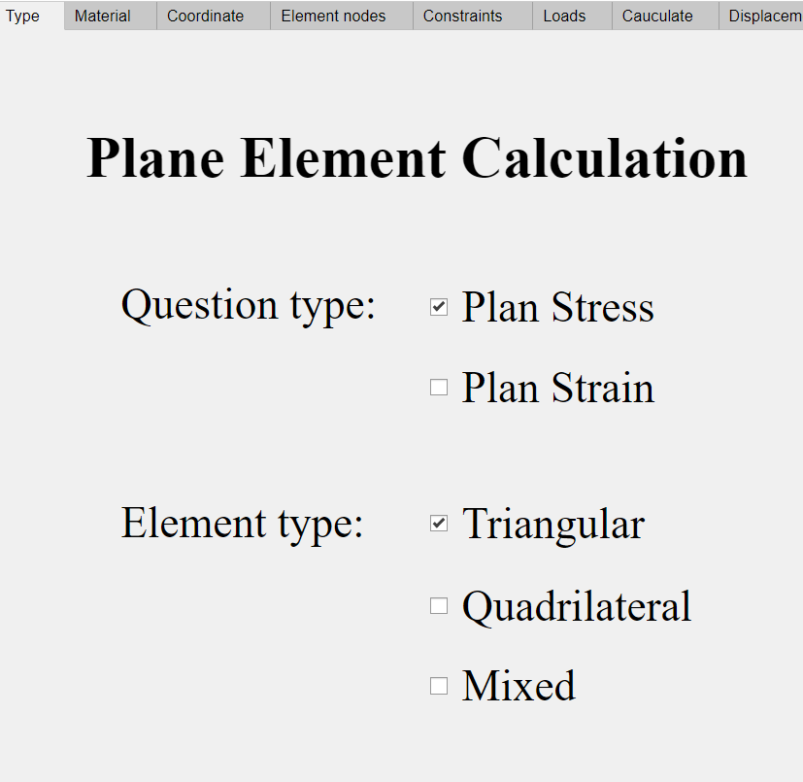

2.2 Material parameter

Enter the unit parameters (elastic modulus, Poisson's ratio, thickness) in the material list. After entering the value in the window, click the Add button to add the material parameters. Click Delete to delete the material parameters in the last row. You can modify the value directly in the list.

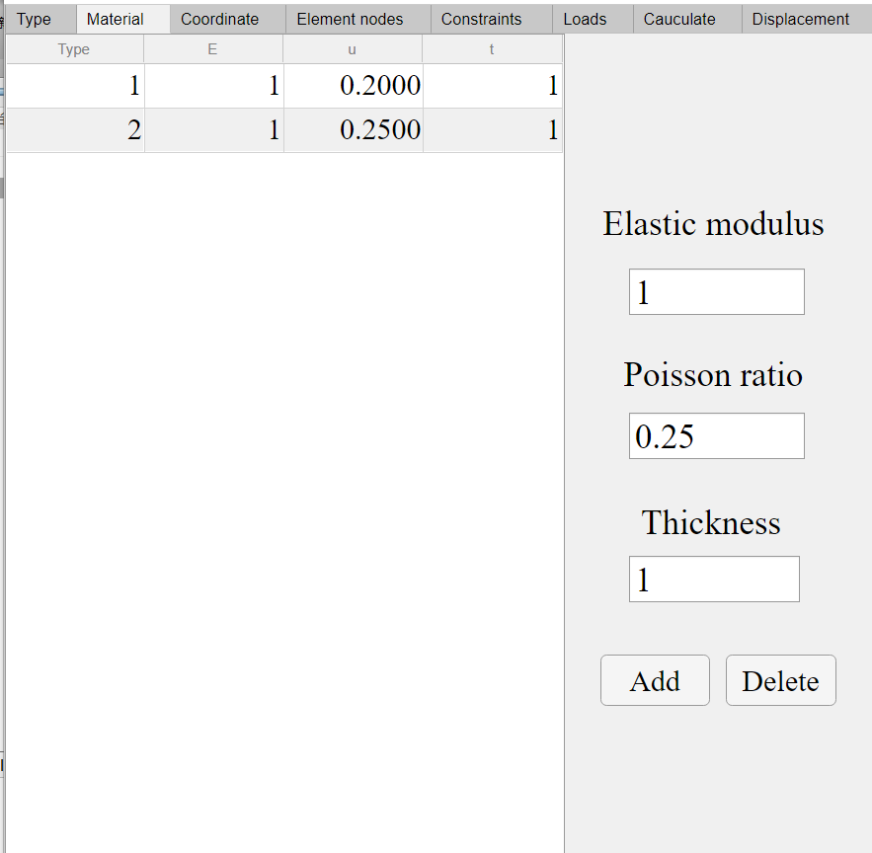

2.3 Node coordinate

Enter the x-coordinate and y-coordinate of the node in the coordinate list, and add again. After adding a node, enter the display size of the number in the graph in scale (the default is 1), and click the plot button to output the node graph position at the right end of the program.

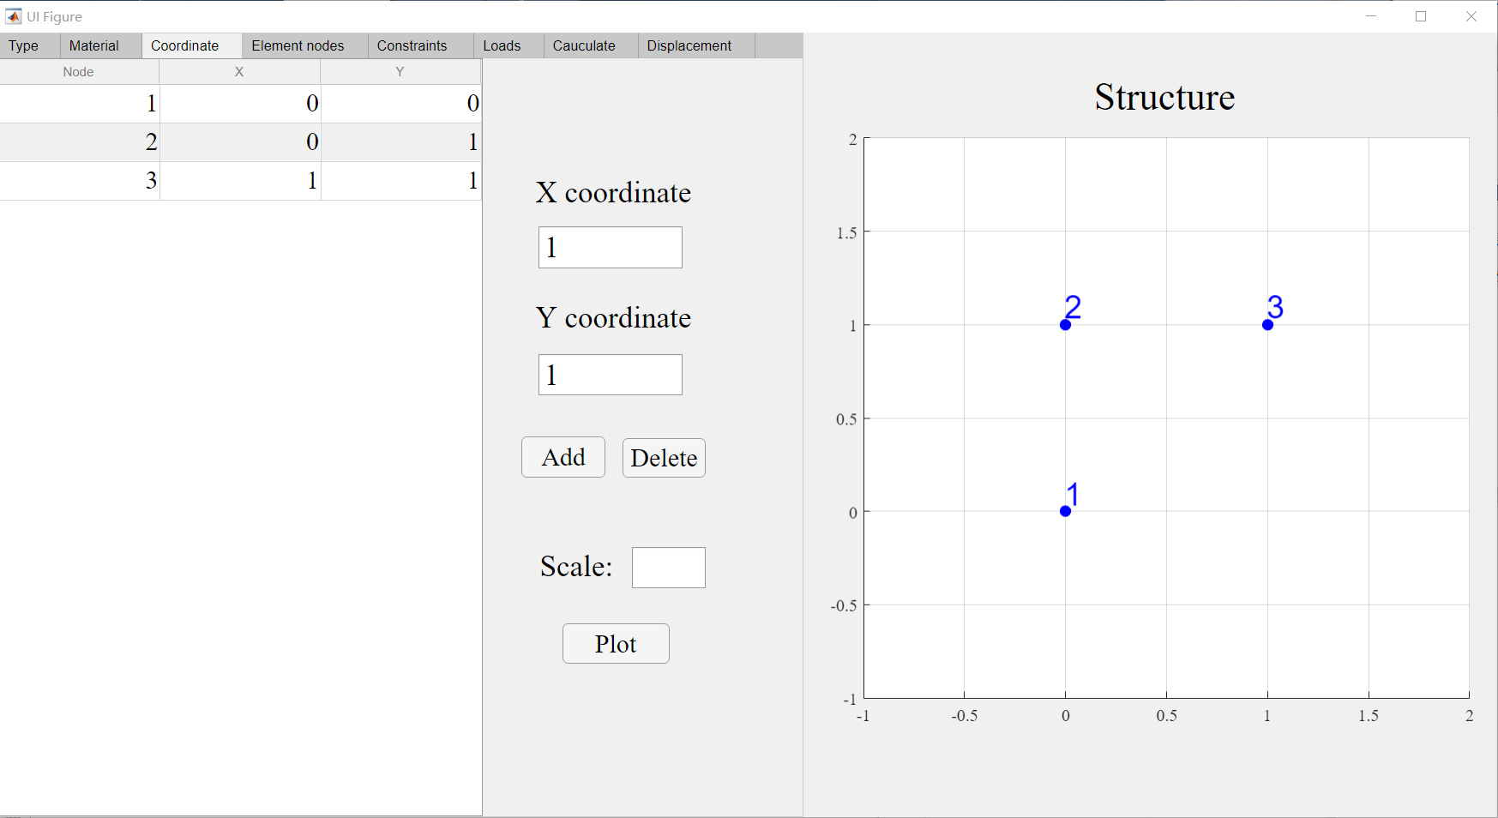

2.4 Element type and nodes

In the element nodes list, enter the material type of the unit, the unit type (3 is a three node unit and 4 is a four node unit) and the unit node number (input counterclockwise with a space between the numbers), and click plot to draw the graph.

If triangular triangular cell is selected in the type interface, the cell type will default to 3; If you select quadrilateral, the cell type will default to 4; If mixed is selected, the unit type needs to be entered manually.

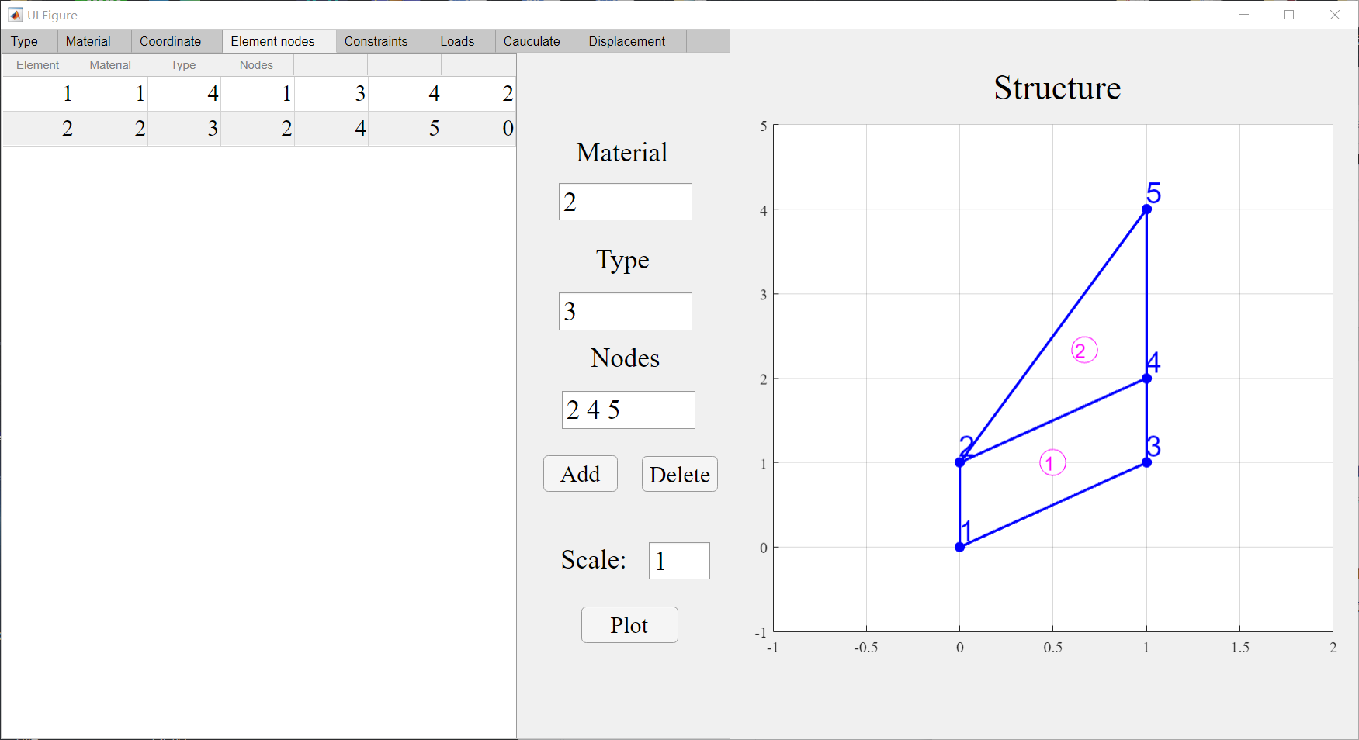

2.5 Constraints

Enter the constraint's degree of freedom number in the constraints list and click plot to draw the drawing.

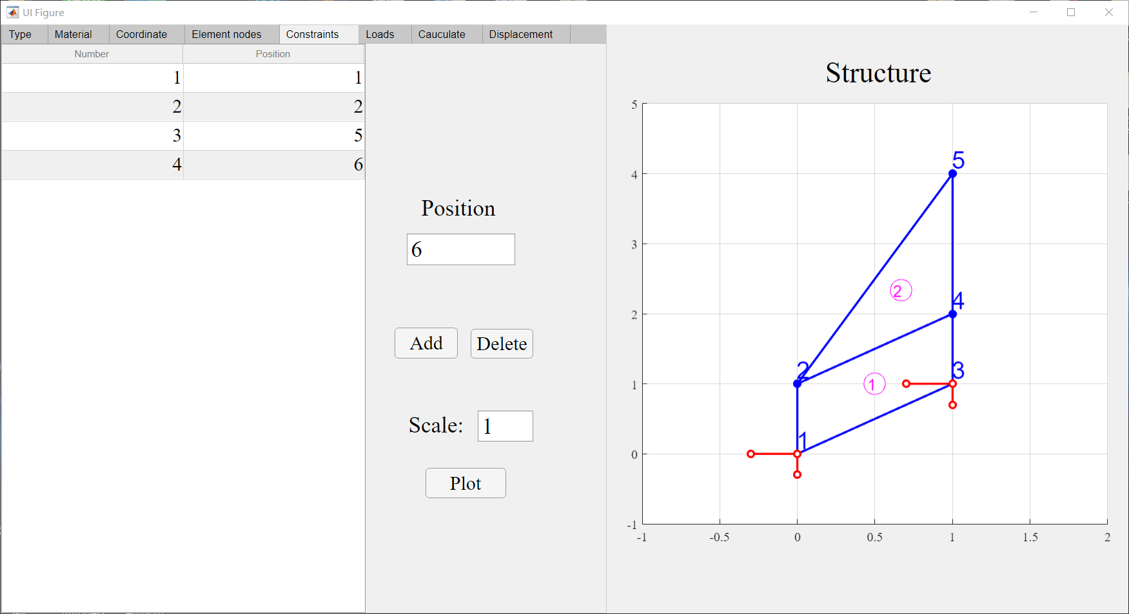

2.6 Load position and value

Enter the load position and size in the loads list and click plot to draw.

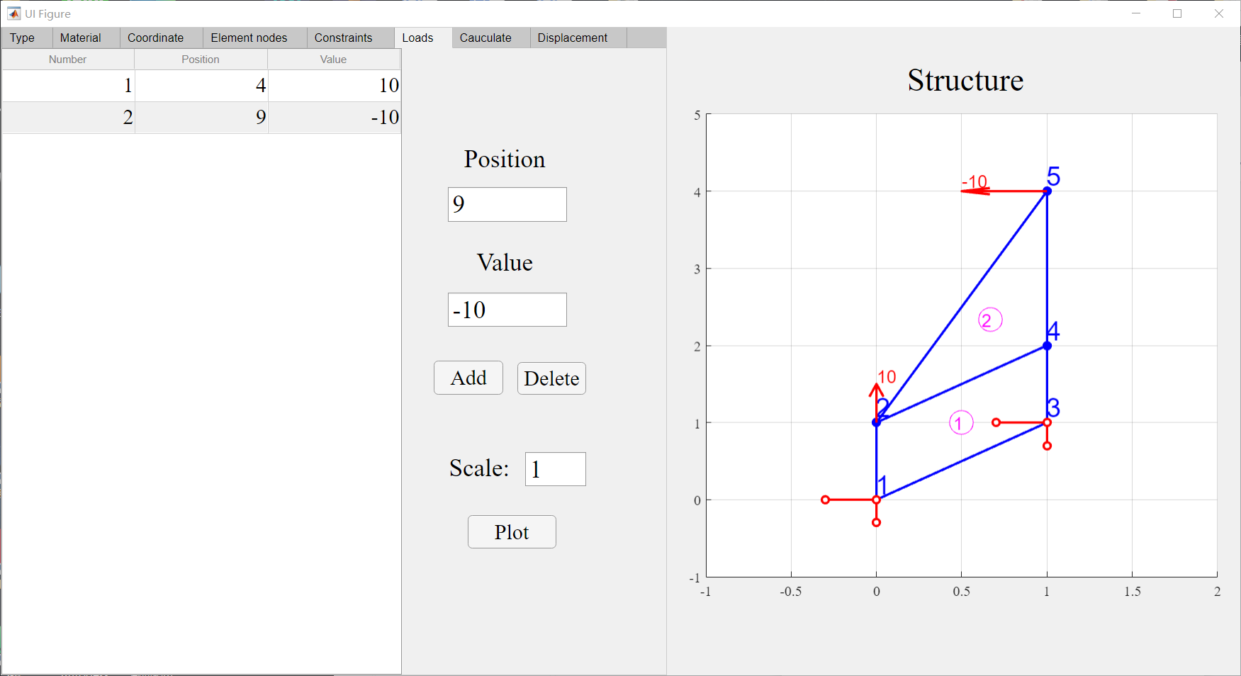

3. Data saving and reading

When the data input is complete, you can view the data you entered in the calculate list. Click the Save button in the window, and the data will be stored in the input in the Inpue_Data, TXT. Click the open button and the data will be imported into the program.

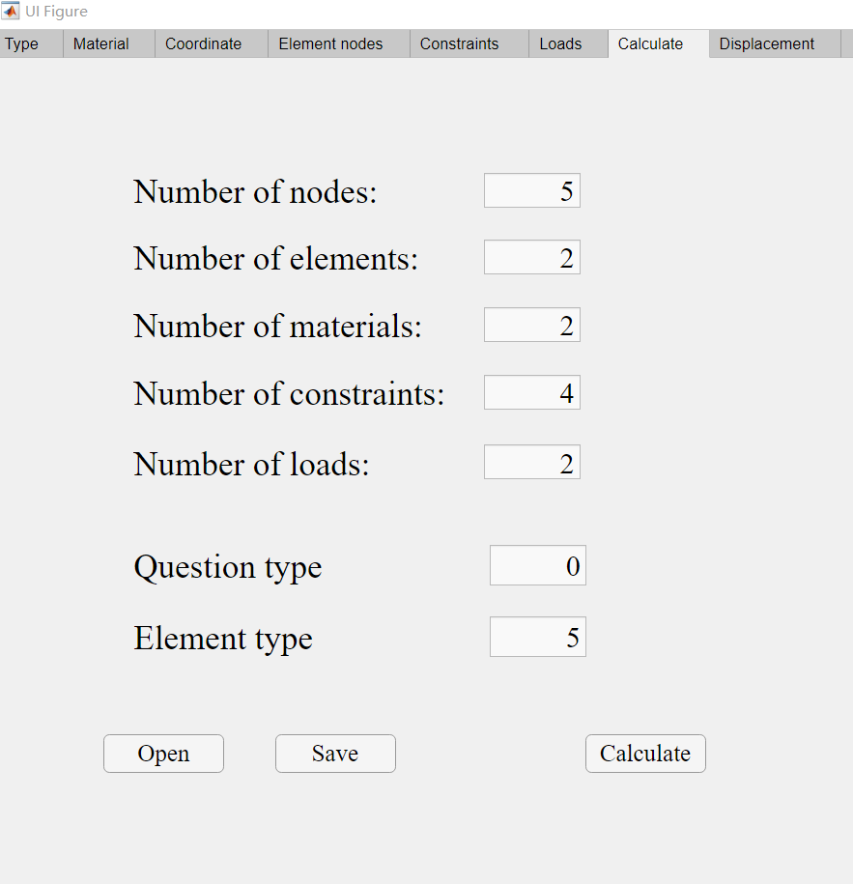

4. Calculation

After data input, click calculate in the calculate list to calculate the structural displacement and stress. And save the data in oOutput_ Data.

Select the displacement list in the program interface and click plot to draw the structural displacement diagram.

