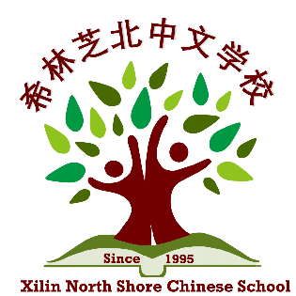
Dear Prospective Sponsor:

Xilin North Shore Chinese School is an Illinois registered 501(c)(3) non‐profit organization. We are located at the Skokie Campus of Oakton Community College. We offer more than 20 Chinese classes as well as other enrichment classes, such as Math, Chinese Dance, Painting, Calligraphy, Chinese Medicine, Go, etc. Our mission is to provide the best experience for children and adults to learn the Chinese language and culture.
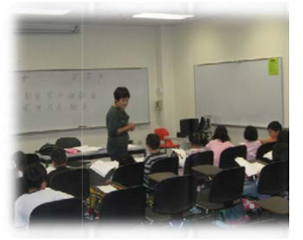
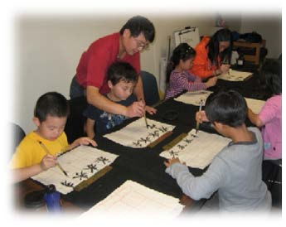
Your generous contribution will help us reach the following goals:
- Maintaining a low tuition/fee structure
- Keeping class size small for effective teaching
- Providing scholarships or tuition discount to low-income families
- Developing new classes to broaden our class offering

We ensure that 100% of your donations will be used for our education programs and services. All donations are tax‐deductible to the extent allowed by tax law. A letter of donation certification will be issued for tax deduction purposes.

In appreciation of your generous contribution, we place an advertisement on our school website as well as in social groups which will help you to reach more than 300 students and families registered, plus the prospective families who check out our website. Please see sponsorship levels and detailed benefits below.

Sponsorship Levels:
- Silver Circle Sponsor ‐ $250(individual) / $350 (company)
Your organization’s logo and link will be displayed on our school website.
- Gold Circle Sponsor ‐ $350(individual) / $500(company)
In addition to the above, your organization’s advertisements will be included in our quarterly newsletter and displayed at all school events.
- Platinum Circle Sponsor ‐ $500(individual) / $1000(company)
In addition to the above, a scholarship will be named in honor of your organization. Other types of recognition will be established upon request.
Workshops for sponsors can be discussed and arranged with school officials.

If you wish to become a sponsor for our school, please return the attached Sponsorship form, or contract:
Jing Miao  Principal  principal@xilinnschinese.org | Yingyan Huang  Chairperson, Board of Directors  ChairpersonBOD@xilinnschinese.org
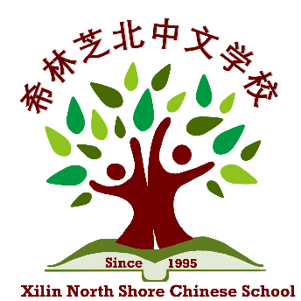
Xilin North Shore Chinese School
Sponsorship Form

Sponsor Information:

Organization: ___________________________________________
Contact Name: ___________________________________________
Phone Number: ___________________________________________
Email: ___________________________________________
Address: ___________________________________________
City, State: ______________________ ZIP: ________________

Sponsorship Levels:
☐ $500/$1000 Platinum Circle Sponsor
☐ $350/$500 Gold Circle Sponsor
☐ $250/$350 Silver Circle Sponsor
☐ Other ______________

Xilin North Shore Chinese School is an Illinois registered, non‐profit organization that meets the requirements of section 501(c)(3) of the IRS Code. All donations are tax‐deductible to the extent allowed by the tax law. School’s TAX ID is 30‐0332045.

Please fill out this form and make checks payable to Xilin North Shore Chinese School.
Mail to:
Xilin North Shore Chinese School
4957 Oakton Street, Suite 292
Skokie, IL 60077

If you have any questions regarding the donation, please email principal at principal@xilinnschinese.org

