**数 据 库 设 计**

1. **E-R图**

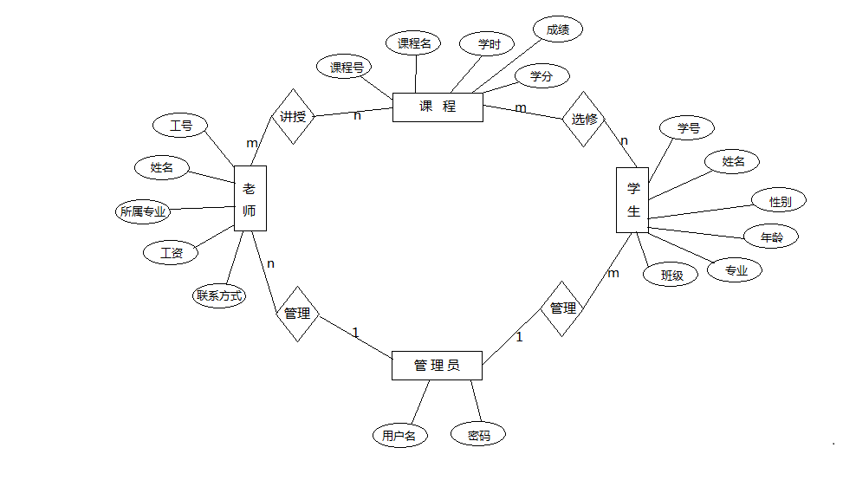

1. **表关系图**

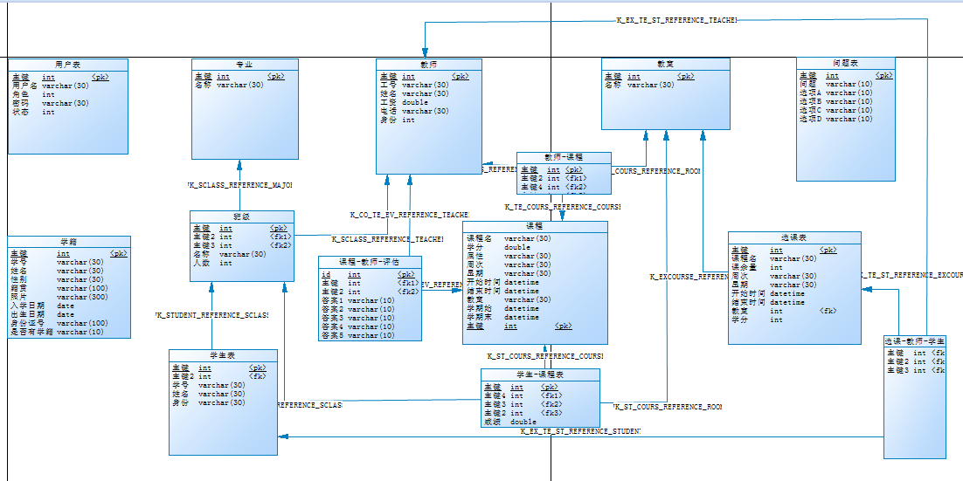

1. **表设计**

用户表：(user)

|  |  |  |  |  |
| --- | --- | --- | --- | --- |
| 编号 | 学（工）号 | 密码 | 角色 | 状态 |
| u_id | u_number | u_pwd | u_role | u_status |
| 主键 |  |  | 1管理员 2老师 3学生 | 1在校 2离校 |
| int | varchar | varchar | int | int |

学生表：(student)

|  |  |  |  |  |
| --- | --- | --- | --- | --- |
| 编号 | 学（工）号 | 姓名 | 班级 | 身份 |
| st_id | st_num | st_name | cl_id | st_behave |
| 主键 |  |  | 外键 | 1班长 2普通学生 |
| int | varchar | varchar | int | varchar |

学籍表：(sroll)

|  |  |  |  |  |  |  |  |  |  |
| --- | --- | --- | --- | --- | --- | --- | --- | --- | --- |
| 编号 | 学（工）号 | 姓名 | 性别 | 籍贯 | 身份证号 | 出生日期 | 照片 | 入学时间 | 是否有学籍 |
| sr_id | sr_num | sr_name | sr_sex | Sr_address | sr_idCard | sr_birthday | sr_img | sr_time | sr_isRoll |
| 主键 |  |  |  |  |  |  |  |  | 1是 2否 |
| int | varchar | varchar | varchar | varchar | varchar | date | varchar | date | varchar |

班级表：(sclass)

|  |  |  |  |  |
| --- | --- | --- | --- | --- |
| 编号 | 名称 | 专业  （对象） | 班主任（属性） | 人数 |
| cl_id | cl_name | ma_id | te_id | cl_count |
| 主键 |  | 外键 | 外键 |  |
| int | varchar | int | int | int |

教师表(teacher)

|  |  |  |  |  |  |  |
| --- | --- | --- | --- | --- | --- | --- |
| 编号 | 工号 | 姓名 | 联系方式 | 身份 | 工资 | 专业 |
| te_id | te_num | te_name | te_phone | te_behave | te_salary | ma_id |
| 主键 |  |  |  | 1.讲师 2.班主任 |  | 外键 |
| int | varchar | varchar | varchar | int | double | int |

专业表：(major)

|  |  |
| --- | --- |
| 编号 | 名称 |
| ma_id | ma_name |
| 主键 |  |
| int | varchar |

教室表：(room)

|  |  |
| --- | --- |
| 编号 | 名称 |
| ro_id | ro_name |
| 主键 |  |
| int | varchar |

总课程表（course）

|  |  |  |  |  |  |  |  |
| --- | --- | --- | --- | --- | --- | --- | --- |
| 编号 | 课程名 | 学分 | 属性 | 专业 | 周次 | 学期始 | 学期末 |
| co_id | co_name | co_score | co_status | ma_id | co_week | co_starttime | co_endtime |
| 主键 |  |  | 1必修  2选修 | 外键 |  |  |  |
| int | varchar | double | varchar | int | varchar | date | date |

必修-课程表（en_course）

|  |  |  |  |  |  |  |  |
| --- | --- | --- | --- | --- | --- | --- | --- |
| 编号 | 课程 | 教室 | 老师 | 班级  (对象) | 星期 | 开始时间 | 结束时间 |
| en_id | co_id | ro_id | te_id | cl_id | en_day | en_start | en_end |
| 主键 | 外键 | 外键 | 外键 | 外键 |  |  |  |
| int | int | int | int | int | varchar | varchar | varchar |

选课表(excourse)

|  |  |  |  |  |  |  |  |  |  |
| --- | --- | --- | --- | --- | --- | --- | --- | --- | --- |
| 编号 | 课程名 | 老师 | 学分 | 课余量 | 周次 | 星期 | 教室 | 开始时间 | 结束时间 |
| ex_id | ex_name | te_id | ex_score | ex_count | ex_week | ex_day | ro_id | ex_start | ex_end |
| 主键 |  | 外键 |  |  |  |  | 外键 |  |  |
| int | varchar | int | int | int | varchar | varchar | int | varchar | varchar |

选课关联关系表(ex_st)

|  |  |
| --- | --- |
| 选修课 | 学生 |
| ex_id | st_id |
| 外键 | 外键 |
| int | int |

成绩表(grade)

|  |  |  |  |
| --- | --- | --- | --- |
| 编号 | 学号 | 课程 | 分数 |
| id | st_num | co_name | score |
| 主键 |  | 课程名 |  |
| int | varchar | varchar | int |

评估问题表(question)

|  |  |  |  |  |  |
| --- | --- | --- | --- | --- | --- |
| 编号 | 问题 | 选项A | 选项 | 选项C | 选项D |
| q_id | q_count | q_a | q_b | q_c | q_d |
| 主键 |  |  |  |  |  |
| int | varchar | varchar | varchar | varchar | varchar |

评估表（co_te_ev）

|  |  |  |  |  |  |  |  |  |
| --- | --- | --- | --- | --- | --- | --- | --- | --- |
| 编号 | 答案1 | 答案2 | 答案3 | 答案4 | 答案5 | 教师 | 课程 | 学号 |
| id | answer1 | answer2 | answer3 | answer4 | asnswer5 | te_id | co_id | st_num |
| 主键 |  |  |  |  |  | 外键 | 外键 |  |
| int | int | int | int | int | int | int | int | varchar |