# 电池充电电流设置

电流设置函数：

qpnp-linear-charger.c：qpnp_lbc_ibatmax_set

修改快充充电最大值：

msm8909-pm8909-mtp.dtsi：qcom,ibatmax-ma = <1080>;

msm-pm8909.dtsi：

qcom,ibatsafe-ma = <1080>;

qcom,thermal-mitigation = <1080 1080 1080 1080>;

下面修改快充的最大电流限制：

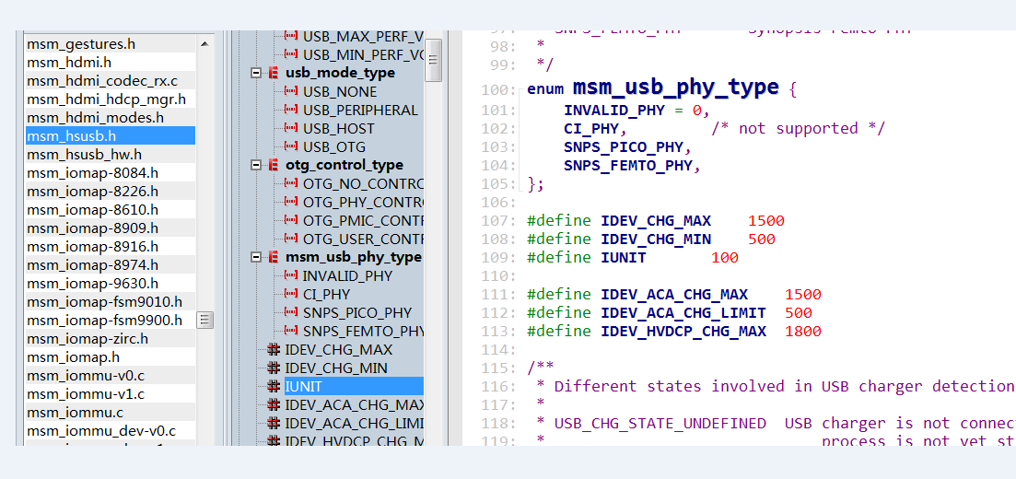

0x1052设置涓流充电电压门限，小于此值进行涓流充电。通过“qcom, vbatweak-uv”配置

[ 926.129467] [<c06cd104>] (qpnp_batt_power_set_property+0xa0/0x3ac) from [<c06c28c0>] (report_eoc+0xa0/0xfc)

[ 926.139188] [<c06c28c0>] (report_eoc+0xa0/0xfc) from [<c06c4b8c>] (report_vm_bms_soc+0x35c/0x824)

[ 926.148042] [<c06c4b8c>] (report_vm_bms_soc+0x35c/0x824) from [<c06c8670>] (monitor_soc_work+0x33c/0x768)

[ 926.157603] [<c06c8670>] (monitor_soc_work+0x33c/0x768) from [<c013af14>] (process_one_work+0x298/0x42c)

[ 926.167058] [<c013af14>] (process_one_work+0x298/0x42c) from [<c013bc88>] (worker_thread+0x228/0x35c)

[ 926.176255] [<c013bc88>] (worker_thread+0x228/0x35c) from [<c014063c>] (kthread+0xa0/0xac)

[ 926.184514] [<c014063c>] (kthread+0xa0/0xac) from [<c0105f98>] (ret_from_fork+0x14/0x3c)

check_eoc_condition函数中:

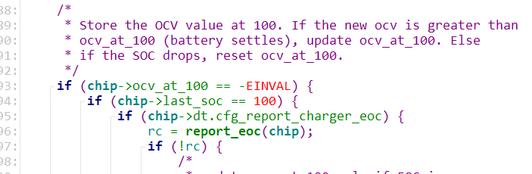

一旦条件成立，则通知停止充电。之后，

1. qcom,resume-soc定义电量达到多少后，重新开始充电
2. 通过中断函数qpnp_lbc_vbatdet_lo_irq_handler，

电压低于VDD_MAX-5%，则重新开始充电。

