1.ftp上传mysql-5.7.22-linux-glibc2.12-x86_64.tar.gz至指定目录/opt/software或者

wget https://cdn.mysql.com//Downloads/MySQL-5.7/mysql-5.7.22-linux-glibc2.12-x86_64.tar.gz

[root@loalhost opt]#

tar -zxvf mysql-5.7.22-linux-glibc2.12-x86_64.tar.gz

[root@loalhost opt]#ll

2.解压拷贝到/usr/改名为mysql-5.7.22

[root@loalhost opt]#

mv mysql-5.7.22-linux-glibc2.12-x86_64 /usr/mysql-5.7.22

3.创建mysql用户组以及用户

[root@loalhost opt]#grouadd mysql

[root@loalhost opt]#useradd -r -g mysql mysql

[root@loalhost opt]#id mysql

uid=993(mysql) gid=1000(mysql) groups=1000(mysql)

4.修改mysql目录的拥有者为mysql组和用户

[root@loalhost opt]#chown -R mysql:nysql /usr/mysql-5.7.22

drwxr-xr-x 10 mysql mysql 4096 Oct 31 16:23 mysql-5.7.22

5.执行mysql初始化

[root@loalhost opt]# cd /usr/mysql-5.7.22

[root@loalhost mysql-5.7.22]#

bin/mysqld --initialize --user=mysql --basedir=/usr/mysql-5.7.22 --datadir=/usr/mysql-5.7.22/data

若报错

bin/mysqld: error while loading shared libraries: libnuma.so.1: cannot open shared object file: No such file or directory

查阅质料说缺少numactl 执行

[root@loalhost mysql-5.7.22]# yum -y install numactl

完成后再次执行初始化结果如下

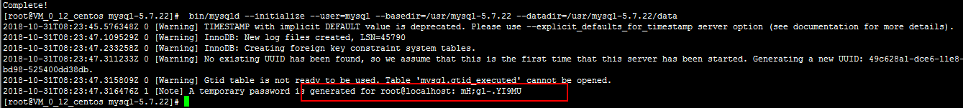

得到标记处为后面要用到的密码,本次为 mH;gl-.YI9MU

6.配置mysql

[root@localhost etc]# vim /etc/my.cnf

#sedir=/usr/local/mysql-5.7.22/

#datadir=/usr/local/mysql-5.7.22/data/

[client]

port=3306

socket=/tmp/mysql.sock

default-character-set=utf8

[mysqld]

datadir =/usr/mysql-5.7.22/data/

port=3306

socket=/tmp/mysql.sock

key_buffer_size=16M

max_allowed_packet=8M

default-storage-engine=INNODB

character-set-server=utf8

collation-server=utf8_general_ci

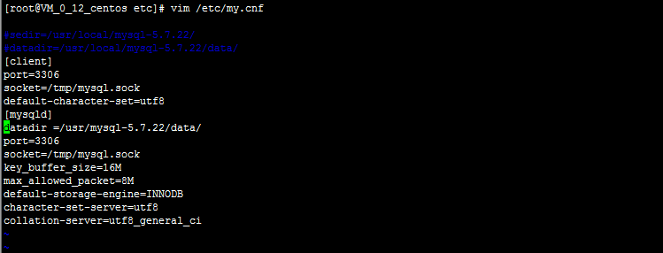

7.启动mysql数据库

[root@localhost mysql-5.7.22]# service mysqld start

Starting MySQL. SUCCESS!

[root@localhost mysql-5.7.22]#

用步骤5得到的密码登录数据库

[root@localhost mysql-5.7.22]#mysql -u root -p

如果出现错误需要添加软连接

[root@localhost mysql-5.7.22]# ln -s /usr/mysql-5.7.22/bin/mysql /usr/bin

[root@localhost mysql-5.7.22]#mysql -uroot -p

Enter password:

Welcome to the MySQL monitor. Commands end with ; or \g.

Your MySQL connection id is 2

Server version: 5.7.22 MySQL Community Server (GPL)

Copyright (c) 2000, 2018, Oracle and/or its affiliates. All rights reserved.

Oracle is a registered trademark of Oracle Corporation and/or its

affiliates. Other names may be trademarks of their respective

owners.

Type 'help;' or '\h' for help. Type '\c' to clear the current input statement.

mysql>show databases;(执行sql提示修改root用户密码)

ERROR 1820 (HY000): You must reset your password using ALTER USER statement before executing this statement.

mysql> set PASSWORD=PASSWORD('root'); --设置root用户密码为root

Query OK, 0 rows affected, 1 warning (0.03 sec)

mysql> flush privileges;(刷新权限)

完成之后可以执行sql查询

8.配置开机启动项,拷贝mysql.server至/etc/init.d/下并修改名称为mysqld

[root@localhost etc]# cp /usr/mysql-5.7.22/support-files/mysql.server /etc/init.d/mysqld

[root@localhost etc]# vim /etc/init.d/mysqld

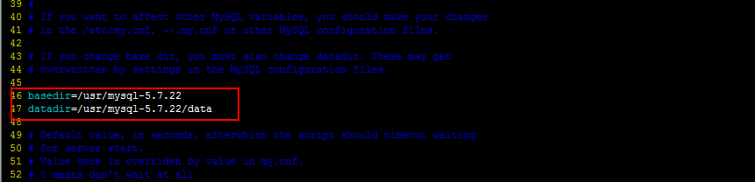

修改46,47行如图

basedir=/usr/mysql-5.7.22

datadir=/usr/mysql-5.7.22/data

执行

[root@localhost mysql-5.7.22]#chkconfig --add mysqld (添加开机启动项)

9.远程连接数据库,使用root登录到数据库

mysql> GRANT ALL PRIVILEGES ON *.* TO 'root'@'%' IDENTIFIED BY 'root' WITH GRANT OPTION;

mysql> flush privileges;(刷新权限)

10.关闭数据库

[root@localhost mysql-5.7.22]# service mysqld stop

Shutting down MySQL.. SUCCESS!

11.卸载数据库

[root@localhost /]#rpm -qa |grep mysql

[root@localhost /]#yum remove mysql*

主要参考一下文字

https://blog.csdn.net/z13615480737/article/details/80019881

http://www.cnblogs.com/chinesern/p/9309853.html?&from=androidqq