git安装

参考:https://www.cnblogs.com/shelly01-zhou/p/7736610.html

[root@localhost ~]# cd /

[root@localhost /]# clear

[root@localhost /]# git --version

-bash: git: command not found

[root@localhost /]# whereis git

git:

[root@localhost /]# yum -y install git (安装yum库中的git版本)

...

Installed:

git.x86_64 0:1.7.1-9.el6_9

Dependency Installed:

perl-Error.noarch 1:0.17015-4.el6 perl-Git.noarch 0:1.7.1-9.el6_9

Complete!

[root@localhost /]# git --version

git version 1.7.1 (此处yum中存在1.7.1版本)

由于github需要的Git版本最低都不能低于1.7.2,

需要升级系统(或不升级)

yum  -y update

安装相关依赖包

yum -y install curl-devel expat-devel gettext-devel openssl-devel zlib-devel gcc perl-ExtUtils-MakeMaker

在https://mirrors.edge.kernel.org/pub/software/scm/git/查看git的最新版本为: 2.19.0,

命令:wget https://Github.com/Git/Git/archive/v2.19.0.tar.gz下载指定目标到当前目录

[root@localhost/]# yum -y install curl-devel expat-devel gettext-devel openssl-devel zlib-devel gcc perl-ExtUtils-MakeMaker

Loaded plugins: fastestmirror, refresh-packagekit, security

Loading mirror speeds from cached hostfile

* base: mirrors.aliyun.com

* extras: mirrors.aliyun.com

* updates: mirrors.163.com

Setting up Install Process

.....

perl-version.x86_64 3:0.77-144.el6

Complete!

依赖更新完成后

[root@localhost /]# cd /opt

[root@localhostopt]#

wget https://Github.com/Git/Git/archive/v2.19.0.tar.gz

--2018-09-13 10:53:45-- https://github.com/Git/Git/archive/v2.19.0.tar.gz

Resolving github.com... 192.30.253.113, 192.30.253.112

Connecting to github.com|192.30.253.113|:443... connected.

HTTP request sent, awaiting response... 302 Found

Location: https://codeload.github.com/git/git/tar.gz/v2.19.0 [following]

--2018-09-13 10:53:46-- https://codeload.github.com/git/git/tar.gz/v2.19.0

Resolving codeload.github.com... 192.30.253.120, 192.30.253.121

Connecting to codeload.github.com|192.30.253.120|:443... connected.

HTTP request sent, awaiting response... 200 OK

Length: unspecified [application/x-gzip]

Saving to: “v2.19.0.tar.gz”

[ <=> ] 7,707,534 268K/s in 32s

2018-09-13 10:54:19 (235 KB/s) - “v2.19.0.tar.gz” saved [7707534]

[root@localhost opt]# ll

total 7528

-rw-r--r-- 1 root root 7707534 Sep 13 10:54 v2.19.0.tar.gz

[root@localhost opt]# pwd

/opt

解压

[root@localhost opt]# tar -zxvf v2.19.0.tar.gz

[root@localhost opt]# cd git-2.19.0/

以下是指定git的安装目录/usr/local/git

[root@localhost git-2.19.0]# make prefix=/usr/local/git all

[root@localhost git-2.19.0]# make prefix=/usr/local/git install

...

done && \

./check_bindir "z$bindir" "z$execdir" "$bindir/git-add"

查看版本,还是1.7.1

[root@localhost git-2.19.0]# git --version

git version 1.7.1

修改配置文件profile 添加 export PATH=/usr/local/git/bin:$PATH

[root@localhost git-2.19.0]# vim /etc/profile

[root@localhost git-2.19.0]# source /etc/profile

[root@localhost git-2.19.0]# whereis git

git: /usr/bin/git /usr/local/git /usr/share/man/man1/git.1.gz

[root@localhost git-2.19.0]# git --version

git version 2.19.0

完成安装

使用git下拉代码

[root@localhost opt]#mkdir app

[root@localhost opt]#cd app

[root@localhost app]#mkdir git

[root@localhost opt]#cd git

[root@localhost git]#

git clone http://www.github.com/liutao1024/github-socket.git

Cloning into 'github-socket'...

warning: redirecting to https://github.com/liutao1024/github-socket.git/

remote: Counting objects: 358, done.

remote: Compressing objects: 100% (184/184), done.

remote: Total 358 (delta 101), reused 317 (delta 64), pack-reused 0

Receiving objects: 100% (358/358), 89.62 KiB | 187.00 KiB/s, done.

Resolving deltas: 100% (101/101), done.

[root@localhost git]# ll

total 4

drwxr-xr-x 4 root root 4096 Sep 13 11:21 github-socket

[root@localhost git]#cd github-socket

使用git

HOW-TO-USE-GIT.txt有介绍

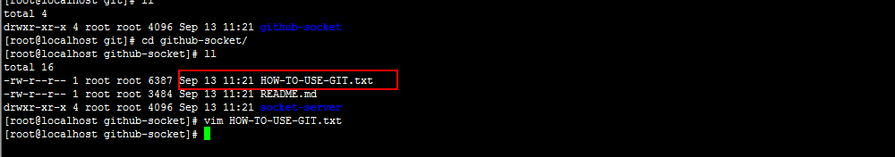

[root@localhost github-doc]#git pull

[root@localhost github-doc]#git push -m