Linux系统安装Nexus

一Nexus安装前准备

1. Nexus官网

|  |
| --- |
| http://www.sonatype.org/nexus/ |

1. Nexus下载

|  |
| --- |
| <http://www.sonatype.org/nexus/archived/> |

1. 创建nexus安装目录

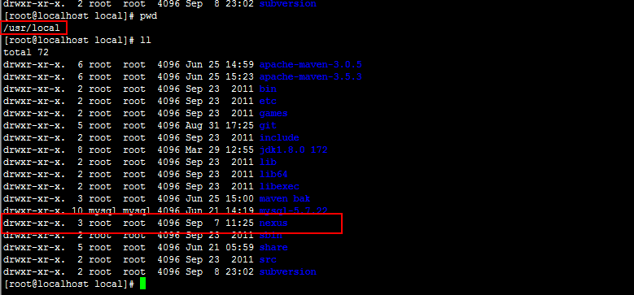

1. 使用FTP上传nexus安装包到Linux系统/user/local/nexus目录下

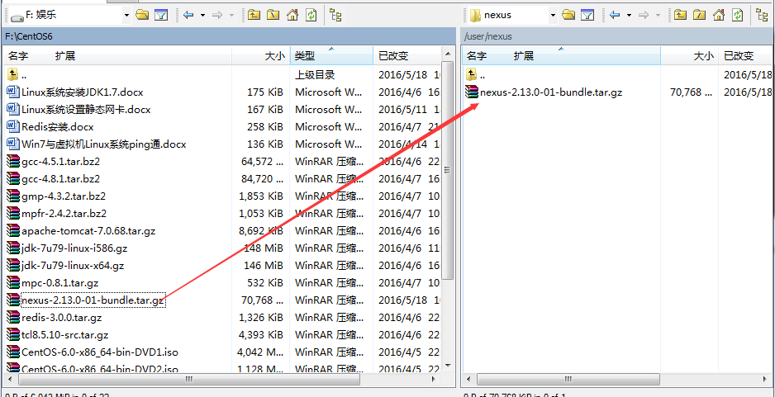

1. 解压nexus

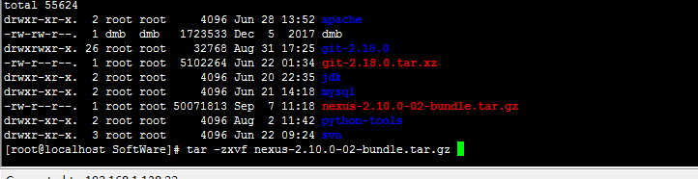

1. 解压nexus后两个压缩包

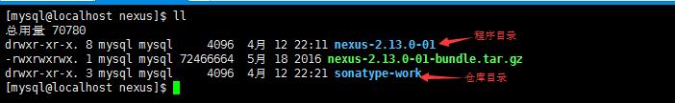

1. 重命名nexus-2.13.0-01

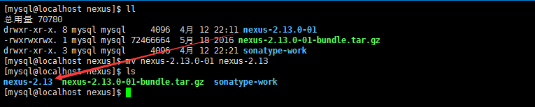

二安装Nexus

1. 编辑系统配置文件：vim /etc/profile

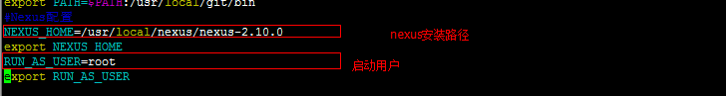

1. 刷新配置

|  |
| --- |
| source /etc/profile |

1. 由于sonatype-work做仓库需要很大空间，将sonatype-work移动到/opt/nexus/目录下

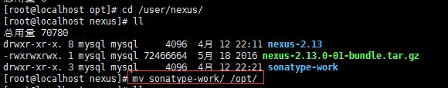

1. 设置配置文件/user/local/nexus/nexus-2.10.0/conf/nexus.properties

|  |
| --- |
| * 把文件中该值：nexus-work=${bundleBasedir}/../sonatype-work/nexus * 改为：nexus-work=/opt/nexus/sonatype-work/nexus |

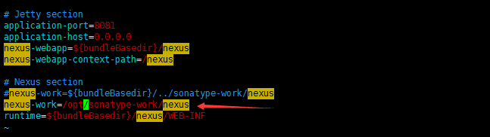

1. 设置java的JDK路径

|  |
| --- |
| /user/local/cnexus/nexus-2.13/bin/jsw/conf/wrapper.conf |

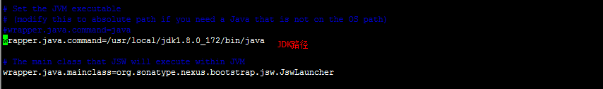

三开放防火墙端口

1. 使用root用户/etc/sysconfig/iptables添加8081端口

|  |
| --- |
| -A INPUT -m state --state NEW -m tcp -p tcp --dport 8081 -j ACCEPT |

2.重启iptables

|  |
| --- |
| sudo service iptables restart |

四测试安装结果

1. 启动nexus

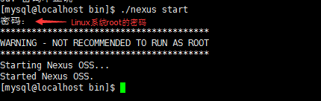

2.查看日志

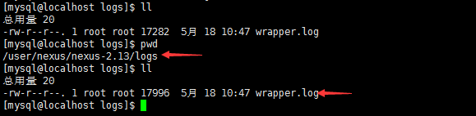

3.使用浏览器访问nexus

|  |
| --- |
| http://10.24.1.151:8081/nexus |

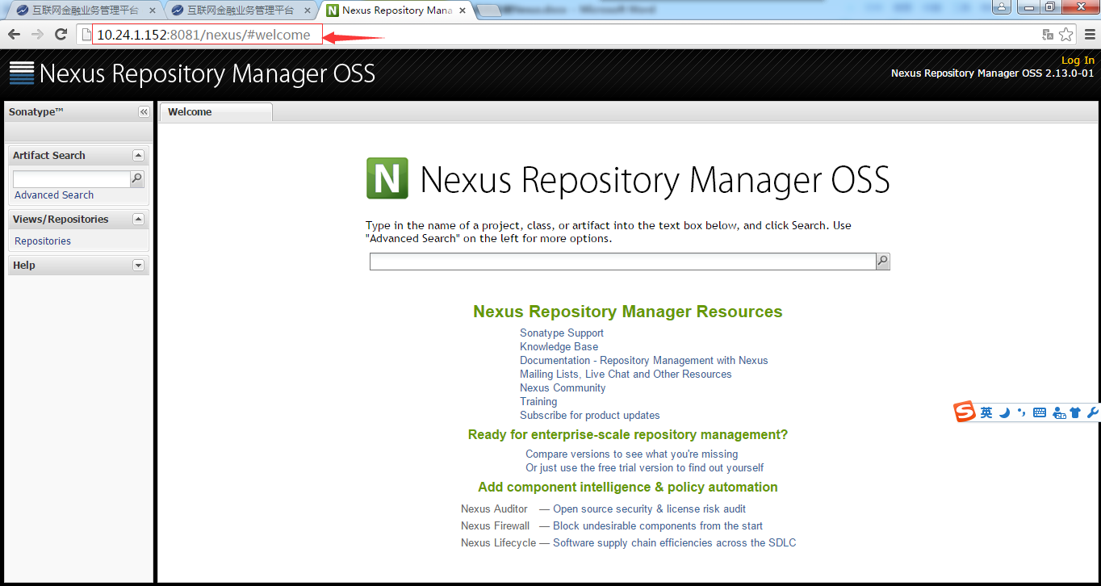

4.登录nexus用户名:admin 密码:admin123

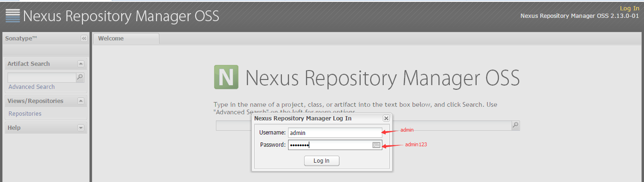

五参考资料

1.nexus安装参考文档

|  |
| --- |
| http://wiki.jikexueyuan.com/project/linux-in-eye-of-java/Nexus-Install-And-Settings.html  https://www.2cto.com/kf/201606/517491.html 20180907 |

六 nexus管理

1.nexus远程仓库地址

|  |
| --- |
| 10.24.1.152:8081/nexus |

2.导入commons-codec-1.4.jar

|  |
| --- |
| /app/nexus/sonatype-work/nexus/storage/releases/commons-codec/commons-codec/1.4 |

3.登录nexus客户端

|  |
| --- |
| 1.单击Public repositories  2.Repair Index  3.Update Index |

https://www.2cto.com/kf/201606/517491.html

update20180911

目前虚拟机如果启动nexus会比较卡,没有做成开机启动