**Game Treatment Design**

**CSSE352 Computer Game Development**

**Team 7**

**Michael Laritz, Jeremy Brinegar, Haodong Liu, Xiangtian Li**

# Storyline

One day, a man wakes up and finds that he is the only human around. So he struggles to find some weapons and kill the zombies trying to live longer. The user will be given some hints and/or instructions about mission at hand to help him to survive.

1. The first mission, he just has a knife. The character must find a better weapon, a pistol, and defend him from nearby zombies. He then has to exit the building he currently resides in as the numbers of zombies are increasing and the building is going to collapse at any moment.
2. The second mission requires the character to find a shelter to make a home base so that he can better fend off the zombies. He has to travel the streets in search of a safe shelter. Some shelters are overrun and spewing out zombies. He also finds a shotgun in the streets.
3. The third mission has the character inside the shelter and he has to kill any remaining zombies, while checking to see if any other humans are around. He finds a new weapon, rifle, in the shelter.
4. The fourth mission requires the character to look for resources as the character has gone without food and water for a while. The character must find better weapons as he has finds out a large hoard of zombies are approaching him and his base. This mission takes place in a nearby military facility. He finds grenades and a machine gun inside the military facility.
5. The fifth mission requires the character to defend his base from swarms of zombies without dying. He will need everything he has to kill the zombies. His house was hit by a few bombs and zombies have poured in overnight. He must kill all the zombies to beat the mission. There is no way out of the house to he kills all the zombies.
6. The sixth mission requires the character to go search for a cure as he has got bitten by a zombie, when the zombie horde attacked during the fifth mission. The character has a limited amount of time to find the cure or else he will die and turn into a zombie. The mission starts in the lab where he must find the archives room to find out where the cure is located in the lab. Then he must access the security room to unlock the door to the lab and to be able to get the cure. Once he gets the cure, he must exit the lab to complete the mission. He finds grenades inside the lab.
7. The seventh mission requires the character to get out of the city as he has found out that the government can’t quarantine the zombies in the city any longer and will drop a nuclear bomb on the city. The character has a limited amount of time to escape before the bomb is dropped but there are several zombies in his path to freedom. This mission takes place in the streets of the city and he finds a rocket launcher.
8. The eighth mission is the final level and also a boss level where the character must kill the boss zombie and the other zombies that are close by. The character must kill the boss zombie within a timely fashion due to the fact that the character is still within the blast radius of the nuclear bomb. After the character beats the boss, the nuclear bomb will go off. An end game screen will appear with what happens to the character and how the character now lives his life.

Each mission will increase in difficulty. After the character completes each mission the game will save. The weapons are upgradeable and will help him in the current and future missions.

# The Human Side

The human in the game is named Cary. Cary has multiple skills attributes chosen at the beginning of the game. As he kills more zombies he acquires more skill in which the user can choose to upgrade any of the following skills, speed, accuracy, strength toughness, and health. Speed allows the human be able to move around faster. Accuracy allows the human to shoot guns better and be able to hit the zombie. Strength allows the human to carry more guns and the weight of the guns do not slow down Cary as much. Health is the total amount hitpoints Cary has. Toughness is the ability to take damage less fatally, i.e. less hitpoints taken every time Cary gets hit.  He also can upgrade his weapons from the money around the city.

**The Zombie Side**

There are four different kinds of zombies. The first zombie is named Jeremy. The Jeremy type zombies are very abundant in the game. They are medium speed, medium health, and deal low damage. The second zombie is called Xiangtian. The Xiangtian type zombies are fairly abundant in the game. The Xiangtian type zombies are high speed, low health, and deal medium damage. Humans that die from wounds or zombie bites either turn into Jeremy or Xiangtian type zombies. The third zombie is named Mike. There aren’t as many Mike type zombies as there are Jeremy and Xiangtian type zombies. The Mike type zombies have low speed, high health, and deal high damage. The Mike type zombies are caused by starving humans trying to eat food that was infected or trying to eat zombies for food. The fourth zombie is named Haodong. There is only one Haodong zombie in the game and he is the boss for the final mission of the game. Haodong was scientist and bitten by a zombie. Haodong tried experimenting with the virus in his lab and made two different possible cures. However, he didn’t know which one worked. Haodong administered one of them but it made him the worst zombie. The Haodong has medium speed but he has a high speed during his rage feature. The Haodong has very high health, deals high damage and spawns zombies.

# Crucial Elements of Game Play

There are two types of game modes the user can play. These include arcade mode or story mode. In arcade mode the user can be on the zombie side or the human side. On the human side, your job is just to survive as long as possible as wave after wave of zombies come at the user.  The zombie side will be more of a strategic type of mode with the user being able to select spawn points and having to use this strategy to overrun the human side.  This mode will consist of multiple rounds of increasing difficulty in each mode. In the story mode, the user is a human, who has to complete several missions. The humans have special skill sets and several types of weapons to kill zombies.

After the user kills zombies, he/she gets points to upgrade his skills. Zombies will drop money after they die or money can be found in various places throughout the map. The money can be spent to upgrade the weapons the user currently has on hand. The zombie side has multiple types of zombies with various strengths and weaknesses.

Throughout the story mode, zombies will spawn around the main character as he is trying to make his way to complete his mission.  Some of these missions will be night missions to inhibit the ability of the user to see what it is coming.

All of the modes and missions will be done from an over the top camera angle and a point and click shooting system.  The character will be controlled by clicking spots on the game screen. This will allow the user to see all around him and quickly turn to fight something in the opposite direction allowing for random spawns without them being considered too hard.

# Game Screens

Background colors for slides are not the actual backgrounds of the screens, they are just there to make it easier to see the dimensions.

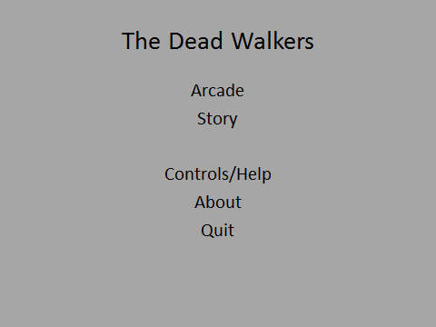

The title screen - Gives the option to explore the controls for help, to exit the game, to see how the game was made, and the choice of two different playing modes.



After selecting story mode, you get the option to load a previously saved game or start a new game along with the option to go back to the main menu.

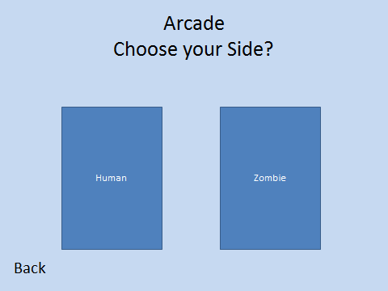

If the user chooses Arcade mode, he/she gets the option to be on the zombie side or the human side along with the option to go back to the main menu.

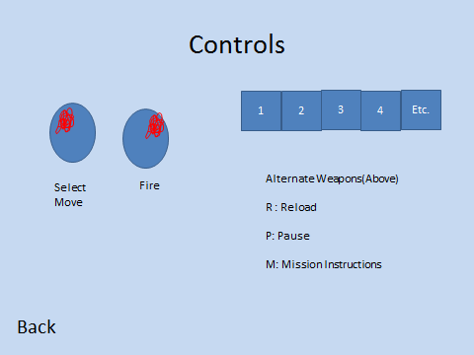

If the user selects controls from the main menu this screen pops up.  Still have the option to go back to the main menu. It tells the user all the types of inputs the user can do to control his character and play the game.

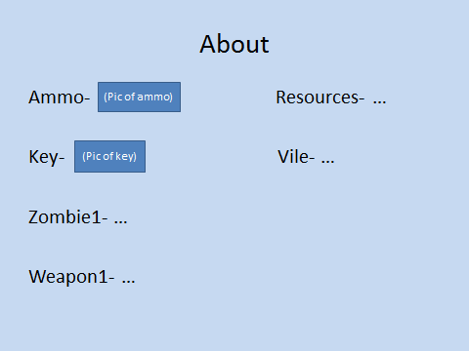

The about section will have a layout like this so that players can see what each of the items and enemies in the game are along with a description of how the game was developed.

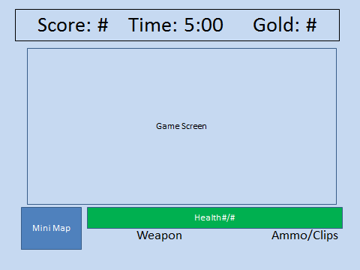

This is the game screen for actual gameplay in story mode and arcade mode.  The mini-map, health meter and weapons and ammo are all on the bottom of the screen.  The score time and money is kept track of at the top of the screen.

**Maps**

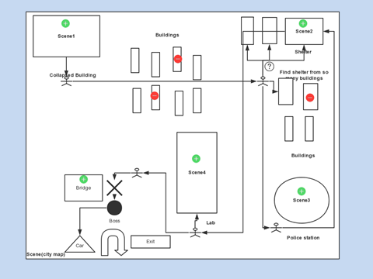

This map is the basic layout in order of the missions and the paths that the user will have to take to go to each of these missions, along with some obstacles along the way.

**Collapsed Building**

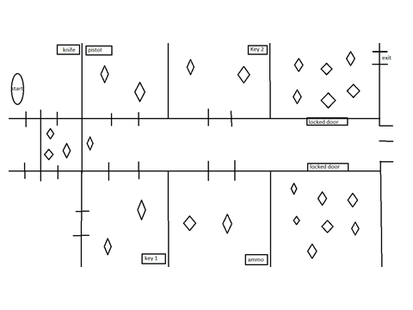

This is where the adventure starts and enemies and weapons are introduced. The user finds a knife and pistol in this building. He must find the correct key to open the door the right door. Both doors lead to zombies but only one door leads to exiting the building. The diamonds in the picture are a sample of where the zombies may be located.This is where the adventure starts and enemies and weapons are introduced.

**Shelter**

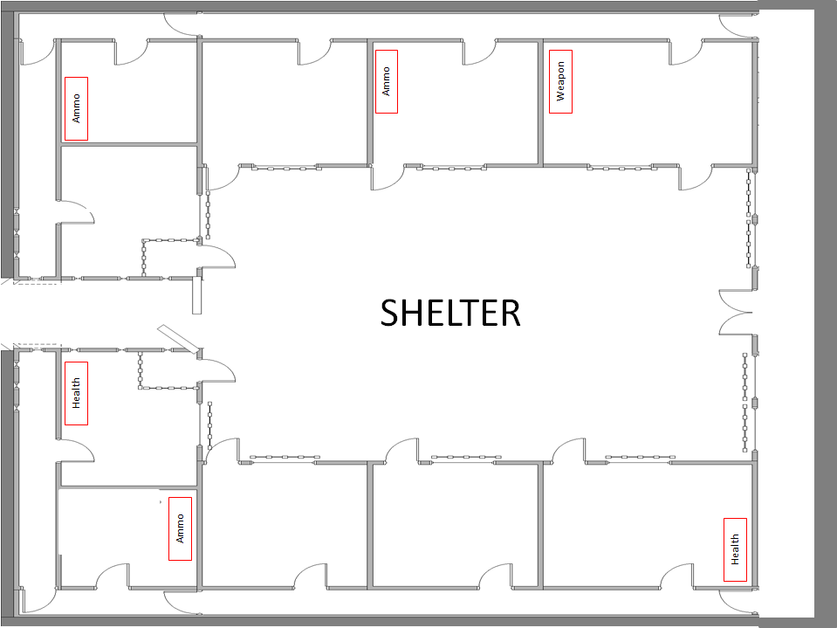

The shelter is for the third mission where the human has to clear out the shelter to make it safe to stay. The shelter was a zombie proof safe house but it has now been littered with zombies. There are many rooms and doors in which zombies can be lurking.

**Military Facility**

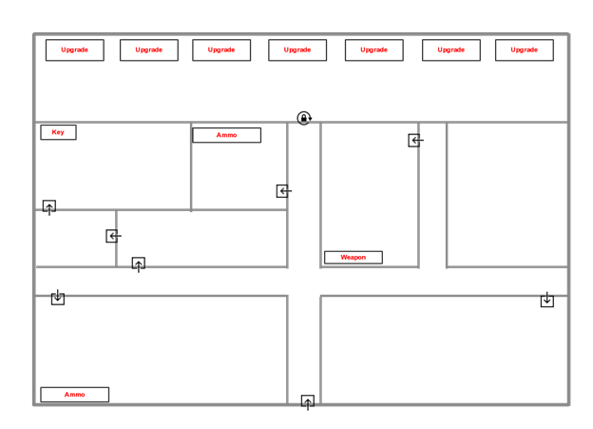

The military facility is for the fourth mission where Cary finds better weapons and new upgrades. The user must find a key to access the weapons inside the facility.

**LAB**

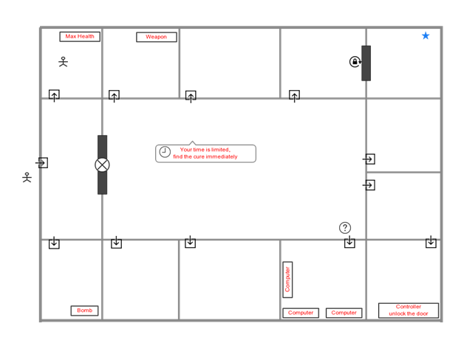

The lab is where the cure is located and Cary must get as part of the sixth mission. The user must use a bomb to break into the main part of the facility. The user must find and access the computer system to find a hint on where the cure is located. Then the user must go to the control room to unlock the room with the cure.