 NOVIKONTAS KALININGRAD Ltd.

## *CREWING AGENCY*

29 December 2023

#### CREW LIST

**Ship owner:**

**Vikingbank BV**

**Voorschoterweg 31-2235 SE-Valkenburg**

**PO Box 504-2220, AM-Katwijk**

**The Netherlands**

**Tel: +31717890000**

**Fax: +31717890001**

|  |  |
| --- | --- |
| **SHIP’S NAME:** | **Alina** |
| **TYPE:** | Fishing Trawler |
| **FLAG:** | Poland |
| **PORT OF CALL:** | Amsterdam |
| **DATE OF CALL:** | 04.01.2024 |

|  |  |  |  |  |  |  |  |  |  |
| --- | --- | --- | --- | --- | --- | --- | --- | --- | --- |
|  | **born** | | | **Passport(P) &Seaman’s(S)** | | | |  |  |
| **Name** | **Date /nat** | | **place** | **Nr.** | | **from** | **until** | **Address** | **Function** |
| Mayorov Alexander | 27.05.1982  Russian | USSR | | P: 763453867  S: RUS0443782 | P: 22.09.2020 S: 24.04.2019 | | P: 22.09.2030 S: 23.04.2024 | Kaliningrad, Russia | AB |

Novikontas Kaliningrad Ltd

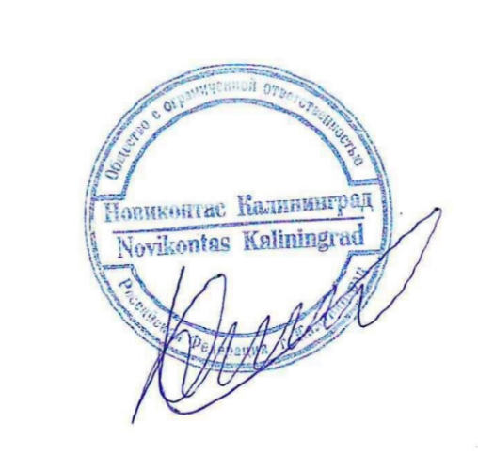Crew Manager

Khakimova Julia

Mob +79062331395