# Department of Computer Science National Tsing Hua University EECS403000 Computer Architecture Spring 2024, Homework 2

Due date: **April 11, 2024 23:59 pm**

To inspect the Assembly code of the program, follow the steps below.

1. Build  the program with the Debug configuration.
2. Start debugging  the desired program as an Application Program.
3. Navigate to the Disassembly view to examine the generated assembly code.
4. To insert breakpoints, double-click on the Assembly code or the corresponding C code lines on the left.
5. 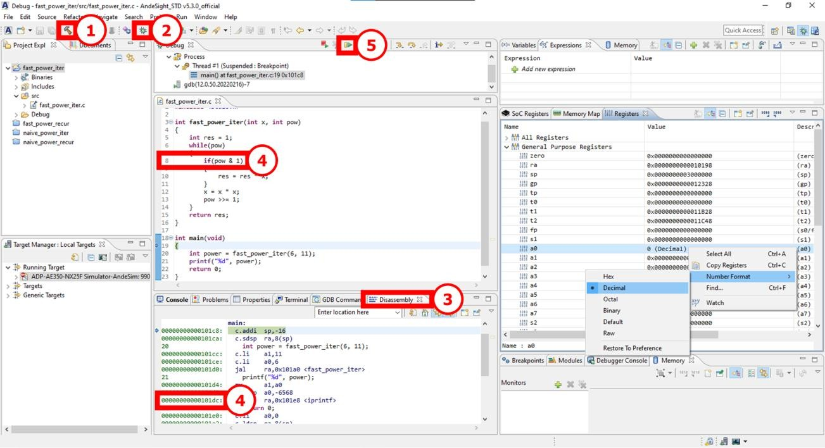Press Resume  in the debug window to proceed to the next breakpoint.

To observe register value changes, Start Debugging  as an Application Program and follow the steps:

1. Access the Registers tab and expand the General Purpose Registers section to view their current values.
2. Customize the Number format by right-clicking a register and choosing the desired format.
3. Add a register to the Expressions tab for convenient monitoring by right-clicking it and selecting Watch.

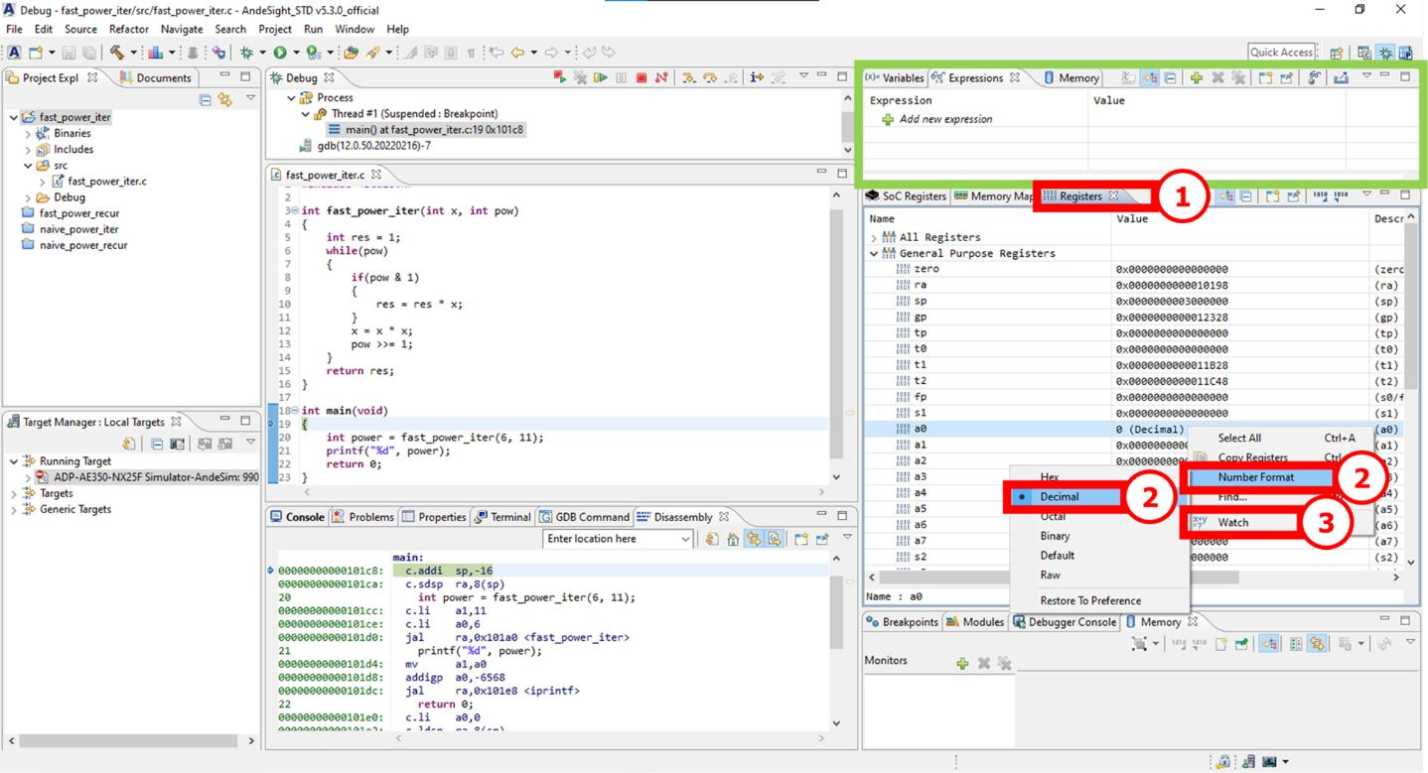

1. (35 points)

This question explores the fast power algorithm implemented in two ways (iterative and recursive) using AndeSight™ with the setup similar to Homework 1. We will analyze the source code for **fast_power_iter.c** and **fast_power_recur.c**. The default optimization level is -Og by default unless stated otherwise. **For each question, attach screenshots of AndeSight™ to support your answer. No points will be given if the screenshot is missing**. **Hint**: Use the “Debug” button  in the toolbar and carefully insert breakpoints in between instructions. Press the “Resume” button  in the debug window to move to the next breakpoint. You can also refer to the RISC-V Specs document if you encounter some difficulty understanding the Assembly code generated by AndeSight™.

* 1. (5 points) ***RISC-V Calling Convention***

Compilers typically translate functions into subroutine and perform function calls using a jump instruction following a calling convention. While function calls can be inefficient, they are essential in programming. Locate the starting and ending memory addresses of the code memory allocated to the **fast_power_recur** and **fast_power_iter** subroutines by examining the Assembly code. Identify how these subroutines are called within main and write them down in the Reference field in the table.

|  |  |  |  |
| --- | --- | --- | --- |
| Subroutine | Starting memory address | Ending memory address | Reference |
| **fast_power_recur** | **00000000000104a8** | **00000000000104e0** | **jal ra,0x104a8 <fast_power_recur>** |
| **fast_power_iter** | **00000000000104a8** | **00000000000104c4** | **jal ra,0x104a8 <fast_power_iter>** |

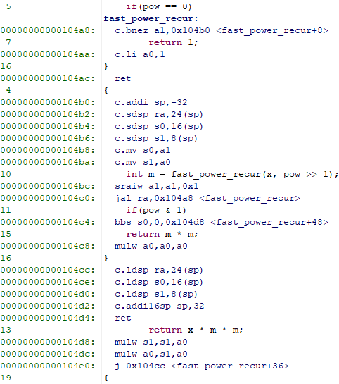

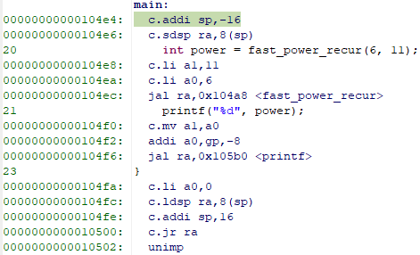

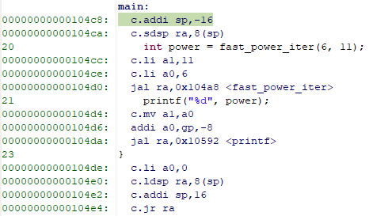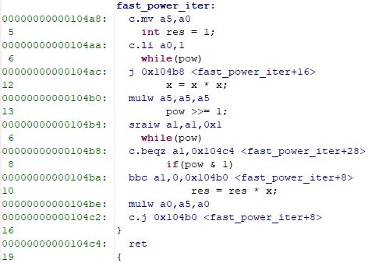

* 1. (10 points) ***RISC-V Calling Convention***

The RISC-V calling convention requires the callee to preserve the values of specific registers across function calls. Examine the Assembly code for **fast_power_recur** function. Find and record the instructions (and the memory locations) that save these registers. Extend the table below to show how these instructions affect the stack. Include the saved register names and corresponding stack offsets. Order the table by the increasing order of stack offset.

|  |  |  |  |
| --- | --- | --- | --- |
| Code memory address | Instruction | Saved register | Stack offset |
| **00000000000104b6** | **c.sdsp s1,8(sp)** | **s1** | **8** |
| **00000000000104b4** | **c.sdsp s0,16(sp)** | **s0** | **16** |
| **00000000000104b2** | **c.sdsp ra,24(sp)** | **ra** | **24** |

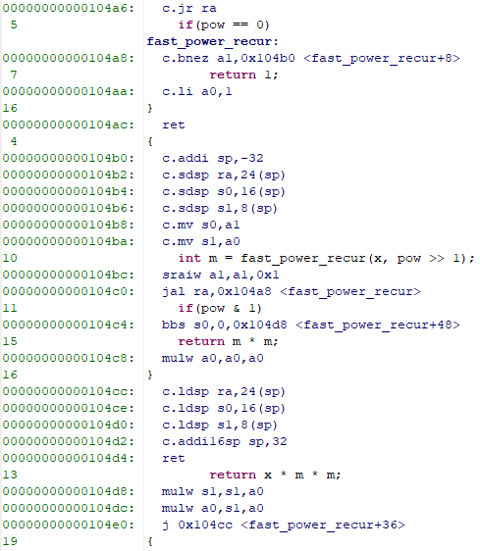

* 1. (10 points) ***Effects of the compiler on RISC-V Assembly Code***

To make common cases fast, compilers can allocate application program variable to processor registers, which are much faster than memory. Compile both **fast_power_iter** and **fast_power_recur** functions with -O0 optimization flag and answer the following questions:

* + 1. Just before jumping to the corresponding subroutine from **main**, which registers hold the parameters **x** and **pow**, and what values do they contain?
    2. Immediately after returning from the subroutine (i.e. just before the next instruction after the jump), which register stores the return value, and what is its value?

|  |  |  |  |  |  |  |
| --- | --- | --- | --- | --- | --- | --- |
| Function | Parameter **x** | | Parameter **pow** | | Return value | |
| Register | Value | Register | Value | Register | Value |
| **fast_power_iter** | **a0** | **6** | **a1** | **11** | **a0** | **362797056** |
| **fast_power_recur** | **a0** | **6** | **a1** | **11** | **a0** | **362797056** |

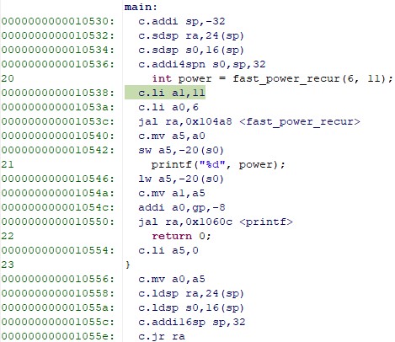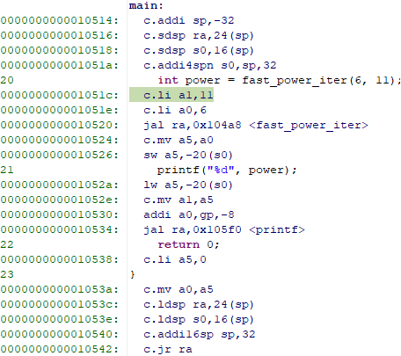

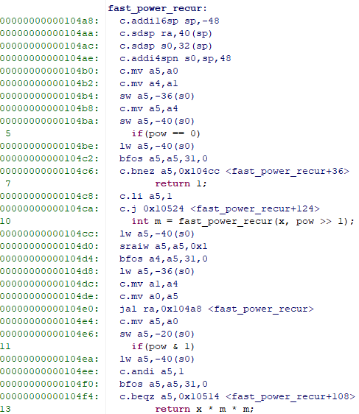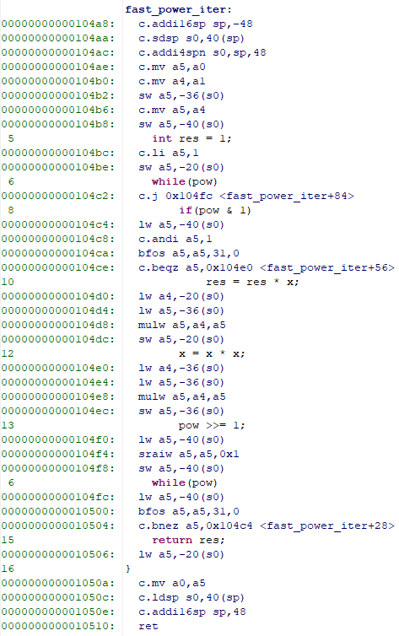

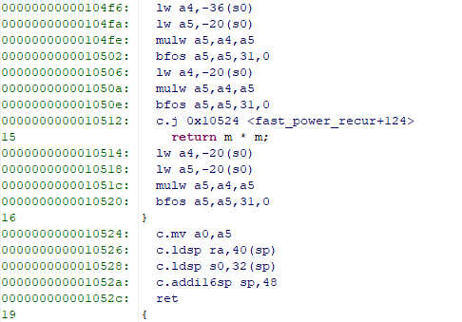

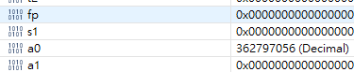

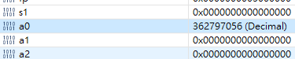

* 1. (10 points) ***Effects of great ideas on performance***

Pipeline execution and parallelization are two key techniques for enhancing performance. Consider **fast_power_iter.c** and disregard overheads from parallelization and data transmission. Here’s an approach for pipelined execution and parallelization using three cores and a two-stage pipeline. Assume that each core fetches and executes the instructions sequentially.

**Core A (Pipeline Stage 1)**: Calculates **x ← x * x**, and passes the new **x** to Core C.

**Core B (Pipeline Stage 1)**: Calculates **pow ← pow >> 1**, and passes the new **pow** to Core C.

**Core C (Pipeline Stage 2)**: Checks if pow is zero. If true, execute a jump and there is nothing left to do. Otherwise, it calculates **res ← res * x** if **pow** is odd, where **res** and **pow** are results from Core A and Core B in the previous cycle.

Time axis →

|  |  |  |  |  |  |  |  |
| --- | --- | --- | --- | --- | --- | --- | --- |
| Core A & B | Core C |  |  |  |  |  |  |
|  | Core A & B | Core C |  |  |  |  |  |
|  |  | Core A & B | Core C |  |  |  |  |
|  |  |  | Core A & B | Core C |  |  |  |
|  |  |  |  | Core A & B | Core C |  |  |
|  |  |  |  |  | Core A & B | Core C |  |
|  |  |  |  |  |  | Core A & B | … |
|  |  |  |  |  |  |  | … |

In other words, Cores A and B operate in parallel, while Core C processes their results in a pipeline fashion. Analyze the code of **fast_power_iter** function in **fast_power_iter.c**, identify the instructions for each core, and record their cycle counts. Explain whether achieving a speedup of 2 for the pipelined parallelized function is possible.

|  |  |  |  |  |
| --- | --- | --- | --- | --- |
| **Core C: 6** |  |  |  |  |
| **Core A: 4**  **Core B: 1** | **Core C: 3** |  |  |  |
|  | **Core A: 1**  **Core B: 1** | **Core C: 2** |  |  |
|  |  | **Core A: 4**  **Core B: 1** | **Core C: 3** |  |
|  |  |  | **Core A: 1**  **Core B: 1** | **Core C: 1** |

**No pipline:**

**total cycle counts = 6+4+1+3+1+1+2+4+1+3+1+1+1 = 29**

**With pipeline:**

**total cycle counts = 6+3+4+3+1 = 17**

**17+n > 29/2+n (n 是無法被優化部分的cycle counts)**

**優化後的cycle count > 優化前cycle counts的一半**

**-> It is impossible to achieve a speedup of 2.**

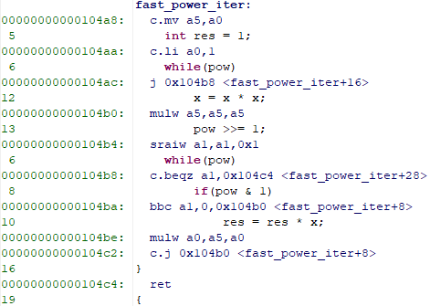

Core A

Core B

Core C

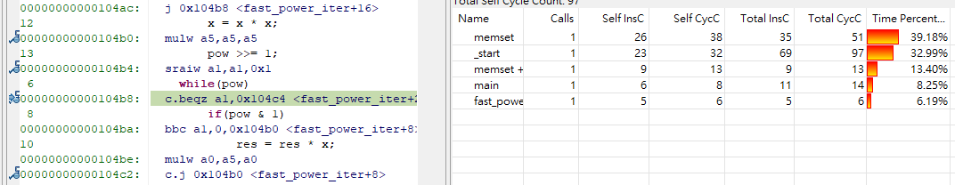

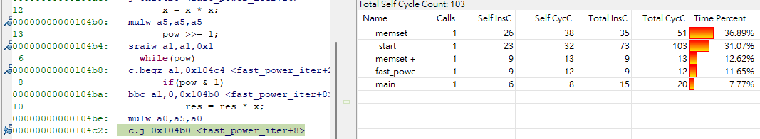

Core C: 6 cycle counts

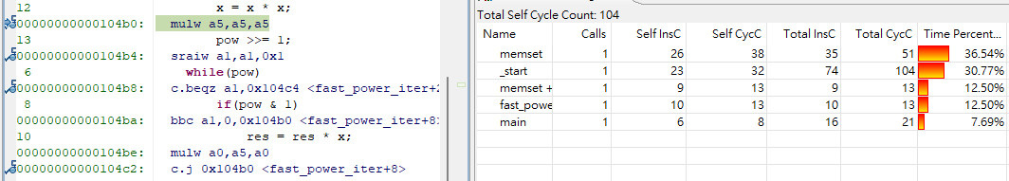

Core A: 4 cycle counts

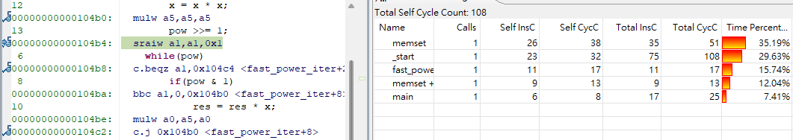

Core B: 1 cycle counts

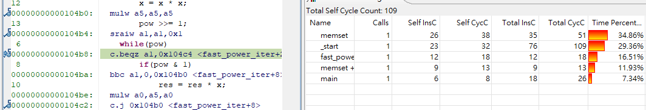

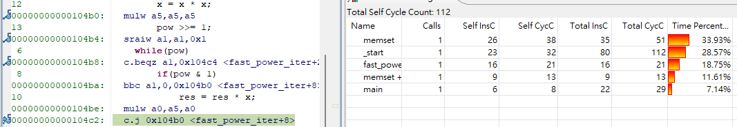

Core C: 3 cycle counts

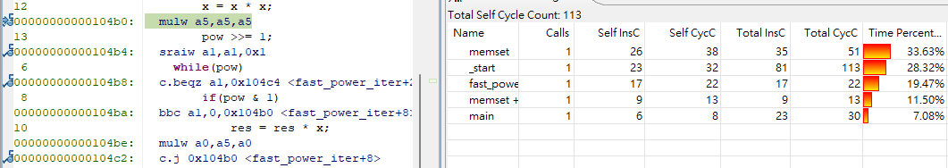

Core A: 1 cycle counts

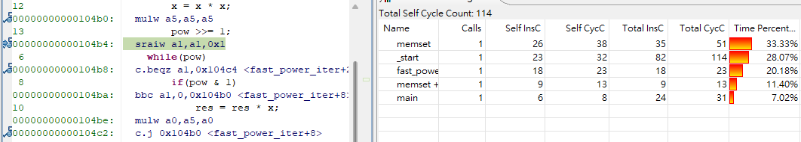

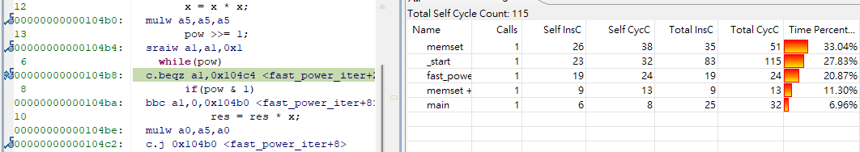

Core B: 1 cycle counts

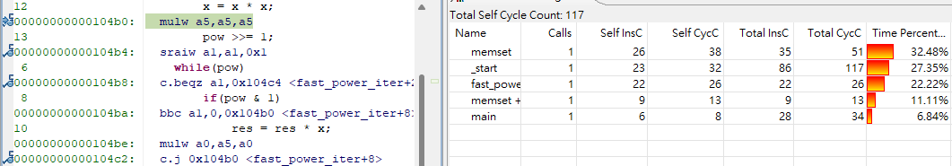

Core C: 2 cycle counts

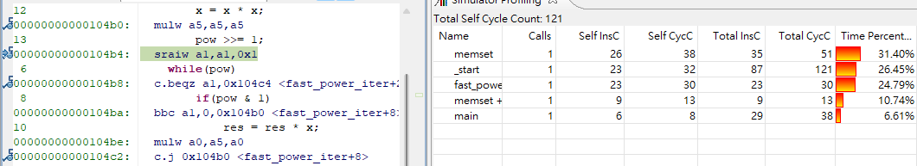

Core A: 4 cycle counts

Core B: 1 cycle counts

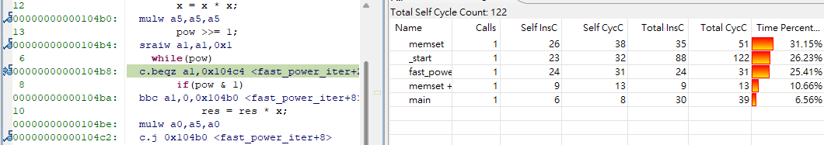

Core C: 3 cycle counts

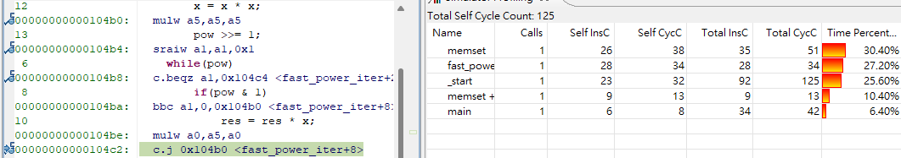

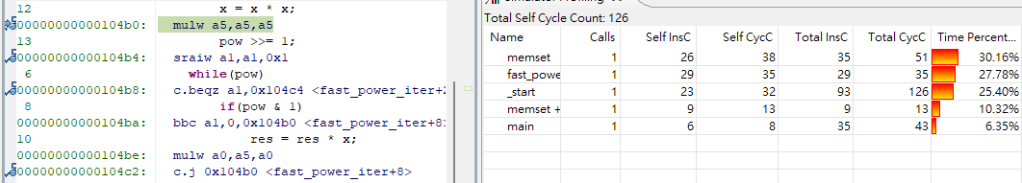

Core A: 1 cycle counts

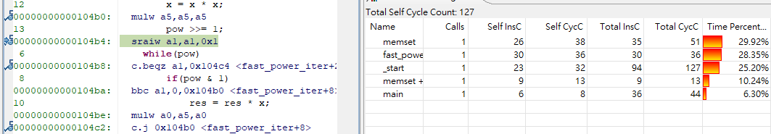

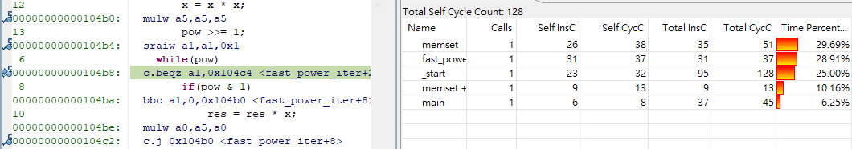

Core B: 1 cycle counts

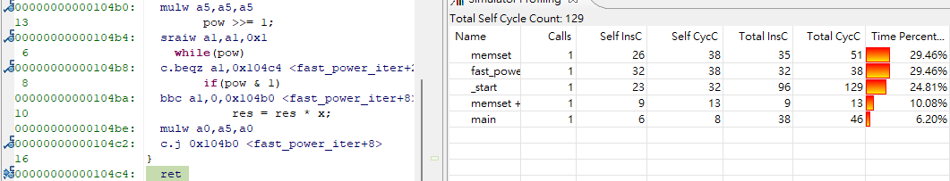

Core C: 1 cycle counts

1. (30 points) ***RISC-V Assembly Code***

Consider a little-endian 64-bit RISC-V sequential processor with the following contents in the register set, data memory, and code memory. Assume that the current **PC** has the value **0x0000 0000 0001 00B0**.

|  |  |  |  |  |  |
| --- | --- | --- | --- | --- | --- |
| Reg. | Initial value | Reg. | Initial value | Memory address | Initial value |
| **x0** | **0x0000 0000 0000 0000** | **x16** | **0x0000 0000 0000 0004** | **0x0000 003E FF20 13C0** | **0x0000 0055** |
| **x1** | **0x0000 0000 0001 00B0** | **x17** | **0x0000 0000 0000 0020** | **0x0000 003E FF20 13C4** | **0x0000 0000** |
| **x2** | **0x0000 003E FF20 13E0** | **x18** | **0x0000 0000 0000 0003** | **0x0000 003E FF20 13C8** | **0x0A0C 0345** |
| **x3** | **0x0000 0000 0001 0000** | **x19** | **0x0000 0000 0000 0040** | **0x0000 003E FF20 13CC** | **0x0450 0000** |
| **x4** | **0x0000 003E FF20 13C0** | **x20** | **0x0000 0000 0000 0000** | **0x0000 003E FF20 13D0** | **0x000D 0000** |
| **x5** | **0x0000 0000 0000 0008** | **x21** | **0x0000 0000 0000 0000** | **0x0000 003E FF20 13D4** | **0x0A00 0010** |
| **x6** | **0x0000 0000 0000 0004** | **x22** | **0x1111 FFFF 0000 5555** | **0x0000 003E FF20 13D8** | **0x0020 0000** |
| **x7** | **0x0000 0000 0000 003A** | **x23** | **0x0000 0000 0000 0000** | **0x0000 003E FF20 13DC** | **0x4000 0000** |
| **x8** | **0x0000 003E FF20 1400** | **x24** | **0x0000 0000 0000 0000** | **0x0000 003E FF20 13E0** | **0x8000 A000** |
| **x9** | **0x0000 0000 0000 0007** | **x25** | **0x0000 0000 0000 0034** | **0x0000 003E FF20 13E4** | **0xA800 3F10** |
| **x10** | **0x0000 0000 0000 0050** | **x26** | **0x0000 003E FF20 13F0** | **0x0000 003E FF20 13E8** | **0x0091 0000** |
| **x11** | **0x0000 003E FF20 1530** | **x27** | **0x0000 003E FF20 13FC** | **0x0000 003E FF20 13EC** | **0x0000 0000** |
| **x12** | **0x0000 0000 0000 1AF3** | **x28** | **0x0000 FFFF 0000 FFFF** | **0x0000 003E FF20 13F0** | **0x00C1 A000** |
| **x13** | **0x0000 0000 0000 0000** | **x29** | **0x0000 0000 0000 000A** | **0x0000 003E FF20 13F4** | **0x0130 00F0** |
| **x14** | **0x0000 F94E 17CC B154** | **x30** | **0x0000 0000 00F0 0000** | **0x0000 003E FF20 13F8** | **0x0041 0000** |
| **x15** | **0xCCCC 0000 0000 0000** | **x31** | **0x0000 00F0 0000 0000** | **0x0000 003E FF20 13FC** | **0x0A0B 0130** |

**Note**: for convenience, there is a unique instruction ID for each instruction in the code memory.

|  |  |  |  |  |  |  |
| --- | --- | --- | --- | --- | --- | --- |
| Instruction ID | Label | Code address | Instruction | | | |
| 1 |  | **0x0000 0000 0001 00B0** | **sub** | **x7,** | **x5,** | **x6** |
| 2 |  | **0x0000 0000 0001 00B4** | **sd** | **x2,** | **16(x2)** | |
| 3 |  | **0x0000 0000 0001 00B8** | **jal** | **x1,** | **BEGIN** |  |
| 4 |  | **0x0000 0000 0001 00BC** | **lw** | **x6,** | **4(x2)** |  |
| 5 |  | **0x0000 0000 0001 00C0** | **0x0040 8067** | | | |
| 6 | **BEGIN:** | **0x0000 0000 0001 00C4** | **0xFF84 3283** | | | |
| 7 |  | **0x0000 0000 0001 00C8** | **and** | **x5,** | **x30,** | **x5** |
| 8 |  | **0x0000 0000 0001 00CC** | **0x4142 D293** | | | |
| 9 |  | **0x0000 0000 0001 00D0** | **add** | **x0,** | **x5,** | **x7** |
| 10 |  | **0x0000 0000 0001 00D4** | **add** | **x28,** | **x0,** | **x2** |
| 11 |  | **0x0000 0000 0001 00D8** | **lb** | **x7,** | **10(x28)** | |
| 12 |  | **0x0000 0000 0001 00DC** | **bge** | **x7,** | **x29,** | **END** |
| 13 |  | **0x0000 0000 0001 00E0** | **jalr** | **x1,** | **0(x1)** |  |
| 14 | **END:** | **0x0000 0000 0001 00E4** | **addi** | **x7,** | **x7,** | **-16** |
| 15 |  | **0x0000 0000 0001 00E8** | **xor** | **x7,** | **x6,** | **x7** |
| 16 |  | **0x0000 0000 0001 00EC** | **srai** | **x7,** | **x7,** | **16** |
| 17 |  | **0x0000 0000 0001 00F0** | **addi** | **x31,** | **x6,** | **1000** |
| 18 |  | **0x0000 0000 0001 00F4** | **srai** | **x31,** | **x31,** | **16** |
| 19 |  | **0x0000 0000 0001 00F8** | **sb** | **x5,** | **-8(x8)** | |
| 20 |  | **0x0000 0000 0001 00FC** | **sd** | **x31,** | **-24(x8)** | |

1. (5 points) Decode instructions with instruction IDs 5, 6, and 8. Then, briefly explain their functionalities.

|  |  |  |
| --- | --- | --- |
| Instruction ID | Hexadecimal  Encoded instruction | Decoded instruction and brief explanation |
| 5 | **0x0040 8067** | **jalr x0,4(x1)**  **跳回 x1+4 那個 address 存的指令**  **然後將下一行的 address 放進 x0 (但 x0 永遠為 0)** |
| 6 | **0xFF84 3283** | **ld x5,-8(x8)**  **將 x8-8 所存的 double word load 進 x5** |
| 8 | **0x4142 D293** | **srai x5,x5,20**  **將 x5 做算術右移 20 位** |

1. (15 points) Trace the execution flow of the assembly code. Extend the table below. For each executed instruction, record its ID, any updated registers and/or memory cells, and their new values (if any) in hexadecimal representation. Annotate updated memory values per 32-bit word. The first three instructions have been completed for you.

|  |  |  |
| --- | --- | --- |
| Instruction ID | Updated register | Updated memory |
| 1 | **x7 <- x5–x6 = 0x0000 0000 0000 0004** |  |
| 2 |  | **MEM[0x0000 003E FF20 13F0] <- 0xFF20 13E0**  **MEM[0x0000 003E FF20 13F4] <- 0x0000 003E** |
| 3 | **x1 <- PC+4 = 0x0000 0000 0001 00BC** |  |
| 6 | **x5 <- -8(x8) = 0x0A0B 0130 0041 0000** |  |
| 7 | **x5 <- x5&x30 = 0x0000 0000 0040 0000** |  |
| 8 | **x5 <- x5>>20 = 0x0000 0000 0000 0004** |  |
| 9 |  |  |
| 10 | **x28 <- x0+x2 = 0x0000 003E FF20 13E0** |  |
| 11 | **x7 <- 10(x28) 0xFFFF FFFF FFFF FF91** |  |
| 12 |  |  |
| 13 | **x1 <- PC+4 = 0x0000 0000 0001 00E4** |  |
| 4 | **x6 <- 4(x2) = 0xFFFF FFFF A800 3F10** |  |
| 5 |  |  |
| 14 | **x7 <- x7-16 = 0xffff ffff ffff ff81** |  |
| 15 | **x7 <- x6^x7 = 0x0000 0000 57FF C081** |  |
| 16 | **x7 <- x7>>16 = 0x0000 0000 0000 57FF** |  |
| 17 | **x31 <- x6+1000 = 0xFFFF FFFF A800 42F8** |  |
| 18 | **x31 <- x31>>16 = 0xFFFF FFFF FFFF A800** |  |
| 19 |  | **MEM[0x0000 003E FF20 13F8] <- 0x0041 0004** |
| 20 |  | **MEM[0x0000 003E FF20 13E8] <- 0xFFFF A800**  **MEM[0x0000 003E FF20 13EC] <- 0xFFFF FFFF** |

1. (5 points) Once you have completed the execution flow table, count the total number of memory accesses (excluding register accesses) performed throughout the code.

**6 + 19 共 25 次**

1. (5 points) Suppose you want to insert an instruction after instruction ID 20. This instruction should use a **blt** to jump to the label **BEGIN** if the value in register **x31** is less than **x7**. Complete the table below with the instruction. Show how you convert the Assembly instruction into its hexadecimal representation. Moreover, will the branch be taken?

|  |  |  |  |
| --- | --- | --- | --- |
| Code address | Assembly instruction | Hexadecimal encoded instruction | Taken? |
| **0x0000 0000 0001 0100** | **blt x31,x7,BEGIN** | **0xFC7FC2E3** | **Yes** |

**opcode: 1100011**

**imm[4:1,11]: 0010 1**

**func3: 100**

**rs1: 11111**

**rs2: 00111**

**imm[12,10:5]: 1 111110**

**(imm: 1 1111 1100 0100)**

**instruction: 1 111110 00111 11111 100 0010 1 1100011**

1. (10 points) ***RISC-V Assembly to C***

Translate the following RISC-V Assembly code to the equivalent C code. Indicate the corresponding C code for each line of Assembly. Assume that variables, **m**, **i**, **j**, and **total** are stored in registers **x3**, **x10**, **x11**, and **x12**, respectively. **MemArray** is an array (consisting of 4-byte integers as its elements) with its base address stored in register **x13**.

**addi x10, x0, 0 addi x28, x13, 0**

**LOOPI:**

**bge x10, x3, ENDI addi x11, x0, 0 addi x12, x0, 0 lw x29, 0(x28) addi x30, x0, 32**

**LOOPJ:**

**bge x11, x30, ENDJ srl x31, x29, x11 andi x31, x31, 1 add x12, x12, x31 addi x11, x11, 1 jal x0, LOOPJ**

**ENDJ:**

**sw x12, 0(x28) addi x10, x10, 1 addi x28, x28, 4 jal x0, LOOPI**

**ENDI:**

|  |  |  |  |
| --- | --- | --- | --- |
| **1**  **2**  **3**  **4**  **5**  **6**  **7**  **8**  **9**  **10**  **11**  **12**  **13**  **14**  **15**  **16**  **17** | **addi x10, x0, 0**  **addi x28, x13, 0**  **LOOPI:**  **bge x10, x3, ENDI**  **addi x11, x0, 0**  **addi x12, x0, 0**  **lw x29, 0(x28)**  **addi x30, x0, 32**  **LOOPJ:**  **bge x11, x30, ENDJ**  **srl x31, x29, x11**  **andi x31, x31, 1**  **add x12, x12, x31**  **addi x11, x11, 1**  **jal x0, LOOPJ**  **ENDJ:**  **sw x12, 0(x28)**  **addi x10, x10, 1**  **addi x28, x28, 4**  **jal x0, LOOPI**  **ENDI:** | **1**  **2**  **3**  **4**  **5**  **6**  **7**  **8**  **9**  **10**  **11**  **12**  **13**  **14**  **15**  **16**  **17** | **i = 0**  **// set x28 point to MemArray[0]**  **while (i < m) {**  **j = 0;**  **total = 0;**  **// load MemArray[i] to x29**  **// set x30 = 32**  **while (j < 32) {**  **unsigned int tmp = MemArray[i];**  **// 因為是 srl 所以要先存成 unsigned, tmp >> j**  **// (tmp >> j) & 1**  **total += (tmp >> j) & 1;**  **j++;**  **}**  **MemArray[i] = total;**  **i++;**  **// 同為上一行的 i++**  **}** |

1. (10 points) ***C to RISC-V Assembly***

For the following C statement, write the corresponding RISC-V Assembly code. Assume that the base addresses of arrays **A** and **B** are in registers **x5** and **x6**, respectively, and the variables **i** and **j** are assigned to registers **x7** and **x11**, respectively.

**j =** **B[A[i*4 + 1]] + B[i]**

* 1. (5 points) Assume that the elements of the arrays **A** and **B** are 4-byte words.

**slli x28,x7,2 # 將 x28 設成 i*4**

**add x29,x28,x6 # 將 x29 指到 B[i]**

**lw x31,0(x29) # 將 B[i] load 進 x31**

**addi x28,x28,1 # 將 x28 設成 (i*4) + 1**

**slli x28,x28,2 # 因為是 4-byte word，所以將 x28 * 4 算出 offset**

**add x28,x28,x5 # 將 x28 指到 A[i*4 + 1]**

**lw x29,0(x28) # 將 A[i*4 + 1] load 進 x29**

**slli x29,x29,2 # 因為是 4-byte word，所以將 x29 * 4 算出 offset**

**add x29,x29,x6 # 將 x29 指到 B[A[i*4 + 1]]**

**lw x30,0(x29) # 將 B[A[i*4 + 1]] load 進 x30**

**add x11,x30,x31 # 將 x11 設成 B[A[i*4 + 1]] + B[i]**

* 1. (5 points) Assume that the elements of the arrays **A** and **B** are 8-byte words.

**slli x28,x7,2 # 將 x28 設成 i*4**

**addi x28,x28,1 # 將 x28 設成 i*4 + 1**

**slli x28,x28,3 # 因為是 8-byte word，所以將 x28 * 8 算出 offset**

**add x28,x28,x5 # 將 x28 指到 A[i*4 + 1]**

**ld x29,0(x28) # 將 A[i*4 + 1] load 進 x29**

**slli x29,x29,3 # 因為是 8-byte word，所以將 x29 * 8 算出 offset**

**slli x28,x7,3 # 因為是 8-byte word，所以將 x7 * 8 算出 offset**

**add x29,x29,x6 # 將 x29 指到 B[A[i*4 + 1]]**

**add x28,x28,x6 # 將 x28 指到 B[i]**

**ld x30,0(x29) # 將 B[A[i*4 + 1]] load 進 x30**

**ld x31,0(x28) # 將 B[i] load 進 x31**

**add x11,x30,x31 # 將 x11 設成 B[A[i*4 + 1]] + B[i]**

1. (15 points) ***RISC-V Calling Convention***

Implement the following C code in RISC-V Assembly. Note the RISC-V Spec: “In the standard RISC-V calling convention, the stack grows downward and the stack pointer is always kept 16-byte aligned.” Moreover, write down comments to describe the Assembly code clearly.

**long long int Func(int n) { if (n == 0) {**

**return 0;**

**}**

**if ((n & 1) != 0) {**

**return n + Func(n >> 1);**

**} else {**

**return Func(n >> 1);**

**}**

**}**

**Func:**

**addi x2,x2,-16 # 將 x2 往下移 16**

**sd x1,8(x2) # 把 x1 的值存進 8(x2)**

**sd x10,0(x2) # 把 n 的值存進 0(x2)**

**bne x10,x0,Odd # 若 n != 0 則跳至 Odd**

**addi x10,x0,0 # 將 x10 設成 0**

**addi x2,x2,16 # 將 x2 往上移 16**

**jalr x0,0(x1) # return 回去上一層 function**

**Odd:**

**andi x28,x10,1 # x28 <- n & 1**

**beq x28,x0,Even # 若 (n & 1) == 0 則跳到 Even**

**srai x10,x10,1 # x10 <- n >> 1**

**jal x1,Func # 呼叫 Func(n >> 1)**

**ld x29,0(x2) # 將 0(x2) 的值 load 到 x29 (原本這層 n 的值)**

**ld x1,8(x2) # 將 8(x2) 的值 load 回 x1 (以 return 回正確的地方)**

**add x10,x10,x29 # 將 return value 設成 n + Func(n >> 1)**

**addi x2,x2,16 # 將 x2 往上移 16**

**jalr X0,0(x1) # return 回去上一層 function**

**Even:**

**srai x10,x10,1 # x10 <- n >> 1**

**jal x1,Func # 呼叫 Func(n >> 1)**

**ld x1,8(x2) # 將 8(x2) 的值 load 回 x1 (以 return 回正確的地方)**

**addi x2,x2,16 # 將 x2 往上移 16**

**jalr x0,0(x1) # return 回去上一層 function**