1.

a.



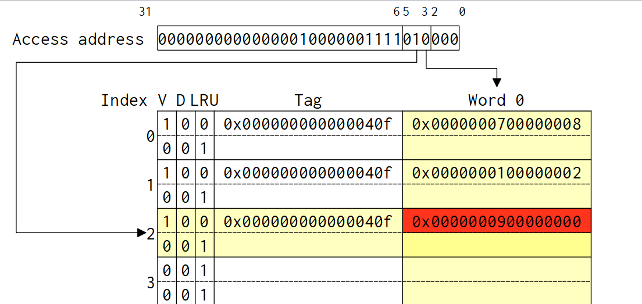

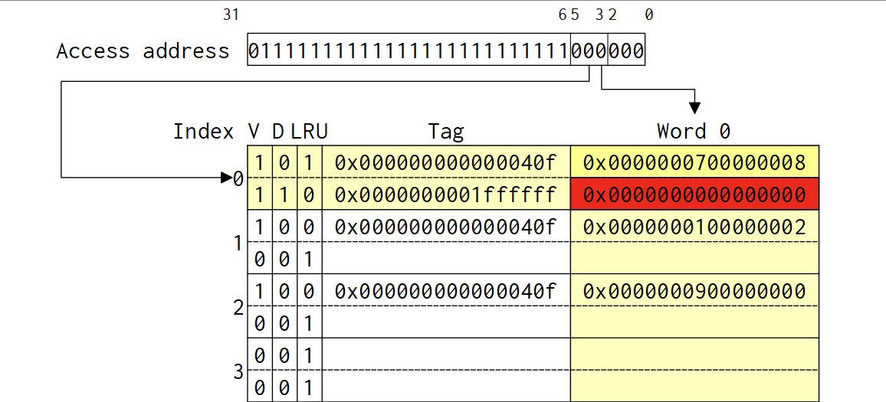

b.



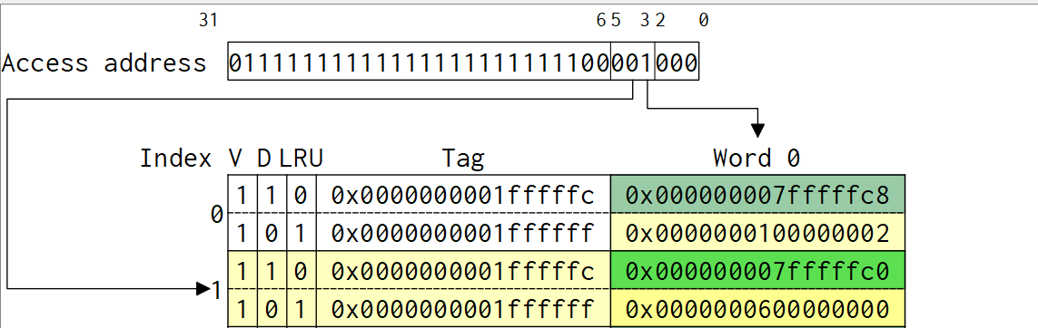

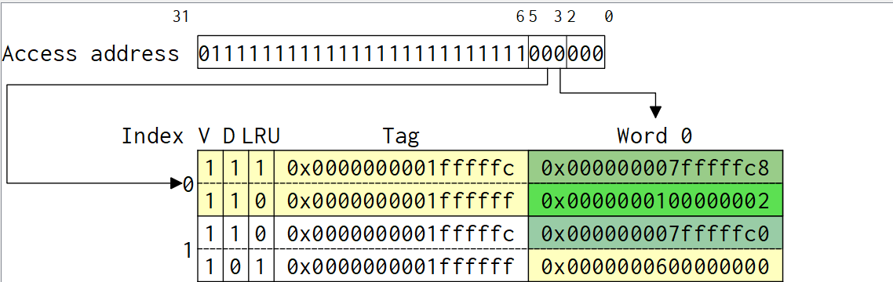

c.



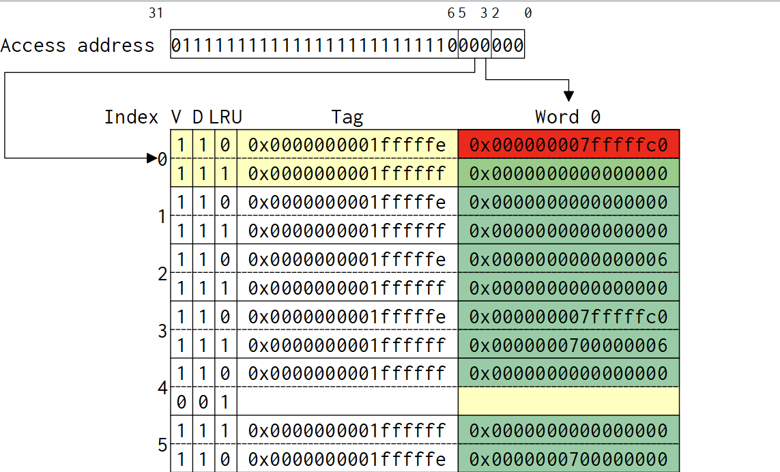

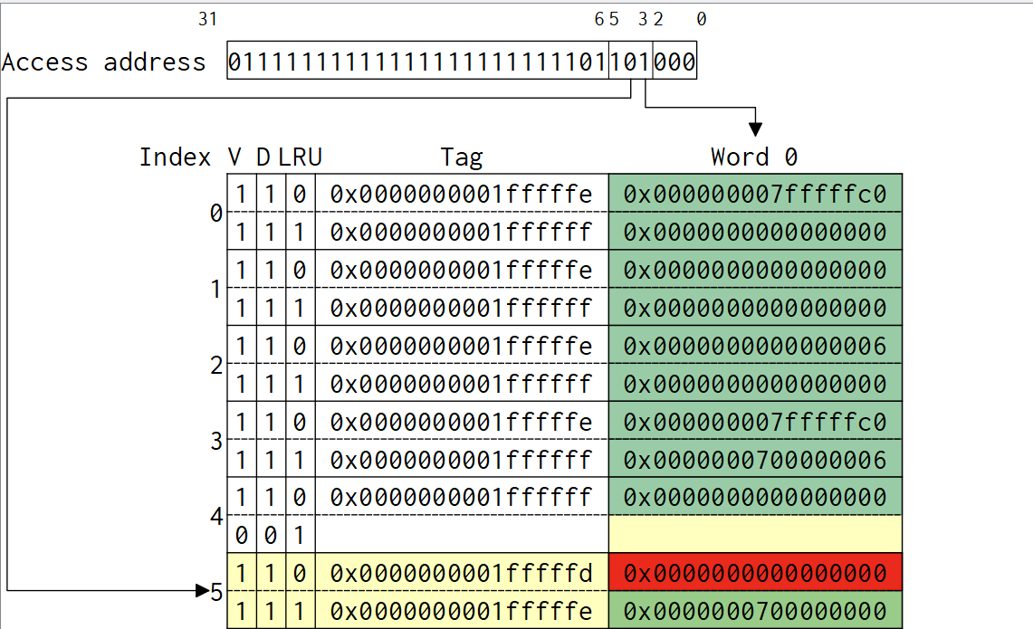

d.

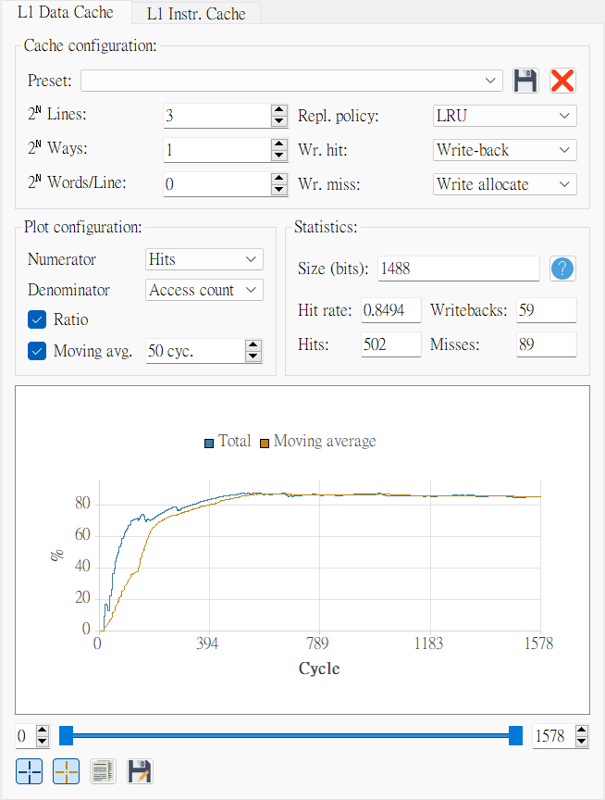

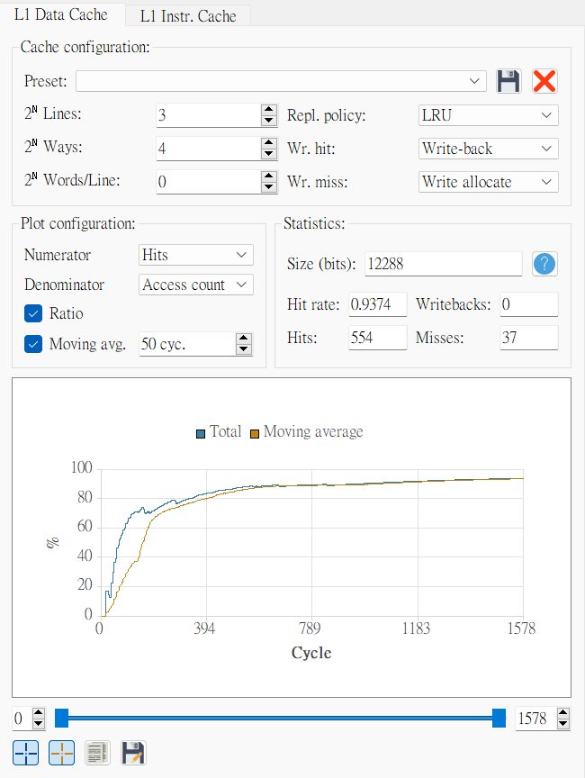

1. (12 points) Consider a 10-bit data, 𝐷 = {𝑑1, 𝑑2, 𝑑3, 𝑑4, 𝑑5, 𝑑6, 𝑑7, 𝑑8, 𝑑9, 𝑑10}, to be protected by using a Hamming single error correcting code with an additional parity bit, 𝑝11, so that double errors can be detected.
2. (2 points) Let the encoded codeword 𝐶 = {𝑝1, 𝑝2, 𝑑1, 𝑝4, 𝑑2, 𝑑3, 𝑑4, 𝑝8, 𝑑5, 𝑑6, 𝑑7, 𝑑8, 𝑑9, 𝑑10, 𝑝11}. Show the encoding process of 𝐷 =1001011001 to obtain the encoded codeword 𝐶.

|  |
| --- |
| Set p1 to make bits 1, 3, 5, 7, 9, 11, 13 even parity. |
| 1-1-001-011001- |
| Set p2 to make bits 2, 3, 6, 7, 10, 11, 14 even parity. |
| 111-001-011001- |
| Set p4 to make bits 4, 5, 6, 7, 12, 13, 14 even parity. |
| 1110001-011001- |
| Set p8 to make bits 8, 9, 10, 11, 12, 13, 14 even parity. |
| 11100011011001- |
| Set p11 to make all bits even parity |
| 111000110110010 |

C = 111000110110010

1. (2 points) Assume no error occurs. Show the decoding process of 𝐶 (i.e., locating/correcting the Screenshots Explanation Instruction: Cache states before and after the write miss 3 single error, detecting double errors, or confirming that there is no error; you have to verify if the result is right or wrong) from (a).

|  |
| --- |
| Check bits 1, 3, 5, 7, 9, 11, 13 if they are even parity. |
| Yes => H = h8h4h2h1 = ---0 |
| Check bits 2, 3, 6, 7, 10, 11, 14 if they are even parity. |
| Yes => H = h8h4h2h1 = --00 |
| Check bits 4, 5, 6, 7, 12, 13, 14 if they are even parity. |
| Yes => H = h8h4h2h1 = -000 |
| Check bits 8, 9, 10, 11, 12, 13, 14 if they are even parity. |
| Yes => H = h8h4h2h1 = 0000 |
| Check all the bits if they are even parity. (By XOR) |
| Yes => h11 = 0 |

H is 0 and h11 is 0. Therefore, there is no error.

1. (2 points) From (a), suppose 𝑑5 of 𝐶 is inverted. Show the decoding process.

|  |
| --- |
| Check bits 1, 3, 5, 7, 9, 11, 13 if they are even parity. |
| No => H = h8h4h2h1 = ---1 |
| Check bits 2, 3, 6, 7, 10, 11, 14 if they are even parity. |
| Yes => H = h8h4h2h1 = --01 |
| Check bits 4, 5, 6, 7, 12, 13, 14 if they are even parity. |
| No => H = h8h4h2h1 = -101 |
| Check bits 8, 9, 10, 11, 12, 13, 14 if they are even parity. |
| Yes => H = h8h4h2h1 = 0101 |
| Check all the bits if they are even parity. (By XOR) |
| No => h11 = 1 |

4 + 1 = 5. H is not 0 and h11 is 1. Therefore, there is a correctable single error of bit 5.

1. (2 points) From (a), suppose 𝑝1 and 𝑑8 of 𝐶 are inverted. Show the decoding process.

|  |
| --- |
| 1. Check bits 1, 3, 5, 7, 9, 11, 13 if they are even parity. |
| Yes => H = h8h4h2h1 = ---0 |
| Check bits 2, 3, 6, 7, 10, 11, 14 if they are even parity. |
| Yes => H = h8h4h2h1 = --00 |
| Check bits 4, 5, 6, 7, 12, 13, 14 if they are even parity. |
| Yes => H = h8h4h2h1 = -000 |
| Check bits 8, 9, 10, 11, 12, 13, 14 if they are even parity. |
| Yes => H = h8h4h2h1 = 0000 |
| Check all the bits if they are even parity. (By XOR) |
| Yes => h11 = 0 |

H is 0 and h11 is 0. Therefore, there is no error.

1. 123