一年级英语（第二册）练习2
听力材料及参考答案
听力部分
一、听录音，圈出与录音内容相符的图片。念两遍。
1. --What do you like? --I like water.
2. --Do you like sweets? --Yes, I like sweets.
3. I like ice cream very much.
4. Look at that ball. It’s nice!
5. Give me some soup, please.
6. Drink some cola. It’s sweet.
7. I have a kite. Play with me, Kitty.
8. This is apple juice. I like apple juice.
9. This is my bicycle. It’s super!
10. The milk is nice. It’s white.
Keys: BABAA AABBB
二、听录音，选出与录音内容相符的图片，在相应的括号内打“√”。念两遍。
1. --Do you like biscuits? --Yes!
2. --What do you like, Danny? --I like water.
3. --May I have a cake and juice, please?
--Here you are. --Thank you.
4. --Happy birthday, Tina. --Thank you.
5. --What do you like? --I like flying a kite.
6. Look at the doll. It’s cute.
Keys: ABAAAB
三、听录音，判断图片内容与录音内容是否相符，相符打“√”，不相符打“×”。念两遍。
1. Taste the soup, Kitty.
2. --What do you like, Eddie?
--I like this kite and that bicycle.
3. --Do you like ice cream? --No, I like jelly.
4. --Look, so many toys. --Yes, there are three balls!
5. --Drink the cola, Tom. --Oh, it’s cold! I like it.
Keys: ××√√×
- 听录音，根据录音内容用 1,2,3,4,5给下列图片排序。念两遍。
- --Can I help you?
--May I have a pizza?
2. --Do you like ice cream, Dan?
--Yes! Ice cream is nice.
3. --Eggs, please.
--How many eggs?
--Ten eggs.
4. Look at the apples. They are big and smell good.
5. --Mum, I’m hungry.
--Do you want a hamburger and cola?
--Yes, I like hamburger and cola!
Keys: 4 1 2 5 3
五、小朋友正在参加Eddie的生日会，请听录音，圈出听到的玩具或者食物。念两遍。
Hi, I’m Danny. Welcome to my birthday party.
1. Look, this is my birthday cake. I’m nine years old.
2. There are some biscuits. I like biscuits.
3. My friends and I drink some orange juice. It’s nice.
4. I also eat some noodles.
5. My birthday gift is a ball. It’s a football.
Keys: birthday cake, biscuits, juice, noodles, ball
六、听录音，连线。念两遍。
1. This is Eddie. He has a bicycle.
2. This is Danny. He likes drinking milk.
3. This is Alice. She loves sweets.
4. This is Kitty. She likes playing with her doll.
5. --What can you smell, Tom?
--I can smell the soup. It’s nice.
Keys:

七、小朋友们正在谈论自己喜欢的食物或饮料，听录音，在相应的方框里打“√”。念两遍。
1. --Hello, Alice. What drink do you like?
--I like water. It’s healthy.
2. --Danny, do you like sweets?
--No, I don’t like sweets. I like jelly.
3. --Kitty, do you like orange juice?
--No, I don’t like juice. But I like oranges.
4. --What food do you like, Eddie?
--I like rice. It’s yummy.
Keys:
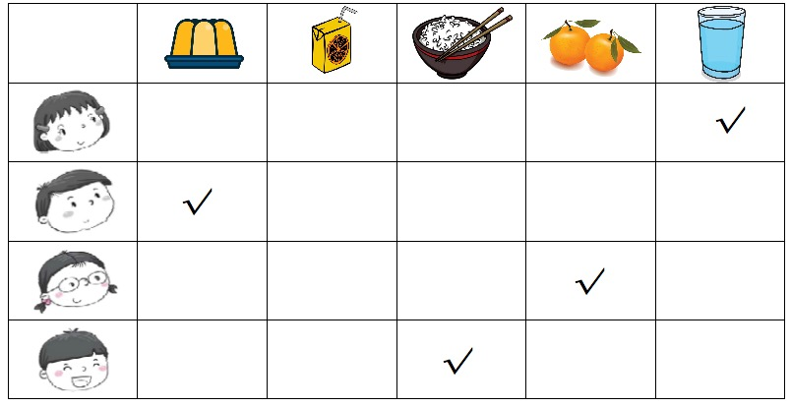
八、听录音，选出你所听到的句子，将其编号写在题前的括号内。念两遍。
1. Happy birthday!
2. I like the cat.
3. Smell the flower.
4. Do you like apples?
5. Here you are.
Keys: BABAB
笔试部分
一、Keys: ball; jelly; sweet; noodles; bicycle
二、Keys: AABBA

