小学英语三年级下册书面作业Unit1-3
Class_________ Name_________
- 请选出不同类的单词。
（ ）① A.ball B.blue C.black
（ ）② A.taste B.smell C.lemon
（ ）③ A.sweet B.sour C.green
（ ）④ A.what B.candy C.how
（ ）⑤ A.short B.long C.white
2.小朋友，请你将下列单词归类，填到相对应的方框中。
lemon; pear; ruler; ball; orange; ice cream; candy; banana
- sweet things
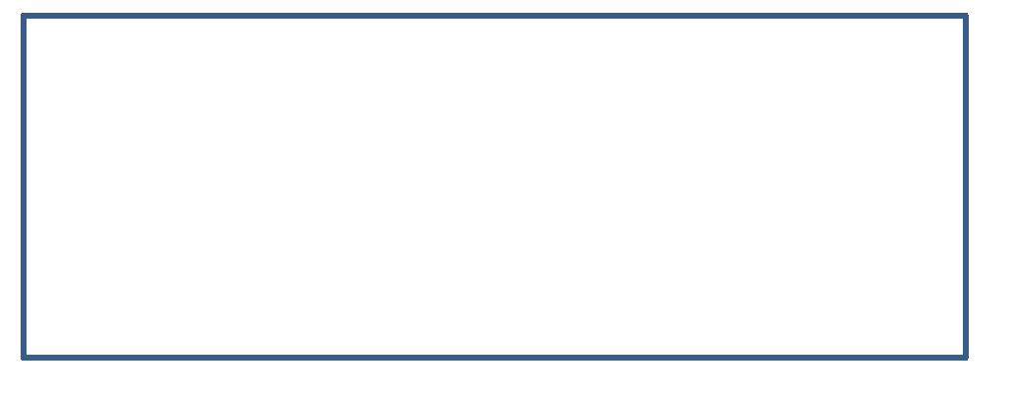
- sour things

- long things

- round things


3.春天到了，我们一起去户外郊游吧，请你根据图片提示，给物品涂上相应的颜色，并口头介绍一下，可以参考句型Look! This is (the sun/…) It’s (yellow/…) They are (flowers/…) They are (pink/blue/…)
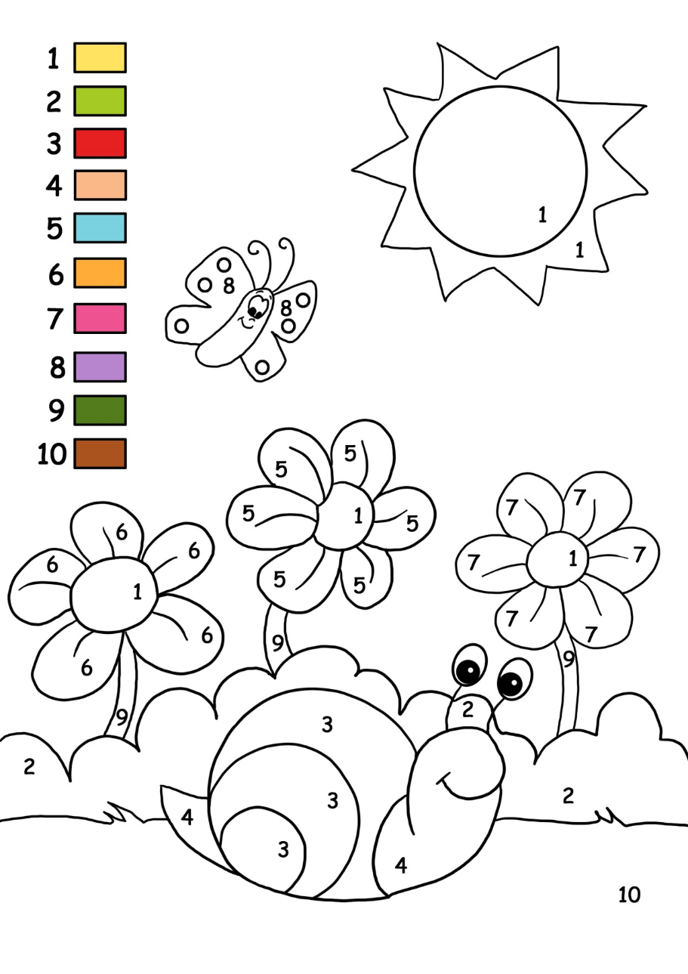
4.连词成句，注意大小写和标点符号。
①matter/ the/ what’s
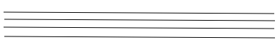
②colour/ is/ ice/ your/ cream/ what


③ can/ i/ bus/ a/ hear

5.请将单词填到合适的横线上。
hard; sweet; soft; sour; lemon

1.Taste this ice cream. It is cold and ___________ .
2.This apple is sweet but a little _________. I like it very much.
3.Taste the __________. It is sour. Do you like it?
4.Look at this desk. Touch it, please. It is ___________ .
5.Touch the bed. It is __________ .
6.将正确的选项填在题前的括号内。
（ ）1.I can see animals _____ the zoo.
A.at B. in C. on
（ ）2.My ________ are big.
- nose B. mouth C. ears
（ ）3. --________ colour is it?
--It's yellow.
A. What's B. What C. How
（ ）4. --What’s the __________ ?
--I can't find my ball.
A. matter B .wrong C. the matter
（ ）5. --________ can you hear?
--I can hear a bus.
A.How B. What C. Who
7.选择合适的答句。
A.I can't find my book.
B. Great！
C. It's a dog.
D. It's blue and white.
E. Yes, it is.
( )1.What colour is it?
( )2.What's the matter?
( )3.What's this?
( )4.Is this your kite?
( )5.Let's mix red and white.

- 选择合适的疑问词填到横线上。

How many; What colour; How; What; Do

1.- _______________ is the apple?
-It's sour and sweet.
2.- _______________monkeys can you see?
-Four.
3. -______________ are they?
-Lemons.
4.-______________is it?
-It’s yellow.
5.-_____________ you like elephants?
-Yes, I do.

9.选择填空。
( )1.I can ________ with my ears.
A. hear B. see C. play
( )2.Gu Dong is___________.
A. come B.to come C. coming
( )3.-__________is it?
-It’s sour.
A. What B. How C. Who
( )4.-Is this your book?
-Yes，it’s __________ book.
A.my B.me C. you
( )5.I can see with my ___________ .
A. ears B. hands C. eyes
10.小朋友，你知道一下交通工具都是在哪里行驶的吗？请将其英文单词填写到对应的方框内。
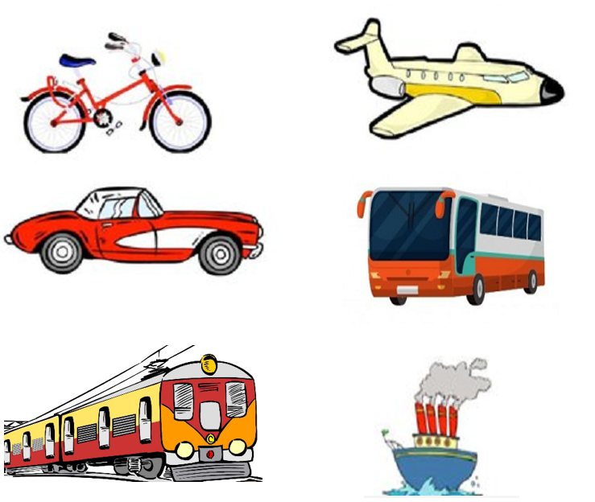
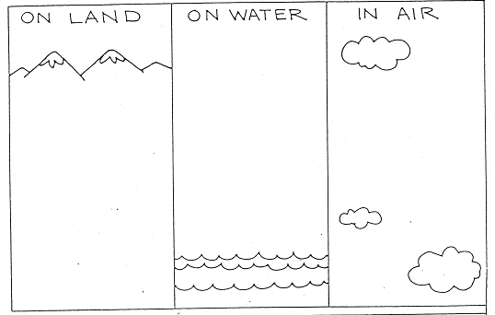
11.观察以下食物，先将思维导图填充完整，再将小短文填充完整,注意标点符号及大小写。
