小学英语三年级下册书面作业Unit3 Sounds
Class_________ Name_________
- 我们身边还有什么交通工具呢，请查一查并写下来，并仔细听一听它们的声音吧。
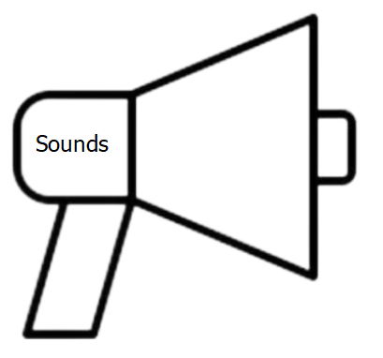
- 读一读，圈出不同类的一项。
①black yellow what white
② hear see plane taste
③ ship cloud plane train
④ listen look taste banana
3.根据句子、对话选择正确的图片，在方框内打“√”。
①Listen! A bus is coming.
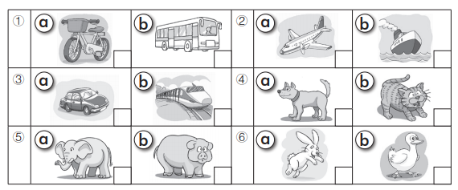
②-- What can you hear?
-- I can hear a ship. It is big.

③ --What can you hear?
--I can hear an elephant.

④ --What can you hear?
--I can hear a train.

4.根据图片完成词汇拼写。

① ②
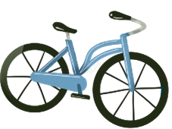
--What can you see？ -- What can you h_ _ _?
--I can see a b_ _ _. -- I can hear a p_ _ _ _.

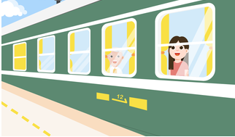

③ ④

Look! It is a big m_ _ _ _ _ _. Look at this picture. I can see a t_ _ _ _.

5.选择合适的选项完成对话。
- I can hear a man.
- How are you?
- What can you hear？
- Yes, it is.
- He is my uncle.

Andy: Hi, Ellen.1. _______
Ellen: Hi, Peter. I’m good.
Andy: Listen! Miao... 2. _______
Ellen: I can hear a cat.
Andy: Yes, it’s a cat. Listen to this, Peep..Peep.
Ellen: Is it a chick?
Andy: 3. _______ Listen! What can you hear?
Ellen: 4. _______ Is he your father?
Andy:No. 5. _______
6.根据实际情况画一画，并写一写上学路上的所见所闻。
