一年级英语（第二册）练习3
听力材料及参考答案
听力部分
一、听录音，圈出与录音内容相符的图片。念两遍。
1. Look at the tree. It’s windy.
2. I like sunny days.
3. It’s summer. I like wearing a T-shirt.
4. --What do you need?
--I need new shorts.
5. It’s cloudy. I like cloudy days.
6. Spring is green. It’s sunny and warm.
7. Summer is red. I go swimming in summer.
8. I can draw. I can draw a blouse.
9. --How’s the weather?
--It’s windy.
10. Rain, rain, go away. Come again another day.
Keys: BAABB ABAAB
二、听录音，选出与录音内容相符的图片，在相应的括号里打“√”。念两遍。
1. --What colour is winter? --It’s white.
2. --What can you do in autumn? --I can fly a kite.
- Look at the sky. It’s cloudy.
4. Look at me. I need a new T-shirt.
5. Winter is coming. I want a new blouse.
6. I like rainy days.
Keys: BBBAAA
三、听录音，判断图片内容与录音内容是否相符，相符的打“√”，不相符的打“×”。 念两遍。
1. I like the sunny day. It’s warm and nice.
2. --How’s the weather?
--It’s sunny today. Let’s go swimming.
3. Look, this is my new blouse. I like it very much.
4. --How’s the weather?
--It’s windy and cool.
5. Summer is hot. I can eat ice cream in summer.
Keys: ×√ ×√ √
- 小朋友们在讨论他们喜欢的季节，请听一听他们在说什么，连一连。念两遍。
The children are talking about the season they like.
1. --Alice, which season do you like?
--I like autumn. It’s cool and windy.
- --Eddie, what do you like?
--I like winter. It’s cold. It’s white.
3. -- Kitty, which season do you like?
--I like spring. It’s warm. It’s green.
4. --Ben, do you like spring?
--No, I like summer. I like eating watermelon in summer.
5. --What about you, Tom?
--Summer is hot. I like summer too.
Keys:

五、听录音，根据录音内容用1、2、3、4给下列图片排序。念两遍。
1. I like sunny days. I can go to the beach and play.
2. --How’s the weather, Tina? --It’s cloudy.
3. It’s windy. It’s so cool!
4. I like rainy days. I can play with my friend.
Keys: 2-4-3-1
六、Peppa在学校和朋友们谈论自己喜欢的天气和季节，听录音，在相应的方框里打“√”。念两遍。
Peppa and her friends are in the school.
1. Suzy: I like summer. I can go to the beach. I like sunny days, too. Look at the sun. It’s red.
2. Danny: I like rainy days. I can play in the rain.
3. Peppa: I like winter very much. In winter, I can make a snowman.
4. Rebecca: I like autumn. It’s windy. It’s cool.
Keys:
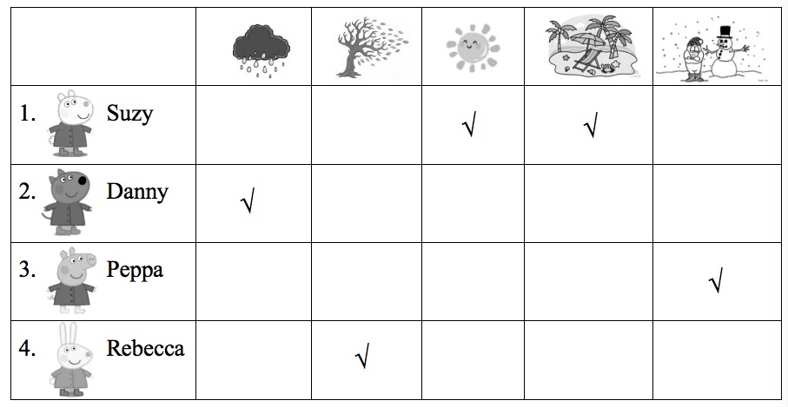
- Danny和家人去商场购物。听一听他们分别买了什么？买了多少？在图片的方框内勾出录音所提到的物品，并在横线上填写相应的数量。念两遍。
Danny and his family go shopping in the supermarket.
1. Mum: What do you need, Danny?
Danny: I need a kite and some balls to play with my friends!
Mum: How many balls?
Danny: Four balls.
2. Danny: What do you need, Mum?
Mum: I need two dresses and three T-shirts. Oh, the pink dress and the red dress look good.
3. Danny: What do you need, Dad?
Dad: I need a bicycle.
Danny: A bicycle only?
Dad: I also need five bottles of milk.
Keys:
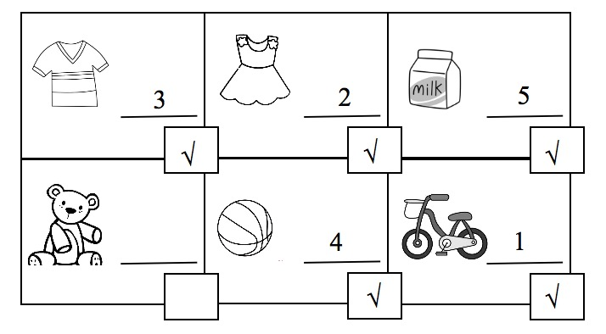
八、听录音，选出你听到的句子，将其编号写在题前的括号内。念两遍。
1. What colour is spring? It’s green.
2. How’s the weather? It’s rainy.
3. I need a blouse.
4. Let’s go to the beach.
5. Thank you, Mum.
Keys: ABAAB
笔试部分
一、Keys: shorts \ cloudy \ winter \ dress \ windy
二、Keys: BABAB

