**Image Processing**

Edited by CAIYu 20 Mars 2016

There are two kinds of image processing the first one is procees the image in the space domain and the other is processing the image in the frequence domain.

1. **Processing the image in the space domain**

**1.1.Smoothing**

This kind of processing is removing the noises with the methods: Mean Filtering ,Gaussian filtering, median filtering. The first two methods are linear filtering and the last one is non-linear filtering

**1.1.1Mean filtering**

We use a mean mask matrix to make sure that the value of each pixel will set to the a new value, the new value equal the mean of this pixel with the pixel around it.

**1.1.2Guassian filtering**

It look like the mean filtering but the new value is not simply the mean of the piexls, we calculate the new value with the pixels with different power.

**1.1.3.Median filtering**

In this case we do not use the mean of the pixel and its surrounding pixels, we use the median of those pixels.

In fact, we can see that the principle idea of the smoothing is that we make each pixel getting similar with its surrounding pixels so that if the pixel is a noise(the value of this pixel can be regarded as a mutation) we will make it not so abrupt.

Actually in the first two cases, imagine that your face is stained by the cream (it likes that there are guassian noises on your face) and we smear the cream make it distribute on the face evenly so that the noises seem to disappear. These two methods are very useful for eliminating guassian noise.

In tha last case, the median filtering, imagine that there are some spots on your face(it likes that there are pepper noises on your face), we compare each point with its surrounding points if it is a spot, it is very different with the other point so that we replace it with the median point. Median filtering is very useful for eliminating the pepper noises.

The defect of the smoothing, the photo will become blur and the edge of the profil will hardly to recognize.

**1.2.Sharpen**

This kind of processing is strengthen the abrupt pixels. Generally, the edge of the object has the abrupt points. To sharpen the photo, we will sharpen the edge. In short, sharpening is used to detect the edge.

The methods for sharpening: Gradient operator, Laplace operator, Robertoperator, Prewitt operator, Sobel operator etc..

In fact, detecting the edge is a matter of derivation operation, since the edge has the abrupt pixels. The variation at the edge is apparent and the derivation here is featuring.

1. **Processing the image in the frequence domain**

**2.1.Smoothing**

In the frequence domain, the noises can be regarded as the high-frequency component. To smooth the photo--to eliminate the noises, wo need to suppress the high-frequence. So that we need to design a low pass filter.

**2.1.1 Ideal low-pass filter**

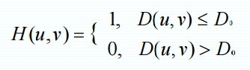

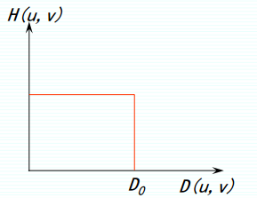

Defect: losing the information about the high-frequence will cause Ringing Eftect!

**2.1.2. Butterworth low-pass filter**

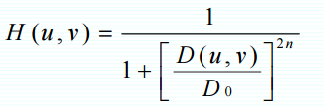

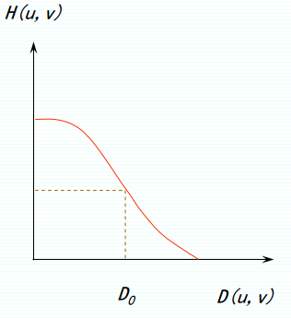

**2.1.3.Ladder filter**

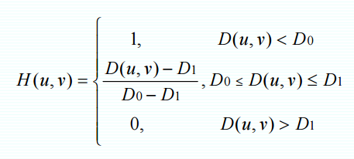

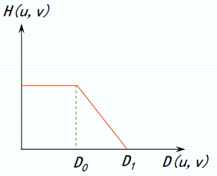

**2.1.4.Exponential filter**

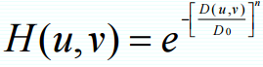

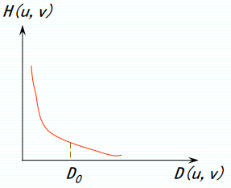

|  |  |  |  |
| --- | --- | --- | --- |
|  | Ringing Effect | Smooth | Blur |
| Ideal | serious | Very good | serious |
| Butterworth | slight | good | slight |
| Ladder | average | average | average |
| Exponential | average | average | average |

**2.2.Sharpen**

In the frequence domain, to sharpen the image, we have to design a high-pass filter.

**2.2.1 Ideal high-pass filter**

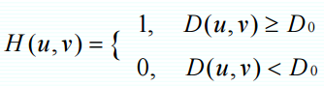

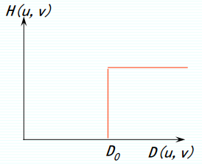

**2.2.2 Butterworth high-pass filter**

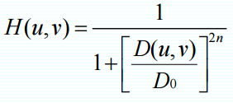

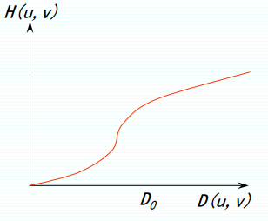

All in all, there are many methods to process the image and there are many advantages and disadvantages of those methods we have to select those methods to match the qulity of the image we want to process. And there are also some other factors that we need to consider, such as the programming language, the operation speed of the chip, the ideal result we need, etc..

For example, I find that is it really slow to process the image in the frequence domain on raspberry pi2 since its chip is not powerful enough to support the operation.

In fact, in python, there are many useful packages that provide the mathematical tool to process the image, which will significantly reduce the workload.