# These scenarios have been created specifically for the Tae Kwon Do case study and should only be used as reference material. These will not apply to your in class case study.

# Casual Use Case Specification: UC1

**Brief Description: This case allows the Customer Service Staff to maintain and manage Customers information**

# Section 1: Business Rule(s):

BR 1: To add a customer information requires customers last name a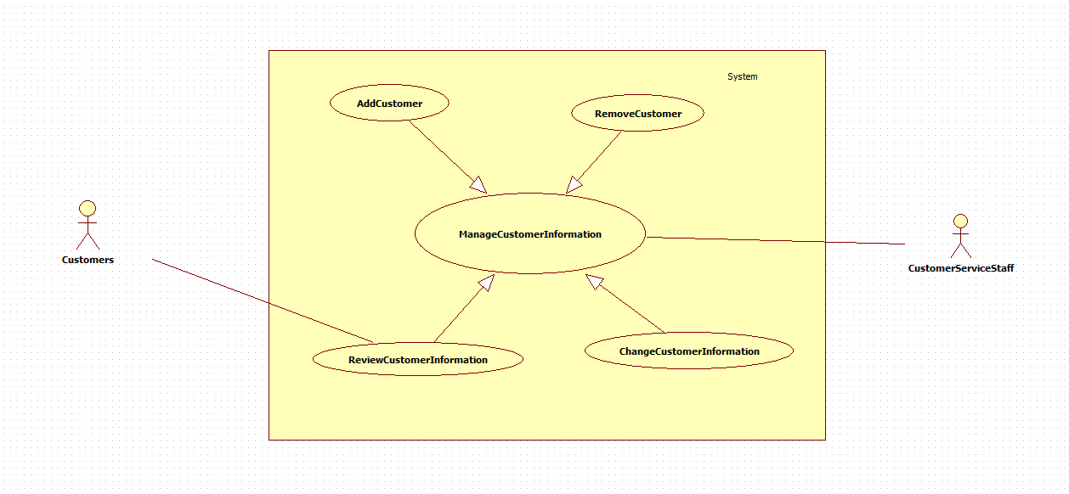nd telephone number;

BR 2: To review a customer information can through customer’s last name, first name, telephone number, Email, address, fuzzy pattern searching acceptable;

BR 3: To change a customer information requires keep the previous information as well;

BR 4: To delete a customer requires confirmation.

# Section 2: Scenarios (HD):

**Scenario 1: Add a Customer to the Customer Information without error.**

# Preconditions The Customer Service Staff member is logged in and the system displays the update customer menu.

| **Step#** | **Actor(CustomerServiceStaff)** | **System** | **Data Used** |
| --- | --- | --- | --- |
| 1 | Selects the Customer Information Management option | Displays a list of Add Customer, Remove Customer,Update Customer Info, Search Customer. The default page shows all the Customer List | CustomerList |
| 2 | Selects to add a customer to the Customer List | Displays a page of customer registration from including customer’s service identity(automatically generated by numeric serial ), first name, last name(required), Gender(sub selection including Mr,Mrs,Miss options ),telephone number(required), Email, address, post code, items/service, date and time(automatically saved as system time),Additional Description | CustomerList  Service Identity  Date and time  First Name  Last Name  Gender  Telephone Number  Address  Post Code  Items/Sevice  Additional Description |
| 3 | Selects a Customer Service Staff from the list | Displays Customer Service Staff List showing as a sub selection menu | Customer Service Staff List |
| 4 | Selects to confirm | Sends a confirmation Email to the customer.  Displays a web page of the new created Customer information  The new added customer is show on the customer list if select or review Customer Information. |  |
| 5 | Chooses to exit | Displays the Customer List |  |

**Successful Post-Conditions: A customer is added to the business system.**

**Scenario 2: Change a customer’s information without error.**

# Preconditions: The Customer Service Staff member is logged in and the system displays the customer list and Update Customer Info menu.

| **Step#** | **Actor(CustomerServiceStaff)** | **System** | **Data Used** |
| --- | --- | --- | --- |
| 1 | Selects or searches a customer supposed to be updated | Displays a web page listing of customer, including a search filter on the top of the page, searching or filter the customer through customer’s last name, first name, telephone number, Email, address, fuzzy pattern searching acceptable; | Customer List |
| 2 | Selects the Update Customer Info option | Displays a weekly calendar for the semester/location, displaying classes currently scheduled. Prompts to edit an existing class, or add a new class to the schedule | Customer List |
| 3 | Selects a customer to edit | Displays the customer information form including the default customer information page including all the customer registered information and service history page option recording all the customer purchase history including date and time, bill, payment, Items/Service. The customer information are editable. | Customer Information  Customer Purchase History |
| 4 | Update the Customer Information | Edit the customer information | Customer Information |
| 5 | Selects to confirm | Updates the customer information  Redisplays the customer information page and prompts for confirmation  Sends a confirmation Email to the customer. |  |
| 6 | Chooses to exit | Redisplays the Customer List and the Customer Information management menu |  |

**Successful Post-Conditions: A customer information is changed successfully.**