**模拟数据产生**

1. 工具

安装SCNVSim

下载：Wget <http://sourceforge.net/p/scnvsim>

安装：unzip scnvsim_1.3.1.zip

mkdir snvindel_output_dir

mkdir sv_output_dir

2、正常组织（normal）模拟数据生成

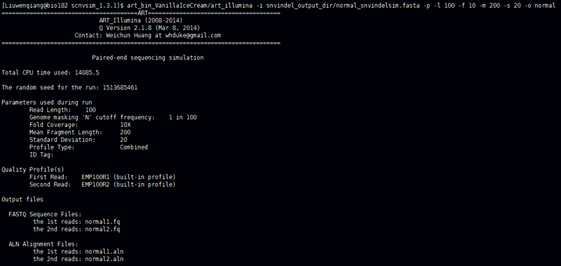

3、肿瘤（tumor）模拟数据生成

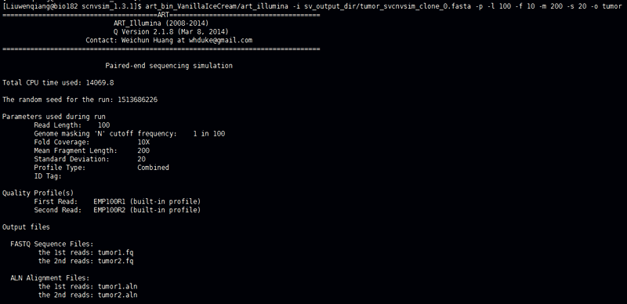

**软件简介**

Linux development platform

1、Installation

①BIC-seq2(Perl):

Download site: <http://www.math.pku.edu.cn/teachers/xirb/downloads/software/BICseq2/BICseq2/BICseq2-norm_v0.2.6.tar.gz>

<http://www.math.pku.edu.cn/teachers/xirb/downloads/software/BICseq2/BICseq2/BICseq2-seg_v0.7.3.tar.gz>

Installation:

Make clean

Make

②cn.MOPS(R):

Download&& Installation:

## try http:// if https:// URLs are not supported

source("https://bioconductor.org/biocLite.R")

biocLite("cn.mops")

③Control-FREEC(R):

Download site:

<https://github.com/BoevaLab/FREEC/archive/v11.0.tar.gz>

Installation:

R install

④LUMPY(python):

Download site:

<https://github.com/arq5x/lumpy-sv.git>

Installation:

git clone --recursive https://github.com/arq5x/lumpy-sv.git

cd lumpy-sv

make

cp bin/* /usr/local/bin/

⑤SAAS-CNV(R):

Download site:

<https://github.com/cran/saasCNV.git>

Install required R packages, including saasCNV:

source("https://bioconductor.org/biocLite.R")

biocLite("DNAcopy")

install.packages(“RANN”)

install.packages("saasCNV")

install.packages("feather")

2、输入文件处理成标准BAM文件

NCBI的SRA下载数据

wget <ftp://ftp-trace.ncbi.nlm.nih.gov/sra/sra-instant/reads/ByStudy/sra/ERP/ERP001/ERP001196/ERR092373/>

fastq-dump –split-files *sra

bwa mem –t 10 reference/ucsc.hg19.fa *1.fastq *2.fastq | samtools view –bS -> *bam

samtools sort –m 5G –T PREFIX -@ 10 *bam –o *.sort.bam

samtools index *.sort.bam

samtools merge -@ 20 merge.bam lane1.sort.bam lane2.sort.bam lane3.sort.bam ...

samtools addreplacerg -r "@RG\tID: merge \tSM: merge " --output-fmt BAM -o merge.add.bam merge.bam

samtools sort -m 5G -T PREFIX4 -@ 10 merge.add.bam -o merge.add.sort.bam

samtools index merge.add.sort.bam(Tumor/Normal BAM Format File)

3、软件命令执行

nohup python2.7 Isa.pipeline.py –o lumpy_out –t merge.tumor.sort.bam –n merge.normal.sort.bam –c config.merge.txt > merge.log.out &



4、结果文件夹图

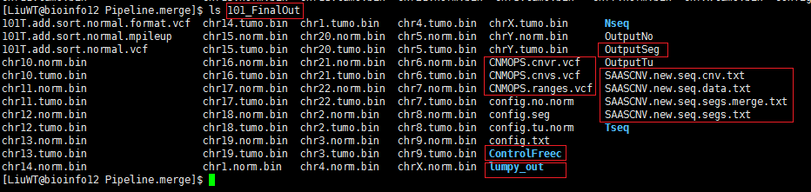

5、帮助目录

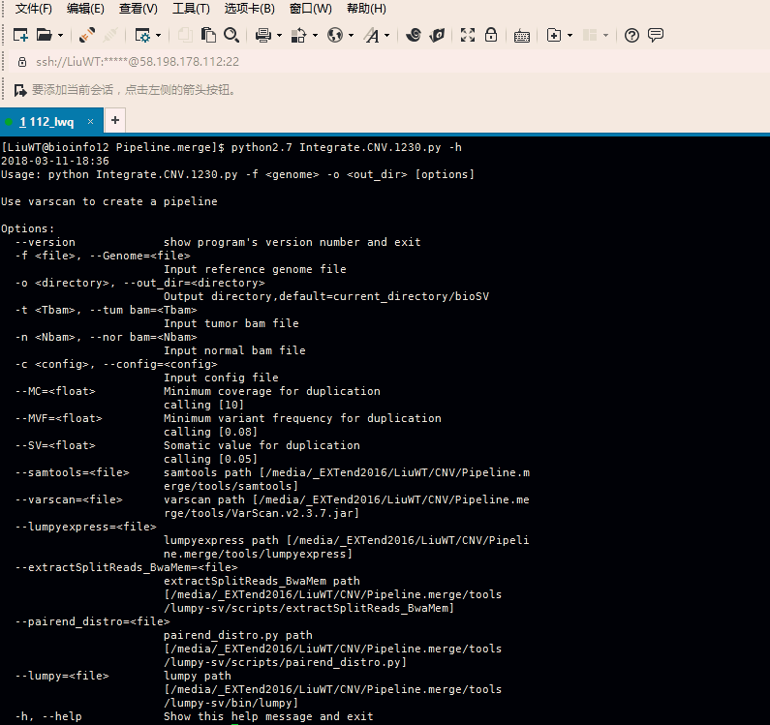

6、日志文件

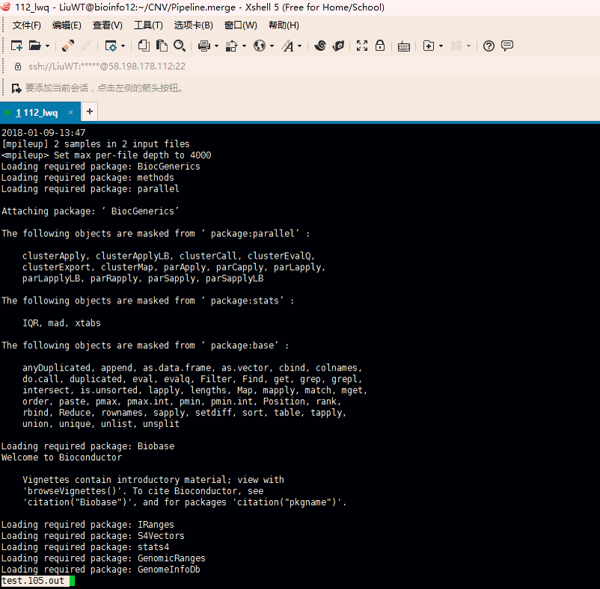

7、标准BAM文件格式

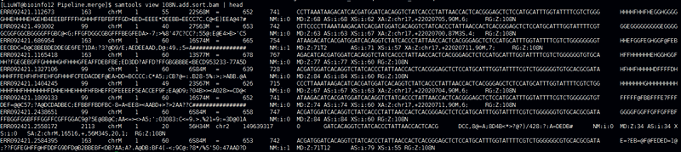

8、软件代码整合

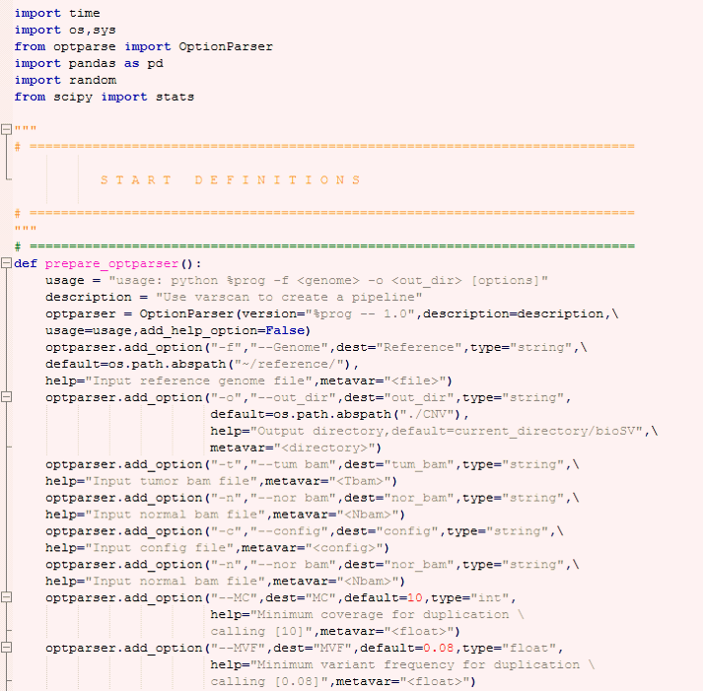

9、断点与组合区间

染色体+断点=>组合区间（计算新区间在整合结果上的支持度）

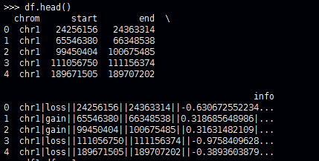

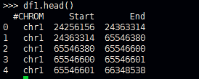

10、组合区间

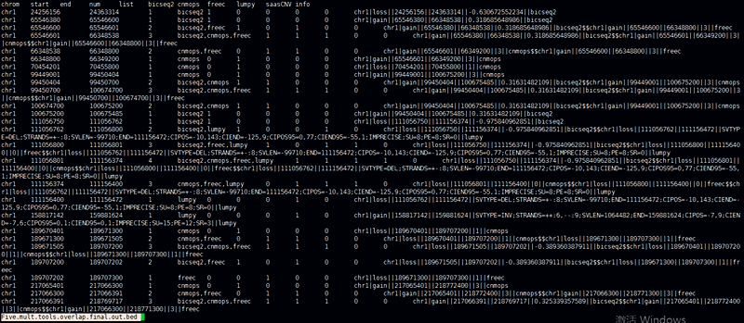

**相关代码展示**

1. 软件包引用

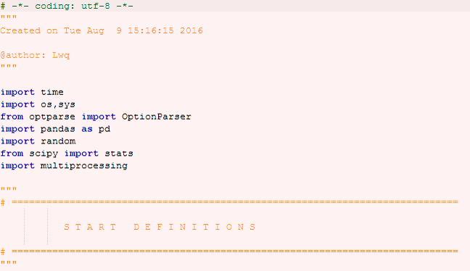

1. 软件说明

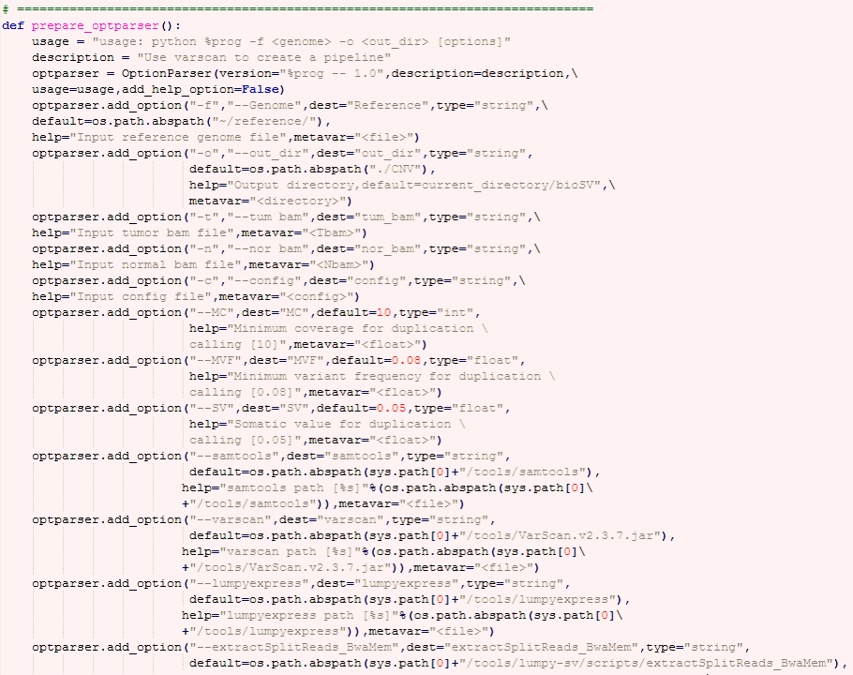

1. 函数定义

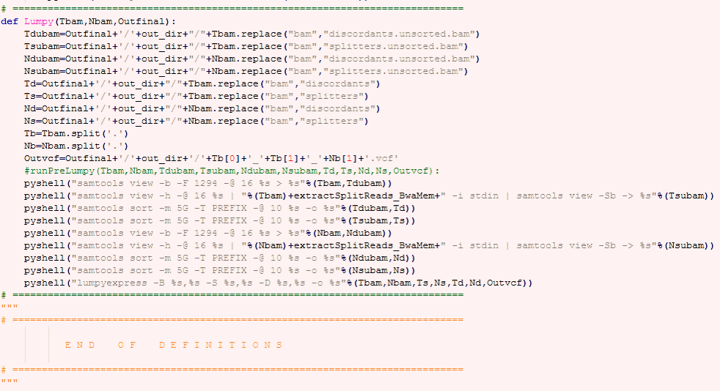

1. 主函数调用

