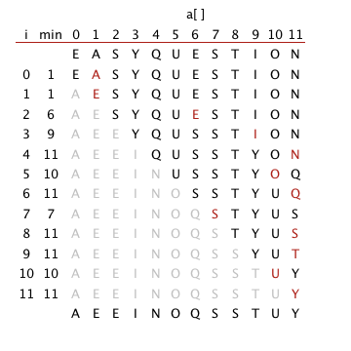

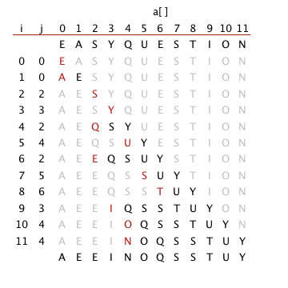

Solution. Insertion sort runs in linear time when all keys are equal.

Solution. Quadratic. Example: 1 2 3 1 2 3 1 2 3 1 2 3 …. The number of 1s, 2s, 3s in front of every element is the same as the above ordered sequence.

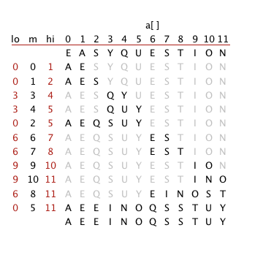

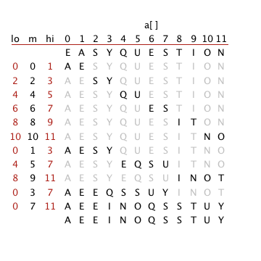

Solution. Since the array is already sorted, there will be no calls to merge(). When N is a power of 2, the number of compares will satisfy the recurrence T(N) = 2 T(N/2) + 1, with T(1) = 0.

1. Solution. ~ N lg N compares. Each partition will divide the array in half, plus or minus one.

Hint: customize quicksort to the problem. Side note: only a very complicated deterministic O(N log N) algorithm is known for this problem.

Solution. Will need to update the maximum value from scratch after a remove-the-maximum operation.