- D
- 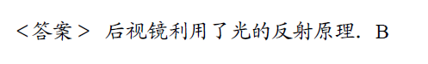
- D
- D
- 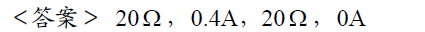
- 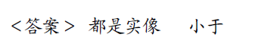
- 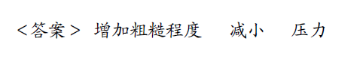
- 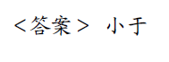
- 
- ---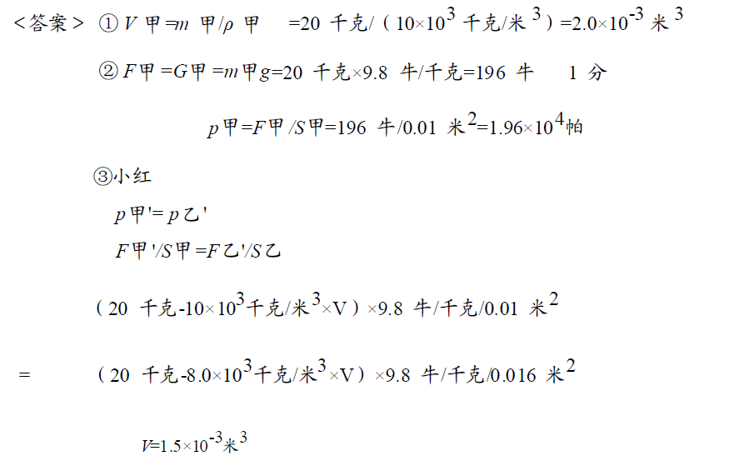
- C
- A
- ---
- ---