- C
- B
- C
- ---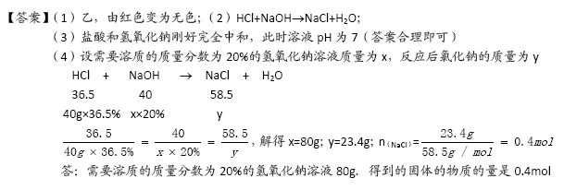
- C
- ---
- ---
- D
- B
- ---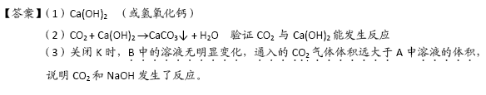
- C
- B
- C

