* [CoreData](https://wiki.hybris.com/display/~steve.barnacle@sap.com/Development" \l "Development-CoreData)
* [SampleData](https://wiki.hybris.com/display/~steve.barnacle@sap.com/Development#Development-SampleData)
* [Product Modelling](https://wiki.hybris.com/display/~steve.barnacle@sap.com/Development#Development-ProductModelling)
* [Localizations](https://wiki.hybris.com/display/~steve.barnacle@sap.com/Development#Development-Localizations)
* [Classifications / Consultants Skills](https://wiki.hybris.com/display/~steve.barnacle@sap.com/Development#Development-Classifications/ConsultantsSkills)
* [SOLR](https://wiki.hybris.com/display/~steve.barnacle@sap.com/Development#Development-SOLR)
* [Prices / PriceRows](https://wiki.hybris.com/display/~steve.barnacle@sap.com/Development#Development-Prices/PriceRows)
* [Acquiring Consultant Images](https://wiki.hybris.com/display/~steve.barnacle@sap.com/Development#Development-AcquiringConsultantImages)
* [Media Conversion Extension](https://wiki.hybris.com/display/~steve.barnacle@sap.com/Development#Development-MediaConversionExtension)

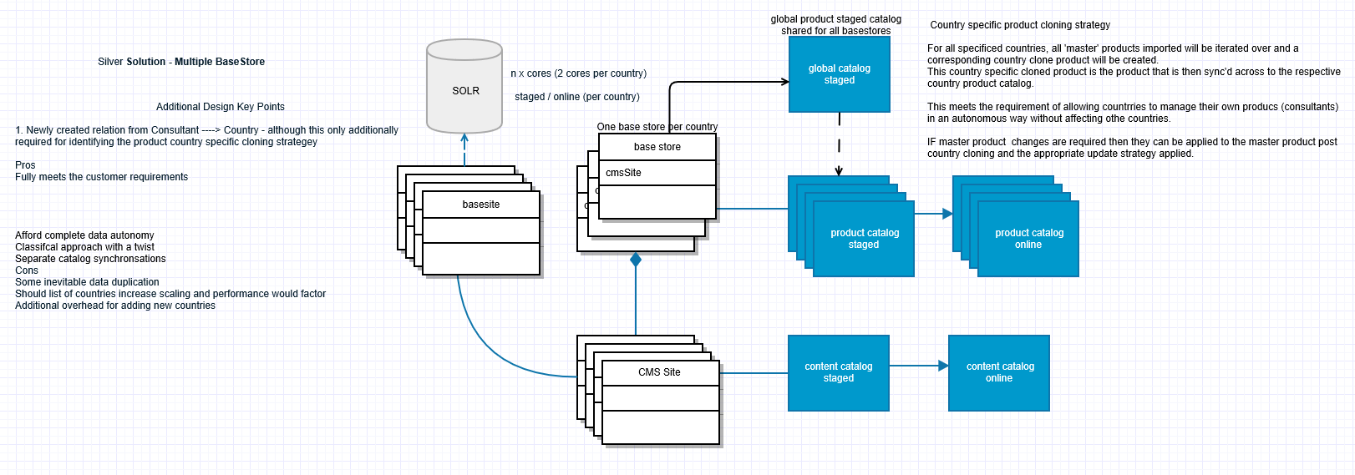

### E-commerce culture

Check only if the candidate claims to have e-commerce experience

What is a SKU? What is a variant?

SKU refers to a **stock keeping unit,** a unique identifier for each distinct product and service that can be purchased in business.

What is a variant?

A product variant is a different version of a product, such as differing sizes or differing colours.

What is a conversion rate?

Ratio between visit and orders

What SEO means?

 Search Engine Optimization

What is a market place? Give us a famous example?

It is an e-commerce website that proposes multiple offers for products coming from different vendors. Amazon is a market place.

What Merchandising means?

Practices to increase sales in the way to present the product

What is Cross-Sell and Up-Sell?

Cross-Sell: Sale additional product that completes initial product interest

Up-sell: Sale similar product but better in term of quality and feature

What is faceted search?

The filtering options indicating the number of products that usually appear in the left column after a keyword search has been performed.

What Searchandizing means?

It is the combination of search and merchandizing to reconciliate potentially conflicting needs : customer wants to search for product he's interested and Merchant wants to show product he's interested to sell.

What BOGOF means?

 "Buy one, get one free", or "Buy one, get one" is a common form of sales promotion. While not always presented to customers in acronym form, this marketing technique is universally known in the marketing industry by the acronyms BOGO, BOGOF, and BOGOHO (Buy one get one half off).

What are a PLP and PDP?

Product List Page and Product Detail Page

What are the main features of an commerce front-end?

* Search and Navigation (PLP)
* Product Information (PDP)
* Cart Management
* Account Management
* Order Fullfilment
* Checkout

 What is a PIM/PCM?

Product Information Management or PIM refers to processes and technologies focused on centrally managing information about products, with a focus on the data required to market and sell the products through one or more distribution channels. A central set of product data can be used to feed consistent, accurate and up-to-date information to multiple output media such as web sites, print catalogs, ERP systems, and electronic data feeds to trading partners. PIM systems generally need to support multiple geographic locations, multi-lingual data, and maintenance and modification of product information within a centralized catalog to provide consistently accurate information to multiple channels in a cost-effective manner.

Do you know what is Forrester research or Gartner?

Analyst companies who publish market research reports in IT sector.

What is a Gartner Magic Quadrant?

The Gartner Magic Quadrant (MQ) is the brand name for a series of market research reports published by Gartner Inc.

Gartner rates vendors upon two criteria: completeness of vision[1] and ability to execute.[1] Using a methodology which Gartner does not disclose, these component scores lead to a vendor position in one of four quadrants:

Leaders are said to score higher on both criteria:

* the ability to execute and completeness of vision. These are said to be typically larger, mature businesses.
* Challengers are said to score higher on the ability to execute and lower on the completeness of vision. Typically larger, settled businesses with what Gartner claims to be minimal future plans for that industry.
* Visionaries are said to score lower on the ability to execute and higher on the completeness of vision. Typically smaller companies.
* Niche players are said to score lower on both criteria: the ability to execute and completeness of vision. Typically new additions to the Magic Quadrant.

#INSERT_UPDATE StockLevel productCode[unique=true] warehouse(code) available(可用数量) reserved(保留数量) overselling(超买数量) preorder(预定) maxPreOrder(最大预定） treatNegativeAsZero(将库存视为0) maxStockLevelHistoryCount

# testProduct1 warehouse1 50 0 10 5 30 TRUE 50000

* Explain next steps
  + Technical screening report shared with the Southern Europe SDM director
  + Feedback to head hunter
  + Technical screening of other candidates
  + Recruitement day in Paris or Italy
* Ask if the candidate has any question.

# **Stores and Sites**

[Skip to end of banner](https://wiki.hybris.com/display/~tuna.ozkasap@sap.com/Stores+and+Sites#page-banner-end)

* [https://wiki.hybris.com/s/en_GB/5997/6f42626d00e36f53fe51440403446ca61552e2a2.59/_/download/resources/com.atlassian.confluence.plugins.confluence-page-banner:page-banner-resources/images/red_padlock.png](https://wiki.hybris.com/display/~tuna.ozkasap@sap.com/Stores+and+Sites)

[Go to start of banner](https://wiki.hybris.com/display/~tuna.ozkasap@sap.com/Stores+and+Sites#page-banner-start)

[Skip to end of metadata](https://wiki.hybris.com/display/~tuna.ozkasap@sap.com/Stores+and+Sites#page-metadata-end)

* Created by [Tuna Özkasap](https://wiki.hybris.com/display/~tuna.ozkasap@sap.com), last modified on [12.05.2015 CEST](https://wiki.hybris.com/pages/diffpagesbyversion.action?pageId=274292338&selectedPageVersions=7&selectedPageVersions=8)

[Go to start of metadata](https://wiki.hybris.com/display/~tuna.ozkasap@sap.com/Stores+and+Sites#page-metadata-start)

# **The Store And Site Structure In Omni-Commerce-Connect**

* The diagram below is a sample about how a store - site - catalog configuration can be.
* Here Koton has two store models; one for Turkey, one for England, each has summer and winter catalogs. Only one catalog for each store is active at a specific time.

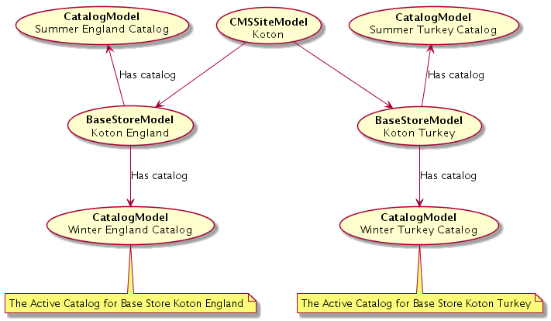

* The CMSSiteModel is the representation of one or more stores. CMSSiteModel also has a defaultCatalog like a store, CMSSiteModel can only select one of the product catalogs assigned to the stores of that model. So here Koton CMSSite can only have one of the Catalogs as its defaultCatalog
  + Winter Turkey Catalog
  + Summer Turkey Catalog
  + Winter England Catalog
  + Summer England Catalog

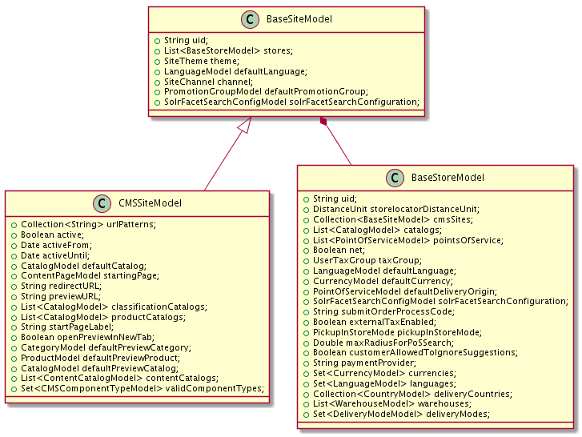

# **Checkout PCI Strategies Overview**

The B2C storefronts offered with the hybris Commerce Accelerator are currently shipped with a number of methods for collecting customer payment details - termed **"Creating a customer subscription"**:

* Using the hybris payment details form for capturing a customer's credit card details (Single Page checkout only).
* A secure page hosted by a third party payment provider used for collecting a customer's card details, that is a Hosted Order Page (HOP).
* A payment details form provided in the hybris Commerce Accelerator that POSTs to an external service for creating the subscription, this is known as Silent Order Post (SOP).

We discuss how the **subscriptionPciOption** is chosen for each of the B2C storefronts.

**Note**

The checkout PCI strategies work only during the multi-step checkout experience.

# **Filters That Handles Active Site And Store In Session**

* BaseSiteMatchingFilter checks the siteId and according to that id finds the active product catalog using the defaultCatalog in CMSSiteModel and catalogs list from BaseStore. If defaultCatalog is not in any of the stores catalog then it returns an exception.
* HandlerExceptionResolver returns an exception thrown from other filters as an XML or JSON
* response using the HandlerExceptionResolver.
* Do not forget that your product should be approved to be shown by OCC services.

[Like](https://wiki.hybris.com/display/~tuna.ozkasap@sap.com/Stores+and+Sites)Be the first to like this

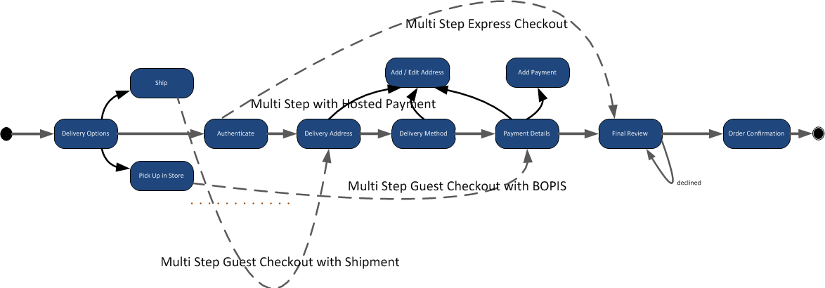

| **Constraint** | **Type** | **Description** |
| --- | --- | --- |
| **Constraint** | **Type** | **Description** |
| Hybris Clustering in UDP mode | Network | It is known that UDP mode is more efficient than TCP. The reason behind is that TCP mode needs to establish a connection at each Hybris node to send a cache invalidation. This TCP connection is re-opened at each time. The overhead and CPU consummation is more important than UDP communication. By consequence, the UDP mode is recommended. |
| Cache invalidation | Performance | When a hybris cluster is designed, cache invalidation issue should be taken into account. Indeed, too many write access on a cluster can conduce to impact the StoreFront performances. In this case, the different cache level can be invalided too often regarding business requirements. The right approach is to separate the hybris business entity (PCM, Catalogs, StoreFront, and so on...) in several physical clusters, when it is possible. |
| Mass importing data | Performance | hybris was not designed to import data in mass. Indeed, impex concept doesn't include bulk import methodology. Furthermore, data model constraint is checked by a java service layer. Over 100 000 items per day, it is preferable to design a solution around delta data importation instead of simple full data importation. To do that, two choices are possibles: compute the delta by source system itself or compute by a ETL (Talend for example) located into middle (between source system and hybris). |
| Data Quality | Integration/Performance | hybris is not a data quality tool. If the source of information (ERP) has low data quality (as bad string format, duplicated information, wrong categorization, and prices), we must have in the middle a true data quality solution. hybris should never customize in this way. |
| SOLR Search Engine | Integration | By default Hybris is running with SOLR for the search engine. For several reasons, we recommend to stay on this technology. The advantage to keep SOLR is multiple:   * Get more experience and feedback from Partner and Hybris Consultant * Follow the search feature evolutions with Hybris core platform * Get open-source solution which is known, well-documented and improved by the community * Be sure to find expert guy in job market in this technology |
| HMC Deployment | Security | Hybris platform cannot be deployed without HMC extension even for the storefront websites. The security workaround is to filter URL access for all administrations consoles in upstream (Web Server: Apache or F5) |
| Service Interruption in Data Model change | High Availability | In case of data model change, Hybris cluster need to be restarted. That means an unavailability period in Production. Even if the data model change concerns only added fields in the tables. This point should be taken in account to consolidate as much as possible data model design in project phase. |
| HTML and Medias Web Caching for B2C | Performance | To improve drastically website storefront performance, we recommend to implement and to use a Web Caching solution for HTML and Media. Hybris standard is Varnish. ESI technology must be supported. This constraint can impact the website design and this point should be kept in mind during solution implementation. |
| Content sharing in W-CMS | Software | W-CMS of hybris is a simple CMS. Natively, it is not possible to update transparently a content from content catalog to another. Indeed, the content conflict management doesn't exist. If we want to define common content for several website, it is preferable to define a master content catalog completely independent from locals ones. This master catalog can be attached to several websites. A website can have several content catalog. Website structure can be composed by several content catalog (Component 1 attached to Master, Component 2 attached to Local). |
| Tomcat for Application Server | Technical | Hybris is embedded into customized a Tomcat server. In order to avoid any issue with a specific Application Server technology, it is recommended to keep this technology. |
| Linux for OS | Technical | Even Hybris can support other OS, the most part of hybris solution is deployed on Linux. It is recommended to stay on this OS to get the benefit of Consultant knowledge and feedback from other project. |

Media Conversion Extension

There are a number of tools out there that can handle DAM (digital asset management) and

**Conversion Groups**and **Conversion Media Format**  
  
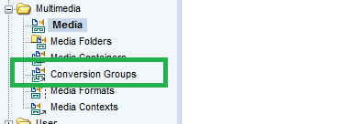

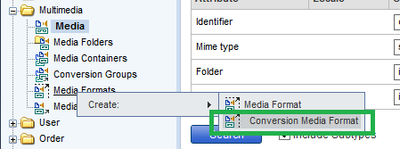

d) Created media formats that will serve my resizing requirements  
NB - in hindsight, i could have removed all of the similar 'default' hybris formats and named mine something similar, if not identical, that would have saved me having to amend the spring configuration files later - but equally i was keen to see my 'distinctively' named formats appear and verify that mine were in fact being used instead of the defacto formats

**Media formats - products-media.impex**

|  |
| --- |
| # Create media conversion formats  # Lge/Zoom = 515 x 515, PDP = 365 x 365, PLP = 96 x 96, Thumb = 65 x 65  INSERT_UPDATE ConversionMediaFormat;qualifier[unique=true];name[lang=$lang];conversionStrategy[default=imageMagickMediaConversionStrategy];conversion;  ;image-conversion-515Wx515H;Magik 515;;-resize 515x515  ;image-conversion-365Wx365;Magik 365;;-resize 365x365  ;image-conversion-96Wx96H;Magik 96;;-resize 96x96  ;image-conversion-65Wx65H;Magik 65;;-resize 65x65 |

e) Created a media folder to store my new media in hybris - not necessay but a cleaner way of proceeding

**Media folder - products-media.impex**

|  |
| --- |
| # Create media folder  INSERT_UPDATE MediaFolder; qualifier[unique=true];path[unique=true]  ;images;images |

f) Created the meda impex for important my master large size consultant images.   
(When acquiring the images, i opted for the largest size possible (close to 640 x 640) as resizing down would be easier and clearer than resizing up).

**Media impex**

|  |
| --- |
| # Create Media  INSERT_UPDATE Media;mediaFormat(qualifier)[default=515Wx515H];code[unique=true];$media;mime[default='image/jpeg'];$catalogVersion;folder(qualifier)[default=images]  ;;master-Consultant-00000001;$siteResource/1.jpg;;;  ;;master-Consultant-00000002;$siteResource/2.jpg;;;  ;;master-Consultant-00000003;$siteResource/3.jpg;;;  ;;master-Consultant-00000004;$siteResource/4.jpg;;;  ;;master-Consultant-00000005;$siteResource/5.jpg;;;  ;;master-Consultant-00000006;$siteResource/6.jpg;;;  ;;master-Consultant-00000007;$siteResource/7.jpg;;;  ;;master-Consultant-00000008;$siteResource/8.jpg;;;  ;;master-Consultant-00000009;$siteResource/9.jpg;;;  ;;master-Consultant-00000010;$siteResource/10.jpg;;; |



WCMS different page reference same template what the relationship between WCMS and site

Content referece Product Catalog if synchronize what happens. 怎么知道是stage 不是online

如果同步从stage到onlie

Check out process and order process,SOP IOP

Solr how to facet ,if change shop price before shop by name.

Different country share same Product catalog with different currency

Create template and Page

How to add a facet



**Your task is to create a service that is able to fulfill orders in some commerce site.**   
As the input you have a list of available products and locations in the following form:

|  |  |  |
| --- | --- | --- |
| **LOCATION** | **SKU** | **AMOUNT** |
| Gliwice | prod-1 | 10 |
| Gliwice | prod-2 | 12 |
| Gliwice | prod-3 | 5 |
| Munich | prod-1 | 4 |
| Munich | prod-2 | 4 |
| Munich | prod-3 | 4 |
| Montreal | prod-1 | 4 |
| Montreal | prod-4 | 5 |

As second input you have a list of submitted orders in the following format:

|  |  |  |
| --- | --- | --- |
| **DESTINATION** | **SKU** | **AMOUNT** |
| Sydney | prod-1 | 14 |
| Sydney | prod-2 | 10 |
| Sydney | prod-3 | 3 |
| Tokyo | prod-2 | 6 |
| Sydney | prod-3 | 1 |
| Tokyo | prod-4 | 5 |

where:

* **LOCATION** is the string that identifies the store in which product is available
* **DESTINATION** is the string that identifies the delivery address for the order
* **SKU** (stock-keeping unit) is the string identifies the product
* **AMOUNT** is the number of products available in given location

# Your task is to produce the list of shipments that fulfill all the orders with the minimum effort for the shipment.

That means that you should have minimum number of unique pairs of location and destination in your result.  
  
Sample answer for input data is:

|  |  |  |  |
| --- | --- | --- | --- |
| **LOCATION** | **DESTINATION** | **SKU** | **AMOUNT** |
| Gliwice | Sydney | prod-1 | 10 |
| Munich | Sydney | prod-1 | 4 |
| Gliwice | Sydney | prod-2 | 10 |
| Munich | Sydney | prod-3 | 4 |
| Gliwice | Tokyo | prod-2 | 2 |
| Munich | Tokyo | prod-2 | 4 |
| Montreal | Tokyo | prod-4 | 5 |

In this answer the number of unique pairs of location and destination is 5 (Gliwice-Sidney, Gliwice-Tokyo, Munich-Sidney, Munich-Tokyo, Montreal-Tokyo).

https://www.hybris.com/medias/sys_master/8800965427230/homepage-separator-long.png

When you are ready please send the project with your implementation to  
[piotr.bochynski@hybris.com](mailto:piotr.bochynski@hybris.com)

C:\Users\liuxiangwin\Desktop\Efood Point Of Service Price Promotions.png

