spring基础包:
org.springframework.beans
org.springframework.context

BeanFactory 接口

ApplicationContext 是BeanFactory的子接口类
what’s about it:
(1)Easier integration with Spring’s AOP features
(2)Message resource handling (for use in internationalization)
(3)Event publication
(4)Application-layer specific contexts such as the WebApplicationContext for use in web applications.
说白了,BeanFactory提供了基础配置和基础功能.而ApplicationContext提供了企业级的功能.

Spring Ioc Container: instantiating, configuring, assembling beans.
Assembling by configuration metadata which is represented in xml, java annotation, or java code .

In stand-alone application , it is a common to create an instance of ClassPathXMLApplication or FileSystemXMLApplication.

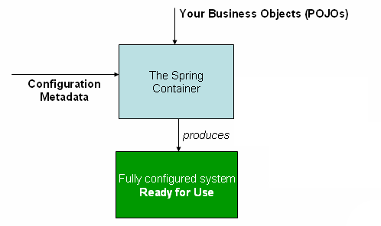
The Spring Ioc Container consumes a form of configuration metadata.
The configuration metadata represents how you, as an application developer , tell the spring ioc container to instantiate, configure, and assemble the objects in your applications.

XML-based metadata is not the only form of configuration metadata.
Spring2.5 introduced support for annotation-based configuration metadata.
Spring3.0 introduced suppert for java-code-based configuration metadata for many features provided.

<beans></beans>
<bean></bean>
is equal to
@Configuration{
@Bean
}

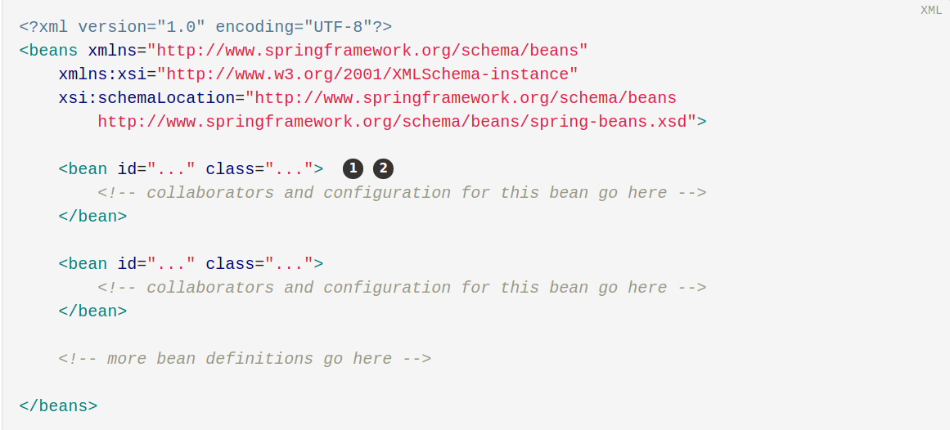
The id attribute is a string that identifies the individuals bean definition. it’s value refers to the collaborating object.
The class attribute defines the type of the bean and use the full qualified classname.

The configuration metadata resources file can be loaded from local file system, the java CLASSPATH, and so on.

eg.
ApplicationContext context = new ClassPathXMLApplicationContext(“services.xml”,”daos.xml”)

daos.xml
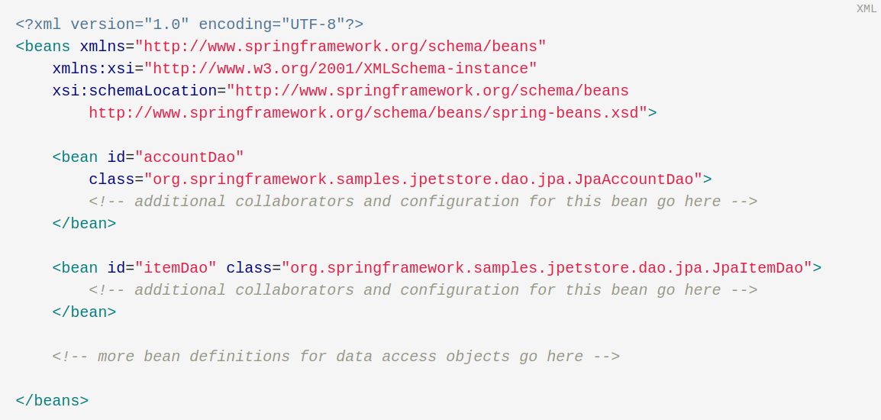
service.xml
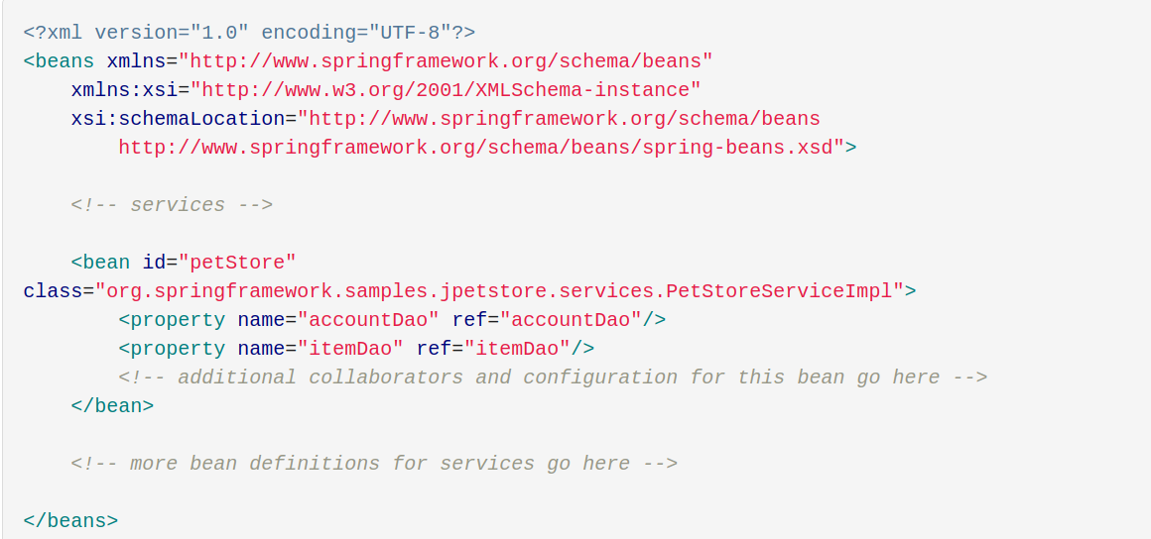
Often, each individual xml configuration metadata file represents a logical layer or moudle in your architecture.

You can use use the application context constructor to load bean definitions from all these xml fragments. Alternatively , use one or more import occurences of the <import/> elments to load bean definitions from another file or files.

eg.
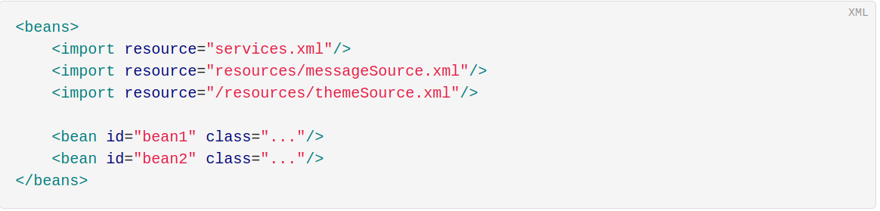
How to get the instance of bean specified.
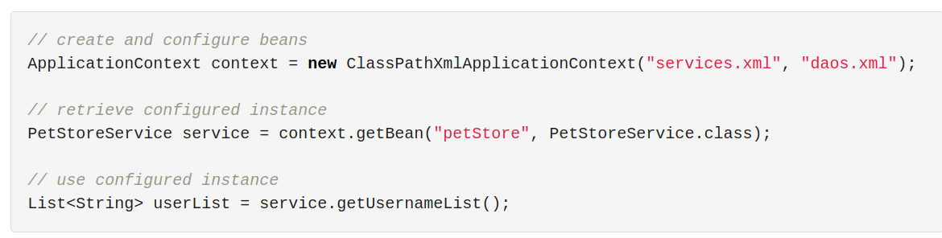
As for Groovy Configuration. eg.
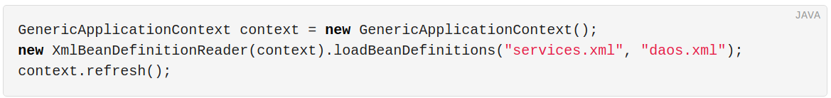
The most flexable variant is GenericApplicationContext in combination with reader delegates

You can also use GroovyBeanDefinitionReader for Groovy files.
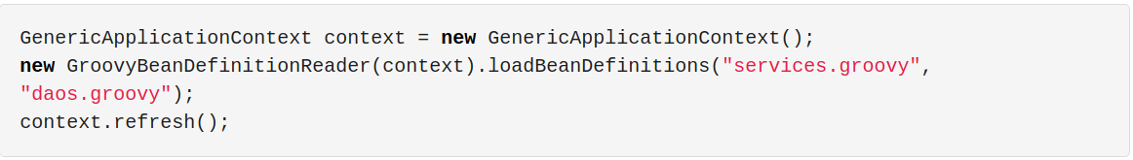
What ‘s in the BeanDefinition?
(1)A package-qualified class name: typically, the actual implementation class of the bean being defined.
(2)Bean behavioral configuration elements, which state how the bean should behave in the container (scope, lifecycle callbacks, and so forth).
(3)References to other beans that are needed for the bean to do its work. These references are also called collaborators or dependencies.
(4)Other configuration settings to set in the newly created object — for example, the size limit of the pool or the number of connections to use in a bean that manages a connection pool.
The metadata translates to a set of properties that make up each bean definition.
The bean definition
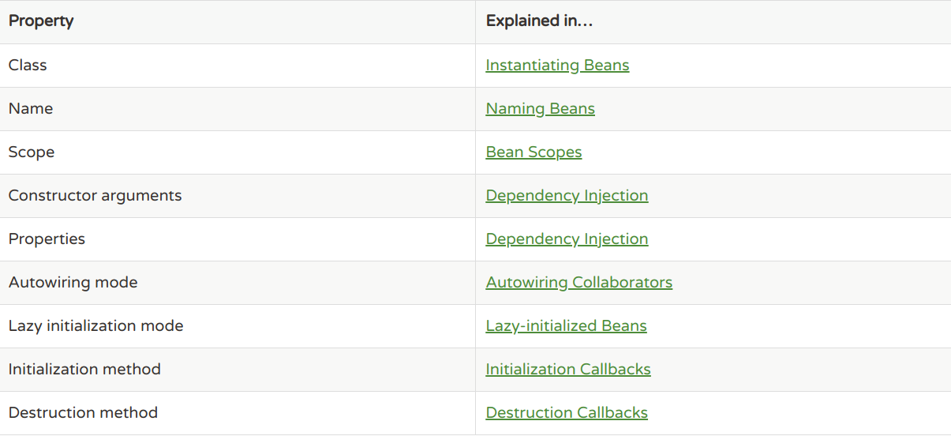
How to manage the of existing object that are created outside the container(by users).
You can use ApplicationContext getBeanFactory() method, which returns the BeanFactory DefaultListableBeanFactory implementation. DefaultListableBeanFactory supports this registration through the registerSingleton(..) and registerBeanDefinition(..) methods

Alias
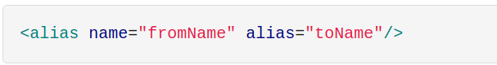
How to configure an inner class
$
eg
SomeThing$InnerClass

Instantiation with Static Factory Method
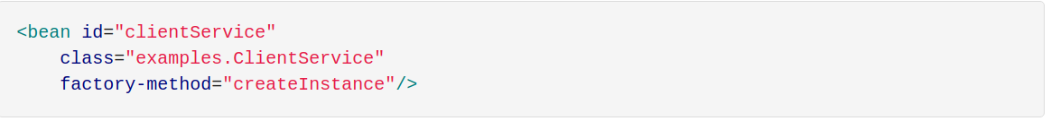
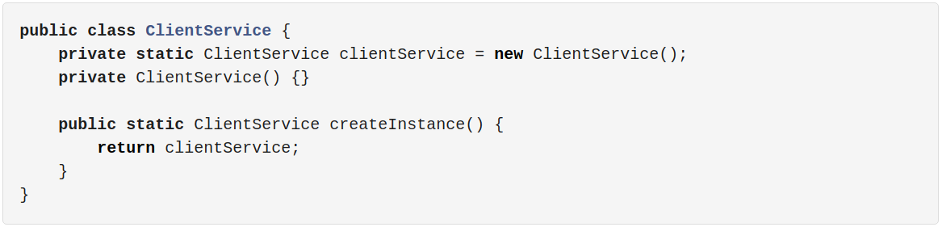
Instantiation by Using an Instance Factory Method
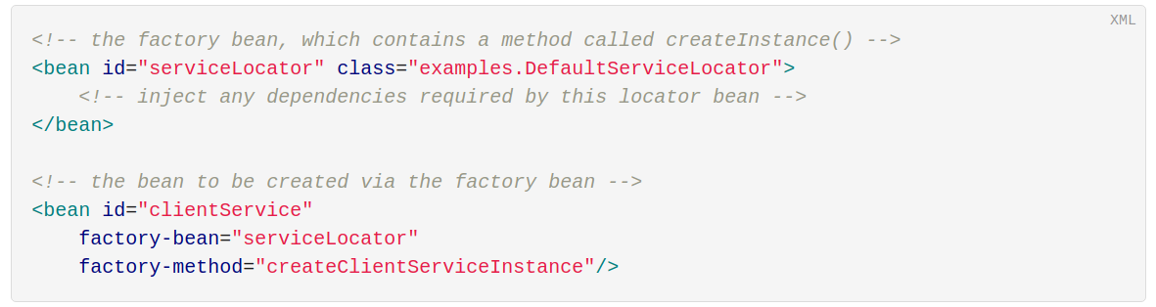
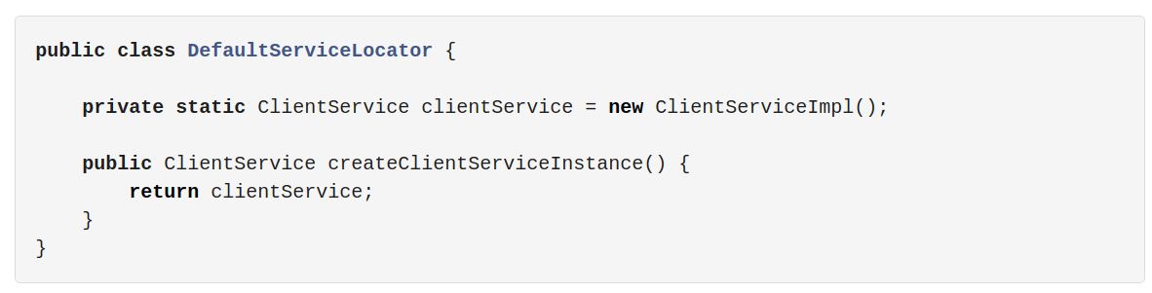
One factory class can also hold more than one fatory method. As the following examples below:
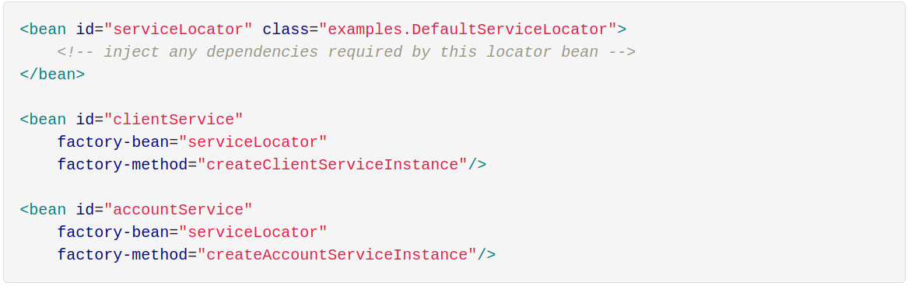
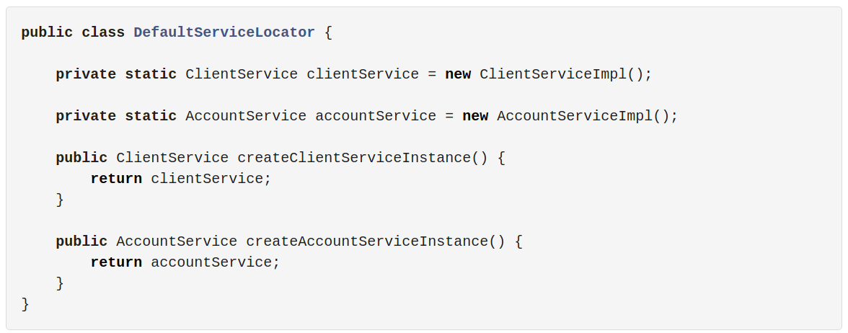
DI exists in two major variants: Constructor-Based dependency injection and Setter-Based dependency injection.

Constructor Argument Resolution
Constructor By reference:
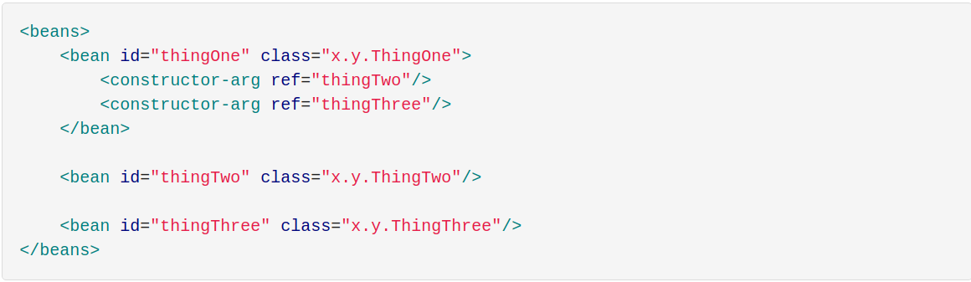
Constructor By Type matching:
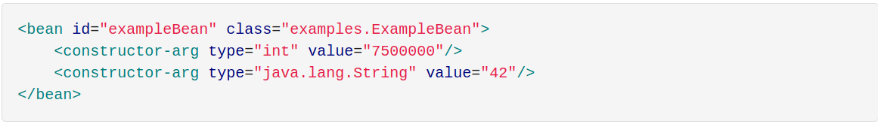
Constructor By Argument Index:
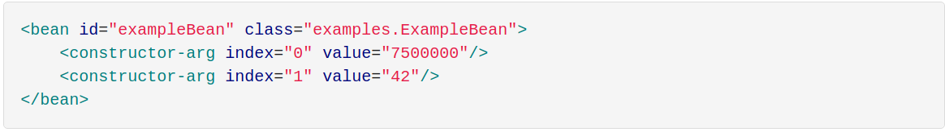
In addition to resolving the ambiguity of multiple simple values, specifying an index resolves ambiguity where a constructor has two arguments of the same type.
Constructor By Argument Name:
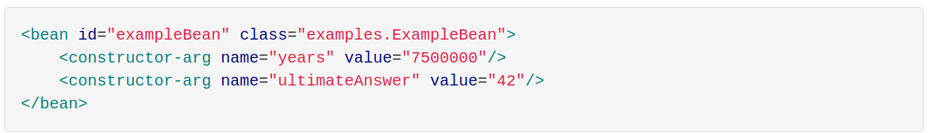
@ConstructorProperties
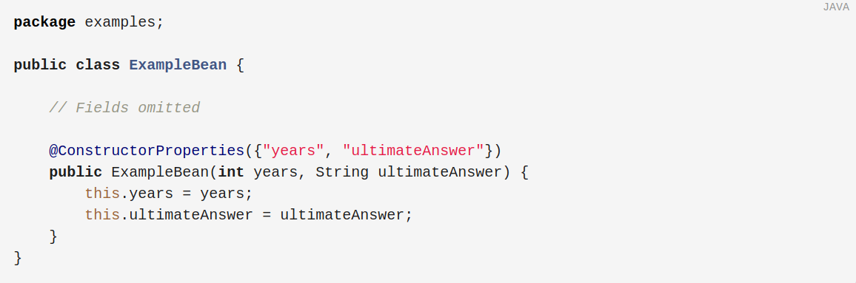
Setter-Based Dependency Injection
@Required
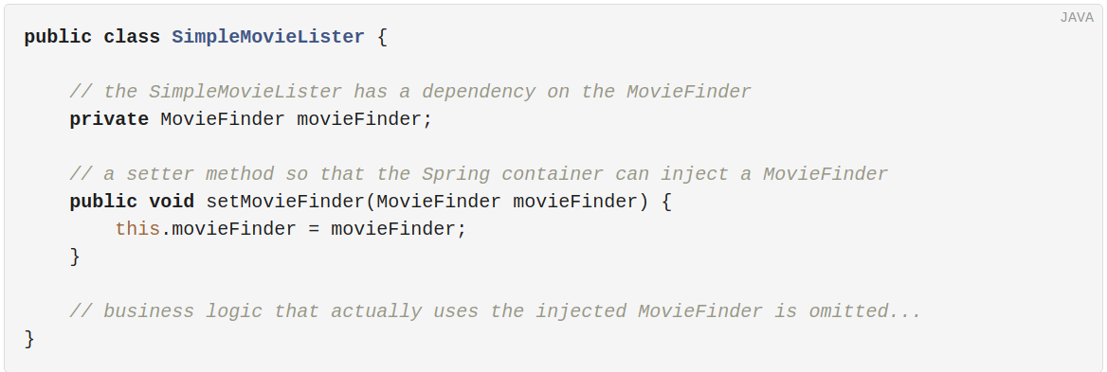
The ApplicationContext supports constructor-based DI and setter-based DI for the beans it manages.It also supports setter-based DI after some dependencies have already been injected through the constructor approach.

Constructor-Based DI or Setter-Based DI?
Constructor-based DI recommented.
Setter-based DI null parameter check; one more times injection; circular dependencies

Examples of Dependency Injection

setter-based DI
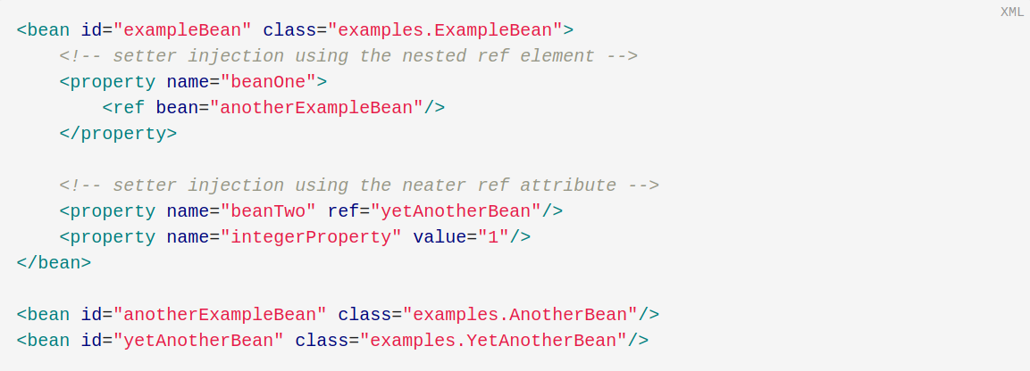
constructor-based DI
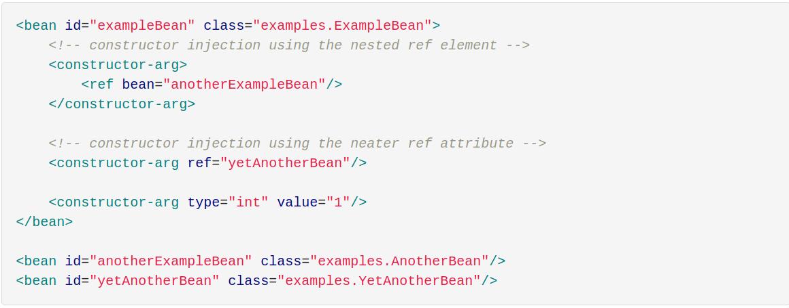
Dependencies and Configuration in Detail
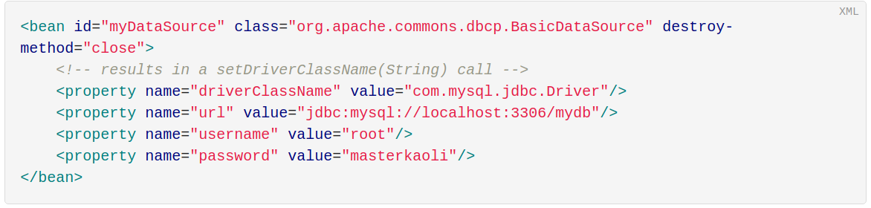
use the p-namespace for even more succinct XML Configuration.
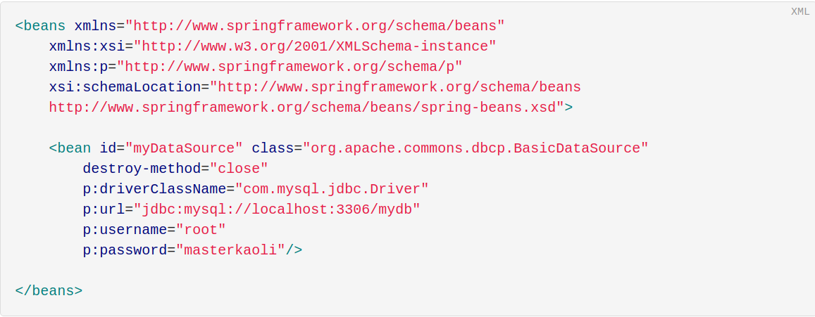
Configure a java.util.Properties instance.
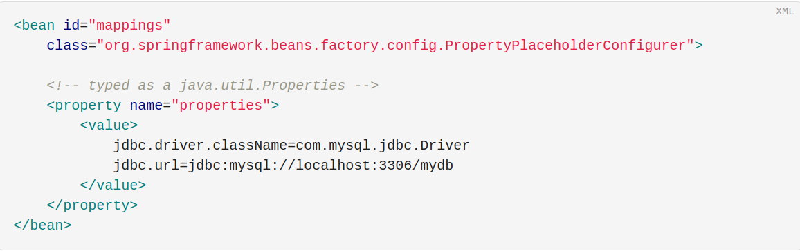
Idref
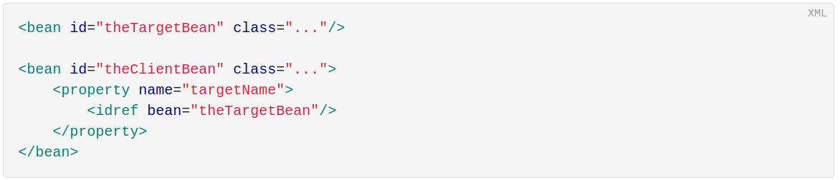
is equivalent to the following:
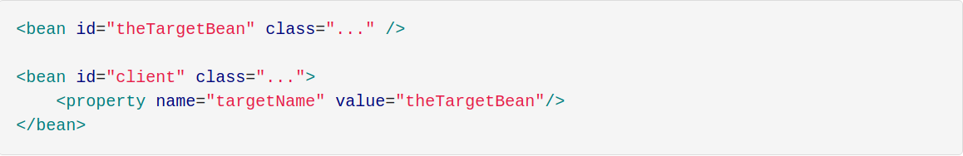
the first form is preferable to the second, because using the idref tag lets the container validate at the deployment time that the referenced, named bean actually exists.

