Analysis Report of Weekly wages of US male workers in 1988——HW1

### Xiaoyue Liu [xiaoyliu@umich.edu](mailto:xiaoyliu@umich.edu) UMID：28589009

### Description

2000 male workers were sampled from the Current Population Survey in 1988. The data collected included their weekly wages(wage), years of education(educ), years of experience(exper), race(race), if living in Standard Metropolitan Statistical Area(smsa), living location(ne,mw,we,so), and if working part time(pt).

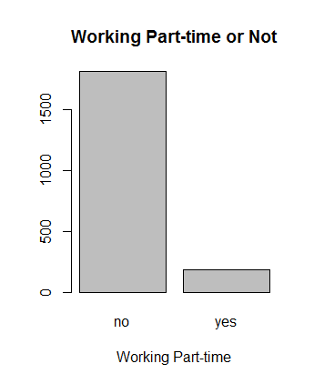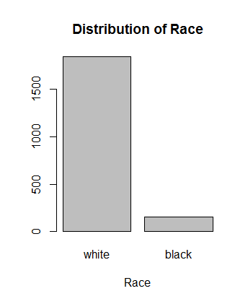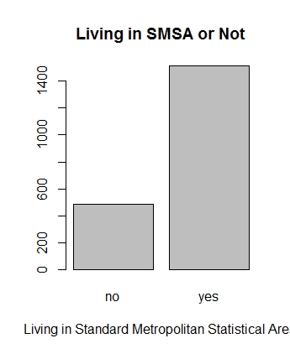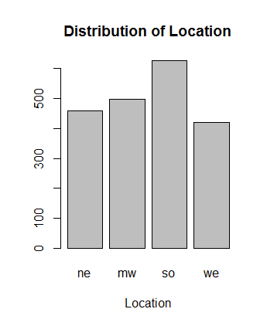These male workers were sampled from all over US (458 from the North East, 497 from the Midwest, 625 from the South, 420 from the West). Most of these male workers were white (1844 out of 2000) , and around ¾ of them were living in Standard Metropolitan Statistical Area(1512 out of 2000). Over 90% of them were not working part-time (1815 out of 2000).

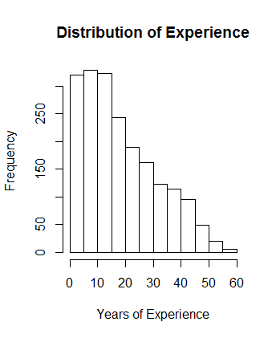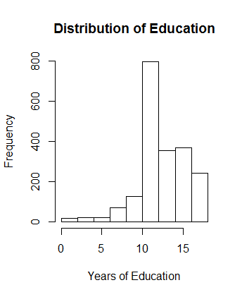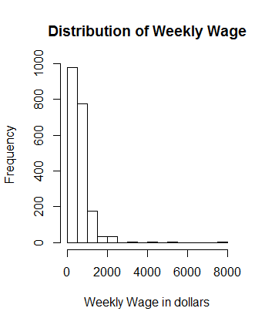Here is a summary of the distribution of weekly wage, years of education and years of experience. (33 of the data in the attribute years of experience were excluded because the data indicated a “negative” years of experience which seems not possible.)

For most workers whose wage is within 2000 dollars per week, we got some interesting findings in the distribution of weekly wage along different factors.

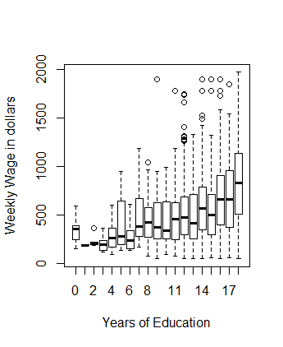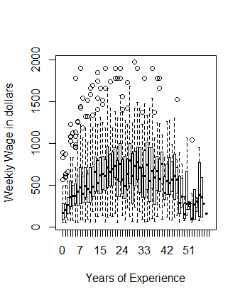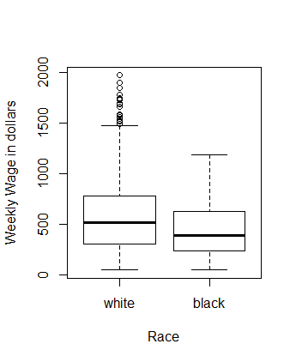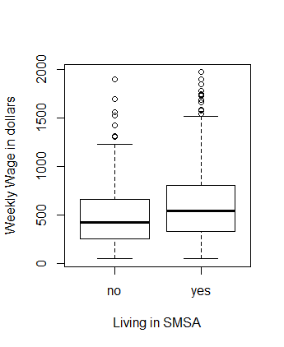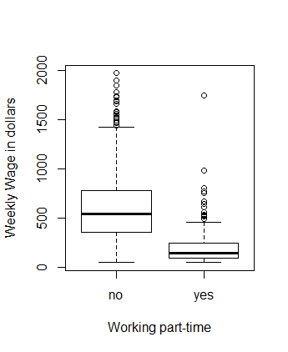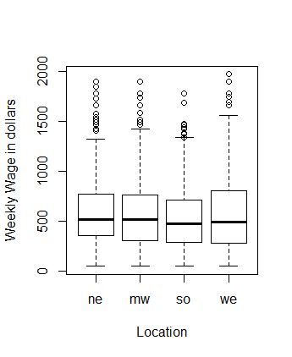

Workers’ weekly wages(median=522.30, mean=608.10, range(50.39~7716.05):

1. Increased as the years of education(median=12,mean=13.11,range(0~18) increased
2. Showed a bell-shape like trend along the years of experience(median=16,mean=18.74,range(0~59),33 negative data excluded)
3. Were higher for white than black male
4. Were higher for workers living in Standard Metropolitan Statistical Area
5. Were much higher if workers were not working part-time
6. Were slightly lower in the south than that in other parts of the country

And also, the interaction of the factors which affect the workers’ weekly wage:

1. It seems that workers living in the west had more years of education
2. More workers in the North East were living in Standard Metropolitan Statistical Area
3. More workers in the South were black
4. More workers living in the Midwest were working part-time
5. Black workers had almost same years of education as white workers did, but more years of experience, living more in the Standard Metropolitan Statistical Area, more working part-time
6. Workers living in the Standard Metropolitan Statistical Area had more years of education but almost same years of experience, slightly less likely working part-time
7. Workers working part-time often had more years of education but fewer years of experience

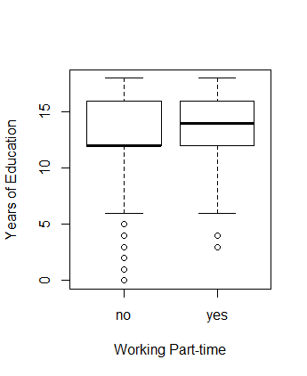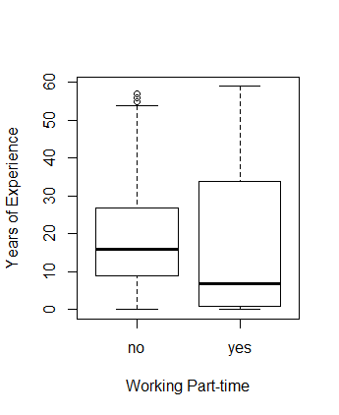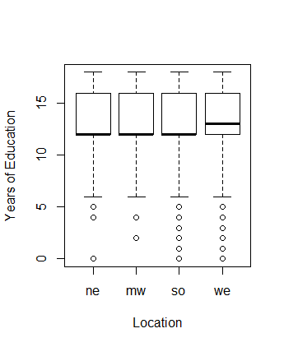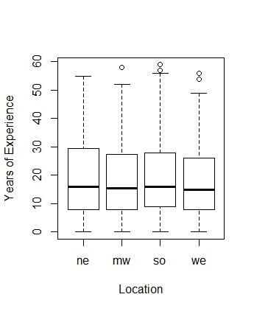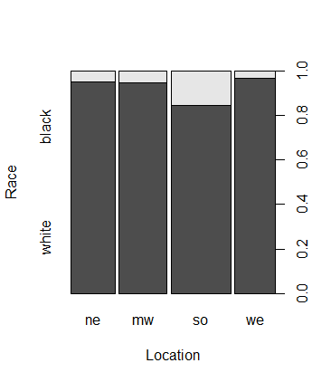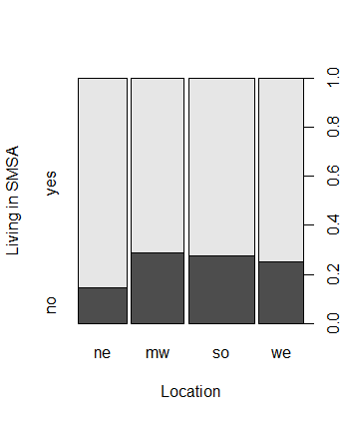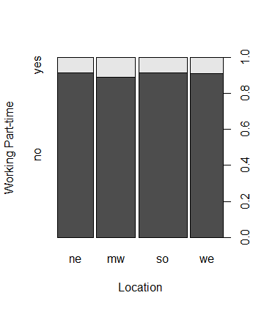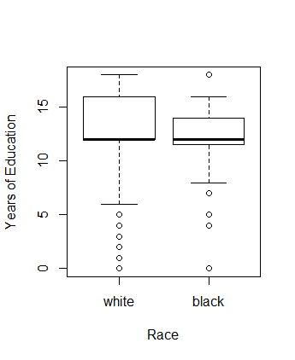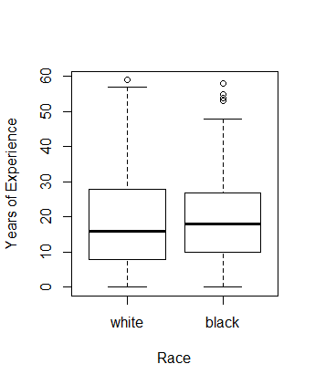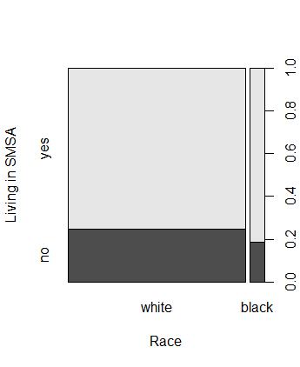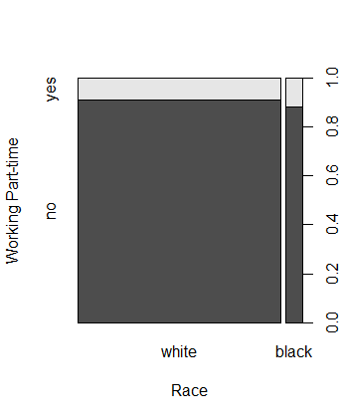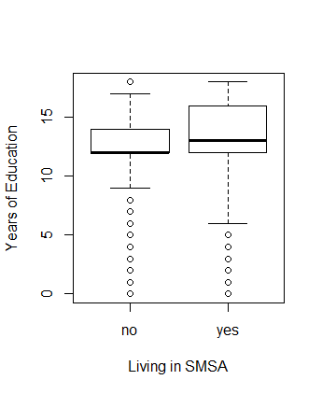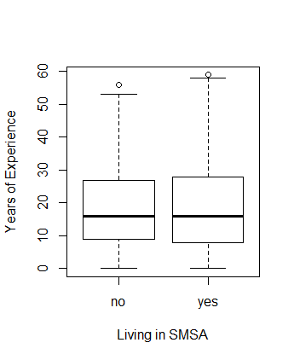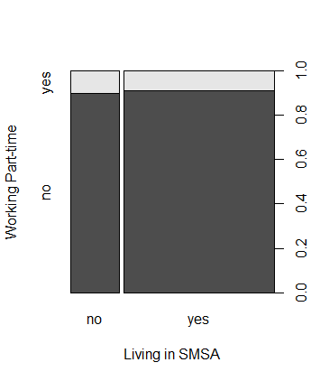

R code utilized in this homework:

library(faraway)

data(uswages)

attach(uswages)

help(uswages)

summary(uswages)

cor(uswages)

uswages$race=factor(uswages$race)

levels(uswages$race)=c("white","black")

uswages$pt=factor(uswages$pt)

levels(uswages$pt)=c("no","yes")

uswages$smsa=factor(uswages$smsa)

levels(uswages$smsa)=c("no","yes")

uswages$location[uswages$ne==1]=1

uswages$location[uswages$mw==1]=2

uswages$location[uswages$so==1]=3

uswages$location[uswages$we==1]=4

uswages$location=factor(uswages$location)

levels(uswages$location)=c("ne","mw","so","we")

sort(uswages$exper)

uswages$exper[uswages$exper<0] <- NA

hist(uswages$wage,main="Distribution of Weekly Wage",xlab="Weekly Wage in dollars")

hist(uswages$race,main="Distribution of Race")

hist(uswages$smsa,main="Living in SMSA or Not")

hist(uswages$pt,main="Working Part-time or Not")

hist(uswages$educ,main="Distribution of Education",xlab="Years of Education")

hist(uswages$exper,main="Distribution of Experience",xlab="Years of Experience")

hist(uswages$location,main="Distribution of Location",xlab="Location")

plot(factor(educ),wage,xlab="Years of Education",ylab="Weekly Wage in dollars")

plot(exper,wage,xlab="Years of Experience",ylab="Weekly Wage in dollars")

plot(uswages$location,uswages$wage,xlab="Location",ylab="Weekly Wage in dollars")

plot(uswages$race,uswages$wage,xlab="Race",ylab="Weekly Wage in dollars")

plot(uswages$educ,uswages$wage,xlab="Years of Education",ylab="Weekly Wage in dollars")

plot(factor(uswages$educ),uswages$wage,xlab="Years of Education",ylab="Weekly Wage in dollars")

plot(factor(uswages$exper),uswages$wage,xlab="Years of Experience",ylab="Weekly Wage in dollars")

plot(factor(uswages$smsa),uswages$wage,xlab="Living in SMSA",ylab="Weekly Wage in dollars")

plot(factor(uswages$pt),uswages$wage,xlab="Working part-time",ylab="Weekly Wage in dollars")

uswages$wage[uswages$wage>2000] <- NA

plot(uswages$location)

plot(uswages$location,main="Distribution of Location")

plot(uswages$location,main="Distribution of Location",xlab="Location")

plot(uswages$race,main="Distribution of Race",xlab="race")

plot(uswages$smsa,main="Living in SMSA or Not",xlab="Living in Standard Metropolitan Statistical Area")

plot(uswages$pt,main="Working Part-time or Not",xlab="Working Part-time")

plot(uswages$pt,main="Working Part-time or Not",xlab="Working Part-time")

plot(uswages$location,wage,xlab="Location",ylab="Weekly Wage in dollars")

plot(uswages$location,uswages$wage,xlab="Location",ylab="Weekly Wage in dollars")

plot(uswages$race,uswages$wage,xlab="Race",ylab="Weekly Wage in dollars")

plot(uswages$educ,uswages$wage,xlab="Years of Education",ylab="Weekly Wage in dollars")

plot(factor(uswages$educ),uswages$wage,xlab="Years of Education",ylab="Weekly Wage in dollars")

plot(factor(uswages$exper),uswages$wage,xlab="Years of Experience",ylab="Weekly Wage in dollars")

plot(factor(uswages$smsa),uswages$wage,xlab="Living in SMSA",ylab="Weekly Wage in dollars")

plot(factor(uswages$pt),uswages$wage,xlab="Working part-time",ylab="Weekly Wage in dollars")

plot(factor(uswages$location),uswages$wage,xlab="Location",ylab="Weekly Wage in dollars")

plot(factor(uswages$location),uswages$exper,xlab="Location",ylab="Years of Experience")

plot(factor(uswages$location),uswages$educ,xlab="Location",ylab="Years of Education")

plot(factor(uswages$location),uswages$race,xlab="Location",ylab="Race")

plot(factor(uswages$location),uswages$smsa,xlab="Location",ylab="Living in SMSA")

plot(factor(uswages$location),uswages$pt,xlab="Location",ylab="Working Part-time")

plot(factor(uswages$race),uswages$educ,xlab="Race",ylab="Years of Education")

plot(factor(uswages$race),uswages$exper,xlab="Race",ylab="Years of Experience")

plot(factor(uswages$race),uswages$pt,xlab="Race",ylab="Working Part-time")

plot(factor(uswages$race),uswages$smsa,xlab="Race",ylab="Living in SMSA")

plot(factor(uswages$smsa),uswages$educ,xlab="Living in SMSA",ylab="Years of Education")

plot(factor(uswages$smsa),uswages$exper,xlab="Living in SMSA",ylab="Years of Experience")

plot(factor(uswages$smsa),uswages$pt,xlab="Living in SMSA",ylab="Working Part-time")

plot(factor(uswages$educ),uswages$pt,xlab="Years of Education",ylab="Working Part-time")

plot(factor(uswages$pt),uswages$educ,xlab="Living in SMSA",ylab="Working Part-time")

plot(factor(uswages$pt),uswages$educ,xlab="Working Part-time",ylab="Years of Education")

plot(factor(uswages$pt),uswages$exper,xlab="Working Part-time",ylab="Years of Experience")

plot(factor(uswages$pt),uswages$educ,xlab="Working Part-time",ylab="Years of Education")

plot(factor(uswages$smsa),uswages$race,xlab="Working Part-time",ylab="Years of Education")

plot(factor(uswages$pt),uswages$race,xlab="Working Part-time",ylab="Years of Education")