Problem Set 5

Xiaoyue Liu 28589009 xiaoyliu@umich.edu

1.Create an HDF5 file containing the TMAX values for every day in 2014 using the GHCND data. Then write an R function that calculates the annual range (maximum minus minimum) for each station, using the data from the HDF5 file. Time how long it takes this function to run. Then calculate the same ranges using the data in-memory and time this calculation. If you cannot load the entire data into memory on your machine, load a fraction, say 10%, then adjust the time by the appropriate factor (e.g. if you load 10% of the data, scale the time by 10 to make it comparable to the HDF5 time).

#First we create the hdf5 file. I did it on the server, it took some time.

source("https://bioconductor.org/biocLite.R")

biocLite("rhdf5")

library(rhdf5)

library(data.table)

ghcn = fread("zcat -dc 2014.csv.gz")

#ghcn = fread("C:/Users/Heathtasia/Desktop/2014.csv/2014.csv")

setnames(ghcn, c("station", "date", "vtype", "value", "x1", "x2", "x3", "x4"))

setkey(ghcn, vtype, station)

stations = unique(ghcn[, station])

H5close()

fname = "ghcn_2014.hdf5"

h5createFile(fname)

for (vt in c("TMIN", "TMAX", "PRCP")) {

h5createGroup(fname, vt)

for (j in 1:length(stations)) {

st = stations[j]

if (j %% 100 == 0) {

print(j)

}

dd = ghcn[.(vt, st), .(date, value)]

dd = as.matrix(dd)

dname = sprintf("%s/%s", vt, st)

h5createDataset(fname, dname, dim(dd), level=7)

h5write(dd, fname, dname)

}

}

H5close()

#Then we compute the range using the hdf5 file

contents = h5ls(fname)

contents = contents[2:dim(contents)[1],]

stations = unique(contents$name)

dfr = data.frame()

t_hfd5=proc.time()

for (j in 1:length(stations)) {

dx = h5read(fname, sprintf("TMAX/%s", stations[j]))

dfr[stations[j], "range"] = (max(dx[, 2],na.rm=TRUE)-min(dx[,2],na.rm=TRUE)) / 10

}

timer_hdf5=proc.time()-t_hfd5

save(as.numeric(timer_hdf5),filefile="hdf5_timer.RData")

q(save="no")

>timer_hdf5

185.80 29.42 228.36

#Try compute the range using the data in memory

t_mem=proc.time()

ghcnd2014=fread("C:/Users/Heathtasia/Desktop/2014.csv/2014.csv")

setnames(ghcnd2014, c("station", "date", "vtype", "value", "x1", "x2", "x3", "x4"))

ghcnd2014=ghcnd2014[ghcnd2014$vtype=="TMAX",]

GHCN2014=ghcnd2014[,(max(value)-min(value))/10,by="station"]

timer_mem=proc.time()-t_memGHCN2014=GHCN2014[order(GHCN2014$station,1)]

>timer_mem

15.78 1.00 20.16

The range calculated is the same. Clearly using data in memory is much faster.

2. Use fread from the data.table package to load the 2014 GHCND data to memory from both a zipped file (using zcat or gzip -dc to decompress on-the-fly), and then from an uncompressed copy of the file. Time these two operations and compare.

library(data.table)

#Calculate the time for reading from zip file

t1=proc.time()

ghcn = fread("zcat -dc 2014.csv.gz")

timer1=as.numeric(proc.time()-t1)

#Calculate the time for reading from uncompressed file

t2=proc.time()

ghcn=fread("2014.csv")

timer2=as.numeric(proc.time()-t2)

Run the program on the server and I got the following result.

>timer1

[1] 19.284 0.637 26.685 6.296 0.432

> timer2

[1] 19.493 0.553 20.075 0.000 0.000

Reading from the uncompressed file require a little bit more time than reading from the zip file however it requires less time for CPU to execute the instructions.

3. Load the 2014 GHCND data into a data.table object (if you cannot load the entire data set on your machine load as large a fraction of it as possible). Then use dplyr’s group_by and summarise to compute the monthly means for every station. Do the same thing using the native data.frame grouping method. Time the two methods. Also assess whether the results of the two calculations are equivalent.

Run the following program on my own laptop. I loaded all the data into memory.

#Prepare for dataset

setnames(ghcn, c("station", "date", "vtype", "value", "x1", "x2", "x3", "x4"))

#Get the month column

ghcn$month=as.numeric(substring(ghcn$date,5,6))

#Load the 2014 GHCND data into a data.table object

GHCN=data.table(ghcn)

#Calculate the time using dplyr for grouping and calculate means

library(dplyr)

t3=proc.time()

summarise(group_by(GHCN,station,month),meantmp=mean(value))

timer3=as.numeric(proc.time()-t3)

#Calculate the time using native data.frame grouping and calculate means

t4=proc.time()

GHCN[,mean(value),by=c("station","month")]

timer4=as.numeric(proc.time()-t4)

I got the following result.

> timer3

[1] 4.17 5.72 14.52 NA NA

> timer4

[1] 2.19 0.35 2.56 NA NA

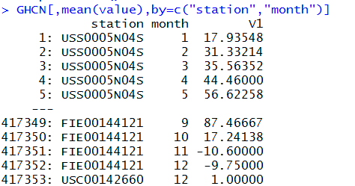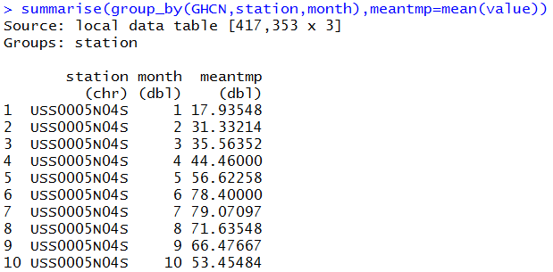When using data as a data.table object, the native data.frame grouping method runs faster than using group_by in the dplyr. The means are the same.