# Land classification from Scanner 2 (Q780)

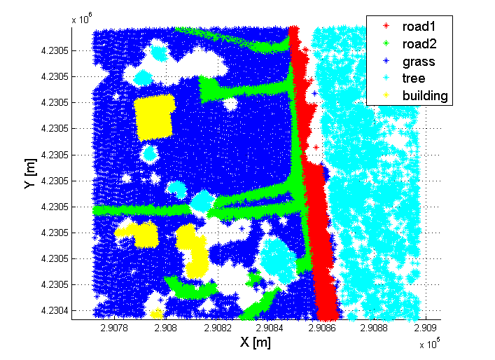

Figure 1 Categories from the Scanner 2 (Q780)

## Median waveforms

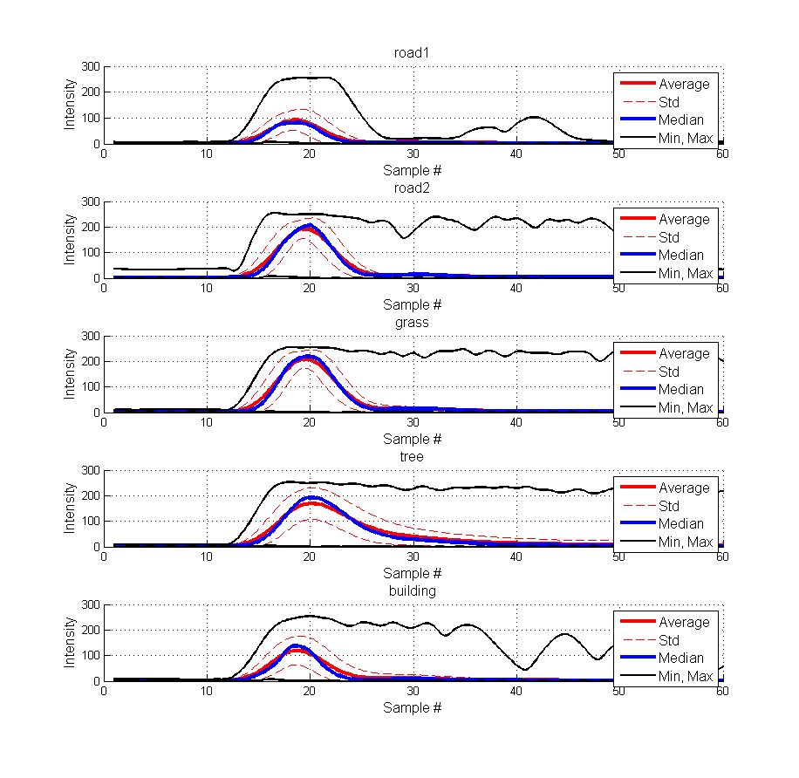

Figure 2 Original waveforms

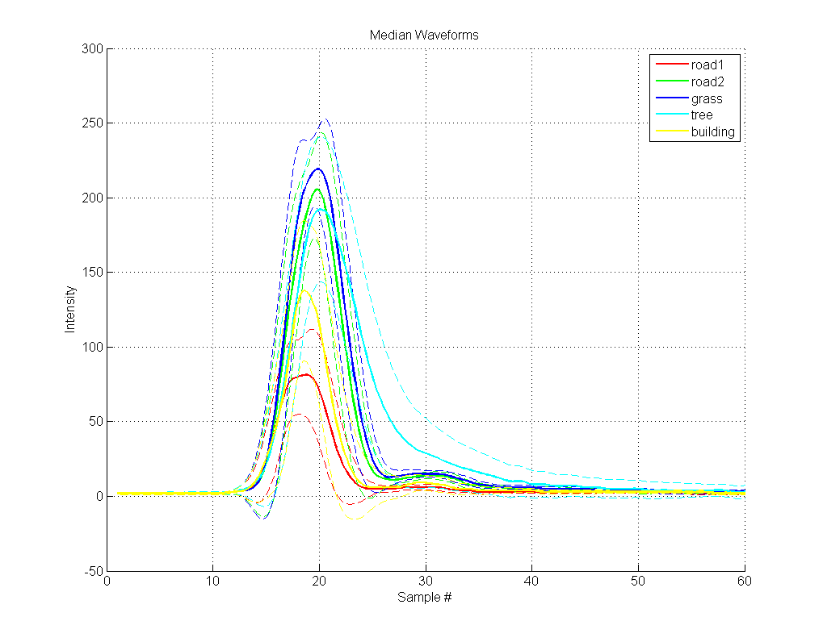

Figure 3 Median waveforms from original sample vector

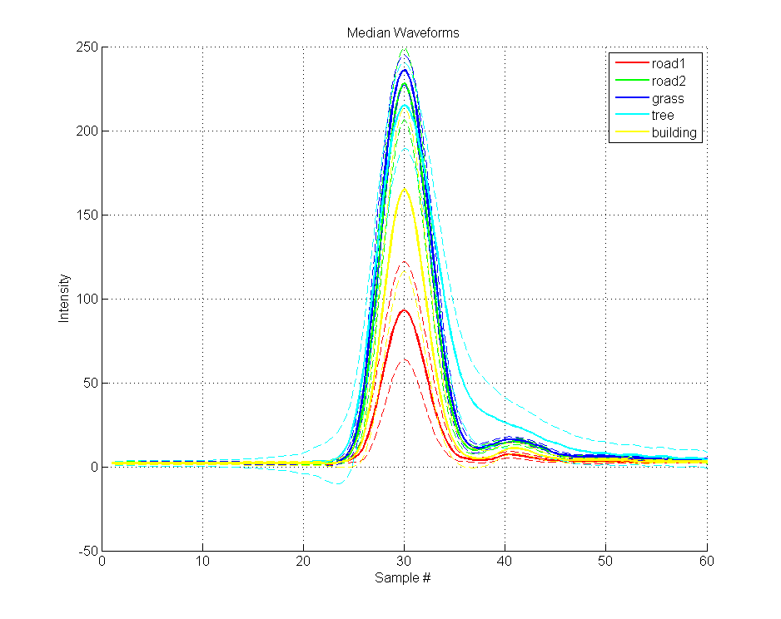

Figure 4 Median waveforms from translated sample vectors

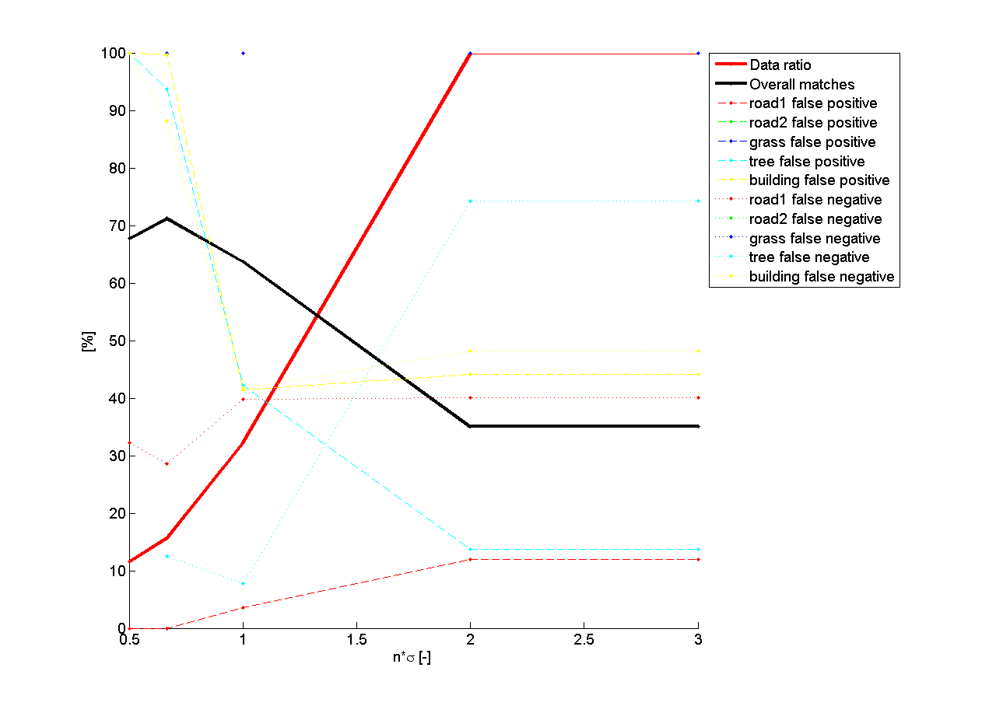

Figure 5 Distances from median waveforms

|  |  |  |  |  |  |  |
| --- | --- | --- | --- | --- | --- | --- |
|  | **road1** | **road2** | **grass** | **tree** | **building** | **False negative** |
| **road1** | **2712** | **129** | **116** | **97** | **215** | ***17.0%*** |
| *57.9%* | *2.4%* | *1.0%* | *0.9%* | *4.4%* |
| **road2** | **176** | **1270** | **2313** | **1943** | **563** | ***79.7%*** |
| *1.7%* | *17.8%* | *18.5%* | *15.6%* | *7.5%* |
| **grass** | **78** | **225** | **4792** | **2511** | **97** | ***37.8%*** |
| *0.7%* | *2.3%* | *41.7%* | *18.8%* | *1.0%* |
| **tree** | **285** | **172** | **1305** | **3259** | **191** | ***37.5%*** |
| *3.1%* | *2.4%* | *10.5%* | *32.2%* | *2.8%* |
| **building** | **875** | **344** | **44** | **352** | **745** | ***68.4%*** |
| *15.6%* | *8.3%* | *0.4%* | *3.5%* | *21.7%* |
| **False positive** | ***34.3%*** | ***40.7%*** | ***44.1%*** | ***60.1%*** | ***58.9%*** | **51.5%** |
|

Figure 6 Classification by the distance from the median waveform without threshold

|  |  |  |  |  |  |  |
| --- | --- | --- | --- | --- | --- | --- |
|  | **road1** | **road2** | **grass** | **tree** | **building** | **False negative** |
| **road1** | **2634** | **104** | **67** | **59** | **165** | ***13.0%*** |
| *69.5%* | *2.4%* | *0.9%* | *0.7%* | *4.2%* |
| **road2** | **53** | **819** | **1246** | **1678** | **338** | ***80.2%*** |
| *0.7%* | *17.2%* | *17.0%* | *22.1%* | *7.0%* |
| **grass** | **30** | **134** | **2568** | **1880** | **63** | ***45.1%*** |
| *0.4%* | *2.2%* | *39.2%* | *23.7%* | *1.1%* |
| **tree** | **150** | **102** | **543** | **1343** | **67** | ***39.1%*** |
| *2.8%* | *2.9%* | *8.9%* | *22.4%* | *2.1%* |
| **building** | **529** | **299** | **21** | **164** | **396** | ***71.9%*** |
| *12.4%* | *11.6%* | *0.4%* | *2.6%* | *19.4%* |
| **False positive** | ***22.4%*** | ***43.8%*** | ***42.2%*** | ***73.8%*** | ***61.5%*** | **50.2%** |
|

Figure 7 Classification by the distance from the median waveform with at 1 thresholds

|  |  |  |  |  |  |  |
| --- | --- | --- | --- | --- | --- | --- |
|  | **road1** | **road2** | **grass** | **tree** | **building** | **False negative** |
| **road1** | **1065** | **33** | **23** | **1** | **59** | ***9.8%*** |
| *82.5%* | *2.2%* | *0.7%* | *0.1%* | *4.6%* |
| **road2** | **10** | **221** | **584** | **0** | **51** | ***74.5%*** |
| *0.5%* | *22.3%* | *25.9%* | *0.0%* | *5.2%* |
| **grass** | **5** | **49** | **1270** | **0** | **15** | ***5.2%*** |
| *0.2%* | *3.0%* | *62.1%* | *0.0%* | *1.0%* |
| **tree** | **25** | **34** | **96** | **124** | **16** | ***58.0%*** |
| *1.7%* | *5.6%* | *4.4%* | *41.2%* | *3.6%* |
| **building** | **70** | **9** | **3** | **5** | **29** | ***75.0%*** |
| *5.7%* | *2.0%* | *0.1%* | *2.1%* | *11.3%* |
| **False positive** | ***9.4%*** | ***36.1%*** | ***35.7%*** | ***4.6%*** | ***82.9%*** | **71.3%** |
|

Figure 8 Classification by the distance from the median waveform with 0.5 sigma threshold

## Gaussian parameters

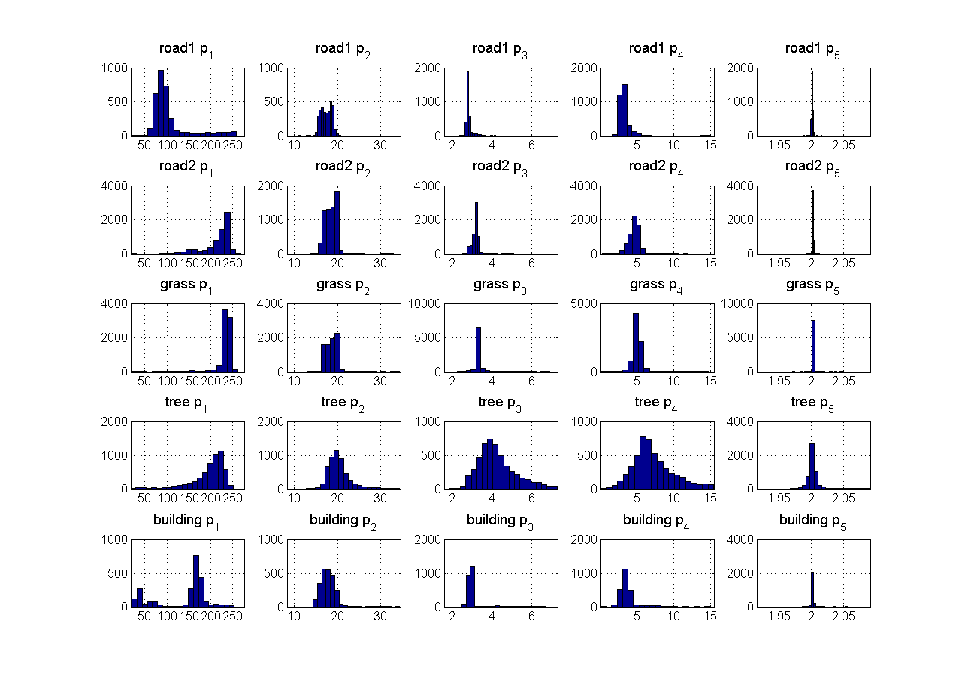

Figure 9 Gaussian parameters from original sample vectors

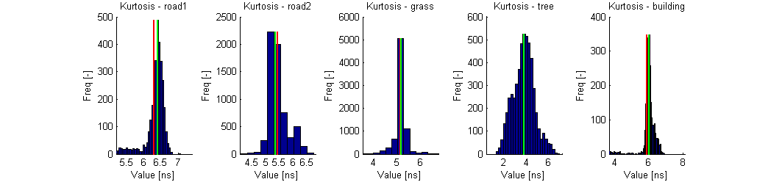

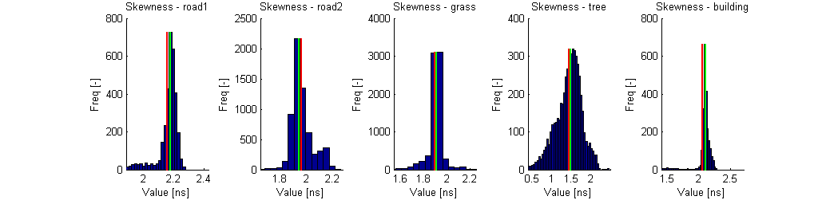

Figure 10 Kurtosis and skewness

|  |  |  |  |  |  |  |
| --- | --- | --- | --- | --- | --- | --- |
|  | **road1** | **road2** | **grass** | **tree** | **building** | **False negative** |
| **road1** | **2795** | **194** | **185** | **7** | **88** | ***14.5%*** |
| *65.6%* | *3.2%* | *1.2%* | *0.1%* | *2.0%* |
| **road2** | **145** | **1346** | **4299** | **34** | **441** | ***78.5%*** |
| *1.5%* | *17.2%* | *29.4%* | *0.3%* | *6.3%* |
| **grass** | **36** | **214** | **7252** | **125** | **76** | ***5.9%*** |
| *0.3%* | *2.1%* | *55.4%* | *1.1%* | *0.9%* |
| **tree** | **169** | **112** | **868** | **4004** | **59** | ***23.2%*** |
| *1.9%* | *1.4%* | *5.1%* | *72.5%* | *0.9%* |
| **building** | **644** | **1050** | **34** | **143** | **489** | ***79.3%*** |
| *11.7%* | *24.8%* | *0.2%* | *2.2%* | *16.2%* |
| **False positive** | ***26.2%*** | ***53.8%*** | ***42.6%*** | ***7.2%*** | ***57.6%*** | **64.0%** |
|

Figure 11 Linear discriminant analysis of the Gaussian parameters

|  |  |
| --- | --- |
| C:\Zoli\Incidence\docs\pics_land_class_2\som_points.png | C:\Zoli\Incidence\docs\pics_land_class_2\points_som_22.png |
| C:\Zoli\Incidence\docs\pics_land_class_2\som_weights.png | C:\Zoli\Incidence\docs\pics_land_class_2\wfmx_som_22.png |
| |  |  |  |  |  |  | | --- | --- | --- | --- | --- | --- | | **Group #** | **road1** | **road2** | **grass** | **tree** | **building** | | **1** | *0.0%* | *0.5%* | *3.7%* | *92.4%* | *3.4%* | | **2** | *0.0%* | *0.0%* | *3.7%* | *95.2%* | *1.1%* | | **3** | *0.0%* | *1.0%* | *5.5%* | *90.0%* | *3.5%* | | **4** | *1.1%* | *32.7%* | *57.7%* | *8.2%* | *0.2%* | | **5** | *6.8%* | *27.2%* | *5.4%* | *13.5%* | *47.1%* | | **6** | *73.8%* | *2.1%* | *1.2%* | *5.6%* | *17.4%* | | **7** | *1.6%* | *30.4%* | *59.8%* | *8.0%* | *0.3%* | | **8** | *5.4%* | *67.5%* | *12.9%* | *12.7%* | *1.4%* | | **9** | *8.5%* | *30.5%* | *4.6%* | *5.8%* | *50.6%* | | |  |  |  |  |  |  | | --- | --- | --- | --- | --- | --- | | **Group #** | **road1** | **road2** | **grass** | **tree** | **building** | | **1** | *73.4%* | *2.3%* | *1.1%* | *5.9%* | *17.2%* | | **2** | *0.0%* | *0.5%* | *3.8%* | *92.5%* | *3.2%* | | **3** | *7.6%* | *32.3%* | *5.4%* | *12.1%* | *42.6%* | | **4** | *1.7%* | *36.5%* | *53.5%* | *8.0%* | *0.3%* | |

Table 1 Land classification by SOM with 4x4 neuron configuration (left) and 2x2 neuron configuration (right)

## Combined method

|  |  |  |  |  |  |  |  |  |  |  |  |  |  |  |  |  |  |  |  |  |  |  |  |  |  |  |  |  |  |  |  |  |  |  |  |  |  |  |  |  |  |  |  |  |  |  |  |  |  |  |  |  |  |  |  |  |  |  |  |  |  |  |  |  |  |  |  |  |  |  |  |  |  |  |  |
| --- | --- | --- | --- | --- | --- | --- | --- | --- | --- | --- | --- | --- | --- | --- | --- | --- | --- | --- | --- | --- | --- | --- | --- | --- | --- | --- | --- | --- | --- | --- | --- | --- | --- | --- | --- | --- | --- | --- | --- | --- | --- | --- | --- | --- | --- | --- | --- | --- | --- | --- | --- | --- | --- | --- | --- | --- | --- | --- | --- | --- | --- | --- | --- | --- | --- | --- | --- | --- | --- | --- | --- | --- | --- | --- | --- |
|  | |  |  |  |  |  |  |  | | --- | --- | --- | --- | --- | --- | --- | |  | **road1** | **road2** | **grass** | **tree** | **building** | **False negative** | | **road1** | **1948** | **65** | **116** | **13** | **146** | ***14.9%*** | | *64.6%* | *1.9%* | *1.2%* | *0.2%* | *3.6%* | | **road2** | **110** | **907** | **2723** | **62** | **583** | ***79.3%*** | | *1.6%* | *19.3%* | *28.7%* | *0.8%* | *10.1%* | | **grass** | **36** | **162** | **4802** | **310** | **82** | ***10.9%*** | | *0.4%* | *2.5%* | *57.1%* | *3.5%* | *1.1%* | | **tree** | **116** | **71** | **168** | **3215** | **78** | ***11.9%*** | | *1.9%* | *1.5%* | *1.5%* | *77.5%* | *1.4%* | | **building** | **464** | **11** | **7** | **115** | **1055** | ***36.1%*** | | *12.0%* | *0.4%* | *0.1%* | *2.2%* | *41.5%* | | **False positive** | ***27.2%*** | ***25.4%*** | ***38.6%*** | ***13.5%*** | ***45.7%*** | **68.7%** | | |
|  |  |
|  | |  |  |  |  |  |  |  | | --- | --- | --- | --- | --- | --- | --- | |  | **road1** | **road2** | **grass** | **tree** | **building** | **False negative** | | **road1** | **2273** | **0** | **1** | **0** | **14** | ***0.7%*** | | *71.5%* | *0.0%* | *0.0%* | *0.0%* | *0.4%* | | **road2** | **256** | **421** | **3281** | **0** | **427** | ***90.4%*** | | *3.5%* | *9.4%* | *34.6%* | *0.0%* | *7.7%* | | **grass** | **80** | **63** | **5069** | **94** | **86** | ***6.0%*** | | *0.9%* | *1.1%* | *58.2%* | *1.0%* | *1.2%* | | **tree** | **64** | **10** | **36** | **3531** | **7** | ***3.2%*** | | *0.9%* | *0.2%* | *0.3%* | *92.4%* | *0.1%* | | **building** | **491** | **0** | **0** | **79** | **1082** | ***34.5%*** | | *11.4%* | *0.0%* | *0.0%* | *1.5%* | *49.5%* | | **False positive** | ***28.2%*** | ***14.8%*** | ***39.6%*** | ***4.7%*** | ***33.0%*** | **71.3%** | | |

Table 2 Results on the training set before applying mode filter (up) and after if (down)

|  |  |  |  |  |  |  |  |  |  |  |  |  |  |  |  |  |  |  |  |  |  |  |  |  |  |  |  |  |  |  |  |  |  |  |  |  |  |  |  |  |  |  |  |  |  |  |  |  |  |  |  |  |  |  |  |  |  |  |  |  |  |  |  |  |  |  |  |  |  |  |  |  |  |  |  |
| --- | --- | --- | --- | --- | --- | --- | --- | --- | --- | --- | --- | --- | --- | --- | --- | --- | --- | --- | --- | --- | --- | --- | --- | --- | --- | --- | --- | --- | --- | --- | --- | --- | --- | --- | --- | --- | --- | --- | --- | --- | --- | --- | --- | --- | --- | --- | --- | --- | --- | --- | --- | --- | --- | --- | --- | --- | --- | --- | --- | --- | --- | --- | --- | --- | --- | --- | --- | --- | --- | --- | --- | --- | --- | --- | --- |
|  | |  |  |  |  |  |  |  | | --- | --- | --- | --- | --- | --- | --- | |  | **road1** | **road2** | **grass** | **tree** | **building** | **False negative** | | **road1** | **826** | **28** | **45** | **5** | **77** | ***15.8%*** | | *63.2%* | *1.9%* | *1.1%* | *0.2%* | *4.4%* | | **road2** | **45** | **382** | **1180** | **28** | **245** | ***79.7%*** | | *1.5%* | *19.0%* | *29.2%* | *0.8%* | *9.8%* | | **grass** | **13** | **73** | **2045** | **137** | **43** | ***11.5%*** | | *0.4%* | *2.7%* | *56.7%* | *3.6%* | *1.4%* | | **tree** | **64** | **26** | **67** | **1369** | **38** | ***12.5%*** | | *2.4%* | *1.3%* | *1.4%* | *76.8%* | *1.6%* | | **building** | **203** | **4** | **3** | **48** | **450** | ***36.4%*** | | *12.3%* | *0.3%* | *0.1%* | *2.1%* | *40.5%* | | **False positive** | ***28.2%*** | ***25.5%*** | ***38.8%*** | ***13.7%*** | ***47.2%*** | **68.1%** | | |
|  |  |
|  | |  |  |  |  |  |  |  | | --- | --- | --- | --- | --- | --- | --- | |  | **road1** | **road2** | **grass** | **tree** | **building** | **False negative** | | **road1** | **969** | **0** | **0** | **0** | **12** | ***1.2%*** | | *70.2%* | *0.0%* | *0.0%* | *0.0%* | *0.7%* | | **road2** | **99** | **166** | **1429** | **0** | **186** | ***91.2%*** | | *3.1%* | *8.6%* | *35.1%* | *0.0%* | *7.7%* | | **grass** | **37** | **29** | **2159** | **40** | **46** | ***6.6%*** | | *1.0%* | *1.2%* | *57.2%* | *1.1%* | *1.5%* | | **tree** | **49** | **11** | **34** | **1461** | **9** | ***6.6%*** | | *1.7%* | *0.6%* | *0.7%* | *89.4%* | *0.4%* | | **building** | **215** | **1** | **0** | **30** | **462** | ***34.7%*** | | *11.5%* | *0.1%* | *0.0%* | *1.4%* | *48.1%* | | **False positive** | ***29.2%*** | ***19.8%*** | ***40.4%*** | ***4.6%*** | ***35.4%*** | **70.1%** | | |

Table 3 Results on the validation set before applying mode filter (up) and after if (down)

# Roof1 from impulse response (using outgoing waveforms)

|  |  |  |  |  |  |  |
| --- | --- | --- | --- | --- | --- | --- |
|  |  |  |  |  |  |  |
| **Class 1** | AVG | *31.769* | *17.451* | *3.234* | *-2.442* | *1.999* |
| **Class 1** | STD | *7.79* | *1.382* | *0.325* | *0.35* | *0.012* |
| **Class 2** | AVG | *31.326* | *16.949* | *3.748* | *-2.611* | *2.927* |
| **Class 2** | STD | *8.019* | *6.392* | *5.523* | *1.936* | *11.531* |

Table 4 Statistics of the Gaussian parameters

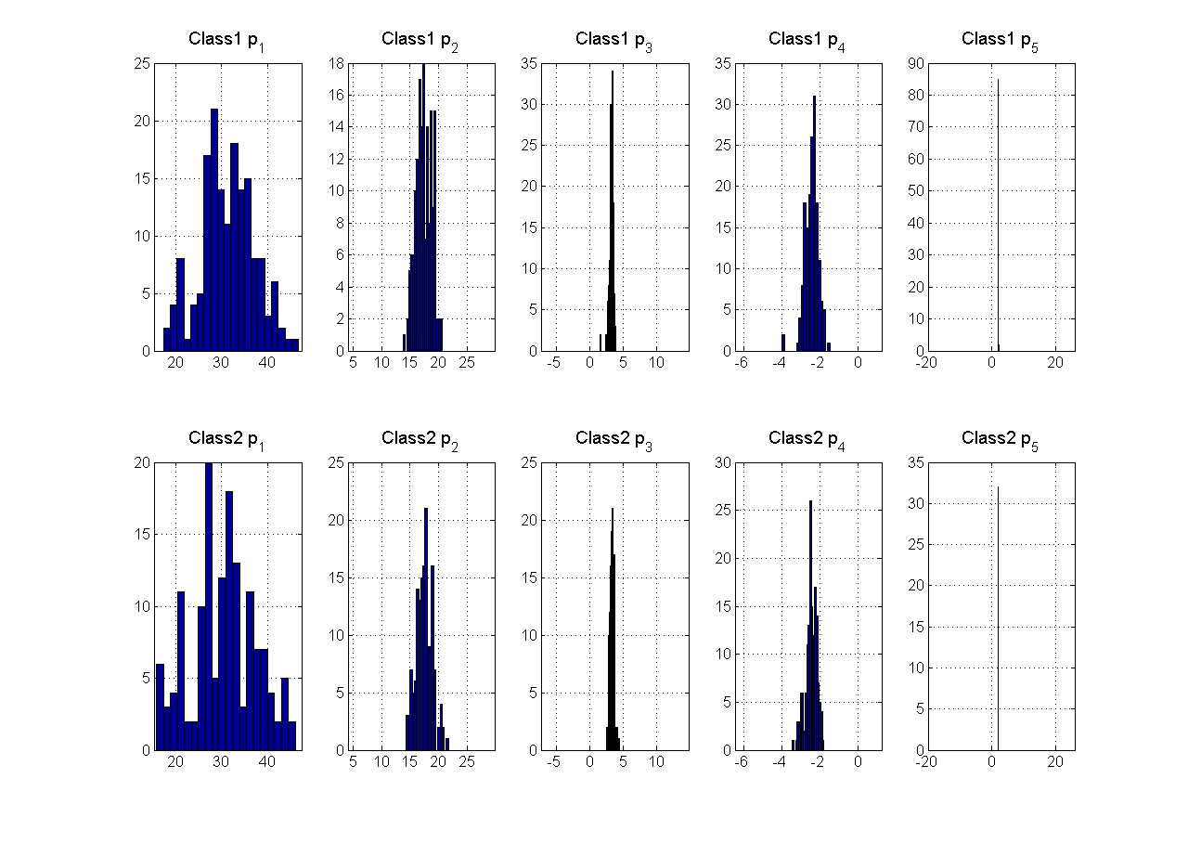

Figure 12 Gaussian parameters

|  |  |  |  |  |
| --- | --- | --- | --- | --- |
|  | **Skewness** | | **Kurtosis** | |
| **AVG** | **Median** | **AVG** | **Median** |
| **Class 1** | *1.794* | *1.796* | *5.236* | *5.144* |
| **Class 2** | *1.740* | *1.811* | *5.073* | *5.210* |

Table 5 Skewness and Kurtosis results

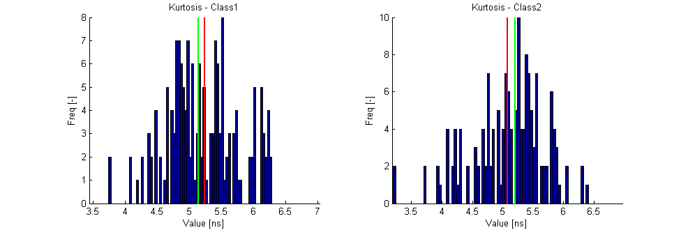

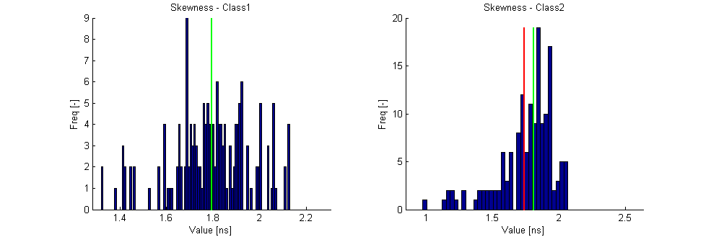

Figure 13 Histograms of the skewness and kurtosis

|  |  |  |  |
| --- | --- | --- | --- |
|  | **roof1** | **roof2** | **False negative** |
| **roof1** | **102** | **63** | ***38.2%*** |
| *41.1%* | *26.7%* |
| **roof2** | **83** | **71** | ***53.9%*** |
| *32.4%* | *32.7%* |
| **False positive** | ***44.9%*** | ***47.0%*** | **54.2%** |
|

Table 6 Confusion matrix from the discriminant analysis

## Median waveforms

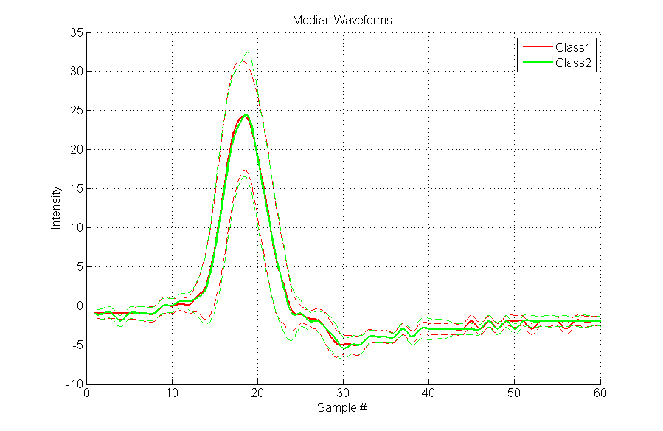

Figure 14 Median waveforms

## Neural network

|  |  |
| --- | --- |
| **Dataset:** roof\_1  **No. of points:** 330  **No. of selected points:** 300 (100.0%)  **Neurons:** [5 10] – sigmoid transfer function | |
| C:\Zoli\Incidence\docs\pics_roof1_impulse_response\nn_cfmx_overall.png   1. Confusion matrix of overall data | C:\Zoli\Incidence\docs\pics_roof1_impulse_response\nn_cfmx_train.png   1. Confusion matrix of training set |
| C:\Zoli\Incidence\docs\pics_roof1_impulse_response\nn_cfmx_test.png  (c) Confusion matrix of validation set | C:\Zoli\Incidence\docs\pics_roof1_impulse_response\nn_waves.png   1. Translated sample vectors (waveforms) |
| C:\Zoli\Incidence\docs\pics_roof1_impulse_response\nn_hist.png   1. Histogram of the Neural netowrk outputs | C:\Zoli\Incidence\docs\pics_roof1_impulse_response\nn_points.png   1. The result: classified points in the 3D space |