Project: **eMart**

Git Repository: <https://github.com/liuxuanhe/eMart>

UI Design Online: <https://free.modao.cc/app/0df057e4335902a6c9144640413e1d309f14dafd?simulator_type=device&sticky>

① eMart Mysql Database design ER diagram

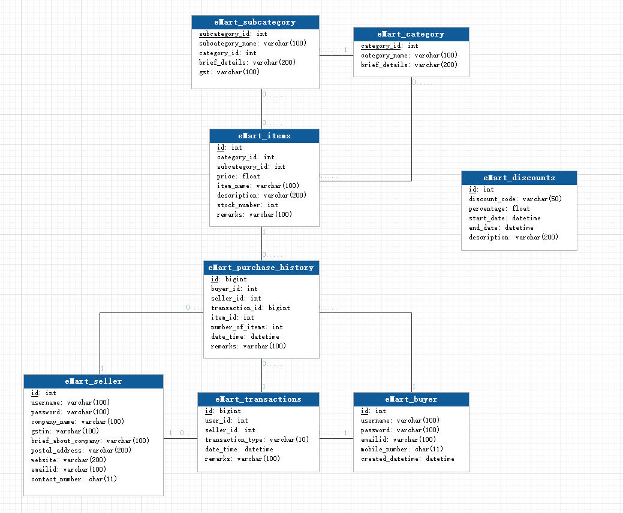

②UI Design Wireframe

1. Login 2.Sign Up

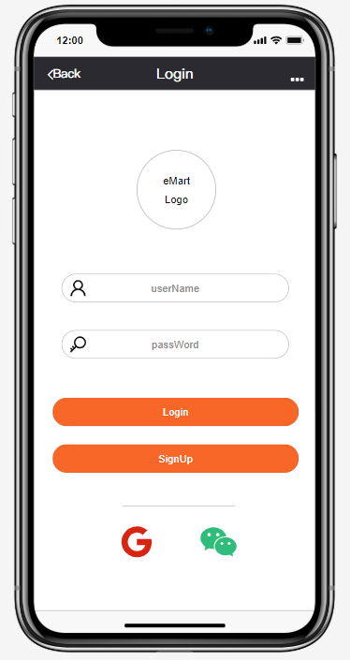 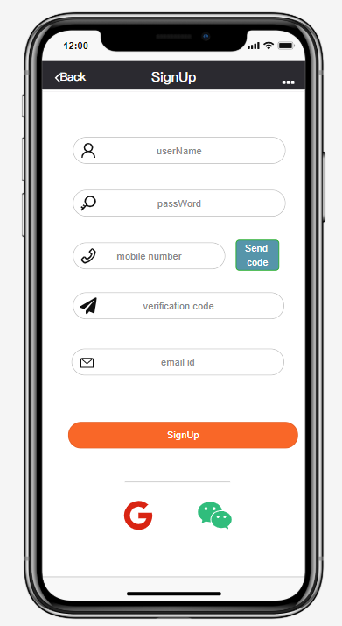

3. Shop 4.Shop Detail

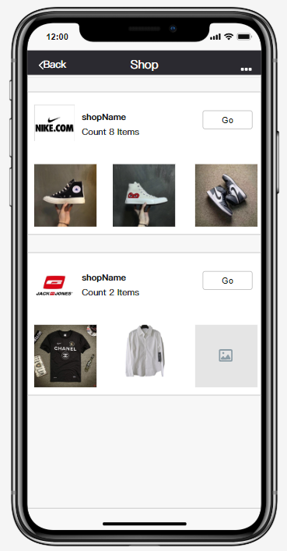 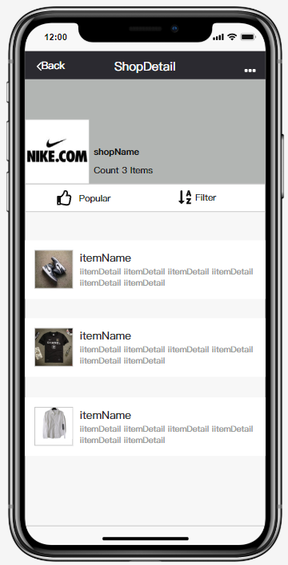

5.Search 6.Search List

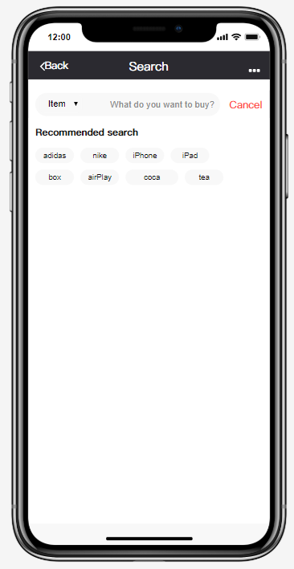 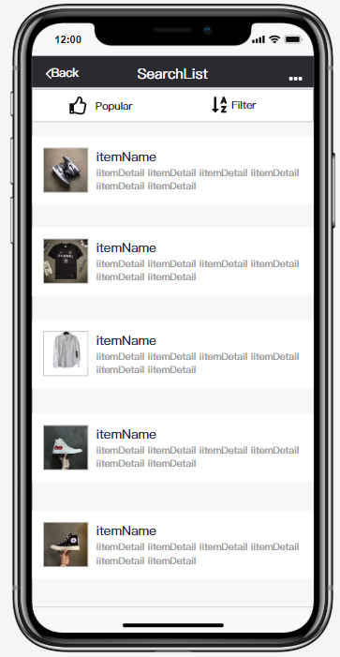

7. Filter 8.Item Detail

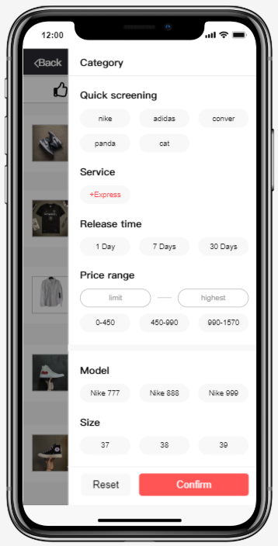 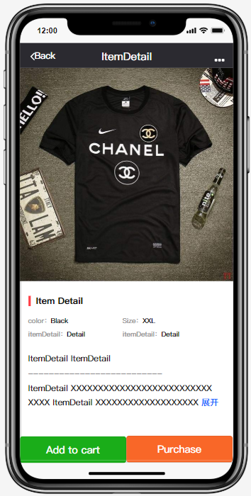

9. Shopping Cart 10.Pay

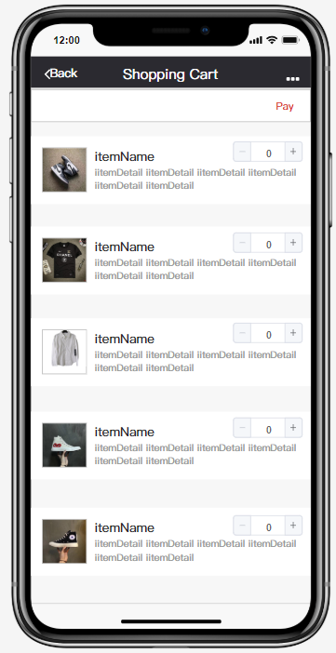 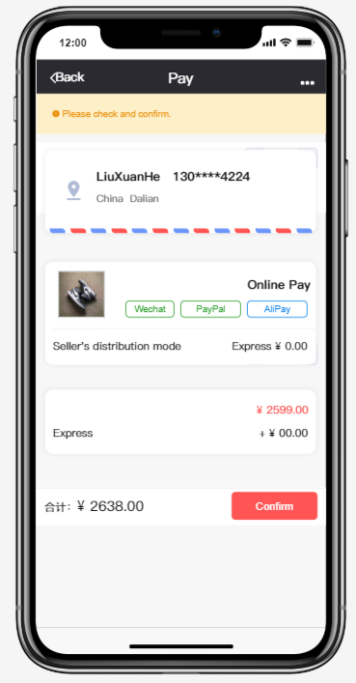

11. Address 12.Payment List

