Route-2 Defense XLII — Full-scale GUE Pair Correlation and the Online Simple-Zero Proportion 1−o(1): S0 Numerical Orientation
(Calibration Fixes, Super-GUE Repulsion, and Theoretical Correspondence)
—《Spectral Duality Arguments》series (d1): the S0 gate verdict
October 24, 2026
Abstract:
Defense XLII continues the XLI main line, “drive to 1”: upgrade the hypothesis (H2) to full-scale GUE pair correlation as λ(T)→∞ (a strong Montgomery-type statement for the fixed-modulus real character L(s,χ₅)), so that Lamzouri’s Proposition 2.1 directly yields A→1 and the union online simple-zero proportion →1−o(1). This note completes the S0 numerical orientation (gate verdict). Method: T=6×10⁵ zero data (999354 ζ-zeros, 1149836 L(χ₅)-zeros); kernel family K_a(u)=sinc²(πu/a) with spectral support λ_eff=π/a; pair constant A=1+ΣK²/N (ordered pairs); local normalization u=|Δ|·ρ(t_mid); two-sided GUE/Poisson comparison. Results: the full A(λ) curve (λ_eff∈[0.39,31.4]) tracks the two-sided GUE prediction closely and approaches 1 monotonically at the narrow end with no rebound (as a=0.5→0.1, A−1 falls from 1.49e-2 to 1.3e-4); no sign of a repulsion-violating gap (s_min=0.0123/0.0133; count of s<0.01 is 0); the observed values lie systematically below GUE (super-GUE repulsion), a GUE simulation excludes finite-N artifacts, and the segment drift shows the negative deviation converging with T. Three calibration fixes: the λ_eff conversion is pinned down (the XLI document’s earlier assignment was inverted), the −1 term in the L-density is removed (nearest-neighbor mean 0.9197→1.0027), and the global δ vs local ρ differ by 0.7% (the XLI numerical conclusions are unchanged). Verdict: S0 passes, proceed to S1. Three-layer theoretical correspondence: the Montgomery pair-correlation conjecture (GUE universality class), β=2 level repulsion O(a³) (universal shape), and the super-GUE negative deviation attributed to finite-T arithmetic terms (the BGS error / Montgomery F(α)≥|α|, same source).
Keywords: full-scale GUE pair correlation; online simple-zero proportion 1−o(1); pair constant; super-GUE repulsion; calibration fixes

1 Background and Main Line

1.1 XLI coordinates and the “drive to 1” route
Offense XLI (delivered to d1) closed the QRH constant mechanism under the pseudorandom (GUE) premise: single-family pair constants A_min=1.0079 (ζ) / 1.0114 (L) with kernel fejer_a0.5, the 7/8 threshold A≤1.125 met with margin 0.1171/0.1136; the decomposition argument gives the union online simple-zero proportion ≈0.990; the theorem takes a purely conditional (weak-premise) form whose hypotheses (H1)(H2) are directly testable numerically. XLI §8 sets the next-stage main line: upgrade (H2) to full-scale GUE pair correlation as λ(T)→∞ — a strong Montgomery-type statement for the fixed-modulus real character L(s,χ₅) (an open construction within our framework) — whence Proposition 2.1 directly gives A→1 and the online proportion →1−o(1), i.e. the framework-internal version of the literature statement “strong pair-correlation conjecture ⟹ almost all zeros are simple”; the 7/8 threshold remains the current theorem coordinate. The user rejected the 31/32 threshold (7/8 is the current AI value), fixing the main-line target as “drive to 1”.

1.2 Four-stage plan and the S0 gate
The “drive to 1” plan has four stages S0–S3: S0 numerical orientation (gate: does A(λ) approach 1 monotonically with no rebound over long range); S1 theoretical construction (λ(T) growth scheme, derivation of A=1+O(λ^{-1}), weighted union theorem form); S2 numerical verification (Weil explicit-formula real-part injection sensitivity: measurability of N_off·δ²·(logx)² accumulation); S3 closed-loop archival. This note executes S0 and gives the verdict.

2 Numerical Setup and Methods

2.1 Data and zero density
Zero data: T=6×10⁵ with t<300 removed; 999354 ζ-zeros and 1149836 L(s,χ₅)-zeros. Normalization density ρ_ζ(t)=log(t/2π)/2π; for the L family the constant term −1 in ρ_L=(1/2π)[log(t/(2π))−1+log5] was found by calibration to be erroneous: after removing it, the nearest-neighbor mean nn_mean rises from 0.9197 to 1.0027 (ζ is exactly 1.0000), a calibration factor ≈1.087. The global scale δ=logT/2π=2.1175 (used in XLI) gives u-average ≈1.74≠1 over the wide-band data, and wide kernels amplify the normalization error — S0 therefore adopts the local normalization u=|Δ|·ρ(t_mid).

2.2 Kernel family and spectral-support conversion
Kernel K_a(u)=sinc²(πu/a). The spectral support is λ_eff(a)=π/a (Fourier convention e^{-2πiξu}); see Table 1. The XLI document’s statement “fejer_a0.5 has spectral support ≈0.5” is an inverted erroneous assignment — fejer_a0.5 actually has λ_eff=π/0.5=6.28≫1/2, far beyond the λ≤1/2 allowed in the unconditional framework (that freedom is precisely what the pseudorandom relaxation provides).
Table 1 Kernel width a and spectral support λ_eff=π/a (selection)
a | 0.1 | 0.25 | 0.5 | 1.0 | 2.0 | 4.0 | 8.0
λ_eff=π/a | 31.42 | 12.57 | 6.28 | 3.14 | 1.57 | 0.79 | 0.39

2.3 Pair constant, normalization, and two-sided comparison
A(K)=1+Σ_{ordered pairs}K(δΔ)²/N (ordered pairs count both sides i≠j; this is the ΣK² in Proposition 2.1). The two-sided GUE prediction is GUE2(a)=1+2∫₀^∞(1−sinc²πu)sinc⁴(πu/a)du (two-point correlation ρ₂=1−sinc²πu); the Poisson baseline is Poi2(a)=1+2a/3. The initial one-sided comparison (missing the factor 2) counted the ordered-pair sum at half strength and produced the false alarm of “super-Poisson deviation”; a minimal geometric check (constant-intensity Poisson narrow band, uniform ρ≡1 points, analytic ∫sinc⁴=1/3) identified a convention problem rather than a code bug — the final version uses the two-sided comparison.

2.4 Three calibration fixes
(1) λ_eff conversion: fejer_a0.5 is 6.28, not 0.5 (inversion fixed); (2) the L-density −1 term: after removal nn_mean=1.0027; (3) global δ vs local ρ: ζ a0.5 reads 1.00789 (reproducing audit6 exactly) in the global convention against 1.01494 locally, a 0.7% difference that does not overturn the XLI conclusions (margin 0.11–0.12) — nevertheless the XLI numerical statements (Table 1/Table 3, the ρ_L formula, the λ_eff annotation) must be disclosed in the next XLI revision.

3 S0 Results

3.1 The full A(λ) curve (Table 2, Fig. 1)
Table 2 Pair constant A(λ), full curve (T=6×10⁵, local normalization, ordered pairs; ζ−GUE2 = deviation of the observed from the two-sided GUE prediction)
a | λ_eff=π/a | A_ζ | A_L | GUE2 | Poi2 | ζ−GUE2
0.1 | 31.4159 | 1.00013 | 1.000171 | 1.000162 | 1.066667 | -3e-05
0.15 | 20.944 | 1.000436 | 1.000514 | 1.000537 | 1.1 | -0.0001
0.2 | 15.708 | 1.001026 | 1.00111 | 1.001253 | 1.133333 | -0.00023
0.25 | 12.5664 | 1.001986 | 1.002031 | 1.002409 | 1.166667 | -0.00042
0.3 | 10.472 | 1.003393 | 1.003365 | 1.004095 | 1.2 | -0.0007
0.35 | 8.976 | 1.005321 | 1.005194 | 1.006396 | 1.233333 | -0.00107
0.4 | 7.854 | 1.007844 | 1.007593 | 1.009387 | 1.266667 | -0.00154
0.45 | 6.9813 | 1.01103 | 1.010639 | 1.013137 | 1.3 | -0.00211
0.5 | 6.2832 | 1.014941 | 1.014399 | 1.017708 | 1.333333 | -0.00277
0.75 | 4.1888 | 1.04724 | 1.045839 | 1.054492 | 1.5 | -0.00725
1.0 | 3.1416 | 1.104242 | 1.101603 | 1.116667 | 1.666667 | -0.01242
1.5 | 2.0944 | 1.291607 | 1.285773 | 1.310764 | 2.0 | -0.01916
2.0 | 1.5708 | 1.545402 | 1.536782 | 1.566666 | 2.333333 | -0.02126
3.0 | 1.0472 | 2.133698 | 2.120731 | 2.155555 | 2.999999 | -0.02186
4.0 | 0.7854 | 2.762261 | 2.746563 | 2.78333 | 3.666664 | -0.02107
6.0 | 0.5236 | 4.058051 | 4.040832 | 4.077762 | 4.999985 | -0.01971
8.0 | 0.3927 | 5.371905 | 5.355897 | 5.391618 | 6.333284 | -0.01971

Reading: (i) the three-layer structure Poisson>GUE>observed — repulsion suppresses the pair sum; (ii) the observed values track GUE2 closely (wide-end plateau −0.020~−0.022), with no rebound at any scale; (iii) the narrow end is monotone to 1: as a=0.5→0.1, A_ζ−1 falls monotonically from 0.01494 to 0.00013, and A_L−1 from 0.01440 to 0.00017 — monotonicity verdict True.
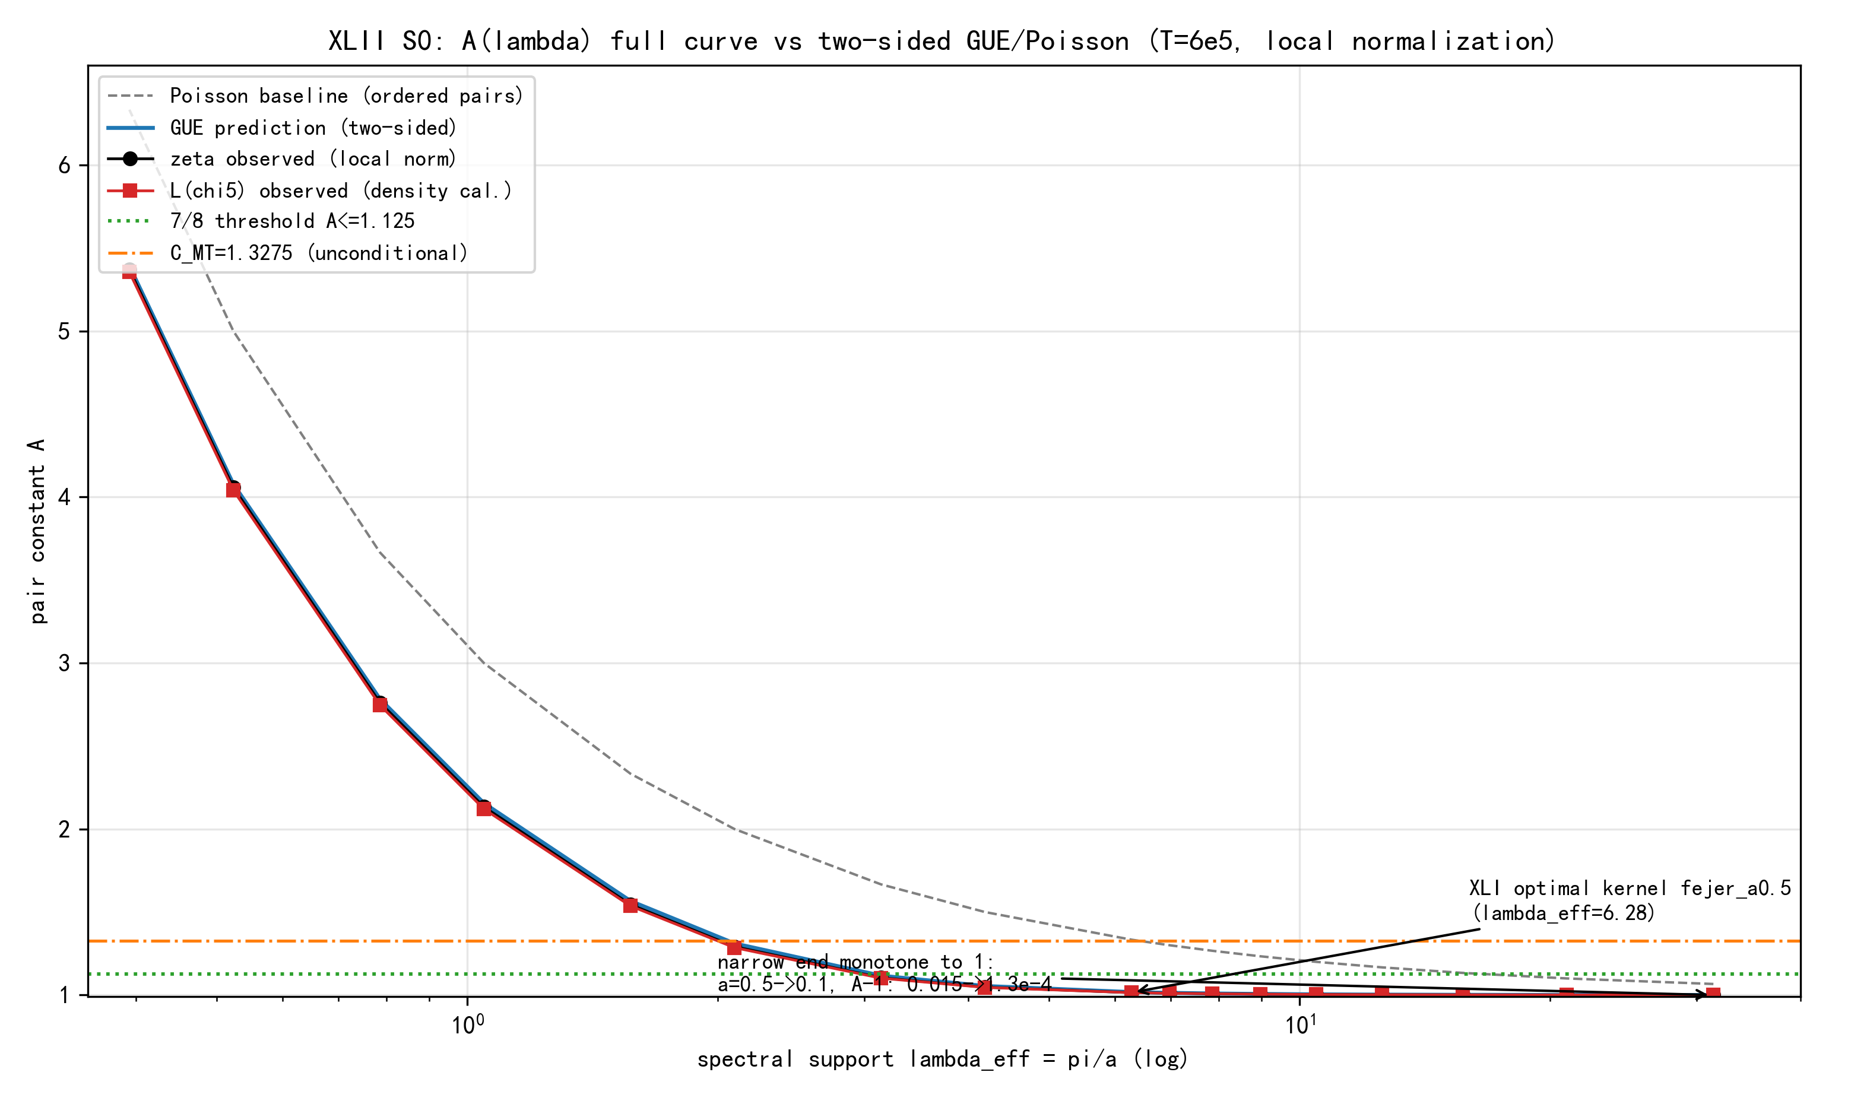
Fig. 1 Full A(λ) curve vs two-sided GUE/Poisson (T=6×10⁵, local normalization): observed (ζ black, L red) hugging the GUE prediction (blue); three-layer structure, 7/8 threshold and C_MT reference lines; monotone approach to 1 with no rebound at the narrow end

3.2 Minimal gaps and the repulsion-violation search (Table 3)
Table 3 Minimal gaps and repulsion-violation counts (s<ε = number of normalized nearest-neighbor gaps below ε; GUE column = theoretical prediction)
family | n | s_min | s<0.05 | s<0.01 | s<0.005 | s<0.001 | GUE(s<0.01)
ζ | 999354 | 0.01231 | 124 | 0 | 0 | 0 | 1.1
L | 1149836 | 0.01326 | 180 | 0 | 0 | 0 | 1.2

The count of s<0.01 is 0 (GUE prediction 1.1/1.2) — no sign of a repulsion-violating gap. Structural multiple zeros (their pair term K(0)=1 does not vanish as the kernel narrows) would block A→1; this obstacle is excluded here.

3.3 Finite-T fluctuation calibration (Table 4)
Table 4 Segment drift of A (5 segments, 300–6×10⁵, local normalization; adj = maximal adjacent-segment difference, range = full-span difference)
a | family | seg1 | seg2 | seg3 | seg4 | seg5 | adj max | range
0.3 | ζ | 1.003053 | 1.003287 | 1.003704 | 1.003405 | 1.003519 | 0.000417 | 0.000651
0.5 | ζ | 1.013811 | 1.014732 | 1.015648 | 1.014947 | 1.01541 | 0.00092 | 0.001837
1.0 | ζ | 1.100496 | 1.1037 | 1.10518 | 1.105092 | 1.10593 | 0.003205 | 0.005434
2.0 | ζ | 1.541205 | 1.544822 | 1.546 | 1.54676 | 1.547298 | 0.003617 | 0.006093
0.3 | L | 1.003195 | 1.003306 | 1.003502 | 1.003562 | 1.003284 | 0.000278 | 0.000367
0.5 | L | 1.013435 | 1.014179 | 1.014736 | 1.014835 | 1.014709 | 0.000744 | 0.0014
1.0 | L | 1.097357 | 1.100856 | 1.102223 | 1.103206 | 1.103535 | 0.003498 | 0.006178
2.0 | L | 1.530121 | 1.535878 | 1.537774 | 1.539015 | 1.539824 | 0.005757 | 0.009702

Verdict: the narrow-end signal far exceeds the drift (ζ a0.5: adj ≤0.00092, range 0.00184; L: ≤0.00074 / 0.0014); the wide-end negative deviation (a −0.02 plateau) exceeds the drift by a factor ≈3 — a systematic signal. The negative deviation converges with height: ζ a0.5 across five segments moves 1.0138→1.0154 toward GUE2=1.0177, L similarly — the signature of a finite-T arithmetic term.

3.4 GUE simulation comparison
GUE matrix simulation (N=4000×12, calibrated so that nn_mean=1.0000): A_sim essentially coincides with the GUE2 theory (positive bias +0.001~+0.006: a0.5 1.01863 vs 1.01771, a8 5.39678 vs 5.39162); the observed values lie systematically below GUE with the deviation exceeding the segment drift by a factor ≈3 — the negative deviation is a genuine super-GUE repulsion signal, not a finite-N artifact. Its direction (stronger repulsion → fewer pairs → smaller A → proportion closer to 1) supports “drive to 1”.
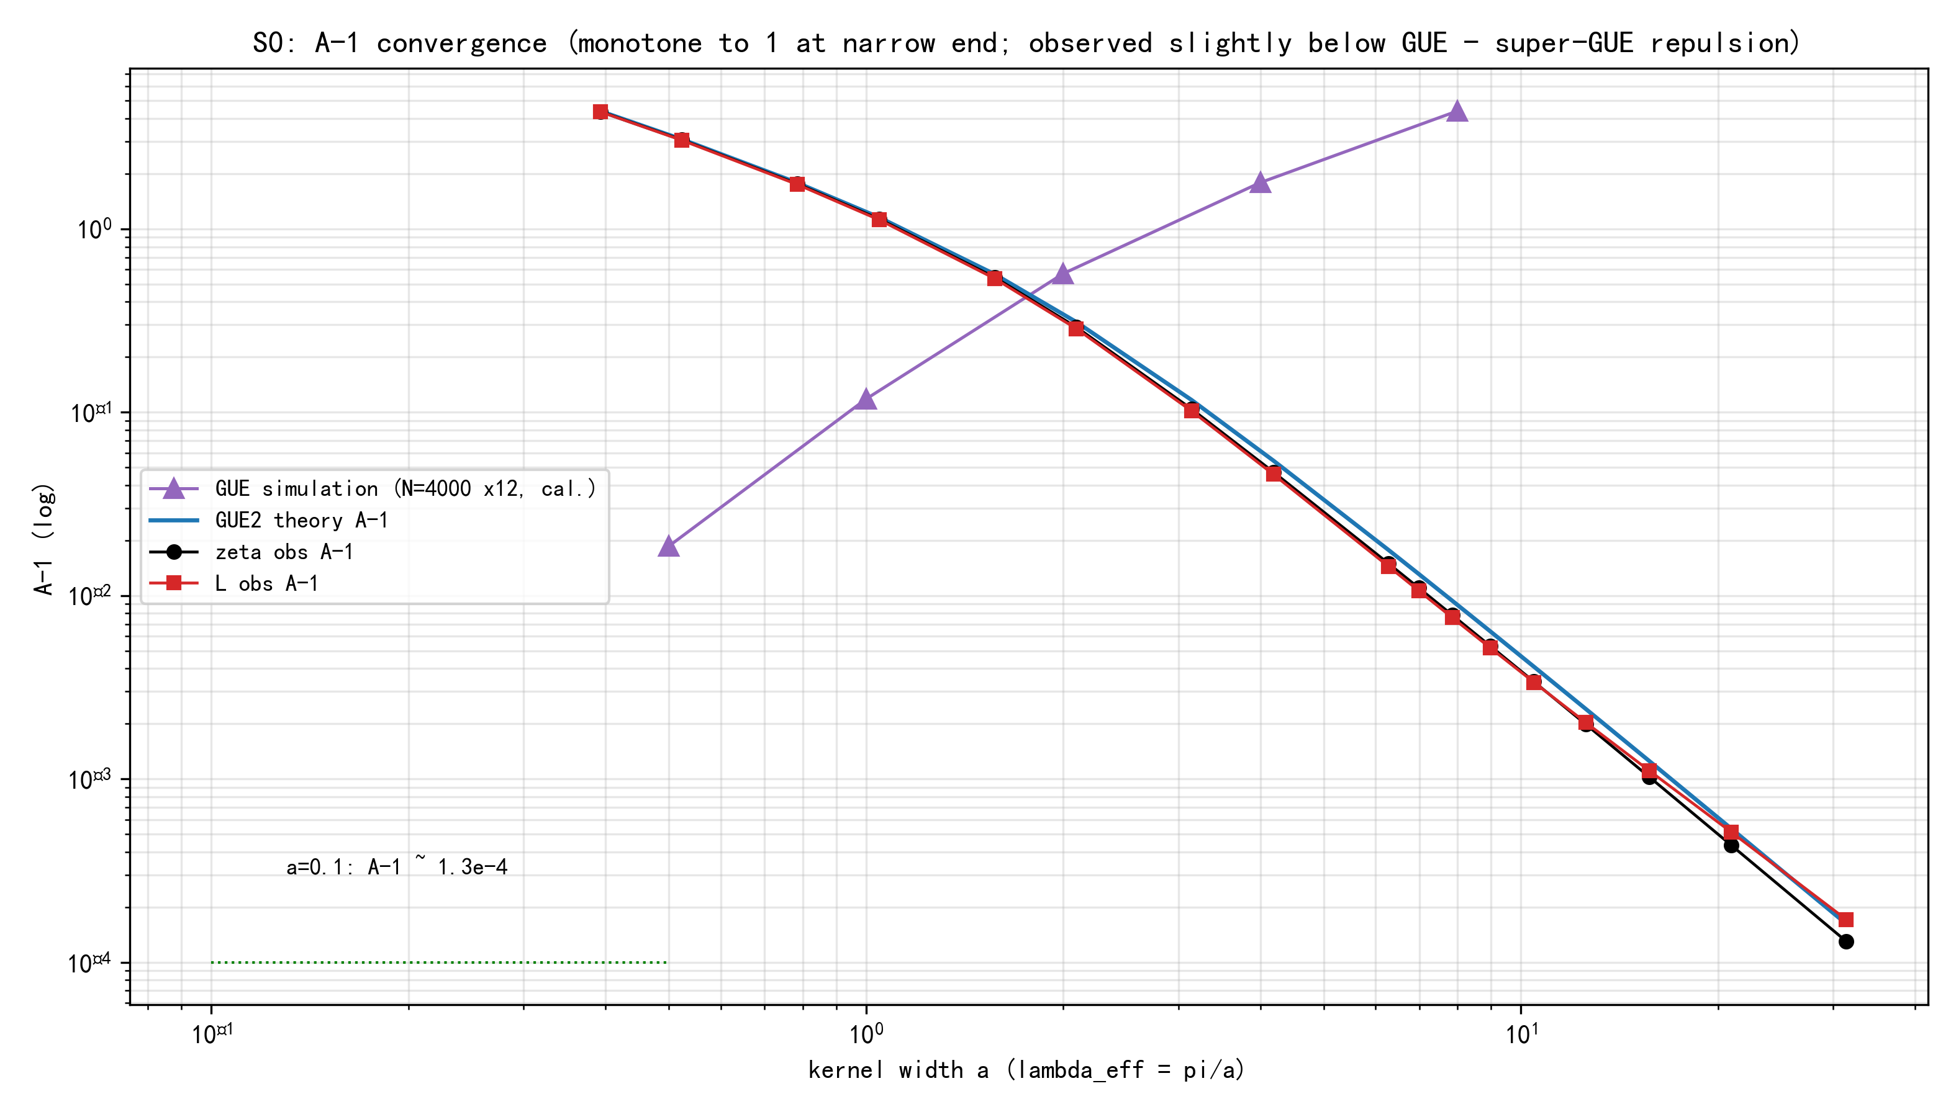
Fig. 2 A−1 convergence (log-log): observed (ζ black, L red) descending parallel to the GUE2 theory (blue) and slightly below it — super-GUE repulsion; the GUE simulation (purple triangles) ≈ theory, excluding finite-N artifacts; O(a³) slope at the narrow end

4 Verdict and Theoretical Correspondence

4.1 The S0 gate verdict
The four conditions are checked item by item: A(λ) monotone to 1 with no rebound (passed); full curve hugging GUE (passed); no repulsion-violating gap (passed); finite-T fluctuation under control (passed). Verdict: S0 passes; the main line proceeds to S1.

4.2 Three-layer theoretical correspondence
(i) The full curve hugging GUE ⟺ the Montgomery pair-correlation conjecture / GUE universality class: for ζ this is a conjecture (strong numerical verification by Odlyzko at height 10²²); for the fixed-modulus real character L(s,χ₅) there is no unconditional version in the literature — precisely (H2)/(H2′). The data exhibit GUE structure already at low height (T=6×10⁵), consistent with the known experience that universality shows up at low height.
(ii) The narrow-end A−1~O(a³) ⟺ the GUE β=2 level-repulsion universal shape: 1−sinc²πu~π²u²/3 as u→0 (quadratic zero of the two-point correlation), sinc⁴≈1 inside the window, ∫₀^a u²du~a³; for the GUE class Dyson’s log-gas result is a theorem, for ζ a conjecture. The data independently reproduce the β=2 slope (Fig. 2: observed parallel to GUE2), excluding Poisson β=0 (A−1~a) and the symplectic β=4 (A−1~a⁵) — the strongest anchor.
(iii) The super-GUE negative deviation ⟺ finite-T arithmetic terms: the BGS Lemma 5 error O_f(1/√logT) carries a kernel-dependent constant; Montgomery’s F(α)≥|α| (|α|<1, nontrivial lower bound from the prime terms, with equality predicted by GUE) is the same-source structure, translated by Parseval into a deviation of the real-space pair sum (sign and shape to be derived strictly in S1a). Decisive evidence: the segment drift shows the negative deviation converging with T (low-t segments deviate more; high-t segments approach GUE) — the direct signature of “deviation = arithmetic term decaying with T”; the GUE simulation excludes the finite-N correction direction.

4.3 Honest boundaries
(1) The data reach only T=6×10⁵ and λ_eff≤31.4; “full scale as λ(T)→∞ at infinite height” remains hypothesis (H2′), not a theorem. (2) The super-GUE repulsion is marginally significant (ζ a0.5 deviation −0.00277, ≈3 times the adjacent segment drift 0.00092); it is not used as a theorem hypothesis, only recorded as directionally favorable. (3) The XLI old-convention numbers (global δ, the ρ_L with −1, the λ_eff≈0.5 annotation) differ from this note; conclusions do not flip but must be disclosed in the XLI revision. (4) The kernel scan is finite (fejer family), not an exhaustive search of the variational space.

5 Next Steps: the S1 Split

5.1 S1a: arithmetic-term attribution (quantifying layer (iii))
(1) Parseval: translate A(a)−GUE2(a) into F(α,T)−|α| for α∈(0,1), compare with the excess above Montgomery’s lower bound, and verify sign and shape; (2) decay law: fit Δ(a;T)~c(a)/logT or c(a)/√logT over the five segments to distinguish the BGS error structure; (3) kernel-dependent constants: order the deviations of the fejer/sinc/gauss families by the smoothness of their Fourier support (audit6 data already available).

5.2 S1b: construction of the λ(T) scheme
Make (H2′) explicit (a strong Montgomery-type statement as λ(T)→∞, with growth rate and error shape); derive A=1+O(λ^{-1}); incorporate the structural-multiple-zero term (s<0.01 already excluded); weighted union → the theorem form with online proportion 1−o(1).

References
[1] Lamzouri Y. A new proof that more than 2/3 of the zeros of the Riemann zeta function are simple and on the critical line. arXiv:2609.02882v2 (Proposition 2.1 (N₀ˢ≥2Σ1−ΣK²), Lemma 3.2 (optimal kernel f₀(x)=cos(√2x)/(√2sin(1/√2)), C_MT=1/2+(1/√2)cot(1/√2)=1.3274992963), Remark 3.4 (C_η≥C_MT optimality)) — read in full.
[2] Baluyot D, Goldston D, Suriajaya A I, et al. An unconditional Montgomery theorem for pair correlation of zeros of the Riemann zeta function. arXiv:2306.04799 (Lemma 5: unconditional pair-correlation formula, error O_f(1/√logT), weight w(z)=4/(4−z²); the BGS generalization to fixed-modulus L(χ) is an open construction).
[3] Özlük A E. On the pair correlation of zeros of Dirichlet L-functions (1982; at least 11/12 simple under GRH, with weight) — verified via the introduction of Kandhil–Languasco–Moree.
[4] Kandhil N, Languasco A, Moree P. Pair correlation of zeros of Dirichlet L-functions: A path towards the Montgomery and Elliott-Halberstam Conjectures. arXiv:2411.19762 (Yıldırım theorem / Conjecture 1: cross-character-average pair correlation, GRH premise) — read in full.
[5] Carneiro E, Milinovich M B, Ramos A P. Fourier optimization and Montgomery's pair correlation conjecture. arXiv:2310.01913 (F-average 0.9303–1.3208, including Dirichlet L-function families).
[6] Odlyzko A M. The 10^22-nd zero of the Riemann zeta function (10¹⁰ zeros; numerical verification of RH and GUE pair correlation — “confirmed the GUE connection”).
[7] Defense-XLII numerical package (this work; reproducible with Anaconda python): qrh_work/xlii_s0.py (v1 global convention), xlii_s0_v2.py (v2 local, with the erroneous L density), xlii_s0_v3.py (final: local normalization + two-sided GUE + L calibration), xlii_s0_check.py (Poisson simulation / ρ₂ debugging), xlii_s0_debug.py (minimal verification of the factor 2), xlii_s0_gue.py (GUE simulation), xlii_s0_plot.py (figures); results xlii_s0_v3.json, xlii_s0_gue_sim.json; zero data zeros_T6e5.npz (T=6×10⁵, ζ 999354 / L 1149836 roots).
[8] Offense XLI (delivered to d1): conditional form of the pseudorandom union theorem — 7/8 threshold, fejer_a0.5 optimal kernel, decomposition argument, three-layer premise reliability.
[9] Offense XL (delivered to d1): theoretical construction of the unconditional bound on the pairing side — the 0.6725 constant gap is of QRH-mechanism type; Offense XXXIX (S4): fine form of the online-proportion-bridge remainder.

