<template>

  <router-link to="/"><h2 class="black" style="text-align: right; margin-right: 30px">return</h2></router-link>

  <!-- 试验区 -->

  <div>

    <input type="text" id="jingyan" v-model="text" placeholder="请输入内容" />

    <button id="sub" @click="ss()">提交</button>

  </div>

  <div v-for="item in video" :key="item.id">

    <table class="list">

      <tr>

        <td>{{ item.id }}</td>

        <td>{{ item.video_name }}</td>

        <td>{{ item.video_author }}</td>

        <td>{{ item.video_content }}</td>

        <td>{{ item.video_url }}</td>

      </tr>

    </table>

  </div>

  <button @click="getDate()">获取数据</button>

  <div align="center" id="Team">

    <h1>Video</h1>

    <el-button type="primary" @click="add">新建</el-button>

    <el-dialog :title="titleName[newRow]" v-model="dialogFormVisible1" width="30%">

      <el-form :model="newRow" label-width="120px">

        <el-form-item label="输入视频链接">

          <el-input v-model="newRow.src" style="width: 80%" />

        </el-form-item>

        <el-form-item label="输入姓名">

          <el-input v-model="newRow.name" style="width: 80%" />

        </el-form-item>

        <el-form-item label="输入视频主题">

          <el-input v-model="newRow.start" style="width: 80%" />

        </el-form-item>

        <el-form-item label="输入视频简介">

          <el-input v-model="newRow.text" style="width: 80%" />

        </el-form-item>

      </el-form>

      <template #footer>

        <span class="dialog-footer">

          <el-button @click="dialogFormVisible1 = false">取消</el-button>

          <el-button type="primary" id="sub" @click="submit()"> 确定 </el-button>

        </span>

      </template>

    </el-dialog>

  </div>

  <!-- <div class="app">

    <div class="add">

      <div class="title">

        <h3 style="text-align: center; margin-left: 45%">添加录制视频</h3>

        <button id="sub" @click="add">提交</button>

      </div>

      <form id="root" @submit.prevent="dome" style="text-align: center">

        <input type="text" v-model="src" placeholder="输入视频链接" />

        <input type="text" v-model="name" placeholder="输入姓名" />

        <input type="text" v-model="start" placeholder="输入视频主题" />

        <input type="text" v-model="text" placeholder="输入视频简介" />

      </form>

    </div>

  </div> -->

  <!-- 修改的弹窗 -->

  <div>

    <el-dialog :title="titleName[tempRow]" v-model="dialogFormVisible" width="30%">

      <el-form :model="tempRow" label-width="120px">

        <el-form-item label="输入视频链接">

          <el-input v-model="tempRow.src" style="width: 80%" />

        </el-form-item>

        <el-form-item label="输入姓名">

          <el-input v-model="tempRow.name" style="width: 80%" />

        </el-form-item>

        <el-form-item label="输入视频名称">

          <el-input v-model="tempRow.start" style="width: 80%" />

        </el-form-item>

        <el-form-item label="输入视频简介">

          <el-input v-model="tempRow.text" style="width: 80%" />

        </el-form-item>

      </el-form>

      <template #footer>

        <span class="dialog-footer">

          <el-button @click="dialogFormVisible = false">取消</el-button>

          <el-button type="primary" @click="sureEdit"> 确定 </el-button>

        </span>

      </template>

    </el-dialog>

  </div>

  <div class="banner">

    <div class="imgList" v-for="item in teamList" :key="item.name">

      <div class="ptho1">

        <div class="row">

          <div>

            <video width="400" height="300" class="video" controls>

              <source :src="item.src" type="video/ogg" />

              <source src="/i/movie.mp4" type="video/mp4" />

              <source src="/i/movie.webm" type="video/webm" />

              <object data="/video/mov_bbb.mp4" width="320" height="240"></object>

            </video>

          </div>

          <div style="margin-left: 10px">

            <h3 class="flot">视频名称：</h3>

            {{ item.start }}

            <h3>视频主讲者：</h3>

            {{ item.name }}

            <h3>视频简介：</h3>

            {{ item.text }}

            <br />

          </div>

        </div>

        <div class="update">

          <button class="upd" @click="update(item)">修改{{ item.uadates }}</button>

          <button class="del" @click="del(item)">删除{{ item.delete }}</button>

        </div>

      </div>

    </div>

  </div>

  <!-- <component :is="currentView" /> -->

</template>

<script>

import axios from 'axios'

export default {

  data() {

    return {

      video: [],

      src: null,

      name: null,

      text: null,

      start: null,

      // tempRow: {},

      dialogFormVisible: false,

      dialogFormVisible1: false,

      titleName: {

        add: '新增',

        edit: '编辑',

      },

      teamList: [

        {

          src: 'http://10.41.95.141:8080/api/public/dl/slYVHO1R?inline=true',

          name: '王凡',

          start: ' ',

          text: '',

        },

        {

          src: 'http://10.41.95.141:8080/api/public/dl/mZ6Yse-t/Nina/DRF/drf.mp4?inline=true',

          name: 'Nina',

          start: 'DRF',

          text: '',

        },

        {

          src: 'http://10.41.95.141:8080/api/public/dl/mZ6Yse-t/Beckman/Python%E4%BD%BF%E7%94%A8SQL/2022-11-11%2015-44-57.mp4?inline=true',

          name: 'Beckman',

          start: 'Python使用postgresql',

          text: '',

        },

        {

          src: ' http://10.41.95.141:8080/api/public/dl/mZ6Yse-t/Chase/Vue3-%E7%BB%84%E4%BB%B6/Vue3-%E7%BB%84%E4%BB%B6.mp4?inline=true',

          name: 'Chase',

          start: 'Vue3-组件',

          text: '',

        },

        {

          src: 'http://10.41.95.141:8080/api/public/dl/mZ6Yse-t/Chengwu/Cindy%E5%AD%A6%E4%B9%A0%E5%88%86%E4%BA%AB_2020.08.31/Training%E8%AF%BE%E7%A8%8B%20-%20Cindy%E5%AD%A6%E4%B9%A0%E5%88%86%E4%BA%AB.mp4?inline=true',

          name: 'Chengwu',

          start: 'Cindy学习分享',

          text: '',

        },

        {

          src: 'http://10.41.95.141:8080/api/public/dl/mZ6Yse-t/Jim/Pandas%E4%BD%BF%E7%94%A8%2020200828/Pandas%E4%BD%BF%E7%94%A8.mp4?inline=true',

          name: 'Jim',

          start: 'Pandas使用',

          text: '',

        },

        {

          src: 'http://10.41.95.141:8080/api/public/dl/mZ6Yse-t/Jim/Tracking%20Management%E9%97%AE%E9%A2%98%E6%B1%87%E6%80%BB%E4%B8%8E%E8%A7%A3%E5%86%B3%E6%96%B9%E6%B3%95%2020200918/Training%E5%88%86%E4%BA%AB%20-%202020%E5%B9%B49%E6%9C%8818%E6%97%A5%2015.25.39.mp4?inline=true',

          name: 'Jim',

          start: ' Tracking Management问题汇总与解决方法',

          text: '',

        },

        {

          src: 'http://10.41.95.141:8080/api/public/dl/mZ6Yse-t/Keil/Linux%E7%9A%84%E5%9F%BA%E7%A1%80%E5%91%BD%E4%BB%A4%E5%88%86%E4%BA%AB_20200828/%E7%AC%AC%E4%BA%8C%E6%AC%A1Training%E8%AF%BE%E7%A8%8B%E5%88%86%E4%BA%AB%20-%202020%E5%B9%B48%E6%9C%8827%E6%97%A5%20%E4%B8%8B%E5%8D%88%2004.05.36.mp4?inline=true',

          name: 'Keil',

          start: ' Linux的基础命令分享',

          text: '',

        },

        {

          src: 'http://10.41.95.141:8080/api/public/dl/mZ6Yse-t/Kenzo/Keil%E5%88%86%E4%BA%AB%E4%BC%9A%E8%AE%AE%20-%202020%E5%B9%B49%E6%9C%8822%E6%97%A5%20%E4%B8%8B%E5%8D%88%2003.04.51.mp4?inline=true',

          name: 'Kenzo',

          start: '  Keil分享会议',

          text: '',

        },

        {

          src: 'http://10.41.95.141:8080/api/public/dl/mZ6Yse-t/Robbin/Ajax%E4%B8%8E%E6%A8%A1%E6%80%81%E6%A1%86%E5%BA%94%E7%94%A8%E5%88%86%E4%BA%AB_2020.9.18/Training%E5%88%86%E4%BA%AB%20-%202020%E5%B9%B49%E6%9C%8818%E6%97%A5%2015.04.14.mp4?inline=true',

          name: 'Robbin',

          start: ' Ajax与模态框应用',

          text: 'Ajax与模态框应用分享',

        },

        {

          src: 'http://10.41.95.141:8080/api/public/dl/mZ6Yse-t/Robbin/bootstrap%E7%AE%80%E5%8D%95%E5%88%86%E4%BA%AB_2020.8.31/bootstrap%E7%AE%80%E5%8D%95%E5%88%86%E4%BA%AB2020.8.31.mp4?inline=true',

          name: 'Robbin',

          start: ' bootstrap',

          text: 'bootstrap简单分享',

        },

        {

          src: 'http://10.41.95.141:8080/api/public/dl/mZ6Yse-t/Robbin/HTML%E5%9F%BA%E7%A4%8E_20200813/HTML%E5%9F%BA%E7%A4%8E%E5%88%86%E4%BA%AB%E6%9C%83%20-%202020%E5%B9%B48%E6%9C%8813%E6%97%A5%2016.11.10.mp4?inline=true',

          name: 'Robbin',

          start: ' HTML',

          text: 'HTML基礎分享',

        },

        {

          src: 'http://10.41.95.141:8080/api/public/dl/mZ6Yse-t/SamKwok/System%20Installation%20guide%2020201009/system%20installation%20guide%20-%202020%E5%B9%B410%E6%9C%889%E6%97%A5%2016.05.57.mp4?inline=true',

          name: 'SamKwok',

          start: '  system installation guide ',

          text: '',

        },

      ],

      // 编辑的的数据

      tempRow: {

        src: '',

        name: '',

        data: '',

        text: '',

        delete: '',

        updates: '',

      },

      newRow: {

        src: '',

        name: '',

        data: '',

        text: '',

        delete: '',

        updates: '',

      },

    }

  },

  methods: {

    add() {

      this.dialogFormVisible1 = true

      // this.tempRow = 'add'

      // this.tempRow = {}

      // console.log(this.)

      // 清空输入

      // ;(this.src = ''), (this.name = ''), (this.start = ''), (this.text = '')

      // alert('提交成功！')

    },

    // 获取数据库内容

    getDate() {

      //请求服务器的api获取到品牌的数据列表

      axios.get('http://127.0.0.1:8000/DivisionalManagement/videlTable/').then(response => {

        console.log('我要获取数据')

        console.log(response.data)

        this.video = response.data

      })

    },

    submit() {

      if (this.newRow.src != '' && this.newRow.name != '') {

        //unshift添加在前，push添加在后

        this.teamList.unshift({

          src: this.newRow.src,

          name: this.newRow.name,

          start: this.newRow.start,

          text: this.newRow.text,

          delete: this.newRow.delete,

          upadates: this.newRow.updates,

        })

        // 发送axios请求，存入数据库

        console.log(this.newRow.src)

        console.log(this.newRow.name)

        console.log(this.newRow.text)

        console.log(this.newRow.start)

        const data = {

          content4: this.newRow.src,

          content3: this.newRow.name,

          content2: this.newRow.text,

          content1: this.newRow.start,

        }

        console.log(data)

        axios

          .post('http://127.0.0.1:8000/DivisionalManagement/videlTable/', data)

          .then(function (response) {

            console.log(response)

            console.log(response)

          })

          .catch(function (error) {

            console.log(error)

          })

      } else {

        alert('输入不能为空！')

      }

      this.dialogFormVisible1 = false

    },

    del(item) {

      // 删除用户，indexOf为删除哪个用户，1为删除一条数据

      var r = confirm('确定删除？')

      if (r == true) {

        this.teamList.splice(this.teamList.indexOf(item), 1)

      } else {

        return

      }

    },

    // 修改

    update(item) {

      this.dialogFormVisible = true

      this.tempRow = 'edit'

      this.tempRow = {}

      this.showModal = true

      this.tempRow = {

        ...item,

      }

      this.editIndex = this.teamList.findIndex(value => value.src === item.src)

    },

    sureEdit() {

      this.dialogFormVisible = true

      this.teamList[this.editIndex] = {

        ...this.tempRow,

      }

      this.showModal = false

      this.dialogFormVisible = false

    },

  },

}

</script>

<style scoped>

.update {

  display: flex;

  flex: 2;

  margin-left: 430px;

}

.sub {

  position: relative;

  background-color: darkcyan;

  color: white;

  width: 40px;

  height: 40px;

  border-radius: 50%;

}

.add {

  position: relative;

  -webkit-box-shadow: rgb(9, 97, 100) 0px 0px 10px 10px;

  -moz-box-shadow: rgb(9, 97, 100) 0px 10px 10px;

  box-shadow: rgb(9, 97, 100) 0px 0px 10px;

  background-color: rgb(184, 208, 208);

  margin: 5px;

  padding: 7px;

  margin-bottom: 20px;

  width: 60%;

  margin-left: 38%;

}

.del,

.upd {

  position: relative;

  background-color: darkcyan;

  color: white;

  width: 40px;

  height: 30px;

  border-radius: 30%;

  margin-right: 5px;

}

.video {

  object-fit: fill;

}

.banner,

.title {

  display: flex;

  flex: 2;

  justify-content: space-between;

}

.row {

  display: flex;

  flex: 2;

}

.ptho1 {

  -webkit-box-shadow: #666 0px 0px 10px 10px;

  -moz-box-shadow: #666 0px 0px 10px 10px;

  box-shadow: #666 0px 0px 10px;

  margin: 5px;

  padding: 7px;

  border-radius: 5%;

  margin-bottom: 20px;

  width: 540px;

  height: 350px;

}

.banner {

  top: 30px;

  widows: 100%;

  height: 100%;

  margin-left: 20px;

  margin-right: 20px;

  position: relative;

  overflow: hidden;

  flex-wrap: wrap;

  padding: 10px 10px 10px 10px;

  margin-bottom: 60px;

}

.pthon {

  width: 100px;

  height: 100px;

  display: flex;

  border-radius: 50%;

  align-items: center;

  justify-content: center;

  overflow: hidden;

}

</style>

10.41.95.85：8100

                RTMS: 6110

            L11：8900

            itqs:8100

            sns: 8510

            tcs:8210

            aoiss:8300

其他服务器：

            AFVCS:

            AEMSLite:

            FMS:

王凡

10.41.95.85:8510

Validation Management System

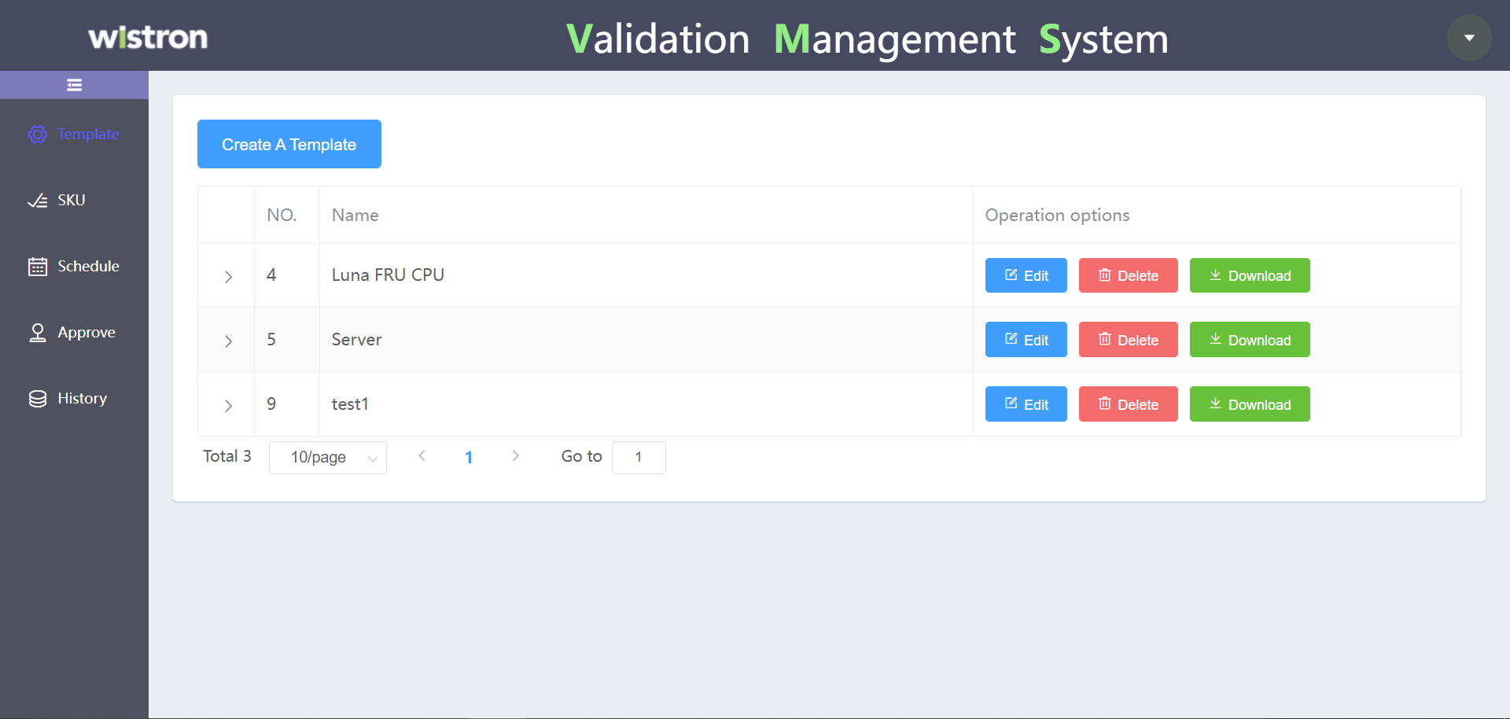

10.41.95.85:6110

Reliability Test Management System

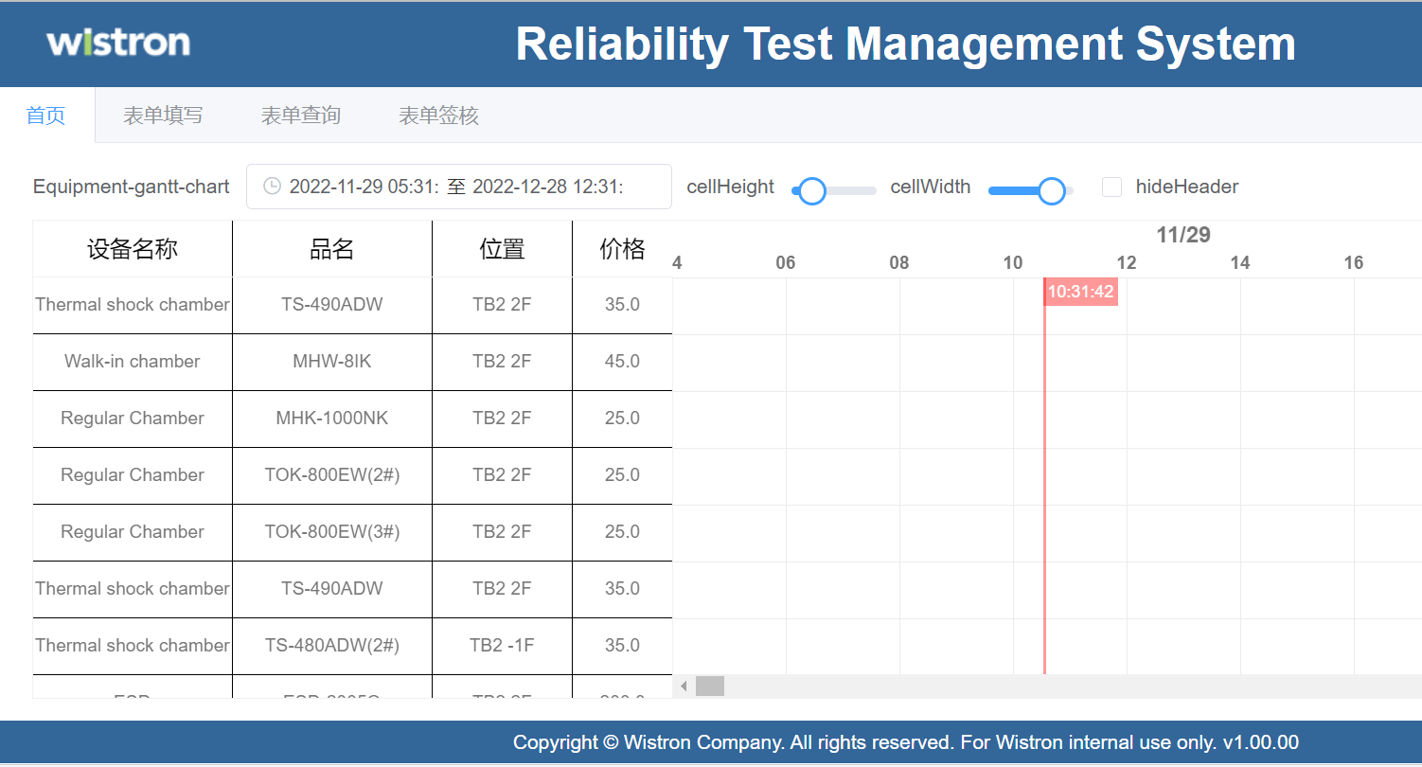

http://10.41.95.85:8210

Test Control Server

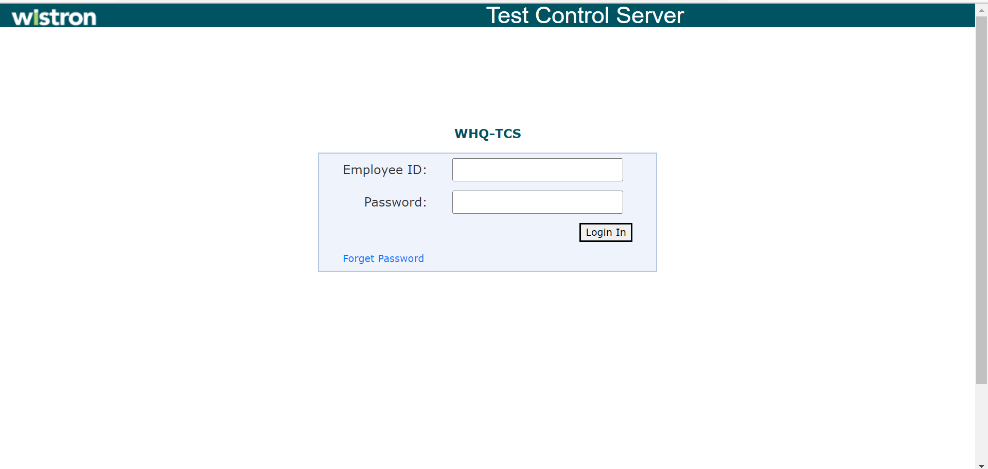

10.41.95.85:8100

王凡

AgTemperatureMonitoring

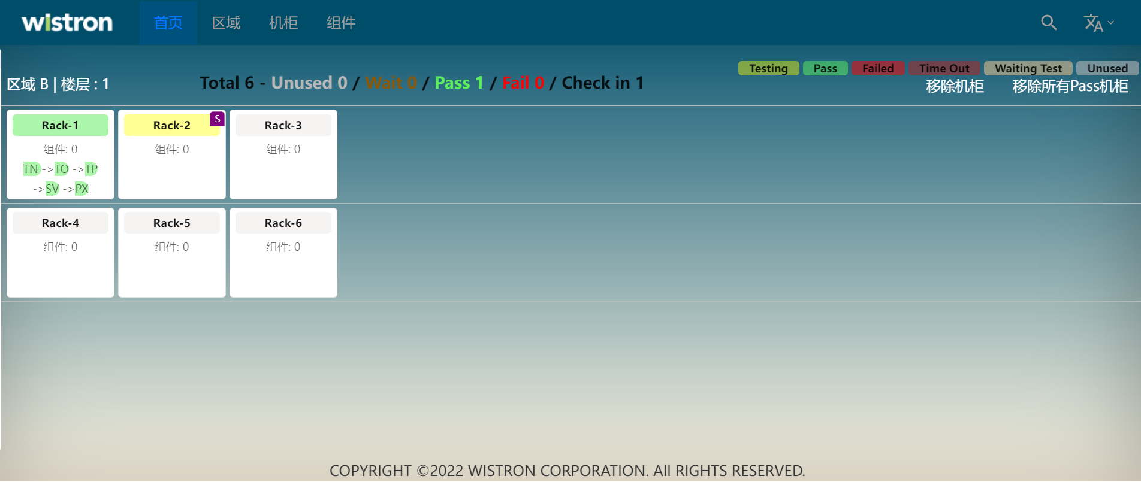

10.41.95.85:8300

AOI Storage System

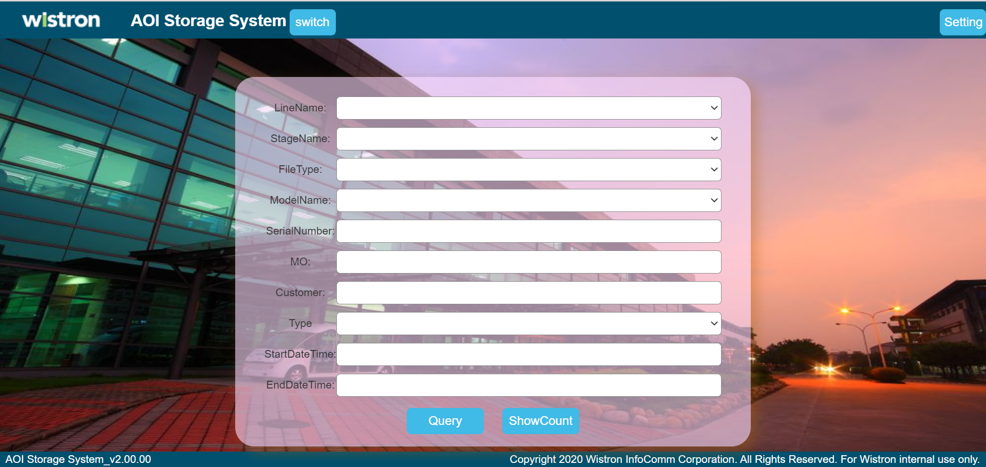

Intelligent Training Quiz System

10.41.95.85:8100

