XJEL2665 Unit 4 Assessment

2024-25

Design Validation Report
Two-mode Timer

201691164
Xinzhe Liu

2025.05.08

Statement of Academic Integrity

By submitting work, I confirm that I have read and understood the University’s definition of Academic Integrity and the University’s rules on Academic Misconduct and am aware that if I commit an academic misconduct offence there can be serious disciplinary consequences.
I am aware that the University defines plagiarism as presenting someone else’s work, in whole or in part, as your own. Work means any intellectual output, and typically includes text, data, images, code, sound or performance.
I promise that in the attached submission I have not presented anyone else’s work, in whole or in part, as my own and I have not colluded with others in the preparation of this work. Where I have taken advantage of the work of others, I have given full acknowledgement. I have not resubmitted my own work or part thereof without specific written permission to do so from the University staff concerned when any of this work has been or is being submitted for marks or credits even if in a different module or for a different qualification or completed prior to entry to the University. I have read and understood the University’s published rules on plagiarism and also any more detailed rules specified at the school or module level. I know that if I commit plagiarism I can be expelled from the University and that it is my responsibility to be aware of the University’s regulations on plagiarism and their importance.
I re-confirm my consent to the University copying and distributing any or all of my work in any form and using third parties (who may be based outside the EU/EEA) to monitor breaches of regulations, to verify whether my work contains plagiarised material, and for quality assurance purposes.
I confirm that I have declared all mitigating circumstances that may be relevant to the assessment of this piece of work and that I wish to have taken into account. I am aware of the University’s policy on mitigation and the School’s procedures for the submission of statements and evidence of mitigation. I am aware of the penalties imposed for the late submission of coursework.

Section A: Submodules Validation
A1 Clock Divider
A1.1 Overview of the Testing Process
Reset the signal low for 100ns, then start the 1Hz counter and the 100Hz counter. After each counter counts twice, end the simulation.
A1.2 Test procedures
- The reset port rst_n is pulled low for 100 ns and then released.
- The 100 Hz counter and the 1 Hz counter start counting respectively.
- The simulation ends when the 100 Hz output counts twice and the 1 Hz output counts twice (since the trigger time of 1 Hz is much longer than that of 100 Hz, the actual counting time is based on the 1 Hz counter).
A1.3 Test result
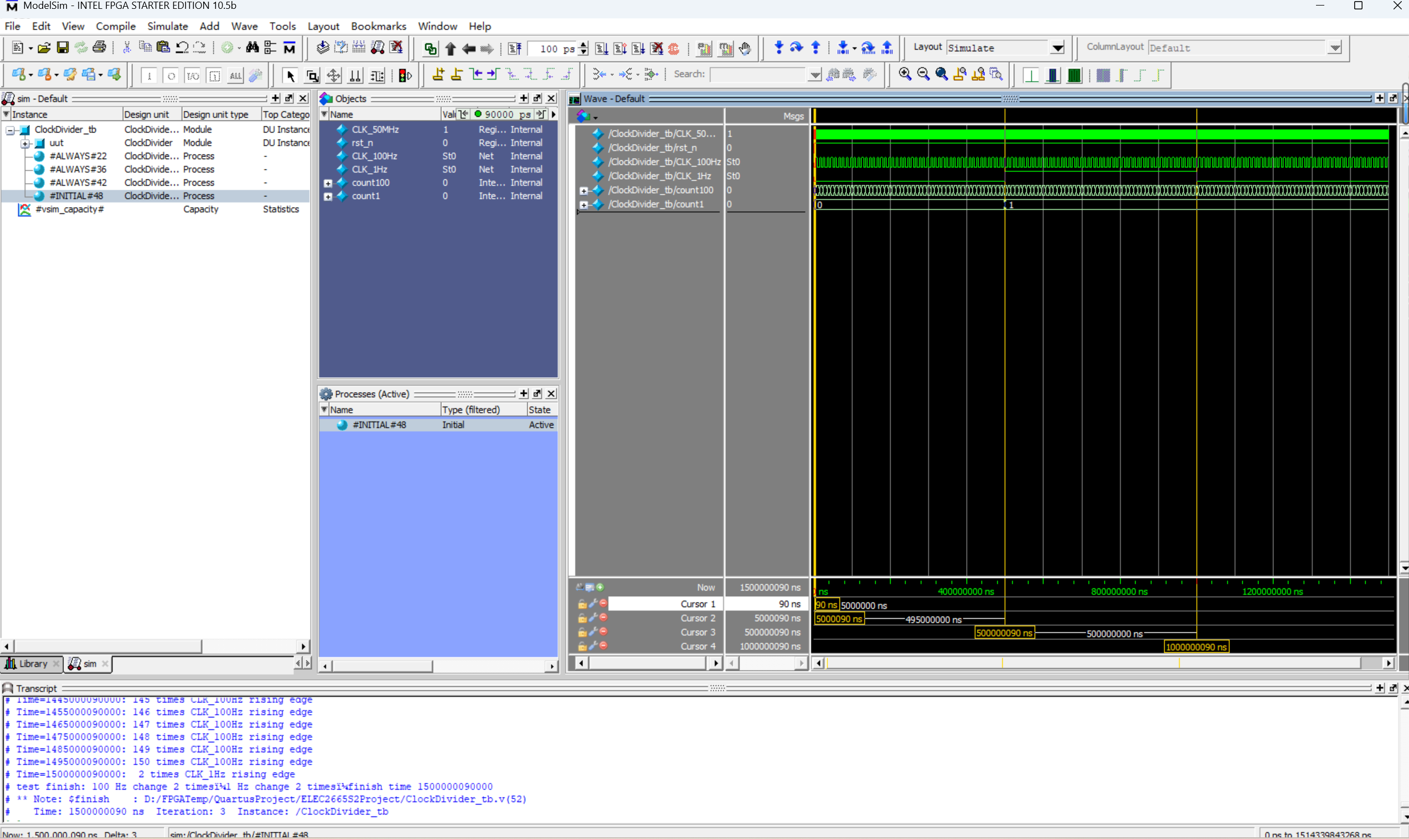

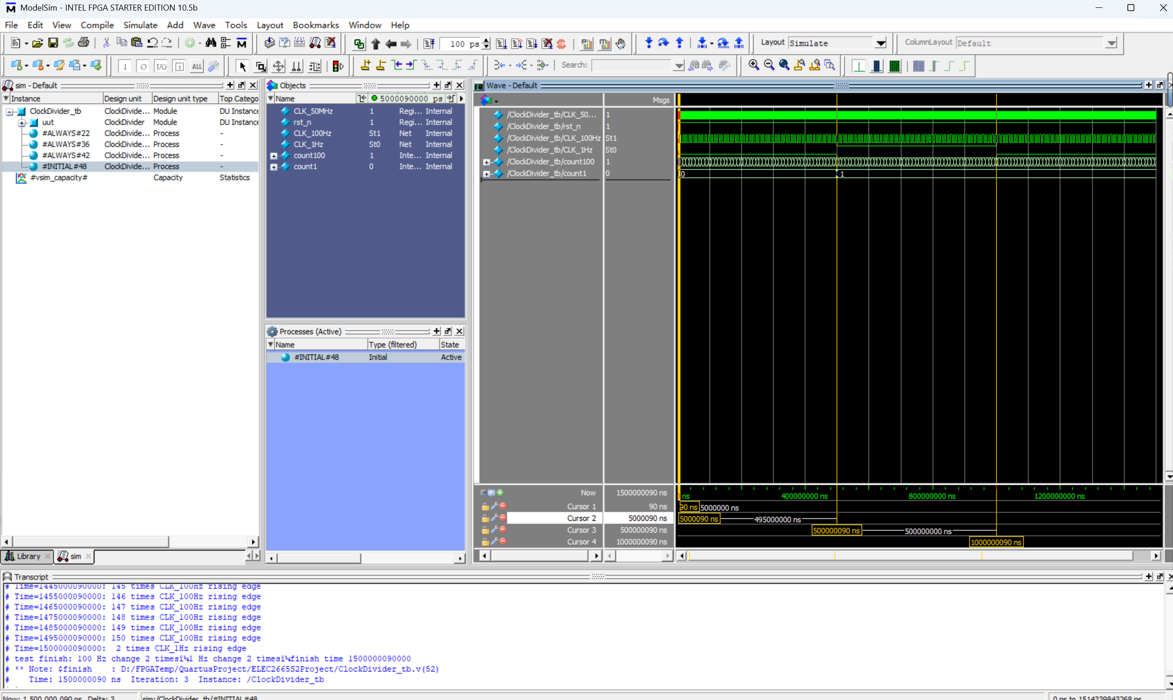
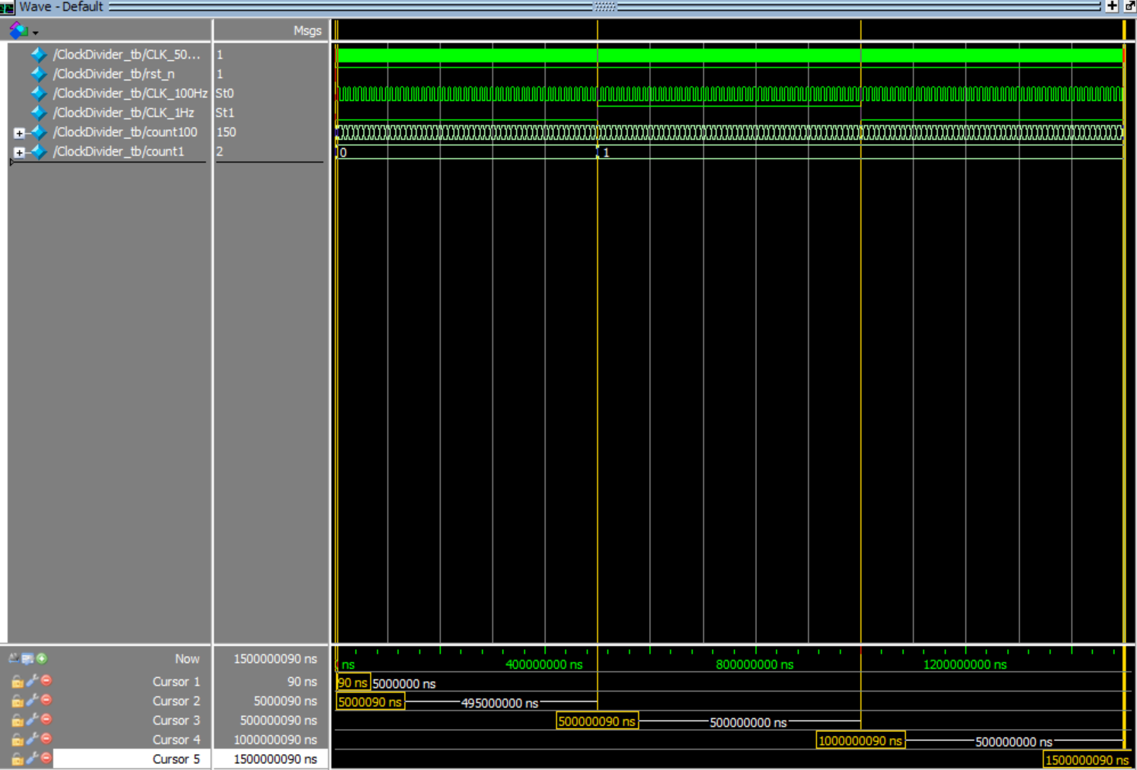
- The initial reset is pulled low for 100 ns. At 100 ns, the reset changes from 0 to 1.
- The 100 Hz counter flips once every 5 ms, meaning it counts once every 10 ms.
- The 1 Hz counter flips once every 500 ms, meaning it counts once every 1000 ms.
- When the 1 Hz counter is about to count for the second time (since the rising edge has not been triggered, the 1 Hz counter has counted a total of 1.5 cycles but still shows 1 count), the 100 Hz counter has counted 150 times.
A2 Program Counter (PC)
A2.1 Overview of the Testing Process
Raise the reset to verify the asynchronous reset.
Set load verification synchronous loading
Set inc verification for synchronous auto-increment
Simultaneously verify the load priority at high level
Print the result and stop the simulation.
A2.2 Test procedures
- Set the initial value: ResetVal = 8'hA5; LoadVal = 8'd5; reset = 0; load = 0; inc = 0;
- When t = 10 ns , reset test: reset = 1 ( 1 ns ), reset = 0.
- When t = 25 ns , load test: load = 1 ( 10 ns ), load = 0.
- When t = 35 ns , increment test: inc = 1 ( 20 ns ), inc = 0.
- When t = 65 ns , priority test: load = 1 ( 10 ns ), inc = 1 ( 10 ns ).
A2.3 Test result
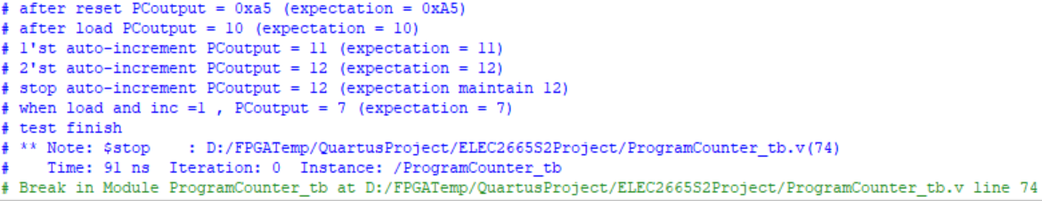
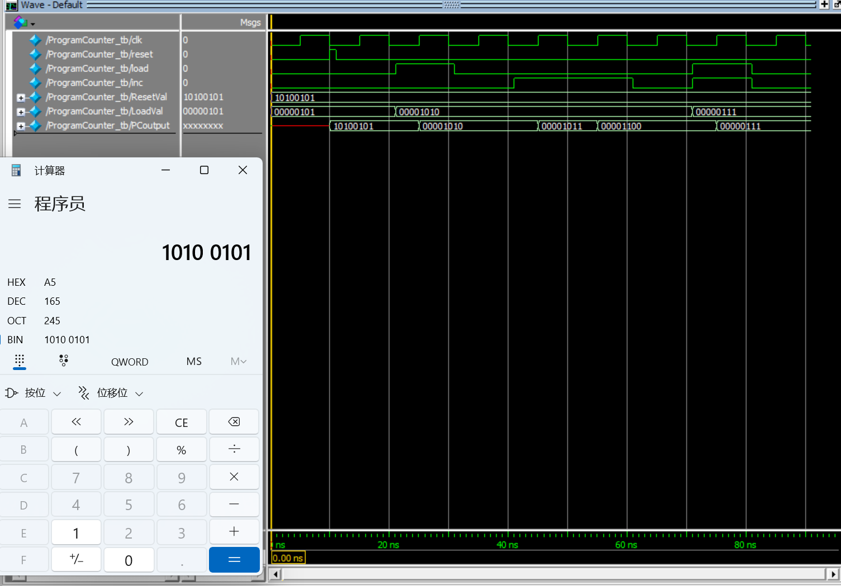
t = 0 ns (Rising edge of clk), reset = 0 , load = 0 , increment = 0 , output = None;
t = 10 ns (Rising edge of clk), reset = 1 , load = 0 , increment = 0 , output = ResetVal = 0xA5 = 165;
t = 25 ns (Rising edge of clk), reset = 0 , load = 1 , increment = 0 , output = LoadVal = 10;
t = 35 ns (Rising edge of clk), reset = 0 , load = 0 , increment = 1 , output = 10 + 1 = 11;
t = 45 ns (Rising edge of clk), reset = 0 , load = 0 , increment = 1 , output = 11 + 1 = 12;
t = 55 ns (Rising edge of clk), reset = 0 , load = 0 , increment = 0 , output = 12;
t = 65 ns (Rising edge of clk), reset = 0 , load = 1 , increment = 1 , output = LoadVal = 7; (Load priority)
A3 Binary to BCD
A3.1 Overview of the Testing Process
Iterate through all values from 0 to 99 and check if the units and tens digits are correct.
A3.2 Test procedures
Test all values of i from 0 to 99. Check if the tens digit is equal to i/10 and the units digit is equal to i%10. If correct, print 'pass'; if incorrect, print 'should be (correct result)'.
A3.3 Test result
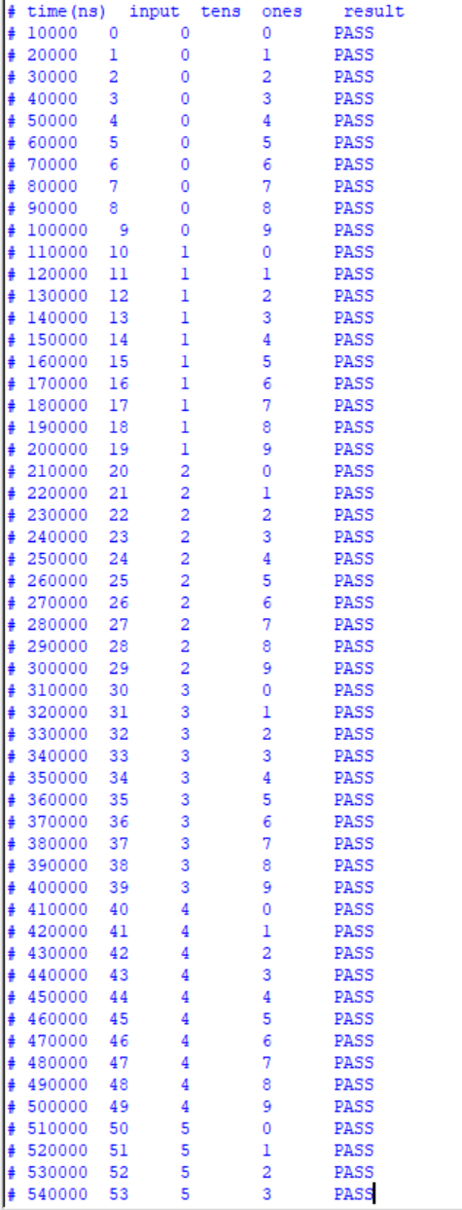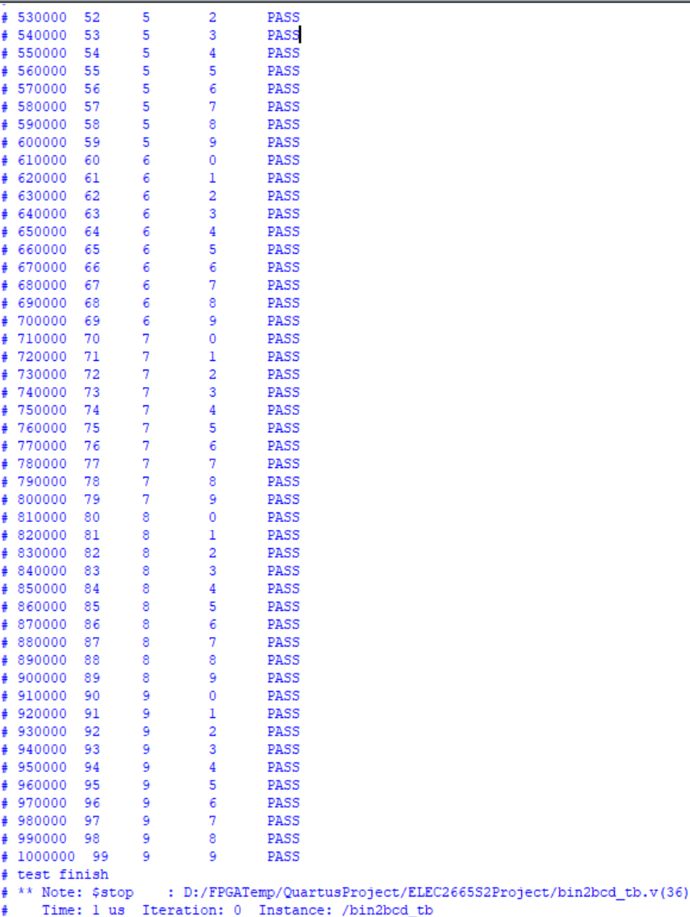
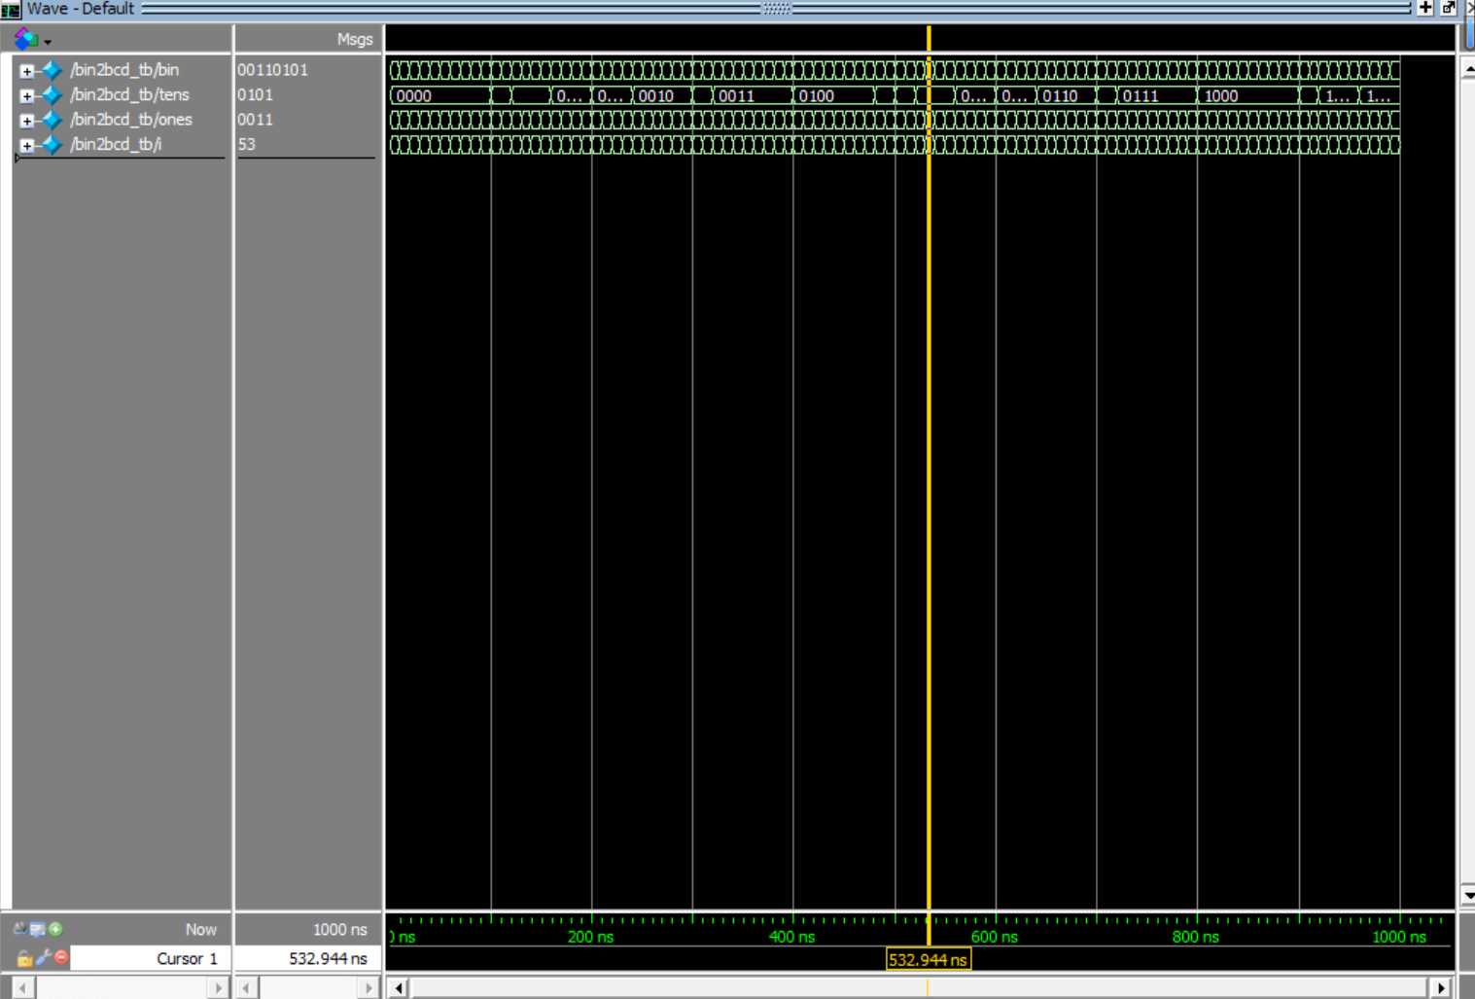
All results passed.

A4 BCD to 7-Segment
A4.1 Overview of the Testing Process
Iterate through all values from 0 to 9 and check if the 7-segment display encoding is correct.
A4.2 Test procedures
Test all values from 0 to 9 to determine if the encoding of the digital tube is consistent with the mapping table.
A4.3 Test result
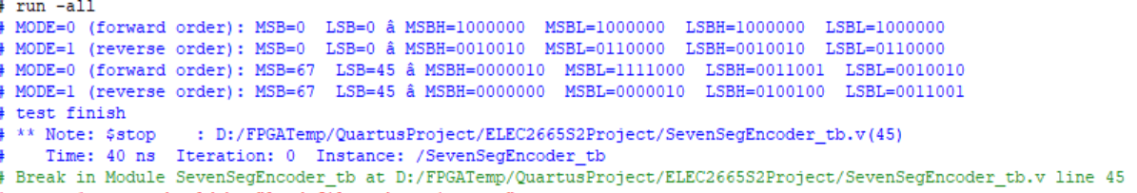
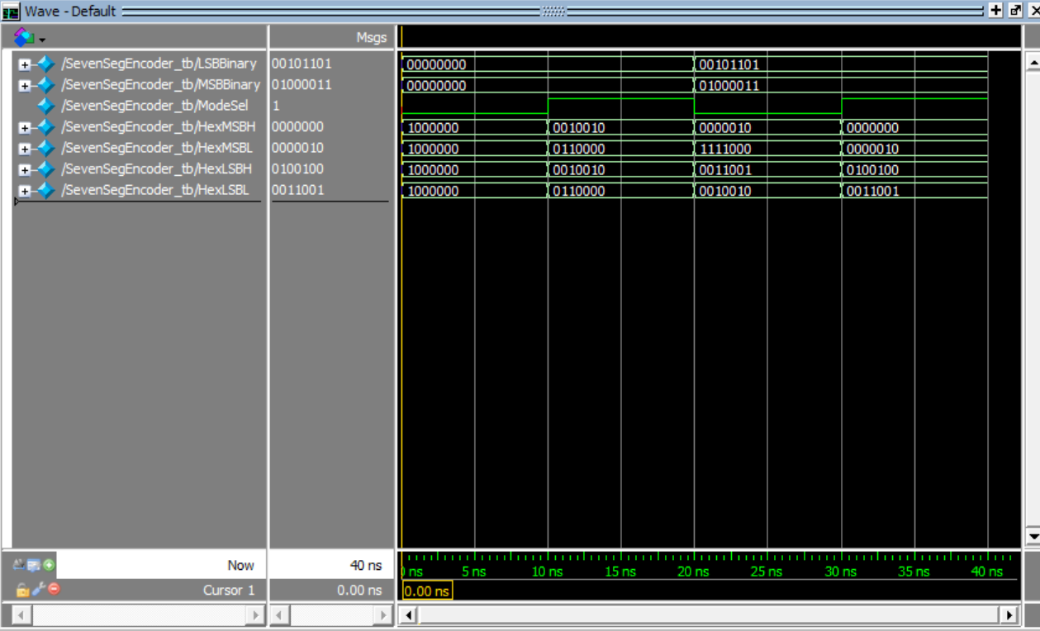
The result is correct.

A5 Seven-Segment Encoder
A5.1 Overview of the Testing Process
Output the seven-segment digital tube time code in two modes respectively.
A5.2 Test procedures
- ModeSel = 0 (stopwatch): 0:0, 34:12, 99:99;
- ModeSel = 1 (count down): 0:0 corresponds to display 2:00, 0:5 corresponds to display 1:55, 2:0 corresponds to display 0:0.
A5.3 Test result
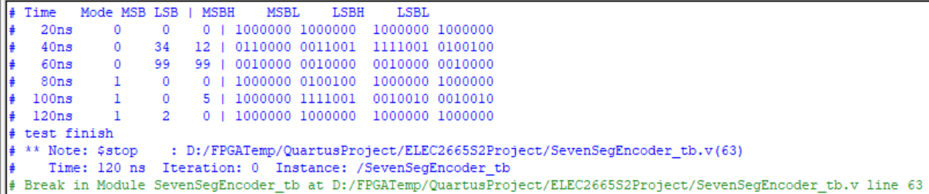
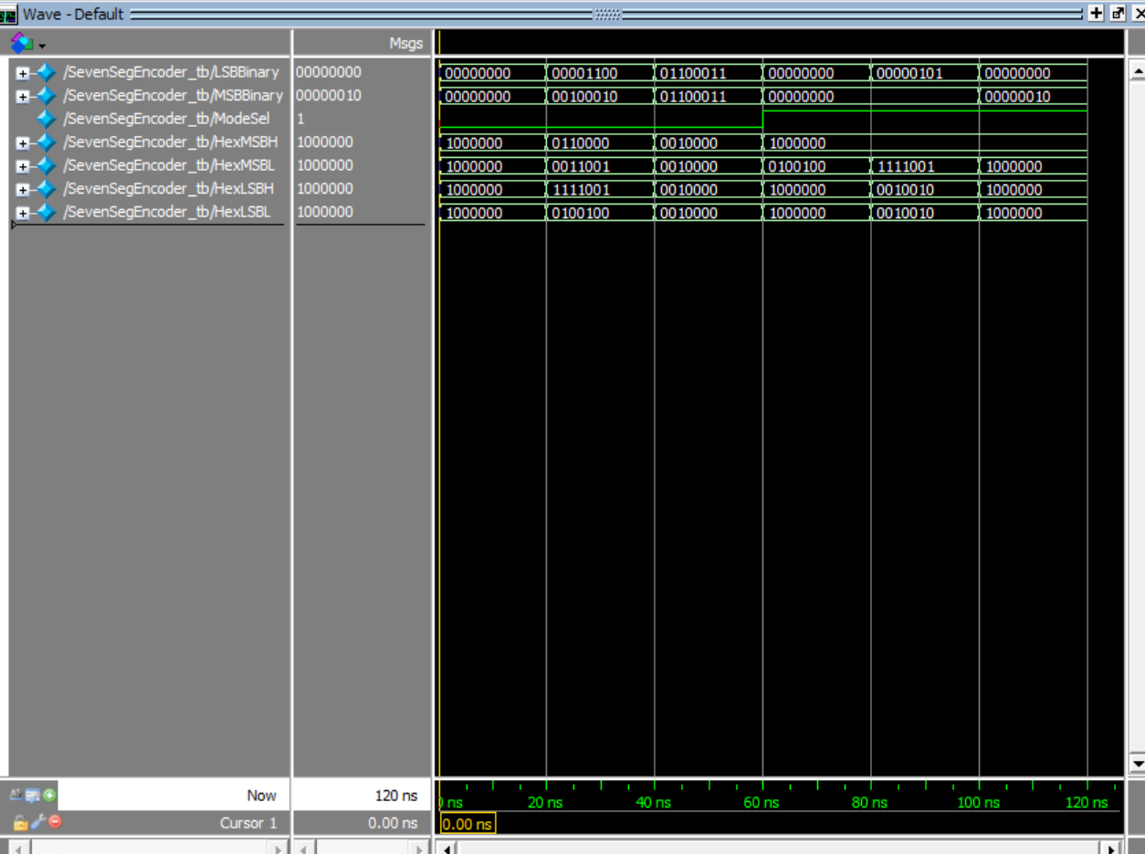

A6 Timer Core Logic
A6.1 Overview of the Testing Process
Driven by a 100 MHz clock, first test the reset, then test the low-active and high-active bit counting and carry, pause and restart the counting.
A6.2 Test procedures
- To observe the wraparound behavior within a limited time, set the maximum value MAX_VAL_LSB to 5 and MAX_VAL_MSB to 3. In the main code, it can be set to 99.
- t = 0 ns, asynchronous reset, the counter is initialized to RESET_VAL.
- t = 35 ns, StartStop = 1, LSB + 1
- t = 85 ns, LSB reaches 5, it wraps around to 0 and generates a carry, and MSB +1.
- t = 145 ns, LSB → MSB +1
- t = 205 ns, the third time LSB→ MSB +1
- t = 230~260 ns, StartStop=0 → all remain unchanged (on hold)
- t = 265 ns, StartStop=1 ，LSB from 2 → 3
- t = 295 ns, LSB → carry out; MSB reach 3 → 0
A6.3 Test result
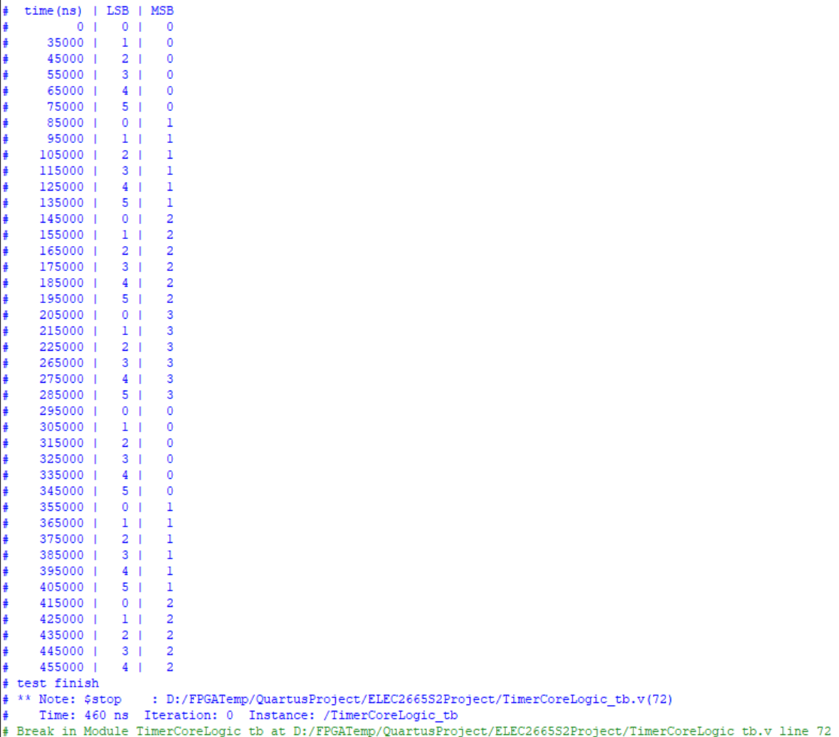
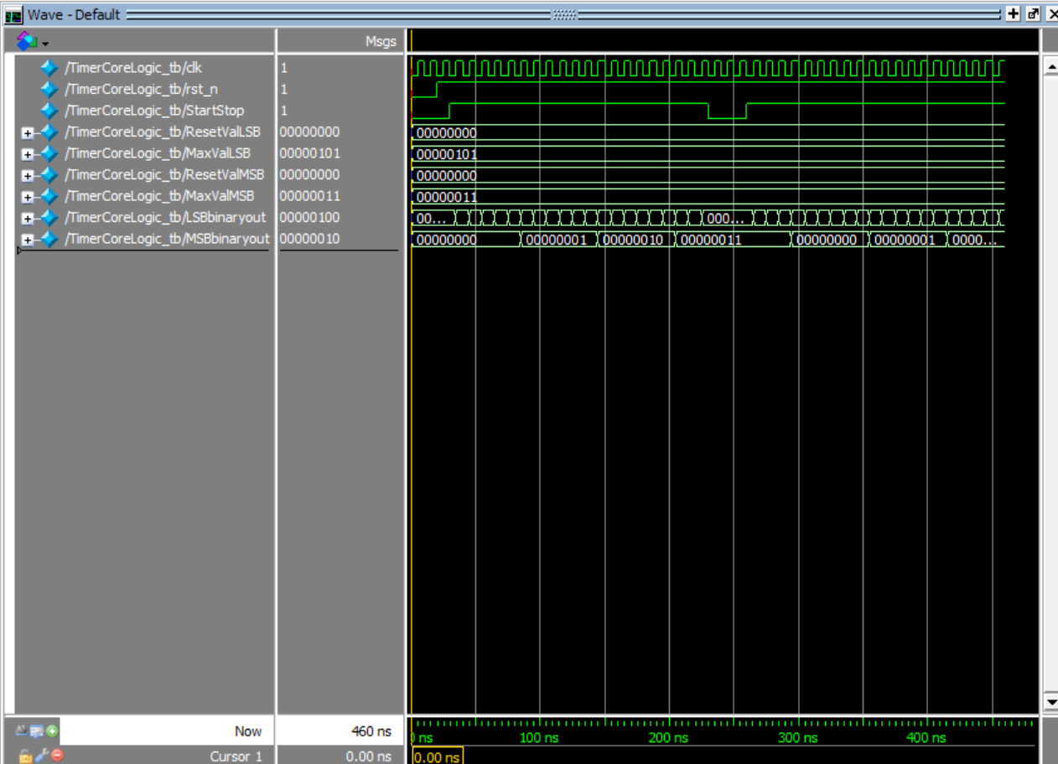

Section B: Two-mode Timer (Top-level module) Validation
B Main code
B Overview of the Testing Process
Verify whether the seven-segment code decoding output is correct under both Stopwatch (100 Hz) and Timer (1 Hz) modes respectively.
In each mode, check whether the counting can start and pause by pulling up/pulling down StartStop.
B Test procedures
- After reset ModeSel=0; StartStop=1, wait ≥20 ms（At least two 100 Hz cycles.
- StartStop=0 stop, Output freeze.
- Reset again, ModeSel = 1; StartStop = 1 to start the countdown, wait for ≥ 2 seconds (at least 2 cycles of 1 Hz); StartStop = 0 to pause and freeze the output.
- Test finish.
B Test result
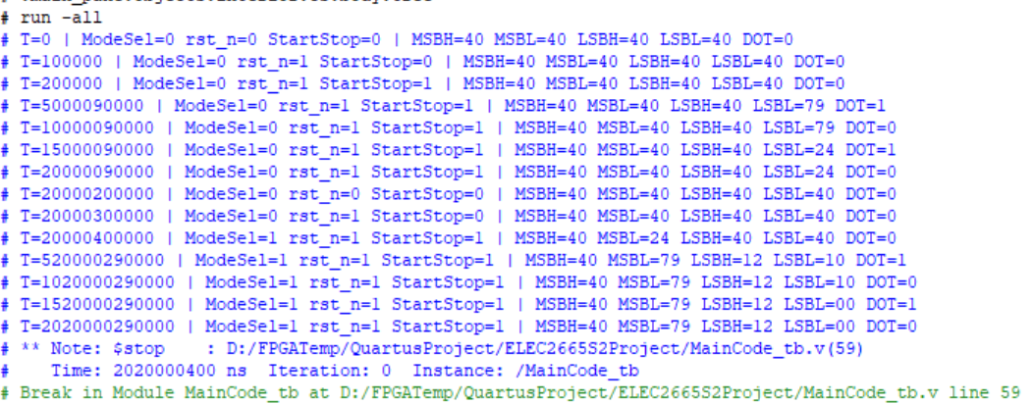
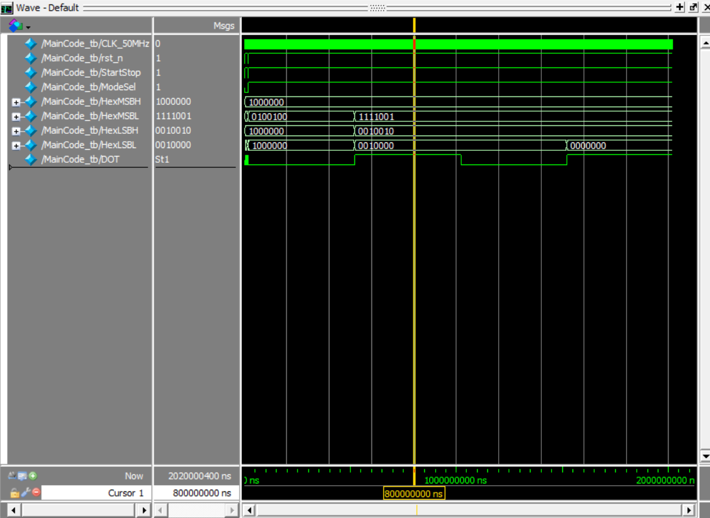

Appendix
Please attach ALL your Quartus codes here.
Note: please make sure you submit the code in pure text format, not image! Fail to do so will severely affect your report mark!

module MainCode (
input wire CLK_50MHz, // 50MHz clk
input wire rst_n, // reset(effective low)
input wire StartStop, // start/stop
input wire ModeSel, // mode select：0 Stopwatch（100Hz），1 count down（1Hz）

output wire [6:0] HexMSBH, // MSB 7-seg
output wire [6:0] HexMSBL, // MSB 7-seg
output wire [6:0] HexLSBH, // LSB 7-seg
output wire [6:0] HexLSBL, // LSB 7-seg
output wire DOT // dot control
);

// clock divider：50MHz → 100Hz / 1Hz
wire clk100Hz, clk1Hz;

ClockDivider u_clkdiv (
.CLK_50MHz (CLK_50MHz),
.rst_n (rst_n),
.CLK_100Hz (clk100Hz),
.CLK_1Hz (clk1Hz)
);

// mode-driven clock selection: 100Hz for stopwatch, 1Hz for timer.
wire select_clk;
assign select_clk = ModeSel ? clk1Hz : clk100Hz;

// parameter (ModeSel = 0 → Stopwatch; = 1 → Timer)
wire [7:0] ResetValLSB = 8'd0;
wire [7:0] MaxValLSB = 8'd99;
wire [7:0] ResetValMSB = 8'd0;
wire [7:0] MaxValMSB = 8'd99;

// core counting logic
wire [7:0] LSBbinaryout, MSBbinaryout;
TimerCoreLogic u_timer (
.clk (select_clk),
.rst_n (rst_n),
.StartStop (StartStop),
.ResetValLSB (ResetValLSB),
.MaxValLSB (MaxValLSB),
.ResetValMSB (ResetValMSB),
.MaxValMSB (MaxValMSB),
.LSBbinaryout (LSBbinaryout),
.MSBbinaryout (MSBbinaryout)
);

// Binary to Seven-Segment Code (Internal Reverser for Up and Down Counting)
SevenSegEncoder u_seg (
.LSBBinary (LSBbinaryout),
.MSBBinary (MSBbinaryout),
.ModeSel (ModeSel),
.HexMSBH (HexMSBH),
.HexMSBL (HexMSBL),
.HexLSBH (HexLSBH),
.HexLSBL (HexLSBL)
);

// Decimal point blinking: Blinking at the same frequency as the selected clock
assign DOT = select_clk;

endmodule

`timescale 1ns/1ps

module MainCode_tb;

reg CLK_50MHz = 0;
reg rst_n = 0;
reg StartStop = 0;
reg ModeSel = 0;

wire [6:0] HexMSBH, HexMSBL, HexLSBH, HexLSBL;
wire DOT;

MainCode uut (
.CLK_50MHz (CLK_50MHz),
.rst_n (rst_n),
.StartStop (StartStop),
.ModeSel (ModeSel),
.HexMSBH (HexMSBH),
.HexMSBL (HexMSBL),
.HexLSBH (HexLSBH),
.HexLSBL (HexLSBL),
.DOT (DOT)
);

// system clk 50MHz, period 20ns
always #10 CLK_50MHz = ~CLK_50MHz;

// show message
initial begin
$monitor("T=%0t | ModeSel=%b rst_n=%b StartStop=%b | MSBH=%h MSBL=%h LSBH=%h LSBL=%h DOT=%b",
$time, ModeSel, rst_n, StartStop, HexMSBH, HexMSBL, HexLSBH, HexLSBL, DOT);
end

initial begin
// reset
rst_n = 0; #100; rst_n = 1; #100;

// mode A
ModeSel = 0;
StartStop = 1;

// wait 20 ms (100 Hz output for 2 cycles)
#20000000;
StartStop = 0;

// mode B
rst_n = 0; #100; rst_n = 1; #100;
ModeSel = 1;
StartStop = 1;

// wait 2 s (2 cycles output at 1 Hz)
#2000000000;
StartStop = 0;

$stop;
end

endmodule

module ClockDivider (

input wire CLK_50MHz, //50MHz clock input
input wire rst_n, //Active-LOW reset signal

output reg CLK_100Hz, //100Hz clock; You can tweak the output type accordingly.
output reg CLK_1Hz //1Hz clock; You can tweak the output type accordingly.

);

// Frequency divider counter
reg [17:0] count_100;
reg [25:0] count_1;

// main logic: Reset triggered by the rising edge of the clock
always @(posedge CLK_50MHz or negedge rst_n) begin
if (!rst_n) begin
// reset
count_100 <= 18'd0;
CLK_100Hz <= 1'b0;
count_1 <= 26'd0;
CLK_1Hz <= 1'b0;

end else begin
// At 100 Hz frequency division, the counter flips when it reaches 250000 - 1
if (count_100 == 18'd250_000 - 1) begin
count_100 <= 18'd0;
CLK_100Hz <= ~CLK_100Hz;

// If not full, continue counting
end else begin
count_100 <= count_100 + 1;

end

// At 1 Hz frequency division, the counter flips when it reaches 25000000 - 1
if (count_1 == 26'd25_000_000 - 1) begin
count_1 <= 26'd0;
CLK_1Hz <= ~CLK_1Hz;

end else begin
count_1 <= count_1 + 1;

end
end
end

endmodule

`timescale 1ns/1ps

module ClockDivider_tb;

reg CLK_50MHz; // 50 MHz clk
reg rst_n; // reset (effective low)
wire CLK_100Hz; // 100 Hz clk
wire CLK_1Hz; // 1 Hz clk

ClockDivider uut (
.CLK_50MHz (CLK_50MHz),
.rst_n (rst_n),
.CLK_100Hz (CLK_100Hz),
.CLK_1Hz (CLK_1Hz)
);

// 50 MHz clock generation: period 20 ns, rising edge interval 10 ns
initial CLK_50MHz = 0;
always #10 CLK_50MHz = ~CLK_50MHz;

// reset
initial begin
rst_n = 0;
#100;
rst_n = 1;
end

// rising edge counting
integer count100 = 0;
integer count1 = 0;

// 100 Hz
always @(posedge CLK_100Hz) begin
count100 = count100 + 1;
$display("Time=%0t: %0d times CLK_100Hz rising edge", $time, count100);
end

// 1 Hz
always @(posedge CLK_1Hz) begin
count1 = count1 + 1;
$display("Time=%0t: %0d times CLK_1Hz rising edge", $time, count1);
end

// process ends when the 100 Hz output occurs twice and the 1 Hz output occurs twice.
initial begin
wait(count100 == 2);
wait(count1 == 2);
$display("test finish: 100 Hz change 2 times，1 Hz change 2 times，finish time %0t", $time);
$stop;
end
endmodule

module TimerCoreLogic #(
// reset value of the counter and the wraparound value when the value reaches the upper limit
parameter RESET_VAL_LSB = 8'd0,
parameter MAX_VAL_LSB = 8'd99,
parameter RESET_VAL_MSB = 8'd0,
parameter MAX_VAL_MSB = 8'd99
)(

input clk, // 100Hz or 1Hz clk
input rst_n, // reset(effective low)
input StartStop, // start/stop
input [7:0] ResetValLSB,
input [7:0] MaxValLSB,
input [7:0] ResetValMSB,
input [7:0] MaxValMSB,
output [7:0] LSBbinaryout, // LSB counter
output [7:0] MSBbinaryout // MSB counter
);

wire [7:0] count_lsb;
wire [7:0] count_msb;
wire carry_lsb = (count_lsb == MaxValLSB) & StartStop; // overflow control: when lower bit reaches the upper limit and is running, a carry pulse is generated
wire carry_msb = (count_msb == MaxValMSB) & carry_lsb; // Overflow control: when higher bit reaches the upper limit and the low bit also generates a carry, a high-bit wraparound pulse is produced.

// output assignment
assign LSBbinaryout = count_lsb;
assign MSBbinaryout = count_msb;

// low-bit counter: rising edge driven
ProgramCounter pc_lsb (
.clk (clk),
.ResetVal (ResetValLSB),
.LoadVal (ResetValLSB),
.reset (~rst_n),
.load (carry_lsb),
.inc (StartStop),
.PCoutput (count_lsb)
);

// high-order counter: carry from the lower order driven
ProgramCounter pc_msb (
.clk (clk),
.ResetVal (ResetValMSB),
.LoadVal (ResetValMSB),
.reset (~rst_n),
.load (carry_msb),
.inc (carry_lsb),
.PCoutput (count_msb)
);

endmodule

`timescale 1ns/1ps

module TimerCoreLogic_tb;

reg clk;
reg rst_n;
reg StartStop;

reg [7:0] ResetValLSB, MaxValLSB;
reg [7:0] ResetValMSB, MaxValMSB;

wire [7:0] LSBbinaryout;
wire [7:0] MSBbinaryout;

TimerCoreLogic #(
.RESET_VAL_LSB (8'd0),
.MAX_VAL_LSB (8'd5),
.RESET_VAL_MSB (8'd0),
.MAX_VAL_MSB (8'd3)
) uut (
.clk (clk),
.rst_n (rst_n),
.StartStop (StartStop),
.ResetValLSB (ResetValLSB),
.MaxValLSB (MaxValLSB),
.ResetValMSB (ResetValMSB),
.MaxValMSB (MaxValMSB),
.LSBbinaryout (LSBbinaryout),
.MSBbinaryout (MSBbinaryout)
);

// system clk
initial clk = 1'b0;
always #5 clk = ~clk;

// reset, start/stop
initial begin
// initial value
ResetValLSB = 8'd0;
MaxValLSB = 8'd5; // reaches 5, overflows by 1

ResetValMSB = 8'd0;
MaxValMSB = 8'd3; // reaches 3, overflows by 1

rst_n = 1'b0;
StartStop = 1'b0;
#20;

// release and reset
rst_n = 1'b1;
#10;

// start
StartStop = 1'b1;
#200;

// stop
StartStop = 1'b0;
#30;

// restart
StartStop = 1'b1;
#2000;

$display("test finish");
$stop;
end

initial begin
$display(" time(ns) | LSB | MSB ");
$monitor(" %8t | %3d | %3d", $time, LSBbinaryout, MSBbinaryout);
end

endmodule

module ProgramCounter (

input clk, //Clock Signal (100Hz or 1Hz)
input [7:0] ResetVal, //input value to update the PC wehn load is active
input [7:0] LoadVal, //input value to update the PC when reset is active
input reset, //An active-high singal to rest the PC (exectute without clk)
input load, //An active-high signal to load value in PC (function activated with clk)
input inc, //An active-high singal to start the counting

output reg [7:0] PCoutput //PC output signal in binary

);

// asynchronous reset + synchronous load/increment/hold
always @(posedge clk or posedge reset) begin
if (reset) begin
PCoutput <= ResetVal; // asynchronous reset first
end

else if (load) begin
PCoutput <= LoadVal; // synchronous load
end

else if (inc) begin
PCoutput <= PCoutput + 1; // increment
end

else begin
PCoutput <= PCoutput; // hold
end

end

endmodule

`timescale 1ns/1ps

module ProgramCounter_tb;
reg clk;
reg reset; // asynchronous high-level reset
reg load; // synchronous loading
reg inc; // synchronous auto-increment
reg [7:0] ResetVal; // value loaded during reset
reg [7:0] LoadVal; // value loaded during loading
wire [7:0] PCoutput; // counter output

ProgramCounter dut (
.clk (clk),
.ResetVal (ResetVal),
.LoadVal (LoadVal),
.reset (reset),
.load (load),
.inc (inc),
.PCoutput (PCoutput)
);

// clk：period 10ns（100MHz）
initial clk = 0;
always #5 clk = ~clk;

initial begin
// initial value
ResetVal = 8'hA5;
LoadVal = 8'd5;
reset = 0;
load = 0;
inc = 0;
#10;

// asynchronous reset test
reset = 1;
#1;
$display("after reset PCoutput = 0x%h (expectation = 0xA5)", PCoutput);
reset = 0;
#10;

// sStep loading test
LoadVal = 8'd10;
load = 1;
#10;
load = 0;
$display("after load PCoutput = %0d (expectation = 10)", PCoutput);
#10;

// synchronous auto-increment test
inc = 1;
#10; $display("1'st auto-increment PCoutput = %0d (expectation = 11)", PCoutput);
#10; $display("2'st auto-increment PCoutput = %0d (expectation = 12)", PCoutput);
inc = 0;
#10; $display("stop auto-increment PCoutput = %0d (expectation maintain 12)", PCoutput);

// priority test: When both load and inc are valid simultaneously, load takes priority.
LoadVal = 8'd7;
load = 1;
inc = 1;
#10;

$display("when load and inc =1 , PCoutput = %0d (expectation = 7)", PCoutput);
load = 0;
inc = 0;
#10;
$display("test finish");
$stop;

end

endmodule

module SevenSegEncoder (

input [7:0] LSBBinary, //The LSB binary value input
input [7:0] MSBBinary, //The MSB bianry value input
input ModeSel, //Control signal for the interal Reverser

output [6:0] HexMSBH, //The 7-Seg display Signal for higer-digit in MSB
output [6:0] HexMSBL, //The 7-Seg display Signal for lower-digit in MSB
output [6:0] HexLSBH, //The 7-Seg display Signal for higer-digit in LSB
output [6:0] HexLSBL //The 7-Seg display Signal for lower-digit in LSB

);

// 2-minute countdown: min
wire [7:0] show_bin_min = ModeSel
? (8'd2 - MSBBinary - (LSBBinary != 8'd0 ? 8'd1 : 8'd0))
: MSBBinary;

// 2-minute countdown: sec
wire [7:0] show_bin_sec = ModeSel
? ((LSBBinary == 8'd0) ? 8'd0 : 8'd60 - LSBBinary)
: LSBBinary;

// binary to BCD
wire [3:0] bcd_min_tens, bcd_min_ones;
wire [3:0] bcd_sec_tens, bcd_sec_ones;

bin2bcd u_b2b_min (
.bin (show_bin_min),
.tens (bcd_min_tens),
.ones (bcd_min_ones)
);

bin2bcd u_b2b_sec (
.bin (show_bin_sec),
.tens (bcd_sec_tens),
.ones (bcd_sec_ones)
);

// BCD counvert to 7-seg
bcd_to_7seg u_seg_min_h (.bcd(bcd_min_tens), .seg(HexMSBH));
bcd_to_7seg u_seg_min_l (.bcd(bcd_min_ones), .seg(HexMSBL));
bcd_to_7seg u_seg_sec_h (.bcd(bcd_sec_tens), .seg(HexLSBH));
bcd_to_7seg u_seg_sec_l (.bcd(bcd_sec_ones), .seg(HexLSBL));

endmodule

`timescale 1ns/1ps

module SevenSegEncoder_tb;
reg [7:0] LSBBinary;
reg [7:0] MSBBinary;
reg ModeSel;

wire [6:0] HexMSBH, HexMSBL, HexLSBH, HexLSBL;

SevenSegEncoder uut (
.LSBBinary (LSBBinary),
.MSBBinary (MSBBinary),
.ModeSel (ModeSel),
.HexMSBH (HexMSBH),
.HexMSBL (HexMSBL),
.HexLSBH (HexLSBH),
.HexLSBL (HexLSBL)
);

initial begin
$display("Time Mode MSB LSB | MSBH MSBL LSBH LSBL");

// mode A (ModeSel=0): show MSBBinary.LSBBinary
ModeSel = 0;
MSBBinary = 8'd0; LSBBinary = 8'd0; #20; // 00.00, mode = 0
$display("%4dns %b %2d %2d | %b %b %b %b",
$time, ModeSel, MSBBinary, LSBBinary,
HexMSBH, HexMSBL, HexLSBH, HexLSBL);

MSBBinary = 8'd34; LSBBinary = 8'd12; #20; // 34.12, mode = 0
$display("%4dns %b %2d %2d | %b %b %b %b",
$time, ModeSel, MSBBinary, LSBBinary,
HexMSBH, HexMSBL, HexLSBH, HexLSBL);

MSBBinary = 8'd99; LSBBinary = 8'd99; #20; // 99.99, mode = 0
$display("%4dns %b %2d %2d | %b %b %b %b",
$time, ModeSel, MSBBinary, LSBBinary,
HexMSBH, HexMSBL, HexLSBH, HexLSBL);

// mode B (ModeSel=1): count down，show 2:00
ModeSel = 1;
MSBBinary = 8'd0; LSBBinary = 8'd0; #20; // 2.00, mode = 1
$display("%4dns %b %2d %2d | %b %b %b %b",
$time, ModeSel, MSBBinary, LSBBinary,
HexMSBH, HexMSBL, HexLSBH, HexLSBL);

// count down 00:05 -> show 01:55
MSBBinary = 8'd0; LSBBinary = 8'd5; #20; // 1.55, mode = 1
$display("%4dns %b %2d %2d | %b %b %b %b",
$time, ModeSel, MSBBinary, LSBBinary,
HexMSBH, HexMSBL, HexLSBH, HexLSBL);

// count down 02:00 -> show MSB=2,LSB=0
MSBBinary = 8'd2; LSBBinary = 8'd0; #20; // 0.00, mode = 1
$display("%4dns %b %2d %2d | %b %b %b %b",
$time, ModeSel, MSBBinary, LSBBinary,
HexMSBH, HexMSBL, HexLSBH, HexLSBL);

$display("test finish");
$stop;
end

endmodule

module bin2bcd (
input wire [7:0] bin, // binary in 0~255
output wire [3:0] tens, // bcd out tens
output wire [3:0] ones // bcd out ones
);

wire [7:0] bcd_value[0:8];
assign bcd_value[0] = 8'd0; // init

genvar i;
generate
for (i = 0; i < 8; i = i + 1) begin : gen_shift

wire [3:0] cur_tens = bcd_value[i][7:4];
wire [3:0] cur_ones = bcd_value[i][3:0];

// if >=5 + 3
wire [3:0] cor_tens = (cur_tens >= 5) ? (cur_tens + 4'd3) : cur_tens;
wire [3:0] cor_ones = (cur_ones >= 5) ? (cur_ones + 4'd3) : cur_ones;

// result after merging and correcting.
wire [7:0] corrected = { cor_tens, cor_ones };

// Shift left by 1 bit and assign the value of bin[7-i] to the least significant bit.
assign bcd_value[i+1] = { corrected[6:0], bin[7-i] };

end
endgenerate

// assignment of high 4 bits / low 4 bits
assign tens = bcd_value[8][7:4];
assign ones = bcd_value[8][3:0];

endmodule

`timescale 1ns/1ps

module bin2bcd_tb;

reg [7:0] bin;
wire [3:0] tens, ones;

bin2bcd dut (
.bin(bin),
.tens(tens),
.ones(ones)
);

integer i;
initial begin
$display("time(ns)\t input\t tens\t ones\t result");
// Conduct a traversal test on the range from 0 to 99.
for (i = 0; i < 100; i = i + 1) begin
bin = i;
#10;
if (tens !== i/10 || ones !== i%10) begin
$display("%0t\t%d\t%d\t%d\tFAIL (should be %d,%d)",
$time, bin, tens, ones, i/10, i%10);
end else begin
$display("%0t\t%d\t%d\t%d\tPASS",
$time, bin, tens, ones);
end
end

$display("test finish");
$stop;
end
endmodule

module bcd_to_7seg (
input wire [3:0] bcd, // bcd code
output wire [6:0] seg // 7-seg code
);

// LUT
wire [6:0] seg_show [0:9];
assign seg_show[0] = 7'b1000000;
assign seg_show[1] = 7'b1111001;
assign seg_show[2] = 7'b0100100;
assign seg_show[3] = 7'b0110000;
assign seg_show[4] = 7'b0011001;
assign seg_show[5] = 7'b0010010;
assign seg_show[6] = 7'b0000010;
assign seg_show[7] = 7'b1111000;
assign seg_show[8] = 7'b0000000;
assign seg_show[9] = 7'b0010000;

// output according to the index
assign seg = ( bcd <= 4'd9 )
? seg_show[bcd]
: 7'b1111111; // if out of range, all segments will be extinguished.

Endmodule

`timescale 1ns/1ps

module bcd_to_7seg_tb;

reg [3:0] bcd;
wire [6:0] seg;

bcd_to_7seg dut (
.bcd (bcd),
.seg (seg)
);

initial begin
$display("time(ns) bcd -> seg(abcdefg)");
// test 0
bcd = 4'd0; #10; $display("%0t %0d -> %b", $time, bcd, seg);
// test 1
bcd = 4'd1; #10; $display("%0t %0d -> %b", $time, bcd, seg);
// test 2
bcd = 4'd2; #10; $display("%0t %0d -> %b", $time, bcd, seg);
// test 3
bcd = 4'd3; #10; $display("%0t %0d -> %b", $time, bcd, seg);
// test 4
bcd = 4'd4; #10; $display("%0t %0d -> %b", $time, bcd, seg);
// test 5
bcd = 4'd5; #10; $display("%0t %0d -> %b", $time, bcd, seg);
// test 6
bcd = 4'd6; #10; $display("%0t %0d -> %b", $time, bcd, seg);
// test 7
bcd = 4'd7; #10; $display("%0t %0d -> %b", $time, bcd, seg);
// test 8
bcd = 4'd8; #10; $display("%0t %0d -> %b", $time, bcd, seg);
// test 9
bcd = 4'd9; #10; $display("%0t %0d -> %b", $time, bcd, seg);
// out-of-bound input: Expect seg to be completely wiped out.
bcd = 4'd10; #10; $display("%0t %0d -> %b (off-limits)", $time, bcd, seg);

$display("test finish");
$stop;
end

endmodule

