浅谈Python单向链表的实现
本文给大家简单介绍了下链表的知识，然后用Python模拟一下单链表，比较简单，初学者可以参考参考，大神可以给我点改进意见
链表由一系列不必在内存中相连的结构构成，这些对象按线性顺序排序。每个结构含有表元素和指向后继元素的指针。最后一个单元的指针指向NULL。为了方便链表的删除与插入操作，可以为链表添加一个表头。
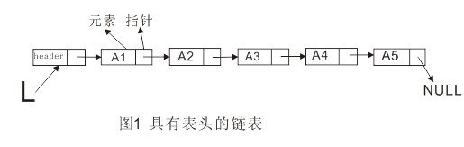
删除操作可以通过修改一个指针来实现。
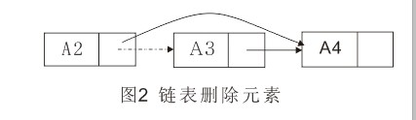
插入操作需要执行两次指针调整。
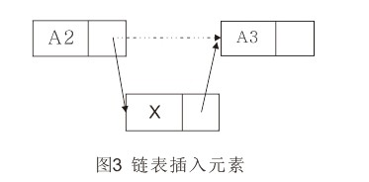
1. 单向链表的实现
1.1 Node实现
每个Node分为两部分。一部分含有链表的元素，可以称为数据域；另一部分为一指针，指向下一个Node。
?
1  2  3  4  5  6  7  8  9  10  11  12  13 | class Node():  __slots__=['_item','_next'] #限定Node实例的属性  def __init__(self,item):  self._item=item  self._next=None #Node的指针部分默认指向None  def getItem(self):  return self._item  def getNext(self):  return self._next  def setItem(self,newitem):  self._item=newitem  def setNext(self,newnext):  self._next=newnext
1.2 SinglelinkedList的实现
?
1  2  3  4 | class SingleLinkedList():  def __init__(self):  self._head=None #初始化链表为空表  self._size=0
1.3 检测链表是否为空
?
1  2 | def isEmpty(self):  return self._head==None
1.4 add在链表前端添加元素
?
1  2  3  4 | def add(self,item):  temp=Node(item)  temp.setNext(self._head)  self._head=temp
1.5 append在链表尾部添加元素
?
1  2  3  4  5  6  7  8  9  10 | def append(self,item):  temp=Node(item)  if self.isEmpty():  self._head=temp #若为空表，将添加的元素设为第一个元素  else:  current=self._head  while current.getNext()!=None:  current=current.getNext() #遍历链表  current.setNext(temp) #此时current为链表最后的元素
1.6 search检索元素是否在链表中
?
1  2  3  4  5  6  7  8  9 | def search(self,item):  current=self._head  founditem=False  while current!=None and not founditem:  if current.getItem()==item:  founditem=True  else:  current=current.getNext()  return founditem
1.7 index索引元素在链表中的位置
?
1  2  3  4  5  6  7  8  9  10  11  12  13  14 | def index(self,item):  current=self._head  count=0  found=None  while current!=None and not found:  count+=1  if current.getItem()==item:  found=True  else:  current=current.getNext()  if found:  return count  else:  raise ValueError,'%s is not in linkedlist'%item
1.8 remove删除链表中的某项元素
?
1  2  3  4  5  6  7  8  9  10  11  12  13 | def remove(self,item):  current=self._head  pre=None  while current!=None:  if current.getItem()==item:  if not pre:  self._head=current.getNext()  else:  pre.setNext(current.getNext())  break  else:  pre=current  current=current.getNext()
1.9 insert链表中插入元素
?
1  2  3  4  5  6  7  8  9  10  11  12  13  14  15  16 | def insert(self,pos,item):  if pos<=1:  self.add(item)  elif pos>self.size():  self.append(item)  else:  temp=Node(item)  count=1  pre=None  current=self._head  while count<pos:  count+=1  pre=current  current=current.getNext()  pre.setNext(temp)  temp.setNext(current)
全部代码
?
1  2  3  4  5  6  7  8  9  10  11  12  13  14  15  16  17  18  19  20  21  22  23  24  25  26  27  28  29  30  31  32  33  34  35  36  37  38  39  40  41  42  43  44  45  46  47  48  49  50  51  52  53  54  55  56  57  58  59  60  61  62  63  64  65  66  67  68  69  70  71  72  73  74  75  76  77 | class Node():  __slots__=['_item','_next']  def __init__(self,item):  self._item=item  self._next=None  def getItem(self):  return self._item  def getNext(self):  return self._next  def setItem(self,newitem):  self._item=newitem  def setNext(self,newnext):  self._next=newnext  class SingleLinkedList():  def __init__(self):  self._head=None #初始化为空链表  def isEmpty(self):  return self._head==None  def size(self):  current=self._head  count=0  while current!=None:  count+=1  current=current.getNext()  return count  def travel(self):  current=self._head  while current!=None:  print current.getItem()  current=current.getNext()  def add(self,item):  temp=Node(item)  temp.setNext(self._head)  self._head=temp  def append(self,item):  temp=Node(item)  if self.isEmpty():  self._head=temp #若为空表，将添加的元素设为第一个元素  else:  current=self._head  while current.getNext()!=None:  current=current.getNext() #遍历链表  current.setNext(temp) #此时current为链表最后的元素  def search(self,item):  current=self._head  founditem=False  while current!=None and not founditem:  if current.getItem()==item:  founditem=True  else:  current=current.getNext()  return founditem  def index(self,item):  current=self._head  count=0  found=None  while current!=None and not found:  count+=1  if current.getItem()==item:  found=True  else:  current=current.getNext()  if found:  return count  else:  raise ValueError,'%s is not in linkedlist'%item  def remove(self,item):  current=self._head  pre=None  while current!=None:  if current.getItem()==item:  if not pre:  self._head=current.getNext()  else:  pre.setNext(current.getNext())  break  else:  pre=current  current=current.getNext()  def insert(self,pos,item):  if pos<=1:  self.add(item)  elif pos>self.size():  self.append(item)  else:  temp=Node(item)  count=1  pre=None  current=self._head  while count<pos:  count+=1  pre=current  current=current.getNext()  pre.setNext(temp)  temp.setNext(current)  if __name__=='__main__':  a=SingleLinkedList()  for i in range(1,10):  a.append(i)  print a.size()  a.travel()  print a.search(6)  print a.index(5)  a.remove(4)  a.travel()  a.insert(4,100)  a.travel()

