python双向链表实现实例代码
python双向链表和单链表类似，只不过是增加了一个指向前面一个元素的指针,下面的代码实例了python双向链表的方法
示意图：
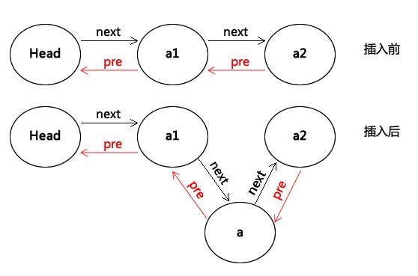
python双向链表实现代码：
复制代码代码如下:
#!/usr/bin/python
# -*- coding: utf-8 -*-
class Node(object):
def __init__(self,val,p=0):
self.data = val
self.next = p
self.prev = p
class LinkList(object):
def __init__(self):
self.head = 0
def __getitem__(self, key):
if self.is_empty():
print 'linklist is empty.'
return
elif key <0 or key > self.getlength():
print 'the given key is error'
return
else:
return self.getitem(key)

def __setitem__(self, key, value):
if self.is_empty():
print 'linklist is empty.'
return
elif key <0 or key > self.getlength():
print 'the given key is error'
return
else:
self.delete(key)
return self.insert(key)
def initlist(self,data):
self.head = Node(data[0])
p = self.head
for i in data[1:]:
node = Node(i)
p.next = node
node.prev = p
p = p.next
def getlength(self):
p = self.head
length = 0
while p!=0:
length+=1
p = p.next
return length
def is_empty(self):
if self.getlength() ==0:
return True
else:
return False
def clear(self):
self.head = 0
def append(self,item):
q = Node(item)
if self.head ==0:
self.head = q
else:
p = self.head
while p.next!=0:
p = p.next
p.next = q
q.prev = p
def getitem(self,index):
if self.is_empty():
print 'Linklist is empty.'
return
j = 0
p = self.head
while p.next!=0 and j <index:
p = p.next
j+=1
if j ==index:
return p.data
else:
print 'target is not exist!'
def insert(self,index,item):
if self.is_empty() or index<0 or index >self.getlength():
print 'Linklist is empty.'
return
if index ==0:
q = Node(item,self.head)
self.head = q
p = self.head
post = self.head
j = 0
while p.next!=0 and j<index:
post = p
p = p.next
j+=1
if index ==j:
q = Node(item,p)
post.next = q
q.prev = post
q.next = p
p.prev = q
def delete(self,index):
if self.is_empty() or index<0 or index >self.getlength():
print 'Linklist is empty.'
return
if index ==0:
q = Node(item,self.head)
self.head = q
p = self.head
post = self.head
j = 0
while p.next!=0 and j<index:
post = p
p = p.next
j+=1
if index ==j:
post.next = p.next
p.next.prev = post
def index(self,value):
if self.is_empty():
print 'Linklist is empty.'
return
p = self.head
i = 0
while p.next!=0 and not p.data ==value:
p = p.next
i+=1
if p.data == value:
return i
else:
return -1
l = LinkList()
l.initlist([1,2,3,4,5])
print l.getitem(4)
l.append(6)
print l.getitem(5)
l.insert(4,40)
print l.getitem(3)
print l.getitem(4)
print l.getitem(5)
l.delete(5)
print l.getitem(5)
l.index(5)
结果为；
5
6
4
40
5
6
和单链表结果一样。

