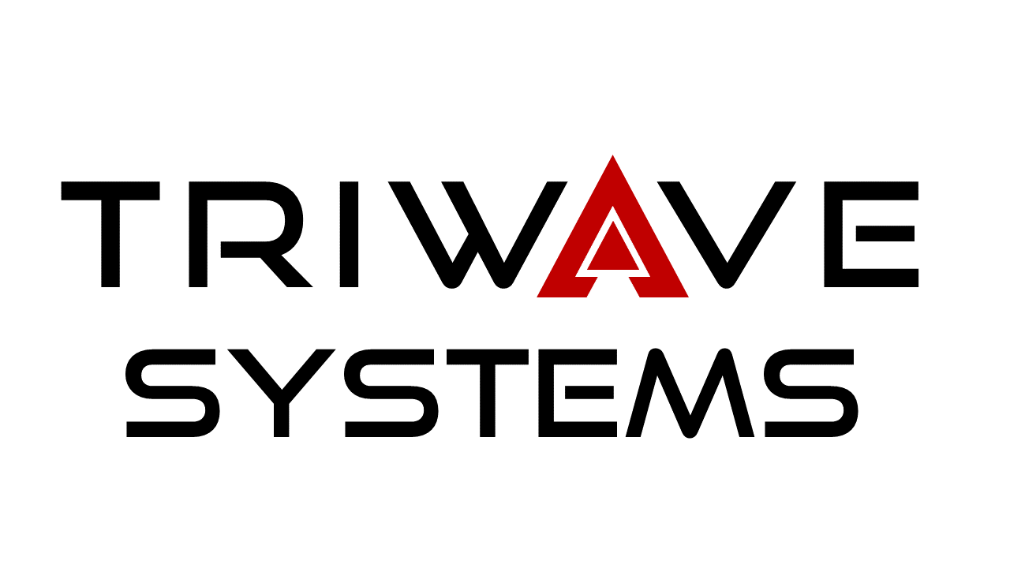

SFU

ENSC 440

Akriveia Beacon

Break-Even Analysis

Team 5

15/11/2019

|  |  |
| --- | --- |
| Project Team | Jeffery Yeung CCO  Keith Leung CTO  Scott Checko COO  Ryne Waterson CIO  Jerry Liu CEO |
| Contact | Jeffery Yeung  zjyeung@sfu.ca |
| Submitted to | Dr. Andrew Rawicz  School of Engineering Science  Simon Fraser University |
| Issue Date | November 15, 2019 |