BR_STM32F407ZGT6_ DP83848系统板用户手册v1.3

一 开发板主要功能特点
1．TF卡模拟U盘
(TF卡 SDIO接口连接)
2．SPI NAND FLASH（M25P16 2M Byte）
3．SRAM: IS61WV102416（2M Byte SRAM）
4．NOR FLASH : M29W128GH70N6 （16M Byte NOR FLASH）
5．以太网络 (DP83848 RMII )

二 开发板其他功能说明
1．标准 ARM JTAG 20 PIN 仿真器接口, 方便连接JLINK, ULINK2等主流仿真器。
2．USB供电。
3．支持串口1 (PA9, PA10), ISP下载; USB DFU下载。
4．25M时钟晶振，32.768khz RTC时钟晶振。
5．未使用的IO口引出 (PC8,9,11 与SDIO复用)，
方便接外部电路做实验。
6．电源指示灯LD5。
7．4路LED灯D1, D2, D3, D4。
8．复位键B1, 用户键B2。
9．USB接口，方便USB通讯实验。

三 下载说明
1．JLINKv8下载
具体参考\ PC_Software\JLINK \ JLINK V8新用户手册中文版.pdf
参考资料PC_Software\JLINK

2．ISP串口下载
JP4的Boot0短接;
JP3要短接2<>3; U15 USB口供电.
USB-TTL与串口1(PA9 USART1_TX, PA10 USART1_RX)连接, 只需接GND,RX,TX 要交叉叉连接.
具体操作参考\PC_Software\ STM32_FLASH的3种烧写方式.pdf
PC_Software\串口下载软件\
stm32-stm8_flash_loader_demo_V2.5.0.zip

3．DFU USB下载
可以从裸板开始,进行USB下载
JP4的Boot0短接;
JP3要短接1<>2; U11 USB口供电.
工具和说明 PC_Software\DfuSe_Demo_V3.0.2

三 例程说明
下列例程在Keil uVision4.23下编译验证。
BR_STM32F407ZET6_DP83848-USB-Device(SD卡USB读卡器)
BR_STM32F407ZET6_DP83848-M25P16
BR_STM32F407ZET6_DP83848_指示灯
BR_STM32F407ZET6_DP83848_实时时钟与年月日
BR_STM32F407ZET6_DP83848_SRAM访问程序
BR_STM32F407ZET6_DP83848_printf打印输出
BR_STM32F407ZET6_DP83848_NOR_FLASH访问
BR-STM32F407ZET6_DP83848_ETH(以太网httpserver网页实验)
IP的设置都在main.h中，参考附1

调TCP Server, TCP Client时, 需先调TCP Server
1) TCP Server例程下载到板
串口连接PB10, 115200
有信息” TCPServer Waiting for client on port 5000...”
Ping 192.168.1.30 OK
网络调试助手设置好,点连接, 点发送

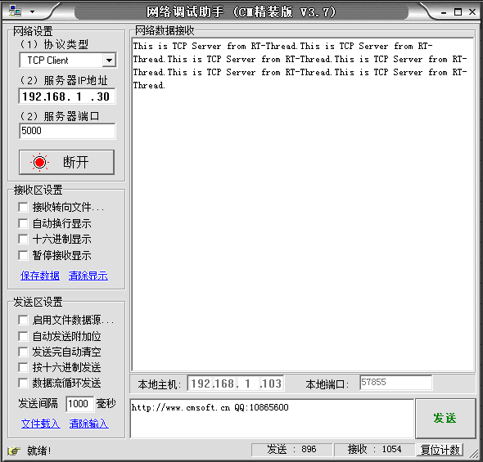

串口有相应信息:

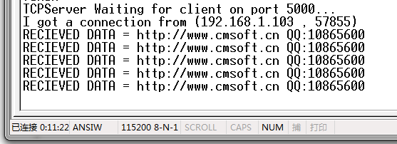
1) TCP Client例程下载到板
网络调试助手先设置好

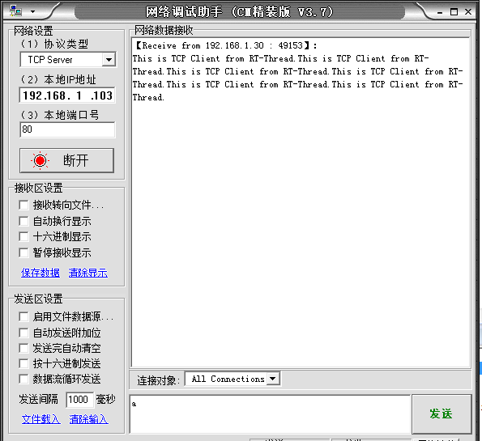
再重起板子,再过几秒,点发送
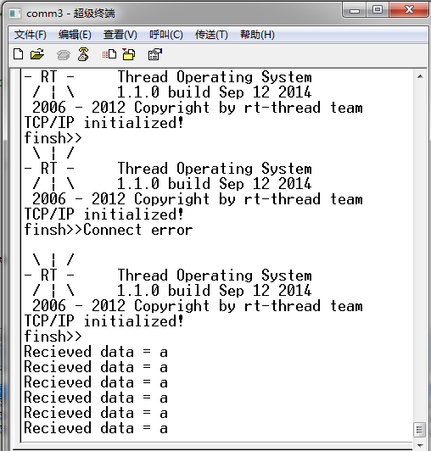

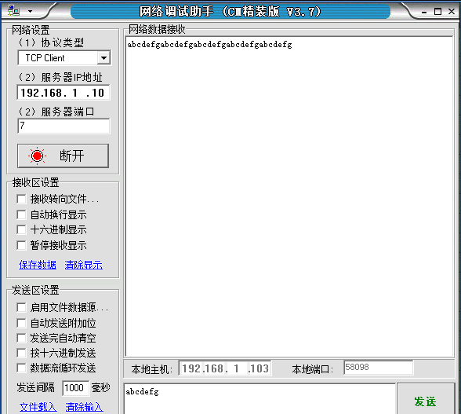

BR-STM32F407ZET6_DP83848-SPI_LCD

SPI LCD 接口:
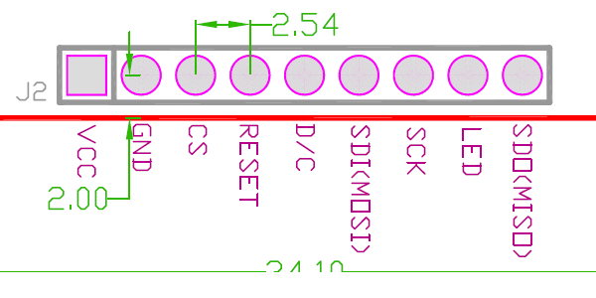

SPI LCD通过9根杜帮线与开发板JP2接口的9个引脚连接
VCC GND CS RESET D/C SDI SCK LED SDO
按顺序对应JP2接口的 2, 4, 6, 8, 10, 12, 14, 16, 18 脚

Core
Memories

附1：
Httpserver:
MAC ADDRESS: 2 0 0 0 0 0
Static IP ADDRESS: 192.168.1.10
NETMASK: 255 255 255 0
Gateway Address: 192.168.1.1

TFTPserver:
同Httpserver
TCPserver:
同Httpserver
TCPclient:
DEST IP ADDRESS: 192.168.1.11
DEST_PORT 7
其他同Httpserver

UDPserver:
MAC ADDRESS: 2 0 0 0 0 0
Static IP ADDRESS: 192.168.1.10
NETMASK: 255 255 255 0
Gateway Address: 192.168.1.1
UDP local connection port ：7
UDPclient:
DEST IP ADDRESS: 192.168.1.11
UDP remote connection port ：7
其他同UDPserver

附2：
Core核心:
- ARM 32-bit Cortex-M4 CPU with FPU
- Adaptive real-time accelerator (ART Accelerator)
- 168 MHz maximum frequency, 210 DMIPS/1.25 DMIPS/MHz
- Memory protection unit

Memories存储 :
- Up to 1 Mbyte of Flash memory
- Up to 192+4 Kbytes of SRAM
- Flexible static memory controller
(supports Compact Flash, SRAM, PSRAM, NOR, NAND memories)

Specific Features属性:
LCD parallel interface, 8080/6800 modes
Clock, reset and supply management
- 1.7 V to 3.6 V application supply and I/Os
- POR, PDR, PVD and BOR
- 4 to 25 MHz crystal oscillator
- Internal 16 MHz factory-trimmed RC
- 32 kHz oscillator for RTC with calibration
- Internal 32 kHz RC with calibration
Low power
- Sleep, Stop, Standby modes
- VBAT supply for RTC,
20Cµ32 bit backup registers + optional 4 KB backup SRAM
3 Cµ 12-bit, 0.41 us A/D converters
- up to 24 channels
2 Cµ 12-bit D/A converters
General-purpose DMA
- 16-stream DMA controller with centralized FIFOs and burst support
Up to 17 timers
- up to 12 16-bit and 2 32-bit timers up to 150 MHz
Debug mode
- Serial wire debug (SWD) & JTAG
- Cortex-M4 Embedded Trace Macrocell
Up to 140 I/O ports with interrupt capability
- Up to 136 fast I/Os up to 60 MHz
- Up to 138 5 V-tolerant I/Os
Up to 15 communication interfaces
- Up to 3 Cµ I2C interfaces
- Up to 4 USARTs/2 UARTs (10.5 Mbit/s, ISO 7816, LIN, IrDA, modem control)
- Up to 3 SPIs (37.5 Mbits/s)
- 2 Cµ CAN interfaces (2.0B Active)
- SDIO interface
Advanced connectivity
- USB 2.0 FS device/host/OTG controller with on-chip PHY
- USB 2.0 HS/FS device/host/OTG controller with dedicated DMA,
on-chip FS PHY and ULPI
- 10/100 Ethernet MAC with dedicated DMA
8 to 14-bit parallel camera interface up to 67.2 Mbytes/s
Cryptographic acceleration
- Hardware acceleration for AES 128, 192, 256, Triple DES, HASH (MD5, SHA-1)
Analog true random number generator
CRC calculation unit, 96-bit unique ID
RTC: subsecond accuracy, hardware calendar

封装 LQFP144

Blueridgemcu.taobao.com
2013-06-18

