1.

代码如下：

model:

sets:

warehouses/wh1..wh3/:capacity;

vendors/v1..v4/:demand;

links(warehouses,vendors):cost, volume;

endsets

data:

capacity = 2500 2500 5000;

demand = 1500 2000 3000 3500;

cost = 10 5 6 7

8 2 7 6

9 3 4 8;

enddata

max=@sum(links(I,J): cost(I,J)\*volume(I,J));

@for(vendors(J):

@sum(warehouses(I):volume(I,J))=demand(J));

@for(warehouses(I):

@sum(vendors(J):volume(I,J))<=capacity(I));

End

结果截图如下：

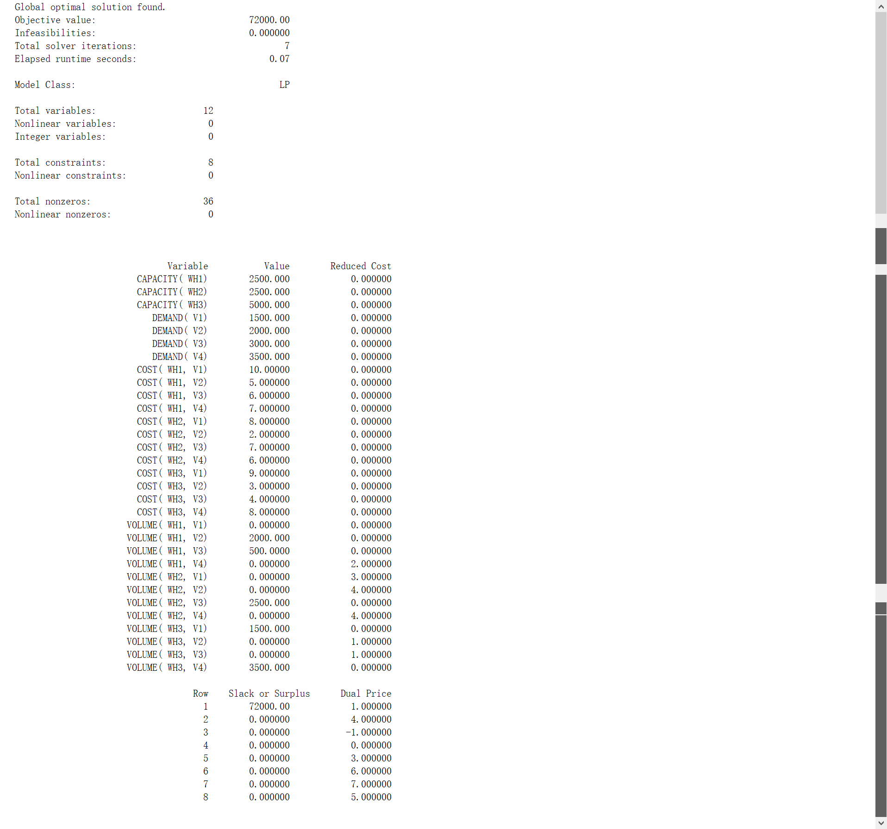

2.

代码如下：

model:

min = p1 \* d1p + p2 \* (d2p + d3p + d4p) + p3 \* (d5n + d6n);

10 \* (100-0.1\*100+x1) + 7.5 \* (120 - x1 + x2) + 5 \* (150 - x2 + x3) + d1n - d1p = 3000 ;

100 \* (1 - 0.1) + x1 + d2n - d2p = 120;

120 - x1 + x2 + d3n - d3p = 150;

150 - x2 + x3 + d4n - d4p = 150;

X1 + d5n - d5p = 120 \* 0.2;

x3 + d6n - d6p = 150 \* 0.2;

x1>=0;

x2>=0;

x3>=0;

d1n>=0;d1p>=0;

d2n>=0;d2p>=0;

d3n>=0;d3p>=0;

d4n>=0;d4p>=0;

d5n>=0;d5p>=0;

d6n>=0;d6p>=0;

@gin(x1);@gin(x2);@gin(x3);

p1=10000;

p2=100;

p3=1;

end

结果截图如下：

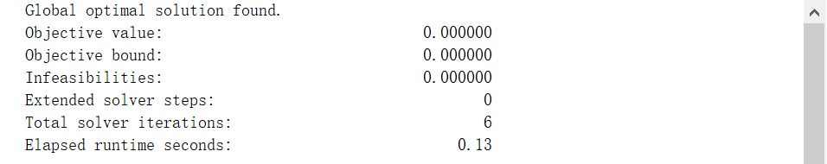

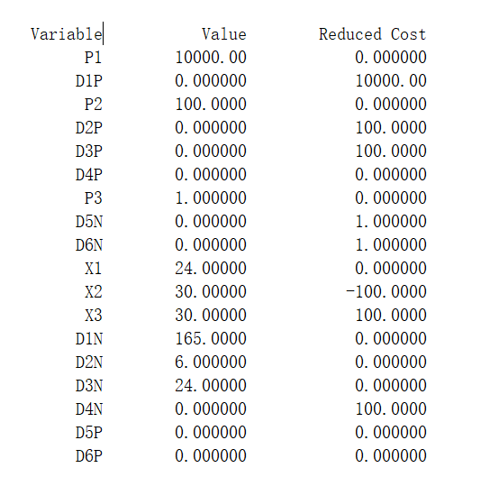

3.

代码如下：

model:

sets:

employee/1..5/;

assg(employee, employee):c, x;

endsets

data:

c = 25 29 31 42 37

39 38 26 20 33

37 27 28 40 32

24 42 36 23 45

24 27 26 20 32;

enddata

min = @sum(assg:c\*x);

@for(employee(i):

@sum(employee(j):x(i, j))=1;

@sum(employee(j):x(j, i))=1;

);

end

结果截图如下：

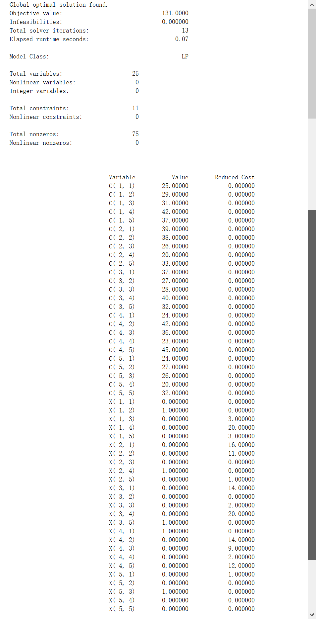



4.

代码如下：

model:

sets:

usr/1..3/;

dvc/1..6/;

assg(dvc,usr):earning, status, selection;

endsets

data:

earning = 0 0 0

3 5 4

7 10 6

9 11 11

12 11 12

13 11 12;

status = 0 0 0

1 1 1

2 2 2

3 3 3

4 4 4

5 5 5;

enddata

max = @sum(assg(i,j):earning(i,j)\*selection(i,j));

@for(assg:@bin(selection));

@for(usr(j):@sum(assg(k,j):selection(k,j))=1);

@sum(assg(i,j):status(i,j)\*selection(i,j))=5;

end

结果截图如下：

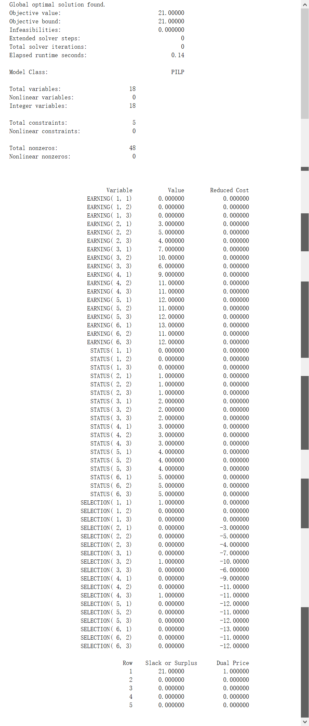



5.

代码如下：

model:

sets:

vtx/vs, v1, v2, v3, vt/;

edg(vtx, vtx)/vs v2, vs v1, v2 v1, v2 v3, v1 v3, v1 vt, v3 vt/:b, c, f;

endsets

data:

b=1 4 2 3 6 1 2;

c=8 10 5 10 2 7 4;

enddata

submodel maxflow:

max = flow;

endsubmodel

submodel minfy:

mn = @sum(edg:b\*f);

endsubmodel

submodel con:

@for(vtx(i)|i #ne# 1 #and# i #ne# @size(vtx):

@sum(edg(i,j):f(i,j))-@sum(edg(j,i):f(j,i))=0);

@sum(edg(i,j)|i #eq# 1 : f(i,j)) = flow;

@for(edg:@bnd(0, f, c));

endsubmodel

calc:

@solve(maxflow, con);

endcalc

end

结果截图如下：

