**USER’S**

**MANUAL**

*STG*

MAY, 2017

<http://47.91.40.70:8088/index>

Introduction to the Stock Game website :

Index page:

Quota page

Sell page

Buy page

Dashboard page:

View stock table

Service:

Service page

Quota page

Sell page

Buy page

Leaderboard:

Leaderboard page

My friend page

History & Current:

History page

Current page

Profile:

Profile page

Price

Message:

**Index page:**



After user login the jump in this page.

This is index page can lead user to quota page sell page history page and buy page.

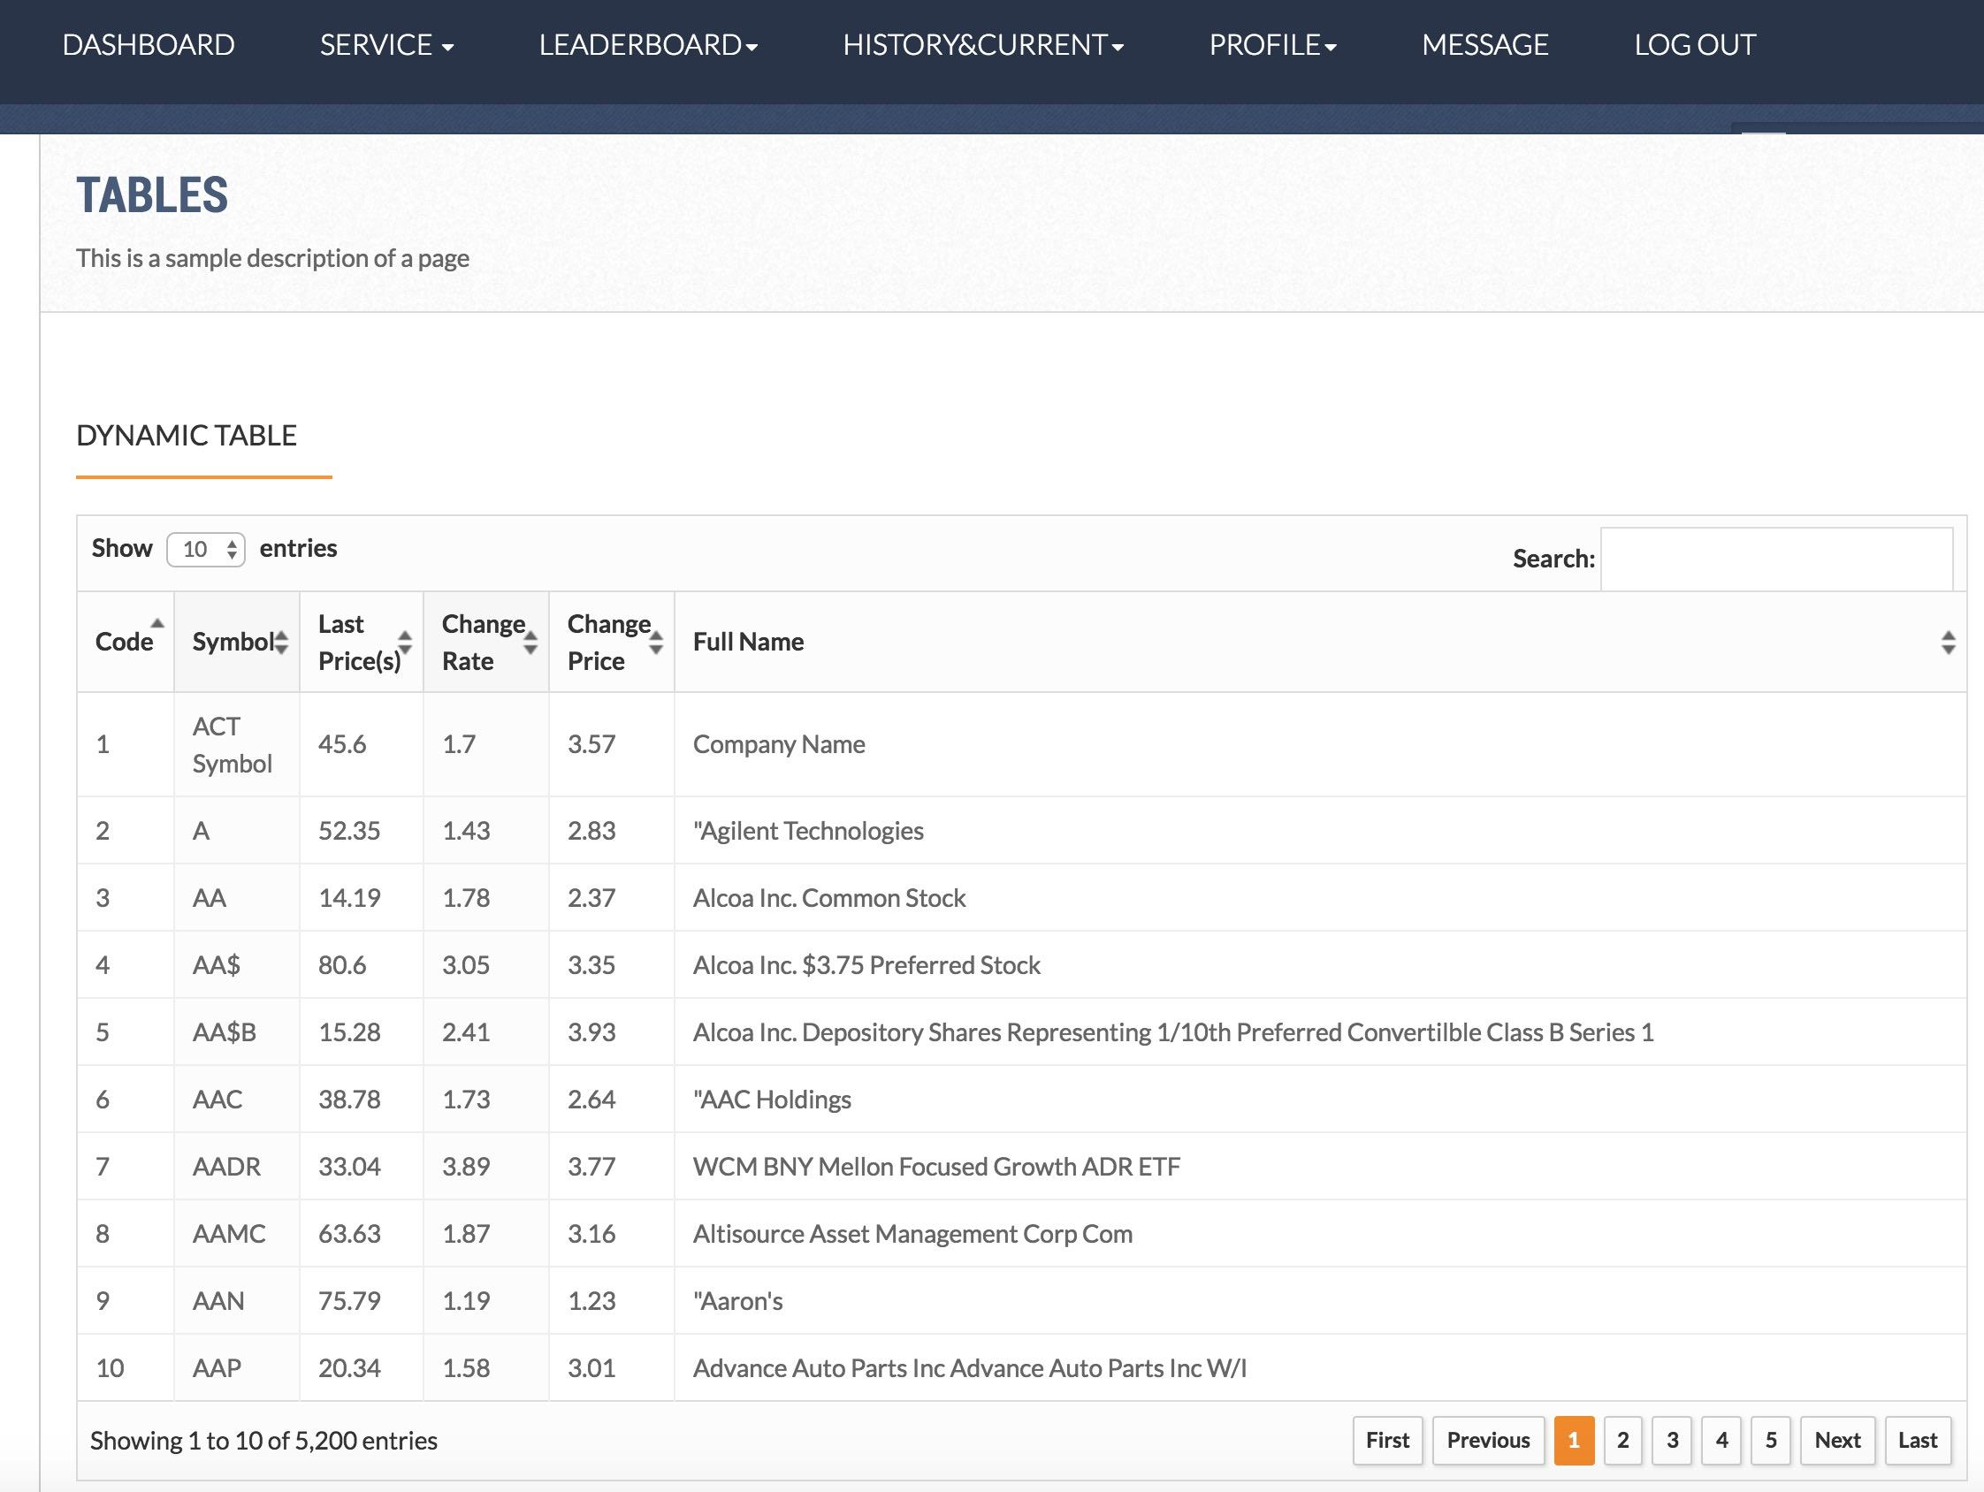

On Dashboard page user can watch all the stock and detail about the stock.



On the left user can put the name of stock to search the stock they want.

**Service:**

* Service page
* Quota page

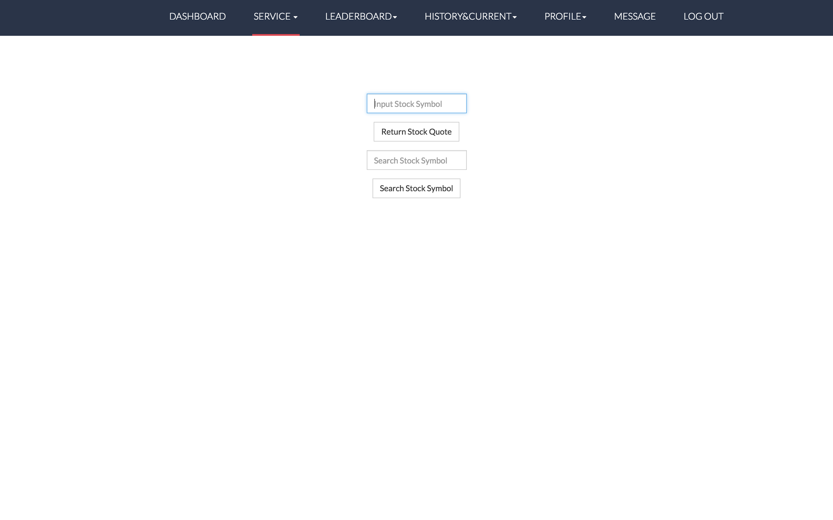

On quota page, users could find the stock codes.

* Sell page

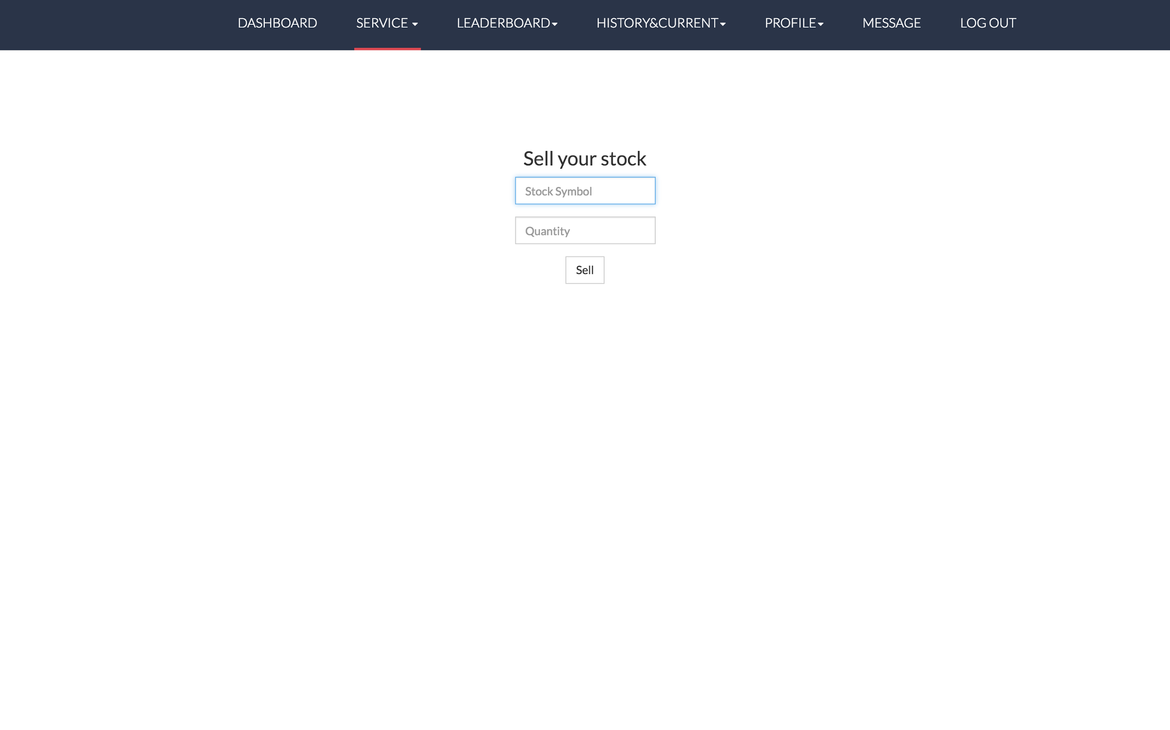

On sell page, users could sell a stock by searching stock symbol and entering how much they want to sell.

* Buy page

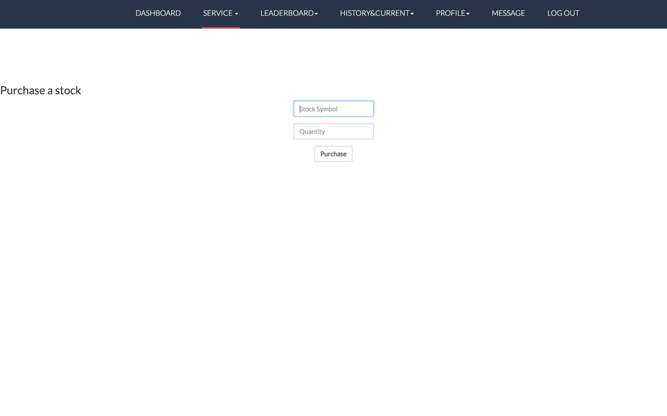

On buy page, users could buy a stock by searching the stock symbol and entering how much they want to buy.

**Leaderboard:**

* Leaderboard page

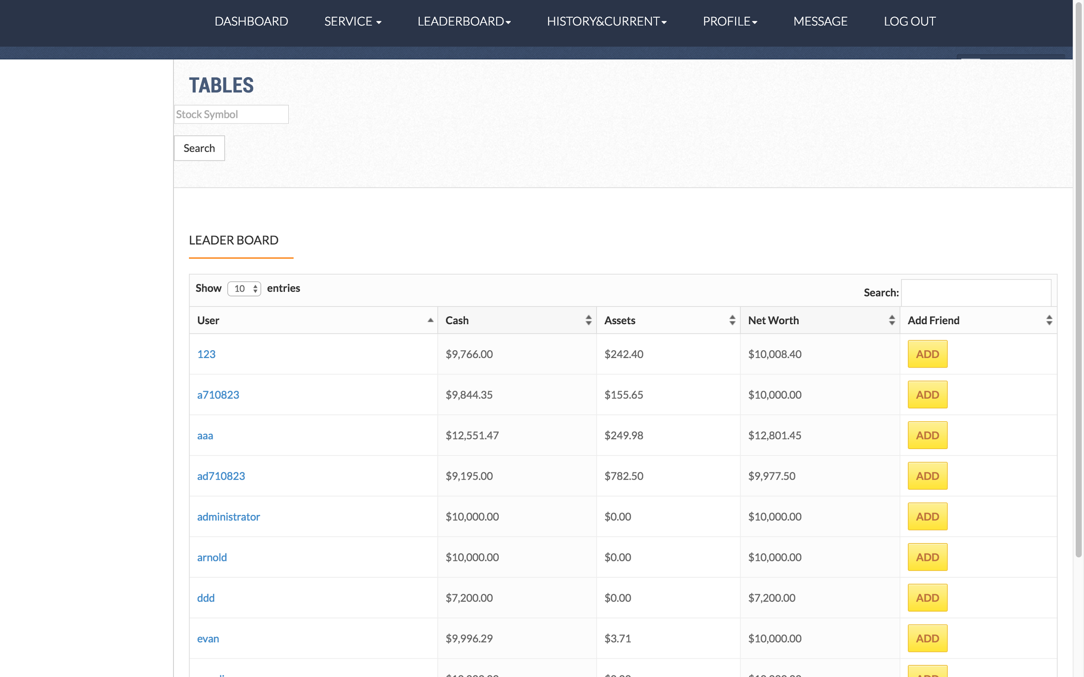

On leaderboard page, users could see all users ranked by cash, assets, or net worth, and they could add others as friends.

* My friend page

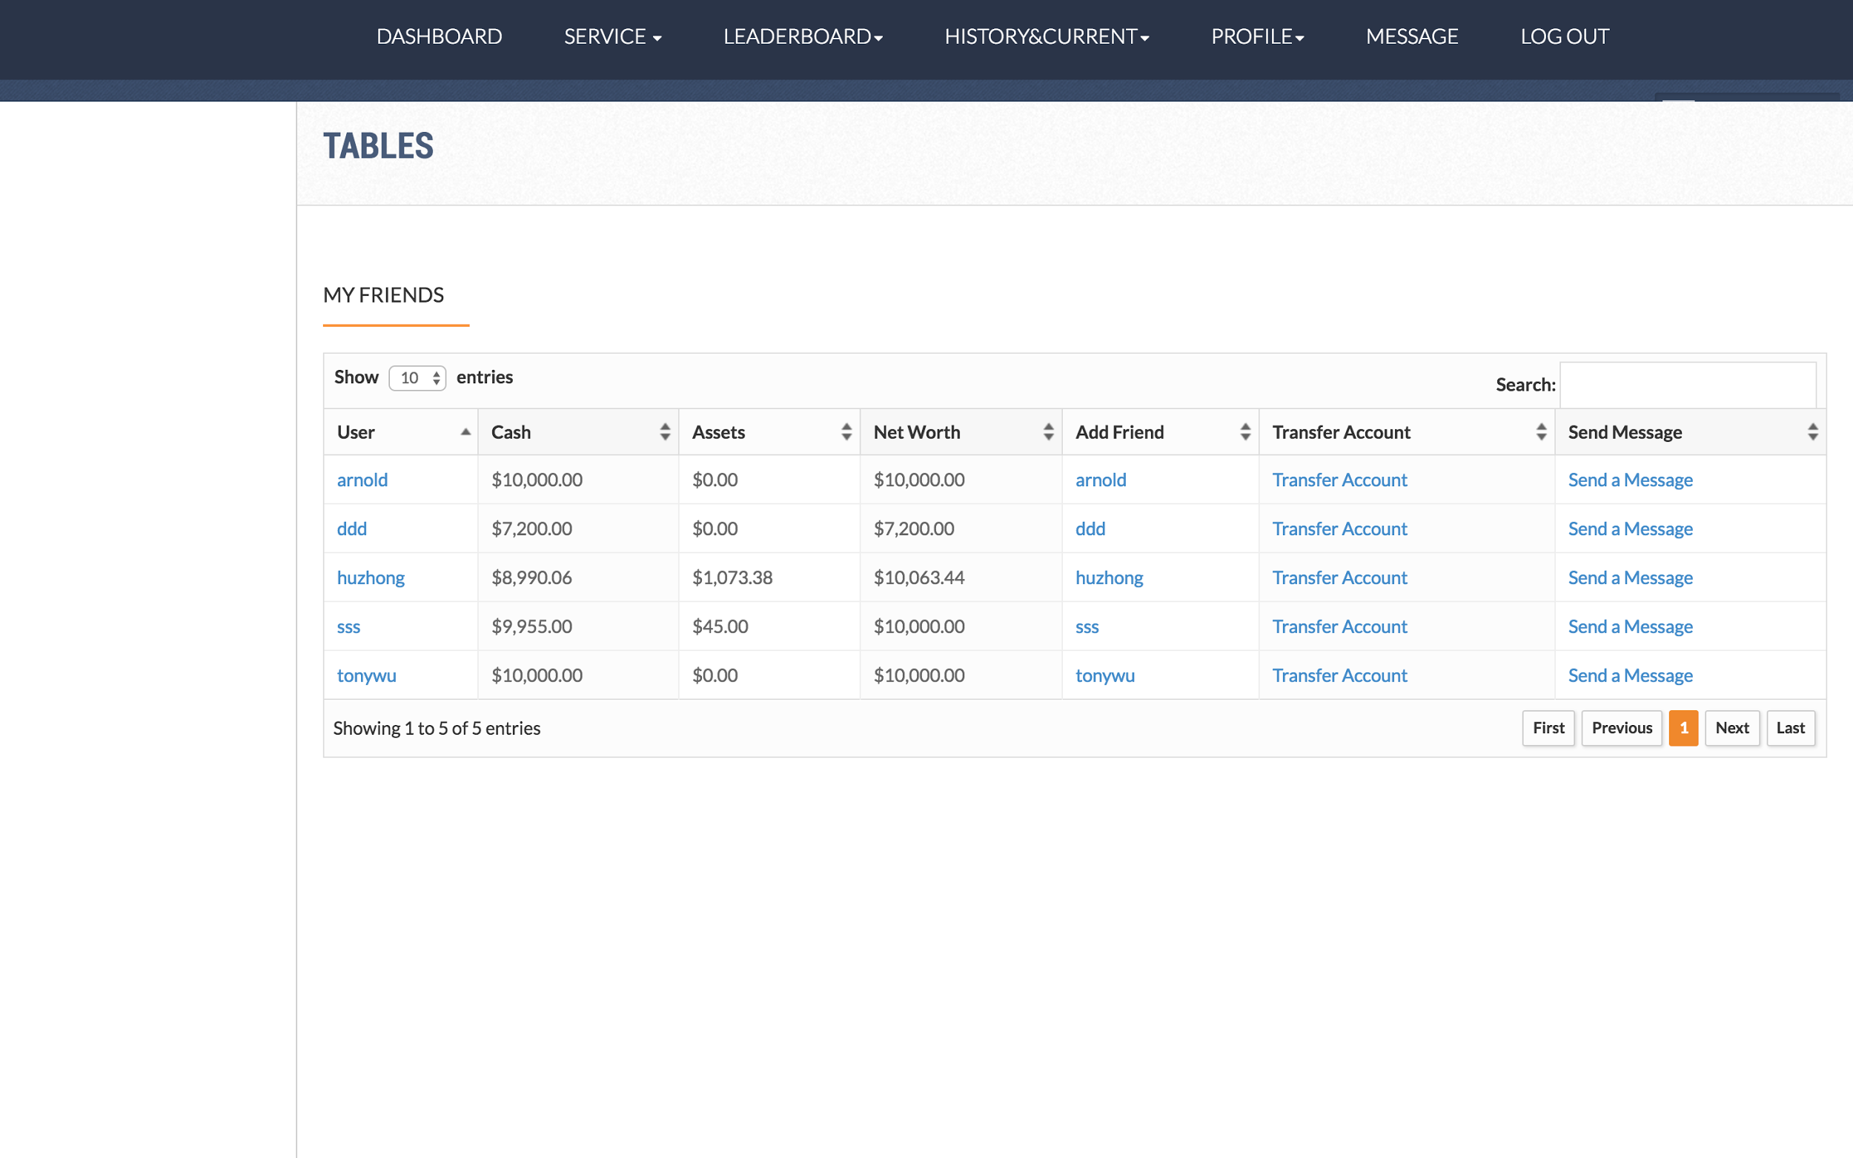

On my friend page, users could find all their friends.

**History & Current:**

* History page

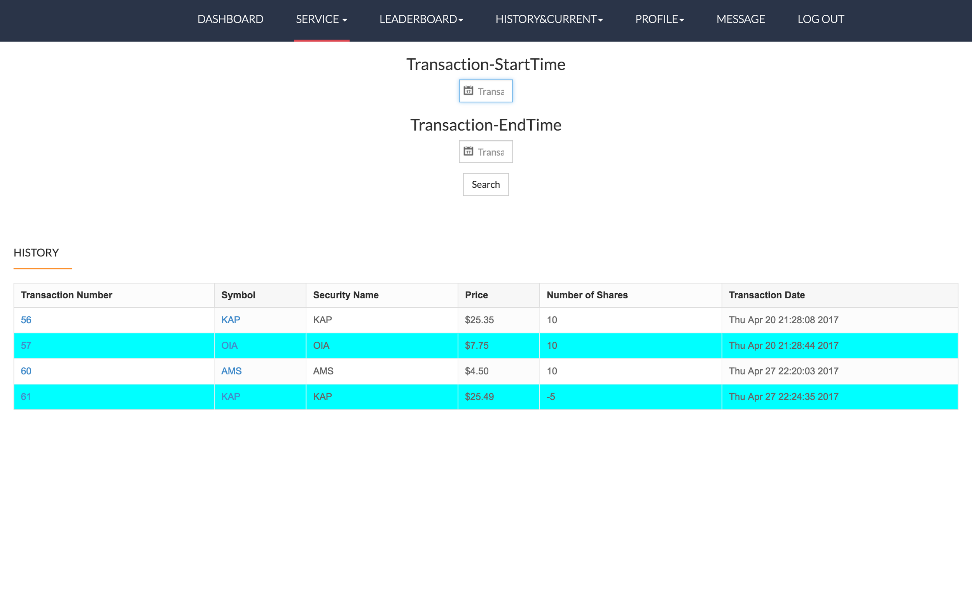

* Current page

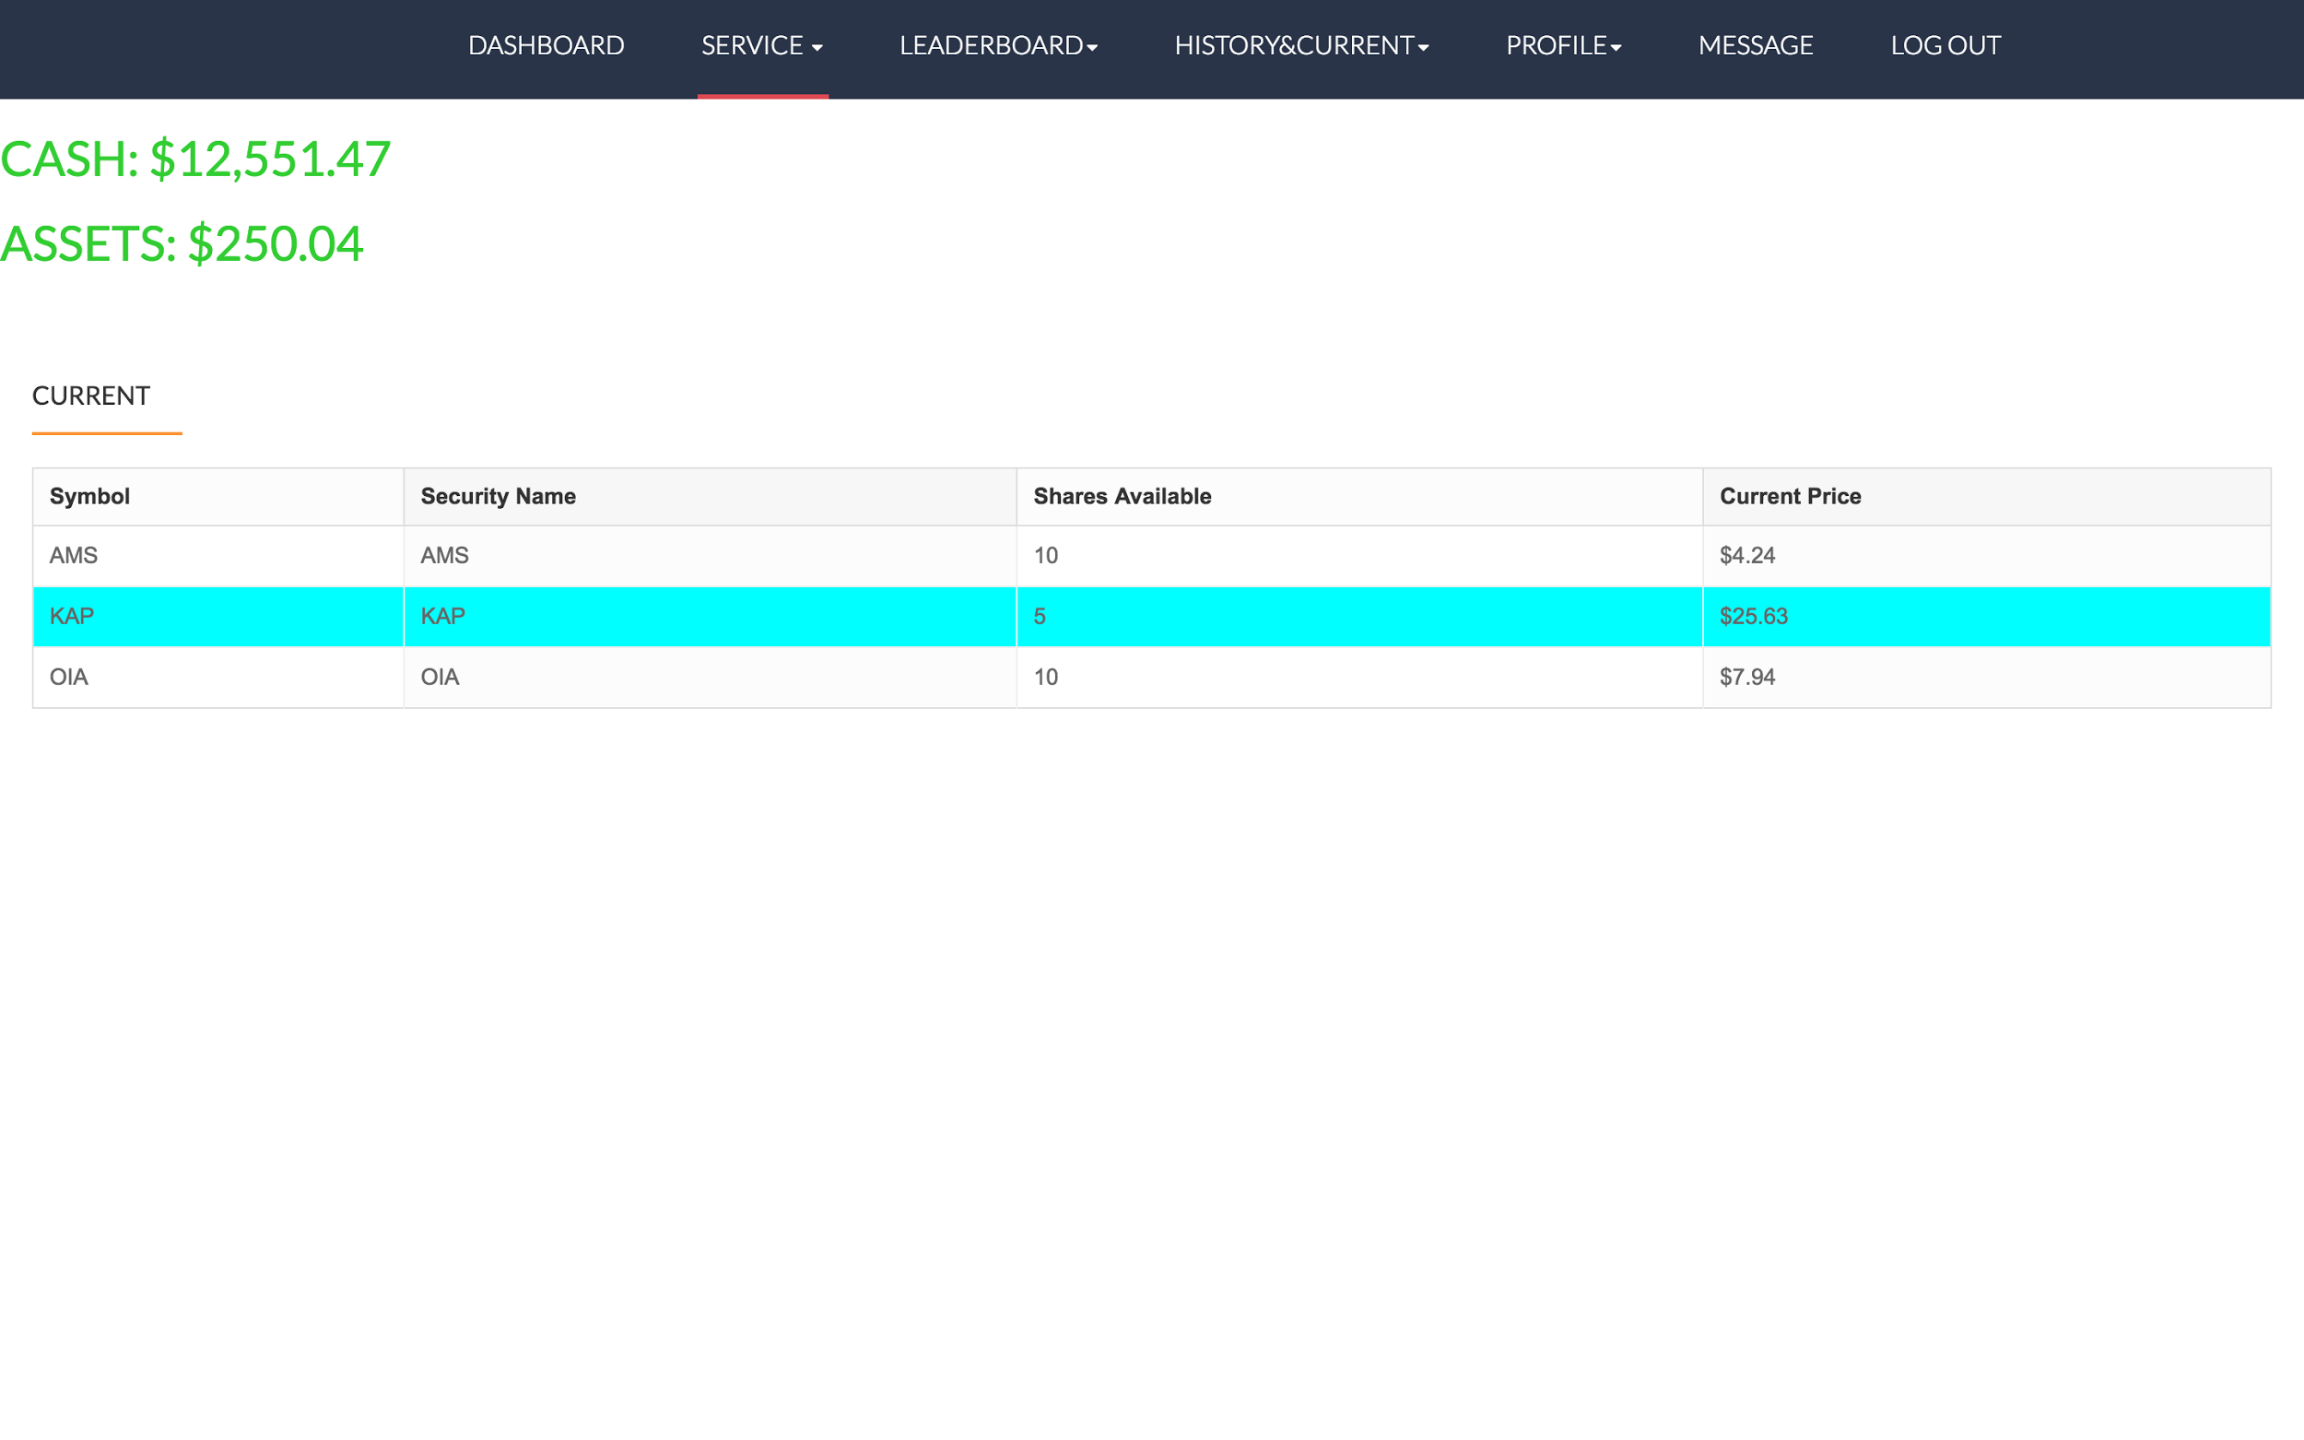

On current page,

**Profile:**

* Profile page

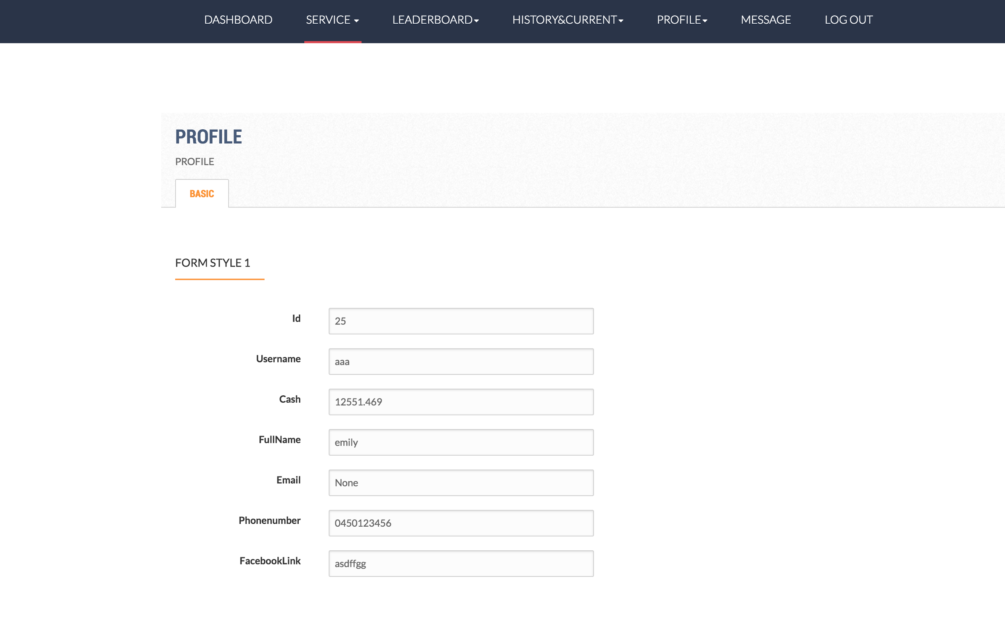

On profile page, users could find their basic information, such as ID, username, and cash, etc.

* Price

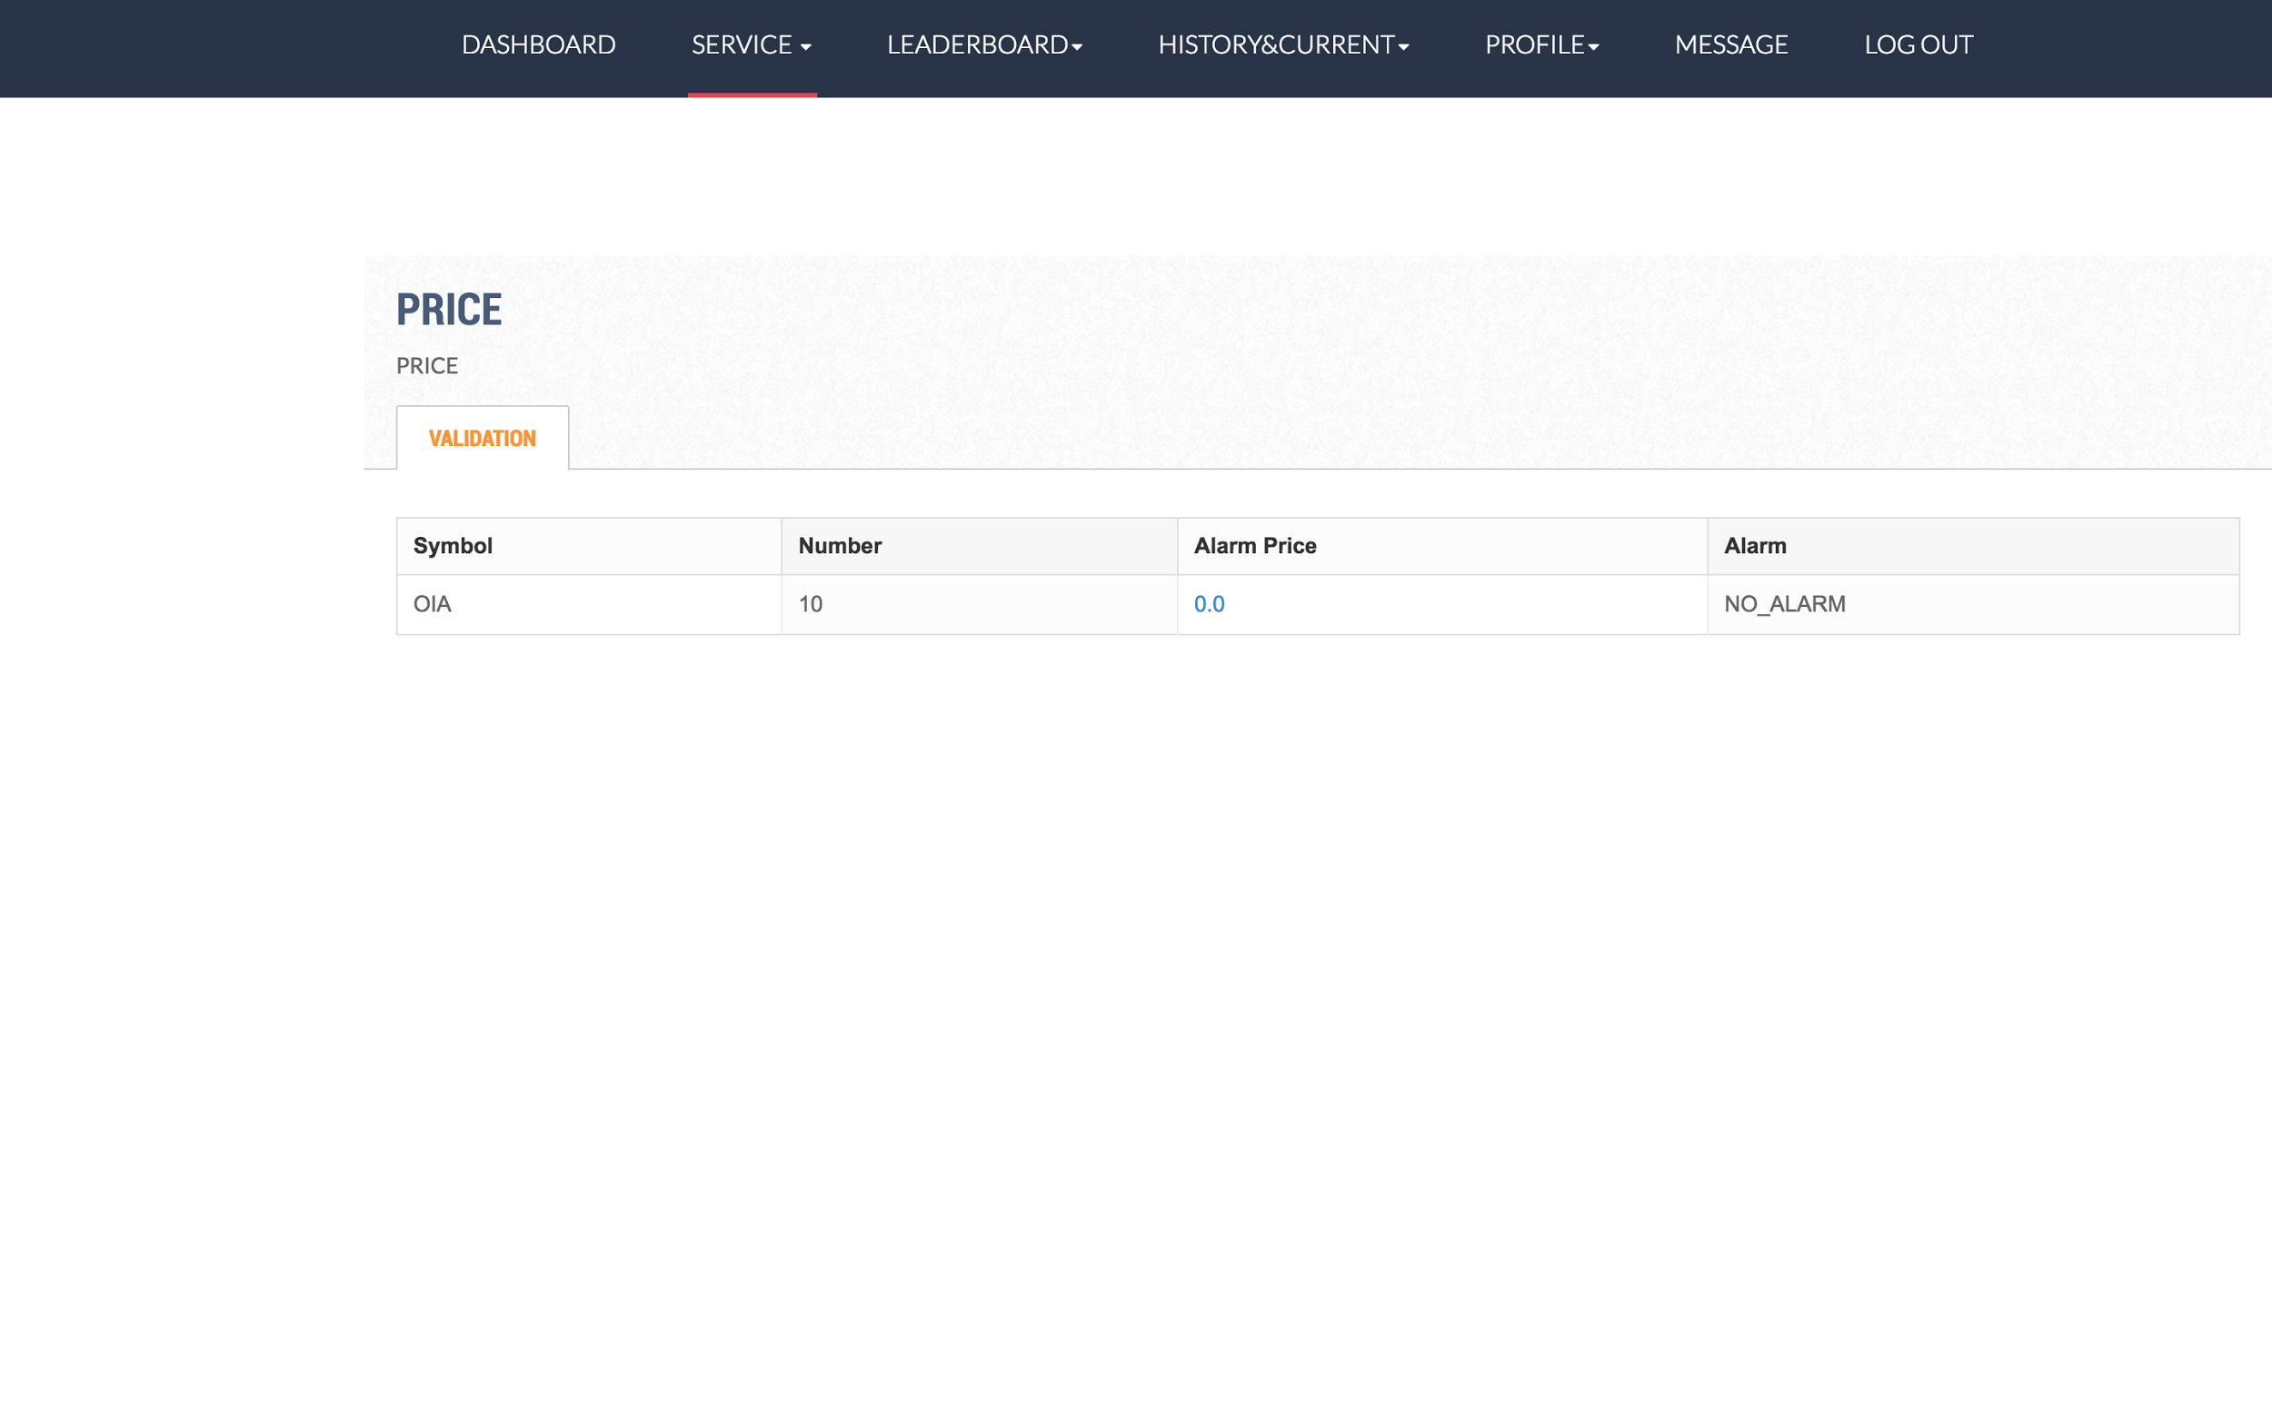

On price page, users could set the alerts when the stocks are reached the desired prices.

**Message:**

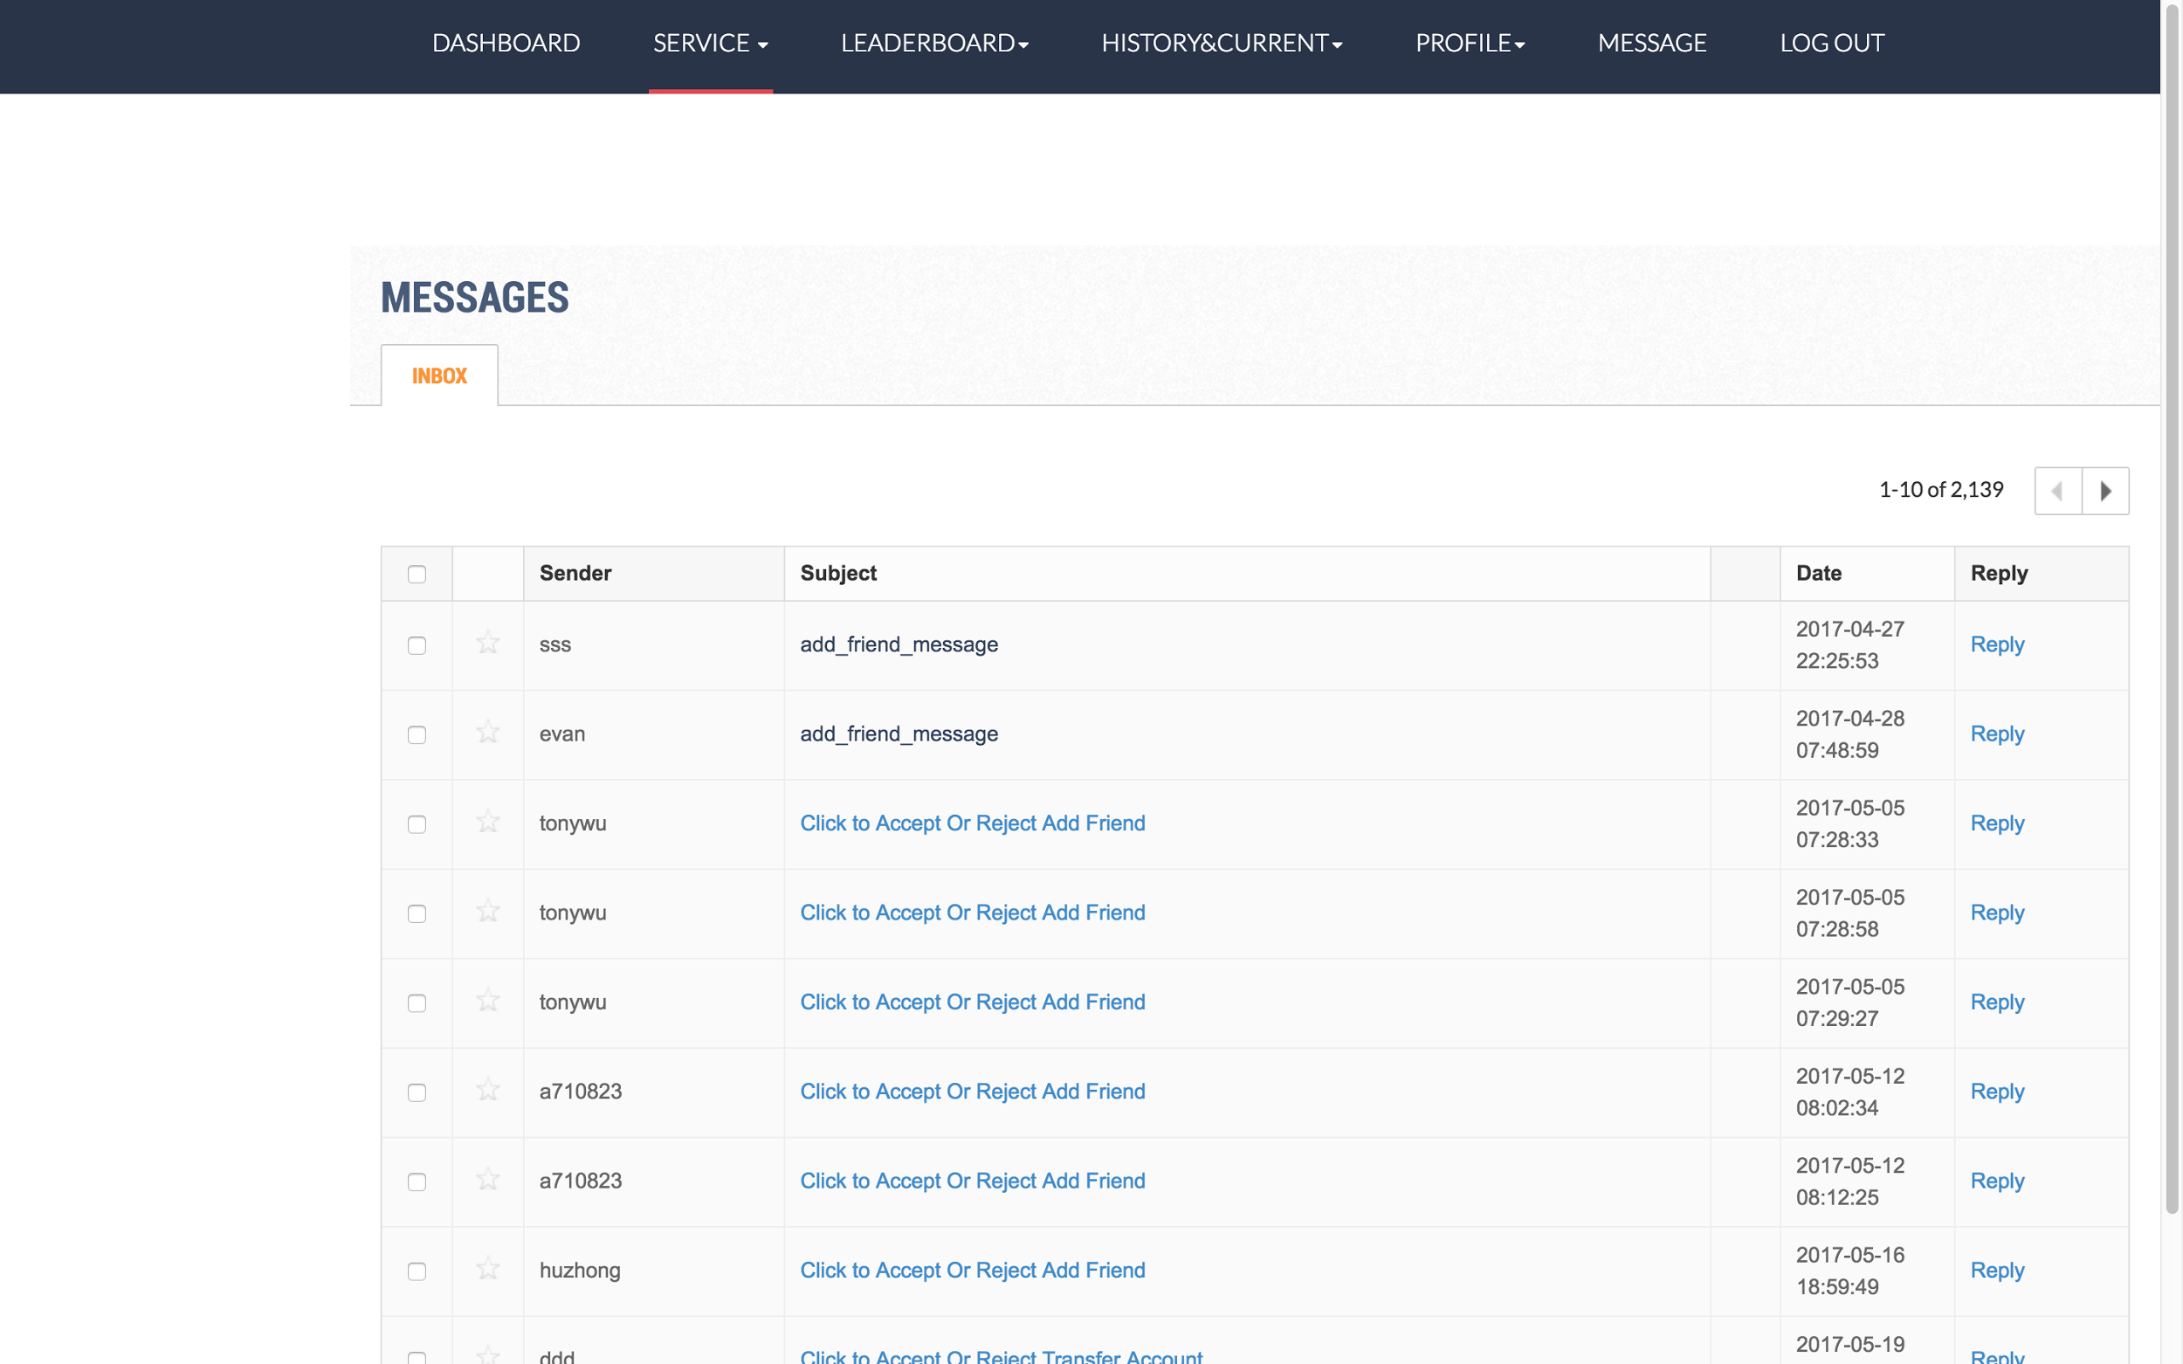

On message page, the users could find all messages that they received.