**Apples-to-Apples: Clustering and Ranking NHL Players Using Location Information**

Paper Track (Cambria, 14pt)

Paper ID

**Abstract**

Using new location data, we introduce a player performance assessment system that supports drafting, trading, and coaching decisions in the NHL. Players who tend to play in similar locations are clustered together using machine learning techniques, which captures similarity in styles and roles. Within each cluster, players are ranked according to how much they affect their team’s chance of scoring the next goal. Clustering avoids apples-to-oranges comparisons, like comparing offensive and defensive players. Our player ranking is based on assigning location-dependent values to actions. A high-resolution Markov model pinpoints the game situations and rink locations in which players perform especially well or especially poorly.

**1. Introduction: Valuing Players and Decisions at Locations**

SPORTLOGiQ is a new data provider whose data assign locations (x-y coordinates) to a rich set of action types. Our work leverages location information in two ways to support player performance assessment. (1) It has been noted that player performance metrics are most meaningful for comparing similar players [Pettigrew 2015]. We use the location pattern of players---where they tend to act---in order to cluster players with similar styles and roles. (2) We assign a value to actions depending on where the action takes place. For example, the value of a pass depends on where it is taken. Players are ranked according to the aggregate value of their actions, and compared to others in their cluster. The value of a player’s action is measured as its impact on his team’s chance of scoring the next goal; the resulting player metric is called their *scoring impact*. Scoring impact correlates with plausible alternative scores, such as a player's total points and salary, but improves on these measures, as the impact rank is based on many more events. We illustrate the results by identifying players that highly impact scoring, yet draw a low salary, compared to others in their cluster.

Our methods utilize two major machine learning techniques. (1) A recent clustering algorithm (affinity propagation) groups players by clustering heatmaps that represent their location patterns. (2) The fundamental dynamic programming algorithm of Markov Decision Processes [Puterman 2009] computes the probability that a team scores the next goal given the current state of the match. Dynamic programming allows us to scale the computation to a large state space comprising over 10,000 possible match settings and a large action space comprising 148 actions. Using relational database technology, we estimate values for over 100K transition probability parameters in a Markov game model. A Markov model is a powerful representation of match dynamics that has recently been shown to be effective for assigning values to actions and evaluating player performance [Cervone et al. 2014, Pettigrew 2015, Routley and Schulte 2015]. A Markov model defines the probability of a match continuation, given a current match state. For instance, given a current match state, it assigns a probability to the set of trajectories on which the home team scores the next goal.

The model-based approach has three main advantages over model-free approaches based on action counts. (i) The model states capture the *context* of actions within a game. For example, a goal is more valuable in a tied-game situation than when the scorer's team is already four goals ahead [Pettigrew2015]. (ii) Modeling game trajectories provides *look-ahead* to the medium-term consequences of an action. Looking ahead to the medium-term consequences allows us to assign a value to *every* action. This is especially important in continuous-flow games like ice hockey because evident rewards like goals occur infrequently [Cervone et al. 2014]. For example, if a player receives a penalty, the likelihood increases that the opposing team will score a goal during the power play at some point, but this does not mean that they will score immediately. (iii) The aggregate impact of a player can be broken down into his average *impact at specific states*. Since the model states provide a high-level of context detail, the model can be used to find the game situations in which a player performs especially well or especially poorly, compared to other players in his cluster. This kind of drill-down analysis explains and goes beyond a player’s overall ranking. We provide what to our knowledge are the first examples of drill-down analysis for two players.

*Previous Work*. The Markov model-based approach to valuing decisions and ranking players was developed for basketball by Cervone et al. [2014], who note that their approach extends to any continuous-flow sport. The details of our NHL model are quite different from their NBA model, mainly because the NBA tracking data from SportVU include the positions of all players. The current SPORTLOGiQ data include the position of the puck action player only. Routley and Schulte [2015] developed a Markov model based on the publicly available NHL data, where the zone of an action is the only location information. Other NHL Markov models assessed player performance based on goals and penalties only [Pettigrew 2015; Thomas 2013]. Depending on the outcome of interest, a Markov model can be used to assess the impact of a player’s actions on outcomes of interest other than goals, such as wins [Pettigrew 2015; Routley 2015] and penalties [Schulte and Routley 2015]. Identifying player types by spatial action patterns was inspired by the work of Miller et al. [2014] on NBA player types. Their work considered shot locations only and applied matrix factorization with Poisson point processes rather than clustering with discrete-region heat maps.

*Paper Outline.* We introduce the new hockey data set used in our research. Section 3 describes clustering player heat maps for grouping similar players. Section 4 describes clustering locations to learn from the data one set of relevant regions for each action type. We define our Markov model, including the key concept of the impact of an action on expected game outcomes. We discuss how the score impact ranking can be used to rank the players in a cluster, using Taylor Hall and Erik Karlsson as examples, who are the most highly ranked in their cluster. Drill-down analysis illustrates how the model points to game states where Taylor Hall and Erik Karlsson perform especially well.

**2. Hockey Dataset**

We make use of a new data source from SPORTLOGiQ using video analysis. Table 1 provides dataset statistics. The data provide play-by-play information about action events for the entire 2015-2016 season, for a total of 1,140 games and 3.3M actions. Every event is marked with a continuous time stamp, an *x-y* location, and the player that carries out the action of the event. The play-by-play event data records the 13 action types shown in Table 1.

In the full dataset, the action types are classified further for a total of 43 types. For example, for each dump-in, the data distinguish a chip-in from an actual dump-in. We used only the 13 main types, to reduce the number of parameters of the Markov model. Fewer parameters reduce the computational complexity, and can be more reliably estimated. Table 2 shows sample play-by-play data. The table shows the spatial coordinates to be adjusted so that negative numbers refer to the defensive zone of the acting player, positive numbers to his offensive zone. To illustrate, Figure 1 shows a schematic layout of the ice hockey rink. The units are feet. Adjusted Y-coordinates run from -42.5 at the bottom to 42.5. The goal line is at X = 89.

*Table 1. Action Types Recorded in the Data. [Add number of clusters and occurrences as shown in DMKD.]*

|  |  |
| --- | --- |
| Action Types | Description |
| Block | A block attempt on the puck’s trajectory |
| Carry | Controlled carry over a blue line or the red center line |
| Check | The player attempts to use his body to remove possession from an opponent |
| Dumpin | The player sends the puck into the offensive zone |
| Dumpout | The defending player dumps the puck up the boards |
| Goal | The player scores a goal |
| Lpr | Loose puck recovery. The player recovered a free puck. |
| Offside | The player is over the offensive blue line ahead of the puck |
| Pass | The player attempts a pass to a teammate |
| Puckprotection | The player uses his body to protect the puck by the boards |
| Reception | The player receives a pass from a teammate |
| Shot | The player shoots on goal |
| Shotagainst | Shot was taken by the opposing team; attributed to goalie |

*Table 2. Sample Play-by-Play Data.*

|  |  |  |  |  |  |  |  |
| --- | --- | --- | --- | --- | --- | --- | --- |
| gameId | playerId | Period | teamId | xCoord | yCoord | Manpower | Action Type |
| 849 | 402 | 1 | 15 | -9.5 | 1.5 | Even | Lpr |
| 849 | 402 | 1 | 15 | -24.5 | -17 | Even | Carry |
| 849 | 417 | 1 | 16 | -75.5 | -21.5 | Even | Check |
| 849 | 402 | 1 | 15 | -79 | -19.5 | Even | Puckprot |
| 849 | 413 | 1 | 16 | -92 | -32.5 | Even | Lpr |
| 849 | 413 | 1 | 16 | -92 | -32.5 | Even | Pass |
| 849 | 389 | 1 | 15 | -70 | 42 | Even | Block |
| 849 | 389 | 1 | 15 | -70 | 42 | Even | Lpr |
| 849 | 389 | 1 | 15 | -70 | 42 | Even | Pass |
| 849 | 425 | 1 | 16 | -91 | 34 | Even | Block |
| 849 | 395 | 1 | 15 | -97 | 23.5 | Even | Reception |

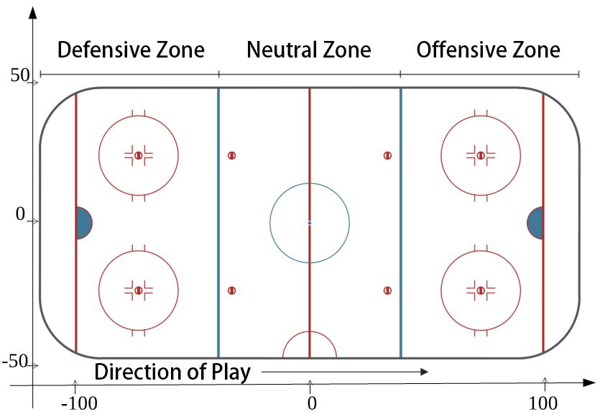

*Figure 1. Rink Layout with Adjusted Coordinates. [Need to increase font size. Attacking Zone -> Offensive Zone.]*

**3. Location-Based Player Clustering**

Hockey is a fast-moving game where players of all roles act in all parts of the ice hockey rink. Our player clustering method is based on each player's distribution of action locations across the rink. To represent the action location pattern of a player, we divide the rink into a fixed number *R* of regions, as shown in Figure 1. This division uses four horizontal and three vertical regions, corresponding to the traditional center, left and right wings. For each player, the **region frequency** is the total number of actions he performed in a region, divided by the total number of his actions. Converting counts to frequencies avoids conflating the level of a player's activity with the location of his actions. We apply the well-known affinity propagation clustering algorithm [1] to the player frequency vectors to obtain a player clustering. Affinity propagation does not require specifying the number of clusters in advance. The appendix provides technical details on affinity propagation. Affinity propagation produced 9 player clusters: 4 clusters containing forwards only, 4 clusters containing defensemen only, and one containing goalies only. Nine is a good number: too few clusters means less discrimination among different types of players. Too many clusters become difficult to interpret, and lead to clusters with few players, which render comparisons within a cluster uninformative due to lack of comparison points.

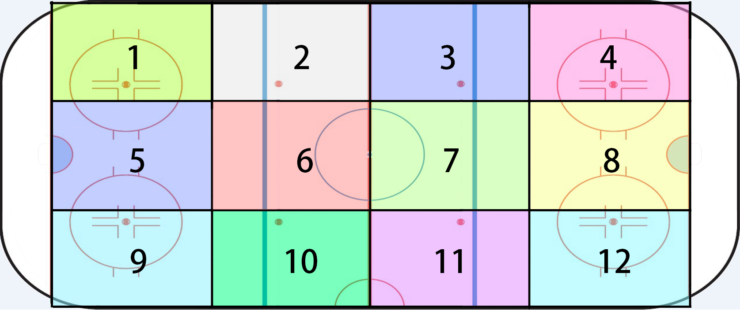

Figure 2 Ice hockey ring divided into 12 regions

Figure 2 shows the 12-region heat map for Erik Karlsson and the average heat map for Karlsson's cluster. The frequency of a region in the average heat map is defined as the average frequency for that region, over all players in the cluster. Figure 3 shows the heat map for Taylor Hall and his cluster. The heat maps show that Karlsson and other players in his cluster tend to play a defensive role on the left wing, whereas Hall and other players in his cluster play a more offensive role, mostly on the right wing.



*Figure 3.* *Heat map for Erik Karlsson and the average heat map for Karlsson's cluster*



*Figure 4. Heat map for Taylor Hall and the average heat map for Hall's cluster*

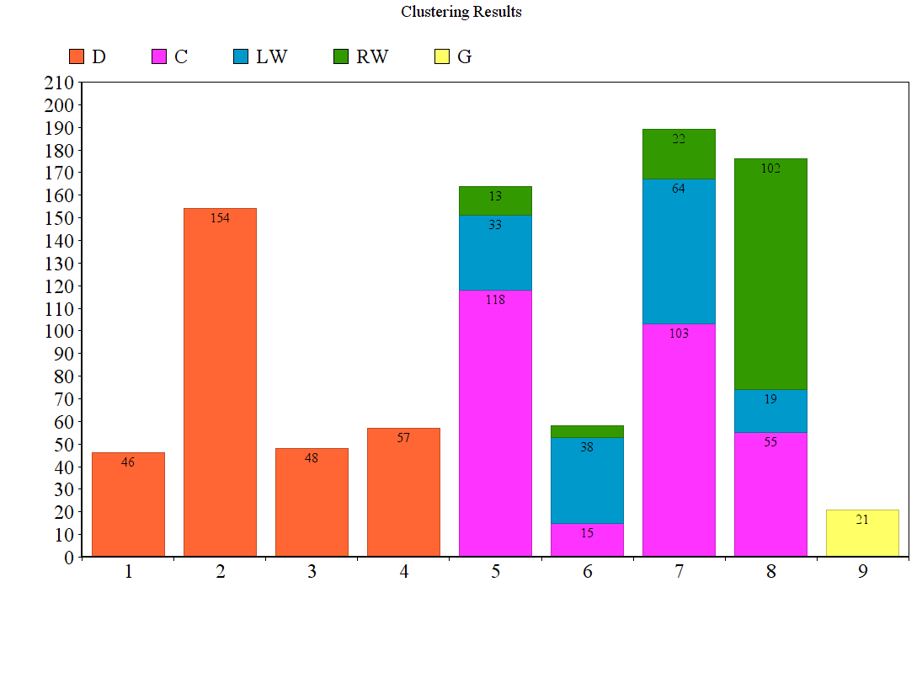

*Figure 5. Learned Clusters vs. Known Player Types. The clusters match the player categories of forward and defenseman.*

**Learned Clusters vs. Known Player Types.** Figure 4 shows that *the clusters match the basic grouping into defensive players and forwards.* We emphasize that the algorithm discovers this grouping from location data only, without being given any explicit information about the player's official position. A further refinement divides forwards into centers, left wing players and right wing players. The forward clusters match this division to some extent. For instance, cluster 5 and 7 contain mainly but not only centers, cluster 6 contains mainly but not only left-wingers, and cluster 8 contains mainly but not only right-wingers. Thus the clusters match the traditional positions, and provide information beyond them.

**Cluster Examples**. Table 3 shows players in Hall’s cluster and Table 4 in Karlsson’scluster. Also shown is the scoring impact described below and other standard metrics.

*Table 3. Players in Taylor Hall's Cluster, Ordered By Scoring Impact.*

|  |  |  |  |  |  |  |  |  |  |  |  |
| --- | --- | --- | --- | --- | --- | --- | --- | --- | --- | --- | --- |
| FirstName | LastName | Cluster | primaryPosition | secPosition | SI | GP | Goals | Assists | Passes | TOI.pg | Salary |
| Taylor | Hall | 6 | F | LW | 4.775 | 81 | 26 | 39 | 320 | 19.204 | 6 |
| Pavel | Datsyuk | 6 | F | C | 4.675 | 60 | 14 | 33 | 159 | 19.655 | 7 |
| Evgeni | Malkin | 6 | F | C | 4.536 | 57 | 27 | 31 | 190 | 19.369 | 9.5 |
| Sidney | Crosby | 6 | F | C | 4.475 | 80 | 36 | 49 | 277 | 20.469 | 12 |
| Anze | Kopitar | 6 | F | C | 4.398 | 81 | 25 | 49 | 218 | 20.867 | 7.7 |
| Aleksander | Barkov | 6 | F | C | 4.396 | 57 | 22 | 31 | 138 | 19.430 | 0.925 |
| Ryan | Getzlaf | 6 | F | C | 4.394 | 67 | 12 | 50 | 261 | 19.506 | 9.25 |
| Jack | Eichel | 6 | F | C | 4.335 | 71 | 21 | 32 | 241 | 19.122 | 0.925 |

*Table 4. Players in Eric Karlsson's Cluster, Ordered by Scoring Impact.*

|  |  |  |  |  |  |  |  |  |  |  |  |
| --- | --- | --- | --- | --- | --- | --- | --- | --- | --- | --- | --- |
| FirstName | LastName | Cluster | primaryPosition | secPosition | SI | GP | Goals | Assists | Passes | TOI.pg | Salary |
| Eric | Karlsson | 11 | D | D | 6.093 | 77 | 15 | 66 | 303 | 28.975 | 7 |
| Kris | Letang | 11 | D | D | 4.888 | 71 | 15 | 51 | 168 | 26.945 | 7.25 |
| Alex | Pietrangelo | 11 | D | D | 4.831 | 73 | 7 | 30 | 202 | 26.305 | 6.5 |
| Tyson | Barrie | 11 | D | D | 4.696 | 78 | 14 | 36 | 163 | 23.200 | 3.2 |
| Brent | Burns | 11 | D | D | 4.637 | 75 | 25 | 48 | 204 | 25.864 | 5.76 |
| Drew | Doughty | 11 | D | D | 4.499 | 82 | 14 | 37 | 168 | 28.018 | 7.1 |
| John | Klingberg | 11 | D | D | 4.393 | 62 | 9 | 48 | 199 | 22.688 | 2.25 |
| Dustin | Byfuglien | 11 | D | D | 4.375 | 81 | 19 | 34 | 177 | 25.203 | 6 |

1. **Spatial Discretization: Regions for Action Locations**

Our Markov model represents the probability that a given action occurs at a given rink location. To model the action occurrence probability, we discretize the rink space into a discrete set of regions.

One option for generating discrete regions is to use a fixed grid, like our Figure 1. The problem with a fixed grid is that different types of actions tend to be distributed in different locations. For example, shots hardly ever occur in the defensive zone, whereas blocks often do. Using the same grid for shots as for blocks is therefore both statistically and computationally inefficient. Instead, we learned from the data *a separate discretization tailored to each action*. This was achieved by applying affinity propagation to cluster the locations of occurrences of a given action type.

Figure 6 shows the resulting regions for Passes, and Figure 7 for Loose Puck Recovery.

Gray dots indicate occurrences. The cluster mean is shown with a label that indicates how many actions of the given type fall into the region.

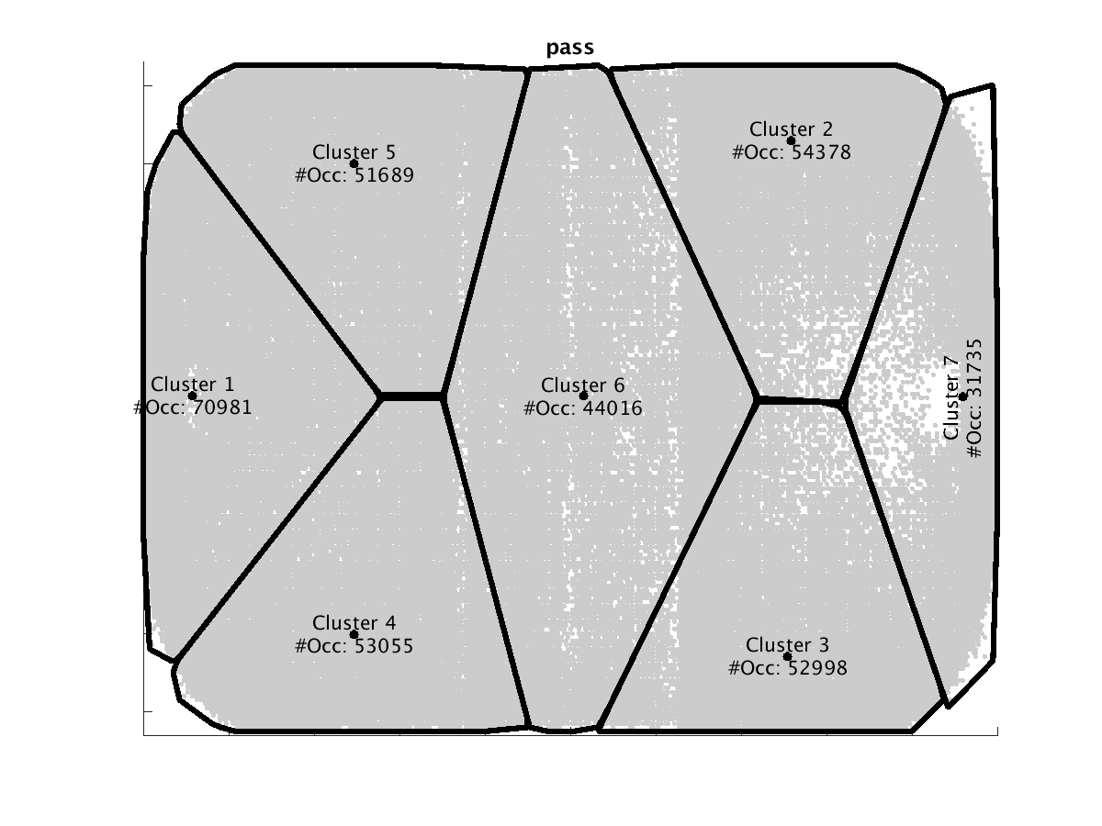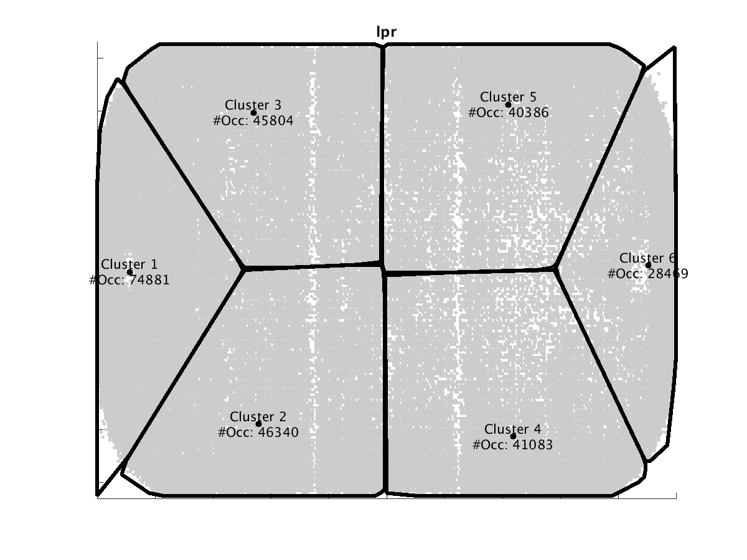

*Figure 6. Learned Regions for Passes.*

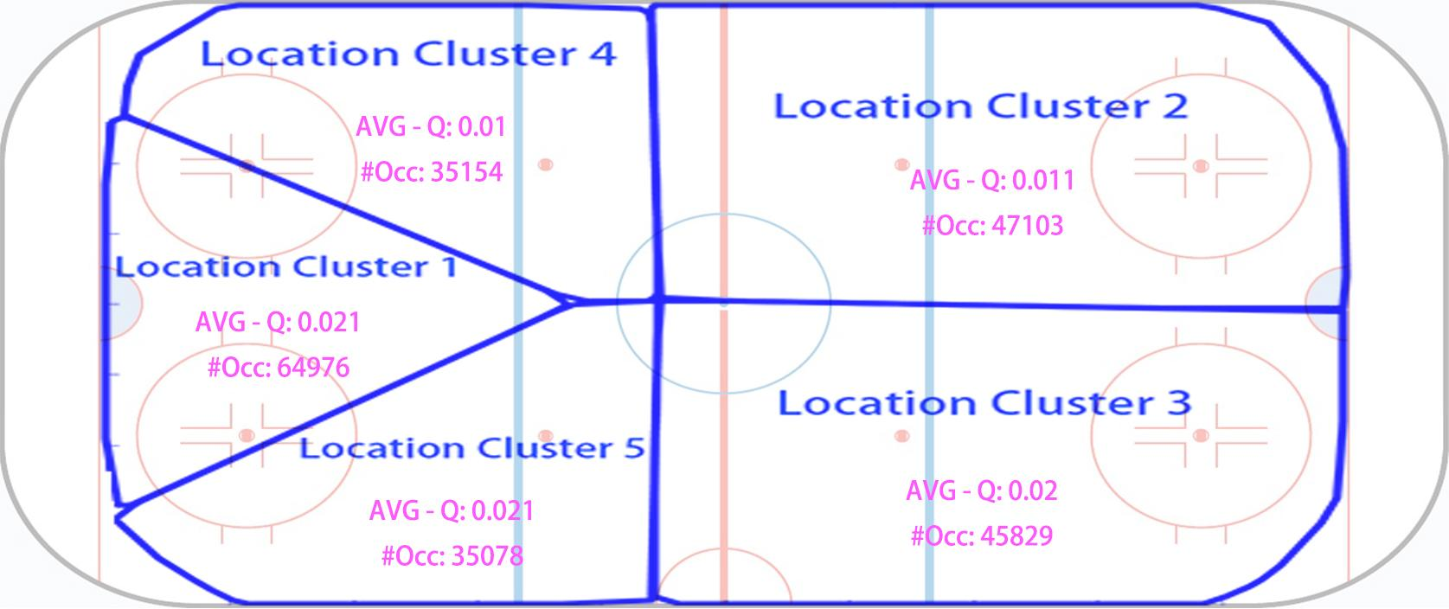

FIG: BLOCK ZONE

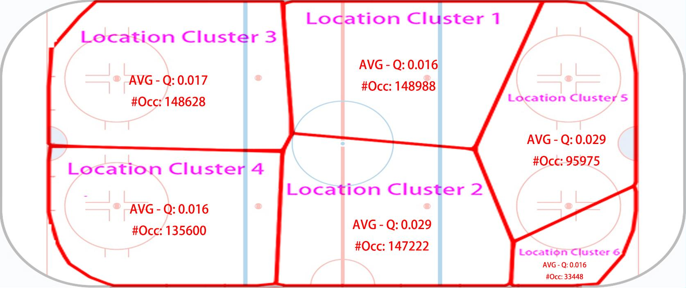

FIG RECEPTION

*Figure 7. Learned Regions for Loose Puck Recoveries.*

1. **The Markov Game Model**

A Markov model is a dynamic model that represents how a hockey match moves from one game state to the next. A sequence of state transitions constitutes a trajectory. The parameters of a (homogeneous) Markov chain are transition probabilities P(s’|s) where s is the current state and s’ the next state. Previous Markov chain models for ice hockey have included goal differential and/or manpower differential in the state space [Thomas 2013, Pettigrew 2015, Kaplan ]. Then the transition probabilities represent how goal scoring and penalty drawing rates depend on the current goal and manpower differentials. This approach can measure the impact only of actions that directly change the state variables, that is, such as goals and penalties. Markov decision processes and Markov game models include both states and actions, which allows us to measure the impact of *all* actions. The parameters of our Markov game model are ***state-action transition probabilities*** of the form *P(s’,a’|s,a)* where a is the current action and a’ the next action event. The model therefore describes state-action trajectories as illustrated in Figure 5. The state trajectory in the figure takes place in period 4 (PR = 4), with equal manpower (MP = even) and equal goal differential (GD = 0). In this example, all actions are taken by the home team; generally in the model either team may take an action at an point. The figure also shows the conditional probability of the home team scoring and the impact of an action, which we define below. Arrows indicate state transitions. In the first state, the home team carries the puck from carry-region #3 in the center of the neutral zone to the top of the neutral zone. Then they manage a pass from pass-region #2 at the top of the offensive zone. The pass is received in reception-region #2 above the goal. The final action is scoring a goal.[1] Table 5 describes the same state-action trajectory in play-by-play format. We now describe the components of our Markov model in detail.

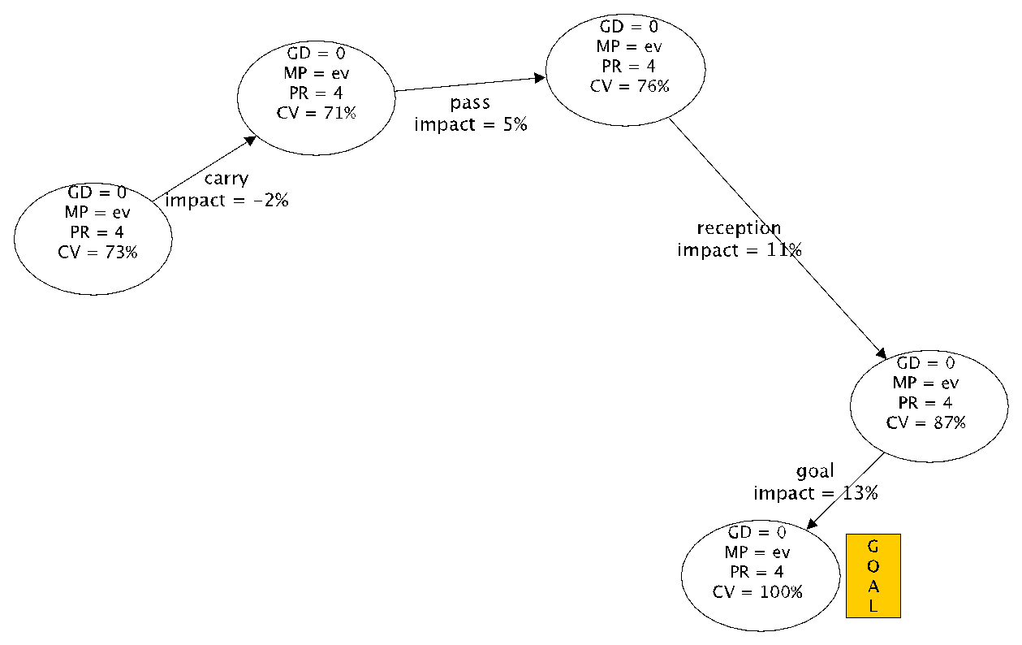

*Figure 8. A possible state-action trajectory in our model. [include transition probabilities on edges] A node in the diagram denotes a match state. CV is the conditional value of a state for the home team, which measures the chance that the home team scores at this game state. Edges are labeled with actions, the impact of the action, and transition probabilities. The impact measures the change in conditional value due to the action.*

*Table 5. A state-action trajectory in Play-by-Play Format. Quantities derived from the Model are defined in the text.*

|  |  |  |  |  |  |  |  |  |  |
| --- | --- | --- | --- | --- | --- | --- | --- | --- | --- |
|  | **State Variables** | | | **Action Parameters** | | | **Quantities derived from Model** | | |
| Event | Goal  Differential | ManPower Differential | Period | Team | Action  Type | Region | Transition  Probability | Conditional  Value (Home) | Impact |
| **0** | **0** | **Even** | **4** | **Home** | **Carry** | **??** | **----** | **71%** | **----** |
| **1** | **0** | **Even** | **4** | **Home** | **Pass** | **??** | **??** | **76%** | **5%** |
| **2** | **0** | **Even** | **4** | **Home** | **Reception** | **??** | **??** | **87%** | **11%** |
| **3** | **0** | **Even** | **4** | **Home** | **Goal** | **0** | **??** | **100%** | **13%** |

**States**

*Table 6. State Variables and their possible values. [please copy]*

|  |  |  |
| --- | --- | --- |
|  |  |  |
|  |  |  |
|  |  |  |
|  |  |  |

A state includes the values of relevant variables for a match context. Table 6 shows the range of integer values observed for these *context variables*. Like previous work, we use the goal differential and the manpower differential. We add the period to include some temporal context. Goal Differential *GD* is calculated as Number of Home Goals - Number of Away Goals. A positive (negative) goal differential means the home team is leading (trailing). Manpower Differential *MD* specifies whether the teams are at even strength (EV), the acting team is short-handed (SH) or in a powerplay (PP). Period *P* represents the current period number the play sequence occurs in. Our model includes periods 1 to 3 and overtime but not shoot-outs (5). The number of states is therefore 17 x 3 x 4 = 204.

**Actions**

The basic set of 13 action types was listed in Table (action table) above. An **action event** *a* is of one of these types, together with a specification of two parameters: which team performs the action (Home or Away) and the action region where the action takes place. For instance, *pass(home,region3)* denotes the event that the home team performs a carry in the region 3 associated with the pass region (see Figure pass clusters). There are 63 action-region pairs (sum of the number of clusters in Table 1, which may occur with either the home or the away team, so our model includes 126 possible action events. We often refer to action events simply as actions.

**Parameter Estimation**

The key quantities in our model specify the joint *state-action distribution P(s’,a’|s,a)* that at game state *s*, action *a* occurs and is followed by game state *s’* and action *a’*. We follow the maximum-likelihood method and estimate the action-state distribution using the **observed occurrence counts** *n(s’,a’,s,a)*, which record how often action *a’* and state *s’* follows state *s* and action *a* in our dataset. For simplicity we slightly abuse notation and use *n* also for marginal occurrence counts, for example . The maximum likelihood estimates are computed as follows:

Decomposing the state-action probability as , we see that it combines two quantities of interest: (1) the state transition probabilities that describe how a game state evolves given players’ actions. Specifically in our model, this includes how goal and penalty rates depend on previous goal and penalty rates as well as the players’ actions. (The state transition probabilities are the standard parameters in a Markov decision process.) (2) The **action distribution** that describes how a random player acts in a given game context. (In a Markov decision process, the action distribution is called a policy.) Because the most distribution of the next action and its location depends on the most recent action and its location, the action distribution represents spatial as well as temporal dynamics. For example, the transition probability of p% in the first two of Table y represents the probability that play moves from action-region1 to action-region2, given the current match context.

The number of possible state-action quadruples is unmanageably large at over 83 Billion. However, the number of quadruples that occur more than zero times is only 112,590. The necessary computations for computing and storing the estimated values can be efficiently managed using an relational database and appropriate data structures; for more details please see [Routley 2015].

We next show how our Markov game model can measure the impact of all actions.

1. **Action Values and Scoring Impact**

In our model, the agents are a generic home team and a generic away team, not individual players, similar to previous Markov models [Pettigrew 2015] for hockey. This is appropriate for the goal of assigning generic values to all action events. In this paper we use the Markov model to quantify how a random player’s action, given a game context, affects the probability that his team scores the next goal, rather than the opposing team. The same approach can be applied to quantify the impact of actions on other outcomes of interest, such as winning the match [Pettigrew 2015, Routley 2015] and penalties [Routley and Schulte 2015]. A key feature of a Markov model is that it quantifies not only the immediate but also the medium-term impact of an action. For *T = home* or *away*, let *P(T scores in l steps|a’,s,a)* denote the probability that after taking action *a’*, the team *T* scores before the opposing team within the next *l* events, given game state *s*, and previous action *a*. The number l is called the *look-ahead.* This *scoring probability* satisfies the following recurrence equations:[2]

1.

2. , and

The probability that team *T* scores next is then defined as the scoring probability when the lookahead grows arbitrarily large. For a game state, it is possible that neither team scores within the look-ahead horizon. Therefore another quantity of interest is the conditional probability that a team scores given that one of the two teams scores within the event horizon. We refer to this as the *conditional value* of a state-action pair for the event horizon.

The conditional value of state-action pair is the probability of scoring the next goal for an arbitrarily large look-ahead. The conditional value measures the relative advantage that a team has over their opponent, rather than the absolute scoring chance associated with a game state. It can be computed by applying the recurrence equations for until the conditional values converge. For the SportLoqiq dataset, convergence occurred for . This means that looking ahead more than 14 steps to future game trajectories does not change the probability estimate of which team is more likely to score next. Figure y illustrates the conditional value concept by plotting the expected conditional value of a loose puck recovery by location, averaged over states and home vs. away team. The conditional value is an appropriate quantity for evaluating actions since the goal of an action is to improve a team’s position relative to their opponent. We therefore use the conditional value to assess the *impact of an action*, which is defined as the extent to which it changes the scoring chance of the acting player’s team at a state:

Table 5 illustrates CV values and impacts. The scoring impact metric for a player is their total impact over all their actions. This can be computed using the occurrence counts that record how many times the game reaches state *s’* and player *i* takes action *a’* after state *s* and some player (not necessarily *i*) took action *a*.

where is the action distribution for player *i.* The second equation shows that the scoring impact metric can be interpreted as the expected impact of a player given a state-action pair, weighted by how often the player reaches the state-action pair.

* 1. **Correlations**

The SI metric shows a strong correlation with other important metrics, such as points, time on ice, and salary. This correlation increases by computing the metric for comparable players rather than all players. As an example, Table 2 shows the correlation between SI and time on ice (per game).

Table 7 Correlation between SI and TOI (per game)

|  |  |  |  |  |  |  |  |  |  |  |  |  |
| --- | --- | --- | --- | --- | --- | --- | --- | --- | --- | --- | --- | --- |
| **Cluster** | All | 1 | 2 | 3 | 4 | 5 | 6 | 7 | 8 | 9 | 10 | 11 |
| **Correlation** | 0.83 | 0.89 | 0.89 | 1.00 | 1.00 | 0.92 | 0.89 | 0.92 | 0.82 | 1.00 | 0.92 | 0.90 |

* 1. **Case Studies**

We discuss the top-ranked player from our running example clusters, and especially undervalued players.

* + 1. **Cluster 6**

Cluster 6 comprises forwards only. Table 3 shows the top 8 players in cluster 6.

The top 4 in cluster 6 are in order: Taylor Hall, Pavel Datsyuk, Evgeni Malkin, and Sidney Crosby. These are known excellent offensive players. Taylor Hall is recognized as a high caliber forward, placing him highly in the NHL fantasy rankings [2]. His goals per game metric is 0.32, which is excellent but behind for instance Malkin's at 0.47. This shows how our ranking is correlated with goals but also takes into account the value of actions other than goals. For instance, our ranking reflects that the total number of Hall's passes is 320, substantially more than Malkin's 190 passes.

The most undervalued players in cluster 6 are Aleksander Barkov (rank 6, salary $M 0.925) and Jack Eichel (rank 8, salary $M 0.925). Both players are junior (first NHL season in 2011 for Barkov, 2012 for Eichel). Barkov is viewed as having played a successful season and received from the Florida Panthers a six-year contract extension of six-year $M 35.4, a six-fold salary increase [3], which is consistent with our ranking. Eichel is a rising star [4]. The fact that Eichel is in the same cluster as for example Crosby and Malkin suggests that he would be a strong candidate for replacing them should they leave their teams.

* + 1. **Cluster 11**

Cluster 11 comprises defense players only. Table 4 shows the top 8 players in cluster 11.

The top player in cluster 11 is Erik Karlsson. He has twice won the Norris Trophy for best all-round defenseman in the NHL. The NHL ranks him the top defenseman for fantasy play in the 2016 season [5].

John Klingberg is also undervalued relative to his rank. Although he signed a contract with the Dallas Stars in 2011, he did not play a full NHL season until 2014-2015. After this season, he was recognized by joining the NHL all-rookie team, which is consistent with our ranking. Being in the same cluster as Karlsson and Letang suggests that he will be a strong prospect for replacing these senior defensemen.

* 1. **Explaining the Rankings: Drill-Down Analysis**

In this section we illustrate how a player’s ranking can be explained by how he performs in specific game situations. This breakdown serves two purposes: First, it makes the ranking interpretable because it explains the specific observations that led to the rating. Second, pinpointing the special strengths and weaknesses of a player is an important task in itself. Our basic approach is to find the game states in which a player’s expected impact differs the most from others in his cluster. The expected impact can be explained in terms of the player’s tendencies to act at a given game state.

Let #(s,P) be the number of actions that player P took at game state s, and let SIp(s) be the expected impact of player P at state s, which is defined as:

The total impact of a player *P* is the sum of his expected impact at each state, weighted by the number of his actions at the state. Weighting each player by how often they act, the average impact of a cluster is given by:

The added impact of player P at state s compares a player’s expected impact at a state to the expected impact of others in his cluster:

A positive expected impact indicates states where a player performs better than other similar players; a negative value states where the performs worse. We illustrate the results of the drill-down analysis in our running examples of Taylor Hall and Erik Karlsson.

* + 1. **Taylor Hall**

Use player Taylor Hall as an example for cluster 6: we find all states where he reached more than 15 times and sort these states according to *FNSIA*, descendingly. The top 5 states are 10, 11, 57, 2191, 20. These are states where Taylor Hall shows most especial strengths. [OS: should try to make the states meaningful in hockey terms. If necessary use fewer states]

Table 5 Compare Taylor Hall and average players in cluster 6 (FNSI * 100)

|  |  |  |  |  |  |
| --- | --- | --- | --- | --- | --- |
|  | State 10 | State 11 | State 57 1st period, MP = even, GD = 0, last event = away reception in cluster 1 | State 2191 | State 20 |
| Average Player | 6.1 | 3.7 | -2.7 | -0.1 | -2.6 |
| Taylor Hall | 10.0 | 7.2 | 0.9 | 2.7 | 0.2 |

Table 5 above shows *FNSI * 100* for Taylor Hall at those states and *FNSI * 100* for average player in cluster 6 at those states. State 57 is interesting since the average cluster player’s expected impact is negative whereas Taylor Hall’s is positive. So, we drill down further at state 57 to examine Taylor Hall’s action distribution in this game state. The result is in Table 6. State 57 is a state where game is at period 1 and manpower is even, with goal differential 0. At this state, the away team just took a reception at location cluster 1 (neutral zone). [is Hall playing for the home team or the away team here?]

Table 6 Compare Taylor Hall and average players in cluster 6 at state 57

|  |  |  |  |  |  |  |  |  |  |  |  |
| --- | --- | --- | --- | --- | --- | --- | --- | --- | --- | --- | --- |
| Action Type | | Block | Carry | Check | Dumpin | Lpr | Offside | Pass | Puckprotection | Reception | Shot |
| Avg. Player | Percent (%) | 2.07 | 32.78 | 1.02 | 16.25 | 2.19 | 0.61 | 31.56 | 4.96 | 0.12 | 8.45 |
| FNSI * 100 | 13.2 | -2.1 | 12.5 | -15.0 | 18.0 | -15.8 | -2.5 | -9.0 | -1.1 | 12.0 |
| Taylor Hall | Percent (%) | 10.00 | 50.00 |  | 10.00 | 5.00 | 5.00 | 15.00 |  |  | 5.00 |
| FNSI * 100 | 21.5 | -1.8 |  | -15.4 | 25.5 | -15.8 | 1.6 |  |  | 7.9 |

From Table 6, we can see Taylor Hall did more blocks at state 57 and his FNSI for block action is higher. Passes at this state for average player is bad since FNSI is negative (which means conditional Q-value decreases after taking this action). However, Taylor Hall managed to make it positive. [not sure about this, isn’t the impact of passing fixe?] So Taylor Hall might be good at passing. [the table is hard to take in. Could visualize in terms of bar charts. What about just finding the biggest difference in SI(action|state 57) x Ptaylor_hall(action|state 57).

We can further drill-down a given action type to see why Taylor Hall is better than average player in his cluster. For example, Figure 4 shows the drill-down for action type ‘block’ at state 57. The red text in this figure shows how often the location clusters are visited. We can see from the figure that location cluster 3 is the best place to act ‘block’ in this situation. Taylor Hall managed to act more ‘block’s in this location cluster than average players.

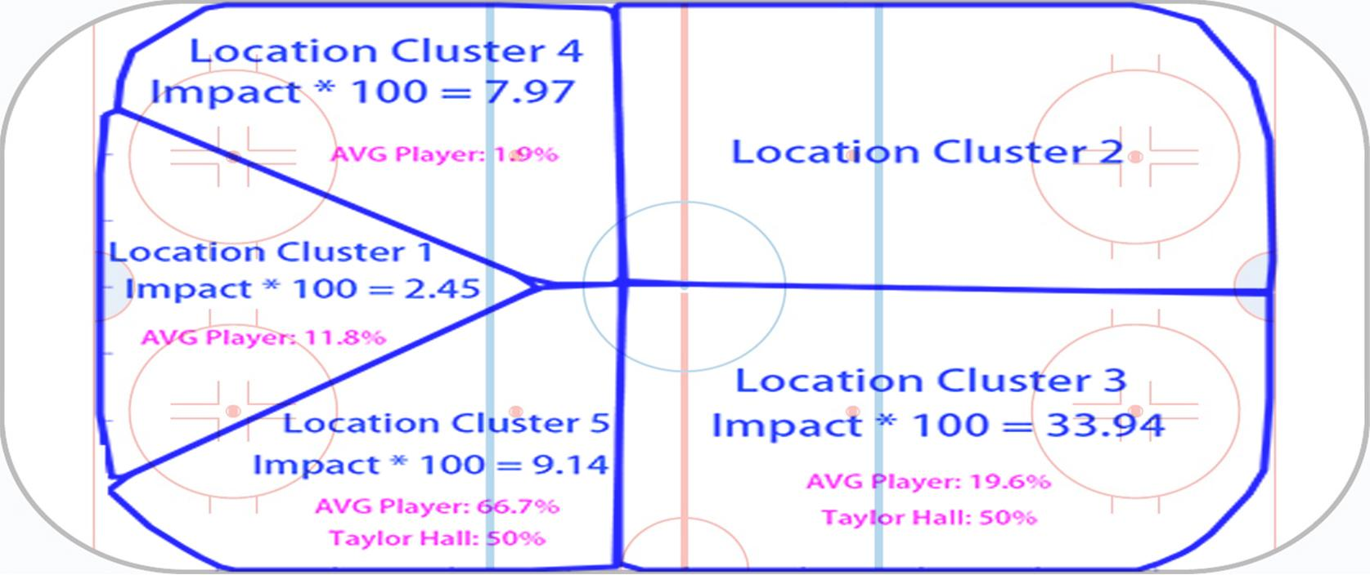

Figure 4 Drill-down for block action at state 57 (AVG Player is average player in cluster 6)

* + 1. **Erik Karlsson**

Use player Erik Karlsson as an example for cluster 11: we find all states where he reached more than 15 times and sort these states according to *FNSIA*, descendingly. The top 5 states are 382, 614, 3086, 2083, 56. These are states where Erik Karlsson shows most especial strengths.

Table 7 Compare Erik Karlsson and average players in cluster 11 (FNSI* 100)

|  |  |  |  |  |  |
| --- | --- | --- | --- | --- | --- |
|  | State 382 | State 614 | State 3086 | State 2083 | State 56 |
| Average Player | 2.1 | 13.2 | 5.3 | 1.2 | 2.3 |
| Erik Karlsson | 10.1 | 17.8 | 9.6 | 5.4 | 6.1 |

Table 7 above shows *FNSI * 100* for Erik Karlsson at those states and *FNSI * 100* for average player in cluster 11 at those states. State 382 is interesting since *FNSIA* for Erik Karlsson is extremely high compared to other states. So, we drill down further at state 382 to see what happens. The result is in Table 8. State 382 is a state where game is at period 3 and manpower is even, with goal differential 0. At this state, the away team just took a pass at location cluster 4 (defensive zone).

Table 8 Compare Erik Karlsson and average players in cluster 11 at state 382

|  |  |  |  |  |  |  |  |
| --- | --- | --- | --- | --- | --- | --- | --- |
| Action Type | | Block | Check | Lpr | Offside | Pass | Reception |
| Avg. Player | Percent (%) | 6.93 | 0.69 | 10.23 | 0.17 | 0.35 | 81.63 |
| FNSI * 100 | 13.9 | 17.9 | 13.9 | -0.6 | -2.8 | -0.4 |
| Erik Karlsson | Percent (%) | 17.65 | 5.88 | 29.41 |  |  | 47.06 |
| FNSI * 100 | 20.9 | 17.9 | 12.0 |  |  | 3.8 |

From Table 8, we can see Erik Karlsson did more blocks at state 382 and his FNSI for block action is higher. He avoids to take bad actions at this state (offside, pass). While reception at this state is generally a bad action, it’s an action with positive *FNSI* for Erik Karlsson. [again I don’t get that] All those factors together make Erik Karlsson really stands out at this state.

We can further drill-down a given action type to see why Erik Karlsson is better than average player in his cluster. For example, Figure 5 shows the drill-down for action type ‘reception’ at state 382. The red text in this figure shows how often the location clusters are visited. We can see from the figure that location cluster 1 and 2 are the best places to act ‘reception’ in this situation. Erik Karlsson managed to act more ‘reception’s in these location clusters than average players.

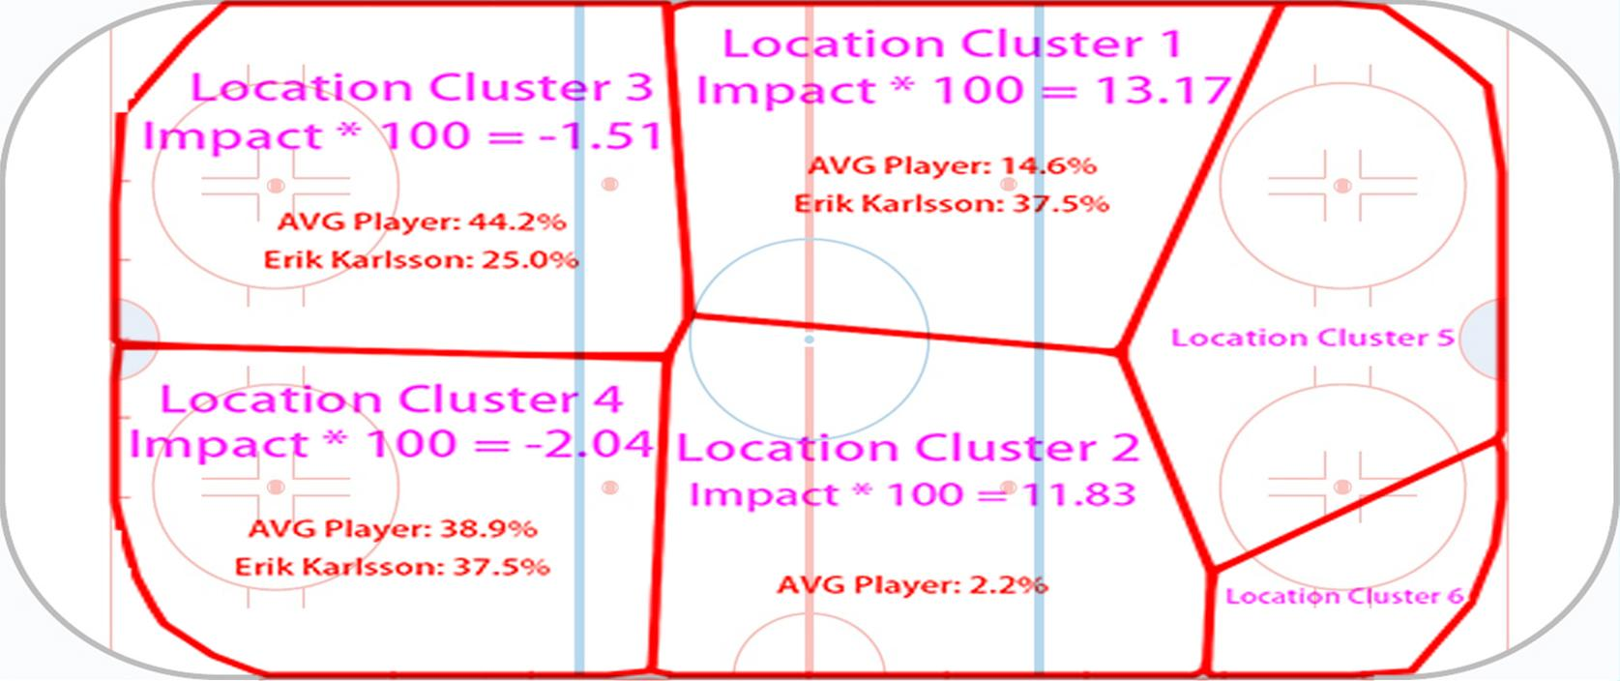

Figure 5 Drill-down for reception action at state 382 (AVG Player is average player in cluster 11)

1. **Discussion and Conclusion**

Action location information can be used with machine learning techniques to identify players with similar styles and roles. This supports apples-to-apples comparisons of similar players. A high-resolution large-scale Markov game model quantifies players impact on their teams goal scoring. The model can be used to pin-point the exact situations in which a player has strengths or weaknesses. This analysis will assist players in developing and teams in making decisions about game strategy or their team roster.

1. **Acknowledgement**

We thank SPORTLOGiQ for providing ice hockey data. We are grateful for constructive discussions in SFU’s Sport Analytics Research Group.

**References**

[WARNING: NEED TO UPDATE REFERENCE.]

Pettigrew, S. (2015), Assessing the offensive productivity of NHL players using in-game win probabilities, *in* '9th Annual MIT Sloan Sports Analytics Conference'.

Puterman, M. L. (1994), *Markov Decision Processes: Discrete Stochastic Dynamic Programming*, John Wiley &amp; Sons, Inc., New York, NY, USA.

Cervone, D.; D’Amour, A.; Bornn, L. & Goldsberry, K. (2014), POINTWISE: Predicting points and valuing decisions in real time with NBA optical tracking data, *in* '8th Annual MIT Sloan Sports Analytics Conference'.

Routley, K. & Schulte, O. (2015), A Markov Game Model for Valuing Player Actions in Ice Hockey, *in* 'Uncertainty in Artificial Intelligence (UAI)', pp. 782--791.

Thomas, A.; Ventura, S.; Jensen, S. & Ma, S. (2013), 'Competing Process Hazard Function Models for Player Ratings in Ice Hockey', *The Annals of Applied Statistics* **7**(3), 1497-1524.

Routley, K. (2015), 'A Markov Game Model for Valuing Player Actions in Ice Hockey', Master's thesis, Simon Fraser University.

Miller, A.; Bornn, L.; Adams, R. & Goldsberry, K. (2014), Factorized Point Process Intensities: A Spatial Analysis of Professional Basketball., *in* 'ICML', pp. 235--243.

[2] *https://www.nhl.com/news/2016-17-left-wing-fantasy-rankings/c-281561644*

[3] *https://en.wikipedia.org/wiki/Aleksander_Barkov_Jr*

[4] *https://en.wikipedia.org/wiki/Jack_Eichel*

[5] *https://www.nhl.com/news/fantasy-hockey-top-60-defensemen-rankings-update/c-798669*

[6] *https://www.nhl.com/avalanche/news/avalanche-signs-barrie/c-890364*

**2. Hockey Rule and Hockey Data**

* 1. **Hockey Rules**

We give a brief overview of rules of play in the NHL and show how we represent actions.

NHL games consist of three periods, each 20 minutes in duration. A team must score more goals than their opponent within three periods in order to win the game. If the game is still tied after three periods, the teams will enter a fourth overtime period, where the first team to score a goal wins the game. If the game is still tied after overtime during the regular season, a shootout will commence. During the playoffs, overtime periods are repeated until a team scores a goal to win the game. Teams have five skaters and one goalie on the ice during even strength situations. Penalties result in a player sitting in the penalty box for two, four, or five minutes and the penalized team will be shorthanded, creating a manpower differential between the two teams. The period where one team is penalized is called a powerplay for the opposing team with a manpower advantage. A shorthanded goal is a goal scored by the penalized team, and a powerplay goal is a goal scored by the team on the powerplay.

Table 1 below shows action types and their descriptions. These action types will be used in latter sections of this paper

* 1. **Hockey Data**

We make use of a new data source from SPORTLOGiQ that tracks the location of each player's action for the entire 2015-2016 season. The data consists of 3.3M actions and 1140 games. Players who tend to play in similar locations are clustered together using algorithm to be introduced in section 4.

1. **Value Iteration**

To apply Markov model, we need a state transition graph and a reward function. We define game states to be the status of the game after each action. Therefore, game states will have features such as period, manpower differential etc.

However, the graph will be too big if each state is treated as a single node in the graph. Therefore, after pre-processing all games data, we aggregated all states with same features into a single node, and subsequently connected two nodes with a directed edge if there exist an action that map to the transition of these two nodes.

We can then evaluate an action in a context-aware way by considering its expected reward after executing it in a given state. This is known in reinforcement learning as the action value, or **Q-value**. We set the reward function with respect to the next goal probability and we do 20 value iterations. The following equation shows how we update Q-value of each node at each iteration.

The initial value of Q-value is set as:

After value iterations for both home and away teams, we can normalize Q-values to get conditional Q-values (CQ):

Actions in games serve as edges in the state transition graph. The value of each action can be viewed as how much this action improves the CQ value. Since our reward function for Q-value is related to the next goal probability, we call the values of actions *Scoring Impact (SI)*. For actions corresponding to the edge from node to , *SI* can be calculated as follows:

Above is *SI* for a single action. We define *SI* for a given player as follows:

**Appendix: Methodology**

An appendix is not required, but if you have one please include it here.

**Player Clustering**.

*Rink division*. It is possible to use three regions for the horizontal direction, corresponding to the defensive, neutral, and offensive zone. However, adding a 4th horizontal division led the clustering algorithm to produce more informative groupings, without producing too many clusters. Adding a 5th horizontal division produced essentially the same player clusters as the 3x4 division of Figure 1.

We used affinity propagation with Euclidean distance, which is equivalent to treating each heatmap as a point in the 12-dimensional probability simplex. [more details on affinity propagation]

*Discussion*. Our model treats events as time series. This loses the information about duration, but avoids parametric assumptions about event rates (e.g., Poisson). In future work we will extend the model to include continuous-time duration information.

**Action Locations**. The disadvantage of discretization is that it loses some information about the exact location of an action event. The computational advantage is that we can employ algorithms for discrete Markov models. The statistical advantage is that discretization requires neither parametric assumptions (e.g. Gaussian or Poisson distribution), nor stationarity assumptions that treat different locations as the same. Cervone et al. [2014] provide further discussion of the pros and cons of spatial discretization.

An alternative approach to discretizing locations is to apply nonnegative matrix factorization to a matrix of location transition counts (Cervone et al.). This has the advantage that the learned regions capture not only where actions occur, but also where the game tends to move next. The disadvantages are higher computational complexity, and that arguably the resulting regions are less straightforward to interpret.

1. [is there no shot?]
2. need to make this prettier, see Sloan template.