**Model-Based Clustering to Identify Exceptional Players in the NHL Draft**

Paper Track (Cambria, 14pt)

Paper ID

**Abstract**

TBD

**1. Introduction: Identifying Predictive Player Cohorts**

*Paper Outline.*

**2. Hockey Dataset**

Explain dependent variable.

*Table 1. Predictor Variables for Dependent Variable*

|  |  |
| --- | --- |
| Variable Name | Description |
| Ceskin rank |  |
|  |  |
|  |  |
|  |  |
|  |  |
|  |  |
|  |  |
|  |  |
|  |  |
|  |  |
|  |  |
|  |  |
|  |  |

Explain success metric (Spearman)

* Two Goals
  + Build predictive model
  + identify cohorts (cite Weissbock, Sony)
  + Unification: identify cohorts s.t. we can build good predictive models.
* More accurate predictions, non-linearity
* Predictively valid cohorts.
* Problem: Cohorts should be interpretable. Interpretability even more important than accuracy.
* Solution: Equation tree (LMT). What’s the terminology for these tree models.
* Get good results in terms of tree, Spearman.
* Extract explainability

## Methods

Explain LMT. Show model tree.

[Figure 1. Model tree.] [Figure 2: visualize of 2 clusters in terms of TOI, GP. Maybe pick top 3 players in cluster]

(have to write this)

*Table 2. Sample Player Data. [show strongest and weakest player from each cluster]*

|  |  |  |  |  |  |  |  |
| --- | --- | --- | --- | --- | --- | --- | --- |
| gameId | playerId | Period | teamId | xCoord | yCoord | Manpower | Action Type |
| 849 | 402 | 1 | 15 | -9.5 | 1.5 | Even | Lpr |
| 849 | 402 | 1 | 15 | -24.5 | -17 | Even | Carry |
| 849 | 417 | 1 | 16 | -75.5 | -21.5 | Even | Check |
| 849 | 402 | 1 | 15 | -79 | -19.5 | Even | Puckprot |
| 849 | 413 | 1 | 16 | -92 | -32.5 | Even | Lpr |
| 849 | 413 | 1 | 16 | -92 | -32.5 | Even | Pass |
| 849 | 389 | 1 | 15 | -70 | 42 | Even | Block |
| 849 | 389 | 1 | 15 | -70 | 42 | Even | Lpr |
| 849 | 389 | 1 | 15 | -70 | 42 | Even | Pass |
| 849 | 425 | 1 | 16 | -91 | 34 | Even | Block |
| 849 | 395 | 1 | 15 | -97 | 23.5 | Even | Reception |

**3. Learned Clusters**

### Learned Model

*Figure 1. Learned Decision Tree Model. (LMT or M5 or both?)*

### Learned Clusters

|  |  |  |  |  |
| --- | --- | --- | --- | --- |
| Cluster Definition | Cluster equation | Cluster Size | Top Player | Bottom Player |
| Show path | Show equation (maybe top three players) |  |  |  |
|  |  |  |  |  |

*Table 3. Cluster Equations.*

*Figure 3. Cluster Scatterplot of lmt vs. GP-after_7-years. Maybe label top 3 players in each cluster.*

*Figure 4. Most important predictor per cluster vs. GP_after_7_years.*

### Predictive Performance

|  |  |  |
| --- | --- | --- |
| Draft Year | LMT classification accuracy | LMT correlation |
|  |  |  |
|  |  |  |

*Table 4. Predictive Performance (our model, over all draft ranking, Shuckers)*

## Identifying Exceptional Players

[maybe use absolute value to identify unusual players]. Maybe project to 2D using PCA.

|  |  |  |
| --- | --- | --- |
| Top Player | Strongest Point | Weakest Point |
|  | (e.g. age vs. average age) |  |
|  |  |  |

*Table 5. Strong Statistics and Weak Statistics for the top player in each cluster*

Discuss cases

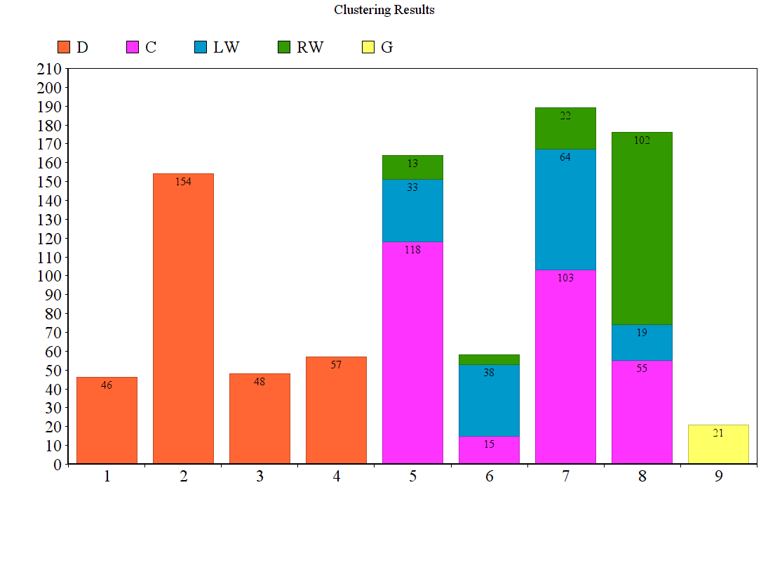

*Figure 5. Learned Clusters vs. Known Player Types. The clusters match the player categories of forward and defenseman.*

**Learned Clusters vs. Known Player Types.** Figure 4 shows that *the clusters match the basic grouping into defensive players and forwards.* We emphasize that the algorithm discovers this grouping from location data only, without being given any explicit information about the player's official position. A further refinement divides forwards into centers, left wing players and right wing players. The forward clusters match this division to some extent. For instance, cluster 5 and 7 contain mainly but not only centers, cluster 6 contains mainly but not only left-wingers, and cluster 8 contains mainly but not only right-wingers. Thus the clusters match the traditional positions, and provide information beyond them.

**Cluster Examples**. Table 3 shows players in Hall’s cluster and Table 4 in Karlsson’scluster. Also shown is the scoring impact described below and other standard metrics.

*Table 3. Players in Taylor Hall's Cluster, Ordered By Scoring Impact.*

|  |  |  |  |  |  |  |  |  |  |  |  |
| --- | --- | --- | --- | --- | --- | --- | --- | --- | --- | --- | --- |
| FirstName | LastName | Cluster | primaryPosition | secPosition | SI | GP | Goals | Assists | Passes | TOI.pg | Salary |
| Taylor | Hall | 6 | F | LW | 4.775 | 81 | 26 | 39 | 320 | 19.204 | 6 |
| Pavel | Datsyuk | 6 | F | C | 4.675 | 60 | 14 | 33 | 159 | 19.655 | 7 |
| Evgeni | Malkin | 6 | F | C | 4.536 | 57 | 27 | 31 | 190 | 19.369 | 9.5 |
| Sidney | Crosby | 6 | F | C | 4.475 | 80 | 36 | 49 | 277 | 20.469 | 12 |
| Anze | Kopitar | 6 | F | C | 4.398 | 81 | 25 | 49 | 218 | 20.867 | 7.7 |
| Aleksander | Barkov | 6 | F | C | 4.396 | 57 | 22 | 31 | 138 | 19.430 | 0.925 |
| Ryan | Getzlaf | 6 | F | C | 4.394 | 67 | 12 | 50 | 261 | 19.506 | 9.25 |
| Jack | Eichel | 6 | F | C | 4.335 | 71 | 21 | 32 | 241 | 19.122 | 0.925 |

*Table 4. Players in Eric Karlsson's Cluster, Ordered by Scoring Impact.*

|  |  |  |  |  |  |  |  |  |  |  |  |
| --- | --- | --- | --- | --- | --- | --- | --- | --- | --- | --- | --- |
| FirstName | LastName | Cluster | primaryPosition | secPosition | SI | GP | Goals | Assists | Passes | TOI.pg | Salary |
| Eric | Karlsson | 11 | D | D | 6.093 | 77 | 15 | 66 | 303 | 28.975 | 7 |
| Kris | Letang | 11 | D | D | 4.888 | 71 | 15 | 51 | 168 | 26.945 | 7.25 |
| Alex | Pietrangelo | 11 | D | D | 4.831 | 73 | 7 | 30 | 202 | 26.305 | 6.5 |
| Tyson | Barrie | 11 | D | D | 4.696 | 78 | 14 | 36 | 163 | 23.200 | 3.2 |
| Brent | Burns | 11 | D | D | 4.637 | 75 | 25 | 48 | 204 | 25.864 | 5.76 |
| Drew | Doughty | 11 | D | D | 4.499 | 82 | 14 | 37 | 168 | 28.018 | 7.1 |
| John | Klingberg | 11 | D | D | 4.393 | 62 | 9 | 48 | 199 | 22.688 | 2.25 |
| Dustin | Byfuglien | 11 | D | D | 4.375 | 81 | 19 | 34 | 177 | 25.203 | 6 |

1. **Spatial Discretization: Regions for Action Locations**

Our Markov model represents the probability that a given action occurs at a given rink location. To model the action occurrence probability, we discretize the rink space into a discrete set of regions.

One option for generating discrete regions is to use a fixed grid, like our Figure 1. The problem with a fixed grid is that different types of actions tend to be distributed in different locations. For example, shots hardly ever occur in the defensive zone, whereas blocks often do. Using the same grid for shots as for blocks is therefore both statistically and computationally inefficient. Instead, we learned from the data *a separate discretization tailored to each action*. This was achieved by applying affinity propagation to cluster the locations of occurrences of a given action type.

Figure 6 shows the resulting regions for Passes, and Figure 7 for Loose Puck Recovery.

Gray dots indicate occurrences. The cluster mean is shown with a label that indicates how many actions of the given type fall into the region.

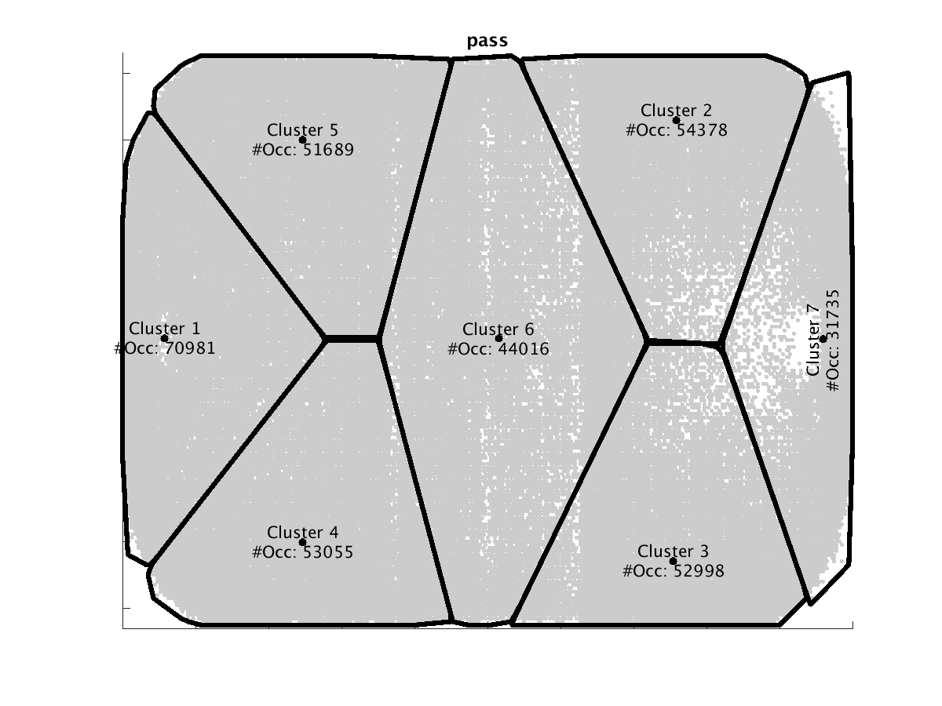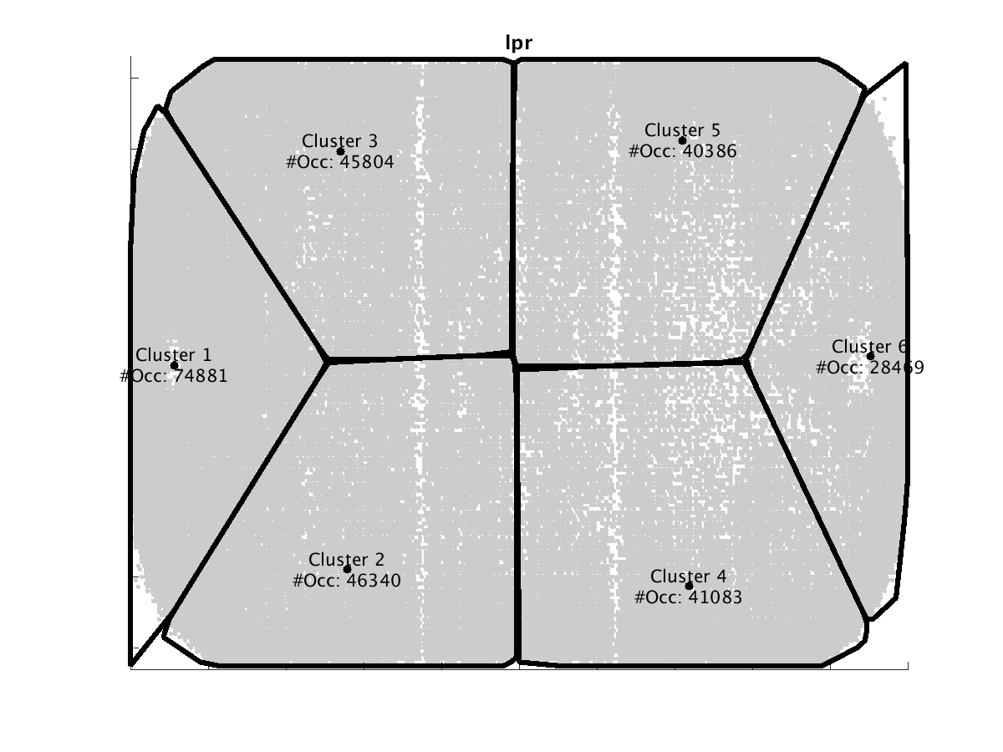

*Figure 6. Learned Regions for Passes.*

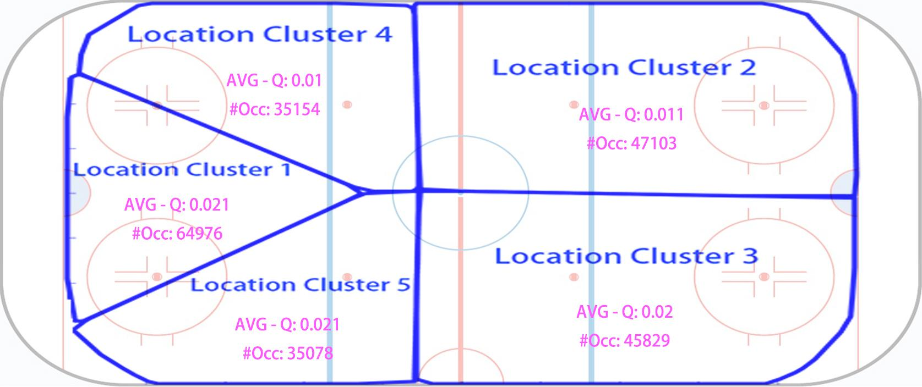

FIG: BLOCK ZONE

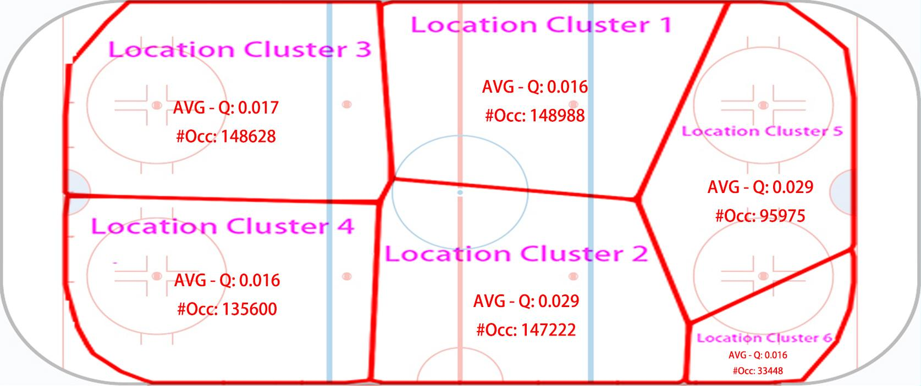

FIG RECEPTION

*Figure 7. Learned Regions for Loose Puck Recoveries.*

1. **The Markov Game Model**

A Markov model is a dynamic model that represents how a hockey match moves from one game state to the next. A sequence of state transitions constitutes a trajectory. The parameters of a (homogeneous) Markov chain are transition probabilities P(s’|s) where s is the current state and s’ the next state. Previous Markov chain models for ice hockey have included goal differential and/or manpower differential in the state space [Thomas 2013, Pettigrew 2015, Kaplan ]. Then the transition probabilities represent how goal scoring and penalty drawing rates depend on the current goal and manpower differentials. This approach can measure the impact only of actions that directly change the state variables, that is, such as goals and penalties. Markov decision processes and Markov game models include both states and actions, which allows us to measure the impact of *all* actions. The parameters of our Markov game model are ***state-action transition probabilities*** of the form *P(s’,a’|s,a)* where a is the current action and a’ the next action event. The model therefore describes state-action trajectories as illustrated in Figure 5. The state trajectory in the figure takes place in period 4 (PR = 4), with equal manpower (MP = even) and equal goal differential (GD = 0). In this example, all actions are taken by the home team; generally in the model either team may take an action at an point. The figure also shows the conditional probability of the home team scoring and the impact of an action, which we define below. Arrows indicate state transitions. In the first state, the home team carries the puck from carry-region #3 in the center of the neutral zone to the top of the neutral zone. Then they manage a pass from pass-region #2 at the top of the offensive zone. The pass is received in reception-region #2 above the goal. The final action is scoring a goal.[1] Table 5 describes the same state-action trajectory in play-by-play format. We now describe the components of our Markov model in detail.

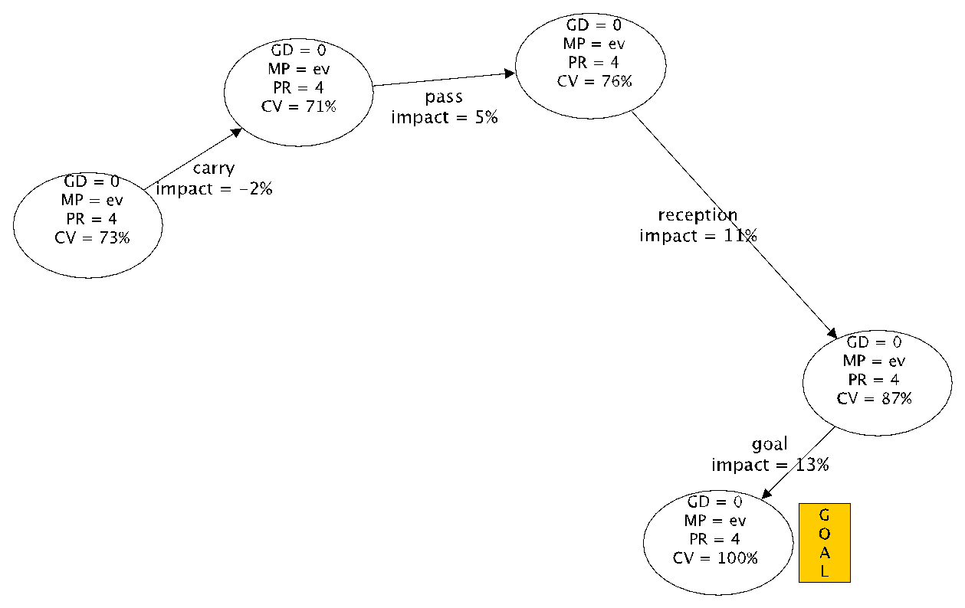

*Figure 8. A possible state-action trajectory in our model. [include transition probabilities on edges] A node in the diagram denotes a match state. CV is the conditional value of a state for the home team, which measures the chance that the home team scores at this game state. Edges are labeled with actions, the impact of the action, and transition probabilities. The impact measures the change in conditional value due to the action.*

*Table 5. A state-action trajectory in Play-by-Play Format. Quantities derived from the Model are defined in the text.*

|  |  |  |  |  |  |  |  |  |  |
| --- | --- | --- | --- | --- | --- | --- | --- | --- | --- |
|  | **State Variables** | | | **Action Parameters** | | | **Quantities derived from Model** | | |
| Event | Goal  Differential | ManPower Differential | Period | Team | Action  Type | Region | Transition  Probability | Conditional  Value (Home) | Impact |
| **0** | **0** | **Even** | **4** | **Home** | **Carry** | **??** | **----** | **71%** | **----** |
| **1** | **0** | **Even** | **4** | **Home** | **Pass** | **??** | **??** | **76%** | **5%** |
| **2** | **0** | **Even** | **4** | **Home** | **Reception** | **??** | **??** | **87%** | **11%** |
| **3** | **0** | **Even** | **4** | **Home** | **Goal** | **0** | **??** | **100%** | **13%** |

**States**

*Table 6. State Variables and their possible values. [please copy]*

|  |  |  |
| --- | --- | --- |
|  |  |  |
|  |  |  |
|  |  |  |
|  |  |  |

A state includes the values of relevant variables for a match context. Table 6 shows the range of integer values observed for these *context variables*. Like previous work, we use the goal differential and the manpower differential. We add the period to include some temporal context. Goal Differential *GD* is calculated as Number of Home Goals - Number of Away Goals. A positive (negative) goal differential means the home team is leading (trailing). Manpower Differential *MD* specifies whether the teams are at even strength (EV), the acting team is short-handed (SH) or in a powerplay (PP). Period *P* represents the current period number the play sequence occurs in. Our model includes periods 1 to 3 and overtime but not shoot-outs (5). The number of states is therefore 17 x 3 x 4 = 204.

**Actions**

The basic set of 13 action types was listed in Table (action table) above. An **action event** *a* is of one of these types, together with a specification of two parameters: which team performs the action (Home or Away) and the action region where the action takes place. For instance, *pass(home,region3)* denotes the event that the home team performs a carry in the region 3 associated with the pass region (see Figure pass clusters). There are 63 action-region pairs (sum of the number of clusters in Table 1, which may occur with either the home or the away team, so our model includes 126 possible action events. We often refer to action events simply as actions.

**Parameter Estimation**

The key quantities in our model specify the joint *state-action distribution P(s’,a’|s,a)* that at game state *s*, action *a* occurs and is followed by game state *s’* and action *a’*. We follow the maximum-likelihood method and estimate the action-state distribution using the **observed occurrence counts** *n(s’,a’,s,a)*, which record how often action *a’* and state *s’* follows state *s* and action *a* in our dataset. For simplicity we slightly abuse notation and use *n* also for marginal occurrence counts, for example $n(s,a)= \sum_{s^{'},a'}{}n(s^{'},a^{'},s,a)$. The maximum likelihood estimates are computed as follows:

$$\hat{P}(s,a)=\frac{n(s^{'},a^{'},a,s)}{n(s,a)}.$$

Decomposing the state-action probability as $P(s',a'|s,a) = P(s^{'}|a^{'},s,a) × P(a'|s,a)$, we see that it combines two quantities of interest: (1) the state transition probabilities $P(s'|a^{'},s,a)$ that describe how a game state evolves given players’ actions. Specifically in our model, this includes how goal and penalty rates depend on previous goal and penalty rates as well as the players’ actions. (The state transition probabilities are the standard parameters in a Markov decision process.) (2) The **action distribution $P(a'|s,a)$** that describes how a random player acts in a given game context. (In a Markov decision process, the action distribution is called a policy.) Because the most distribution of the next action and its location depends on the most recent action and its location, the action distribution represents spatial as well as temporal dynamics. For example, the transition probability of p% in the first two of Table y represents the probability that play moves from action-region1 to action-region2, given the current match context.

The number of possible state-action quadruples is unmanageably large at over 83 Billion. However, the number of quadruples that occur more than zero times is only 112,590. The necessary computations for computing and storing the estimated values can be efficiently managed using an relational database and appropriate data structures; for more details please see [Routley 2015].

We next show how our Markov game model can measure the impact of all actions.

1. **Action Values and Scoring Impact**

In our model, the agents are a generic home team and a generic away team, not individual players, similar to previous Markov models [Pettigrew 2015] for hockey. This is appropriate for the goal of assigning generic values to all action events. In this paper we use the Markov model to quantify how a random player’s action, given a game context, affects the probability that his team scores the next goal, rather than the opposing team. The same approach can be applied to quantify the impact of actions on other outcomes of interest, such as winning the match [Pettigrew 2015, Routley 2015] and penalties [Routley and Schulte 2015]. A key feature of a Markov model is that it quantifies not only the immediate but also the medium-term impact of an action. For *T = home* or *away*, let *P(T scores in l steps|a’,s,a)* denote the probability that after taking action *a’*, the team *T* scores before the opposing team $\underline{T}$ within the next *l* events, given game state *s*, and previous action *a*. The number l is called the *look-ahead.* This *scoring probability* satisfies the following recurrence equations:[2]

1.

2. , and

The probability that team *T* scores next is then defined as the scoring probability when the lookahead grows arbitrarily large. For a game state, it is possible that neither team scores within the look-ahead horizon. Therefore another quantity of interest is the conditional probability that a team scores given that one of the two teams scores within the event horizon. We refer to this as the *conditional value* of a state-action pair for the event horizon.

$${CV}_{T}^{l}{(s,a)}_{} = \frac{P(T scores next within l steps|s,a)}{P(T scores next within l steps|s,a) + P(\underline{T} scores next within l steps|s,a)}$$

$${CV}_{T}(s,a)= \lim_{l→∞} {{CV}_{T}^{l}{(s,a)}_{}}^{n}$$

The conditional value of state-action pair is the probability of scoring the next goal for an arbitrarily large look-ahead. The conditional value measures the relative advantage that a team has over their opponent, rather than the absolute scoring chance associated with a game state. It can be computed by applying the recurrence equations for $l =1,2,…$ until the conditional values converge. For the SportLoqiq dataset, convergence occurred for $l = 14$. This means that looking ahead more than 14 steps to future game trajectories does not change the probability estimate of which team is more likely to score next. Figure y illustrates the conditional value concept by plotting the expected conditional value of a loose puck recovery by location, averaged over states and home vs. away team. The conditional value is an appropriate quantity for evaluating actions since the goal of an action is to improve a team’s position relative to their opponent. We therefore use the conditional value to assess the *impact of an action*, which is defined as the extent to which it changes the scoring chance of the acting player’s team at a state:

$$Impact(s,a)=\sum_{s'}{}{CV}_{T}(s^{'},a^{'})×P(a^{'},s,a)-{CV}_{T}(s,a)$$

Table 5 illustrates CV values and impacts. The scoring impact metric for a player is their total impact over all their actions. This can be computed using the occurrence counts $n_{i}(a^{'},s^{'},s,a)$ that record how many times the game reaches state *s’* and player *i* takes action *a’* after state *s* and some player (not necessarily *i*) took action *a*.

$${SI}_{i}=\sum_{a^{'},s,a}{}n_{i}(a^{'},s,a)×Impact(s,a)=\sum_{s,a}{}n_{i}(s,a)×\sum_{a'}{}Impact(a^{'};s,a)×P_{i}(a^{'}|s,a)$$

where $P_{i}=\frac{\frac{n_{i}(a^{'},s,a)}{}}{n_{i}(s,a)}$ is the action distribution for player *i.* The second equation shows that the scoring impact metric can be interpreted as the expected impact of a player given a state-action pair, weighted by how often the player reaches the state-action pair.

* 1. **Correlations**

The SI metric shows a strong correlation with other important metrics, such as points, time on ice, and salary. This correlation increases by computing the metric for comparable players rather than all players. As an example, Table 2 shows the correlation between SI and time on ice (per game).

Table 7 Correlation between SI and TOI (per game)

|  |  |  |  |  |  |  |  |  |  |  |  |  |
| --- | --- | --- | --- | --- | --- | --- | --- | --- | --- | --- | --- | --- |
| **Cluster** | All | 1 | 2 | 3 | 4 | 5 | 6 | 7 | 8 | 9 | 10 | 11 |
| **Correlation** | 0.83 | 0.89 | 0.89 | 1.00 | 1.00 | 0.92 | 0.89 | 0.92 | 0.82 | 1.00 | 0.92 | 0.90 |

* 1. **Case Studies**

We discuss the top-ranked player from our running example clusters, and especially undervalued players.

* + 1. **Cluster 6**

Cluster 6 comprises forwards only. Table 3 shows the top 8 players in cluster 6.

The top 4 in cluster 6 are in order: Taylor Hall, Pavel Datsyuk, Evgeni Malkin, and Sidney Crosby. These are known excellent offensive players. Taylor Hall is recognized as a high caliber forward, placing him highly in the NHL fantasy rankings [2]. His goals per game metric is 0.32, which is excellent but behind for instance Malkin's at 0.47. This shows how our ranking is correlated with goals but also takes into account the value of actions other than goals. For instance, our ranking reflects that the total number of Hall's passes is 320, substantially more than Malkin's 190 passes.

The most undervalued players in cluster 6 are Aleksander Barkov (rank 6, salary $M 0.925) and Jack Eichel (rank 8, salary $M 0.925). Both players are junior (first NHL season in 2011 for Barkov, 2012 for Eichel). Barkov is viewed as having played a successful season and received from the Florida Panthers a six-year contract extension of six-year $M 35.4, a six-fold salary increase [3], which is consistent with our ranking. Eichel is a rising star [4]. The fact that Eichel is in the same cluster as for example Crosby and Malkin suggests that he would be a strong candidate for replacing them should they leave their teams.

* + 1. **Cluster 11**

Cluster 11 comprises defense players only. Table 4 shows the top 8 players in cluster 11.

The top player in cluster 11 is Erik Karlsson. He has twice won the Norris Trophy for best all-round defenseman in the NHL. The NHL ranks him the top defenseman for fantasy play in the 2016 season [5].

John Klingberg is also undervalued relative to his rank. Although he signed a contract with the Dallas Stars in 2011, he did not play a full NHL season until 2014-2015. After this season, he was recognized by joining the NHL all-rookie team, which is consistent with our ranking. Being in the same cluster as Karlsson and Letang suggests that he will be a strong prospect for replacing these senior defensemen.

* 1. **Explaining the Rankings: Drill-Down Analysis**

In this section we illustrate how a player’s ranking can be explained by how he performs in specific game situations. This breakdown serves two purposes: First, it makes the ranking interpretable because it explains the specific observations that led to the rating. Second, pinpointing the special strengths and weaknesses of a player is an important task in itself. Our basic approach is to find the game states in which a player’s expected impact differs the most from others in his cluster. The expected impact can be explained in terms of the player’s tendencies to act at a given game state.

Let #(s,P) be the number of actions that player P took at game state s, and let SIp(s) be the expected impact of player P at state s, which is defined as:

$$FNSI(N_{i},P)=\frac{\sum_{Action \{N_{i},N_{j}\} P took for home team}{}{SI}_{i,j}(Home)+\sum_{Action \{N_{i},N_{j}\} P took for away team}{}{SI}_{i,j}(Away)}{Number of actions \{N_{i},N_{j}\} P took}$$

The total impact of a player *P* is the sum of his expected impact at each state, weighted by the number of his actions at the state. Weighting each player by how often they act, the average impact of a cluster is given by:

$$FNSI(N_{i},C)=\frac{\sum_{All players k in cluster C}{}FNSI(N_{i},k)*\#Actions \{N_{i},N_{j}\} k took}{\#Actions \{N_{i},N_{j}\} taken by players in cluster C}$$

The added impact of player P at state s compares a player’s expected impact at a state to the expected impact of others in his cluster:

$$FNSIA(N_{i},P)=FNSI(N_{i},P)-FNSI(N_{i},Cluster(P))$$

A positive expected impact indicates states where a player performs better than other similar players; a negative value states where the performs worse. We illustrate the results of the drill-down analysis in our running examples of Taylor Hall and Erik Karlsson.

* + 1. **Taylor Hall**

Use player Taylor Hall as an example for cluster 6: we find all states where he reached more than 15 times and sort these states according to *FNSIA*, descendingly. The top 5 states are 10, 11, 57, 2191, 20. These are states where Taylor Hall shows most especial strengths. [OS: should try to make the states meaningful in hockey terms. If necessary use fewer states]

Table 5 Compare Taylor Hall and average players in cluster 6 (FNSI * 100)

|  |  |  |  |  |  |
| --- | --- | --- | --- | --- | --- |
|  | State 10 | State 11 | State 57 1st period, MP = even, GD = 0, last event = away reception in cluster 1 | State 2191 | State 20 |
| Average Player | 6.1 | 3.7 | -2.7 | -0.1 | -2.6 |
| Taylor Hall | 10.0 | 7.2 | 0.9 | 2.7 | 0.2 |

Table 5 above shows *FNSI * 100* for Taylor Hall at those states and *FNSI * 100* for average player in cluster 6 at those states. State 57 is interesting since the average cluster player’s expected impact is negative whereas Taylor Hall’s is positive. So, we drill down further at state 57 to examine Taylor Hall’s action distribution in this game state. The result is in Table 6. State 57 is a state where game is at period 1 and manpower is even, with goal differential 0. At this state, the away team just took a reception at location cluster 1 (neutral zone). [is Hall playing for the home team or the away team here?]

Table 6 Compare Taylor Hall and average players in cluster 6 at state 57

|  |  |  |  |  |  |  |  |  |  |  |  |
| --- | --- | --- | --- | --- | --- | --- | --- | --- | --- | --- | --- |
| Action Type | | Block | Carry | Check | Dumpin | Lpr | Offside | Pass | Puckprotection | Reception | Shot |
| Avg. Player | Percent (%) | 2.07 | 32.78 | 1.02 | 16.25 | 2.19 | 0.61 | 31.56 | 4.96 | 0.12 | 8.45 |
| FNSI * 100 | 13.2 | -2.1 | 12.5 | -15.0 | 18.0 | -15.8 | -2.5 | -9.0 | -1.1 | 12.0 |
| Taylor Hall | Percent (%) | 10.00 | 50.00 |  | 10.00 | 5.00 | 5.00 | 15.00 |  |  | 5.00 |
| FNSI * 100 | 21.5 | -1.8 |  | -15.4 | 25.5 | -15.8 | 1.6 |  |  | 7.9 |

From Table 6, we can see Taylor Hall did more blocks at state 57 and his FNSI for block action is higher. Passes at this state for average player is bad since FNSI is negative (which means conditional Q-value decreases after taking this action). However, Taylor Hall managed to make it positive. [not sure about this, isn’t the impact of passing fixe?] So Taylor Hall might be good at passing. [the table is hard to take in. Could visualize in terms of bar charts. What about just finding the biggest difference in SI(action|state 57) x Ptaylor_hall(action|state 57).

We can further drill-down a given action type to see why Taylor Hall is better than average player in his cluster. For example, Figure 4 shows the drill-down for action type ‘block’ at state 57. The red text in this figure shows how often the location clusters are visited. We can see from the figure that location cluster 3 is the best place to act ‘block’ in this situation. Taylor Hall managed to act more ‘block’s in this location cluster than average players.

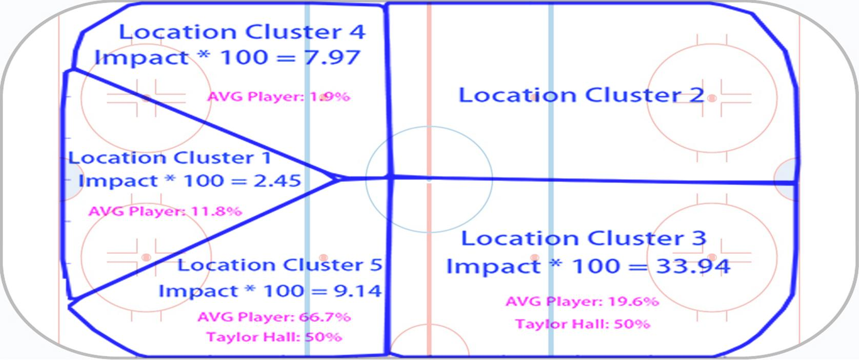

Figure 4 Drill-down for block action at state 57 (AVG Player is average player in cluster 6)

* + 1. **Erik Karlsson**

Use player Erik Karlsson as an example for cluster 11: we find all states where he reached more than 15 times and sort these states according to *FNSIA*, descendingly. The top 5 states are 382, 614, 3086, 2083, 56. These are states where Erik Karlsson shows most especial strengths.

Table 7 Compare Erik Karlsson and average players in cluster 11 (FNSI* 100)

|  |  |  |  |  |  |
| --- | --- | --- | --- | --- | --- |
|  | State 382 | State 614 | State 3086 | State 2083 | State 56 |
| Average Player | 2.1 | 13.2 | 5.3 | 1.2 | 2.3 |
| Erik Karlsson | 10.1 | 17.8 | 9.6 | 5.4 | 6.1 |

Table 7 above shows *FNSI * 100* for Erik Karlsson at those states and *FNSI * 100* for average player in cluster 11 at those states. State 382 is interesting since *FNSIA* for Erik Karlsson is extremely high compared to other states. So, we drill down further at state 382 to see what happens. The result is in Table 8. State 382 is a state where game is at period 3 and manpower is even, with goal differential 0. At this state, the away team just took a pass at location cluster 4 (defensive zone).

Table 8 Compare Erik Karlsson and average players in cluster 11 at state 382

|  |  |  |  |  |  |  |  |
| --- | --- | --- | --- | --- | --- | --- | --- |
| Action Type | | Block | Check | Lpr | Offside | Pass | Reception |
| Avg. Player | Percent (%) | 6.93 | 0.69 | 10.23 | 0.17 | 0.35 | 81.63 |
| FNSI * 100 | 13.9 | 17.9 | 13.9 | -0.6 | -2.8 | -0.4 |
| Erik Karlsson | Percent (%) | 17.65 | 5.88 | 29.41 |  |  | 47.06 |
| FNSI * 100 | 20.9 | 17.9 | 12.0 |  |  | 3.8 |

From Table 8, we can see Erik Karlsson did more blocks at state 382 and his FNSI for block action is higher. He avoids to take bad actions at this state (offside, pass). While reception at this state is generally a bad action, it’s an action with positive *FNSI* for Erik Karlsson. [again I don’t get that] All those factors together make Erik Karlsson really stands out at this state.

We can further drill-down a given action type to see why Erik Karlsson is better than average player in his cluster. For example, Figure 5 shows the drill-down for action type ‘reception’ at state 382. The red text in this figure shows how often the location clusters are visited. We can see from the figure that location cluster 1 and 2 are the best places to act ‘reception’ in this situation. Erik Karlsson managed to act more ‘reception’s in these location clusters than average players.

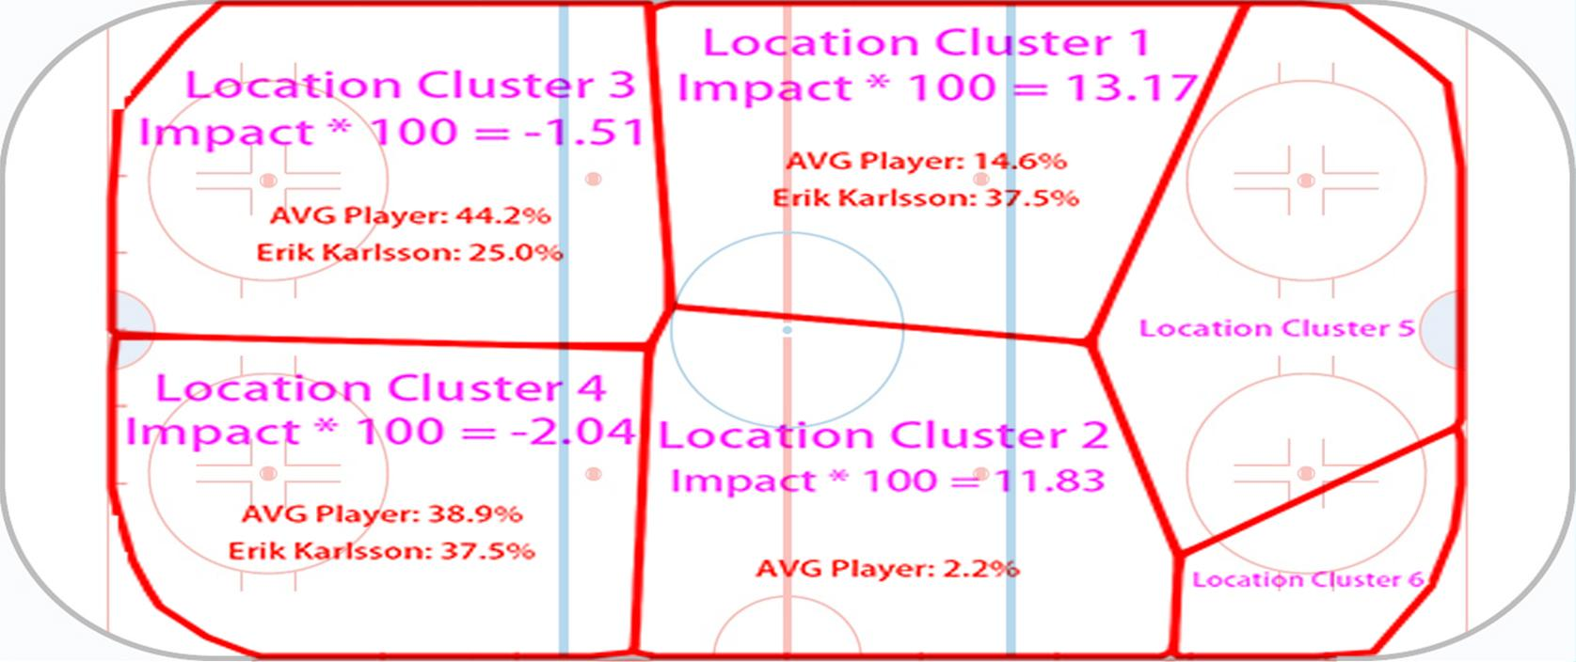

Figure 5 Drill-down for reception action at state 382 (AVG Player is average player in cluster 11)

1. **Discussion and Conclusion**

Action location information can be used with machine learning techniques to identify players with similar styles and roles. This supports apples-to-apples comparisons of similar players. A high-resolution large-scale Markov game model quantifies players impact on their teams goal scoring. The model can be used to pin-point the exact situations in which a player has strengths or weaknesses. This analysis will assist players in developing and teams in making decisions about game strategy or their team roster.

1. **Acknowledgement**

We thank SPORTLOGiQ for providing ice hockey data. We are grateful for constructive discussions in SFU’s Sport Analytics Research Group.

**References**

[WARNING: NEED TO UPDATE REFERENCE.]

Pettigrew, S. (2015), Assessing the offensive productivity of NHL players using in-game win probabilities, *in* '9th Annual MIT Sloan Sports Analytics Conference'.

Puterman, M. L. (1994), *Markov Decision Processes: Discrete Stochastic Dynamic Programming*, John Wiley &amp; Sons, Inc., New York, NY, USA.

Cervone, D.; D’Amour, A.; Bornn, L. & Goldsberry, K. (2014), POINTWISE: Predicting points and valuing decisions in real time with NBA optical tracking data, *in* '8th Annual MIT Sloan Sports Analytics Conference'.

Routley, K. & Schulte, O. (2015), A Markov Game Model for Valuing Player Actions in Ice Hockey, *in* 'Uncertainty in Artificial Intelligence (UAI)', pp. 782--791.

Thomas, A.; Ventura, S.; Jensen, S. & Ma, S. (2013), 'Competing Process Hazard Function Models for Player Ratings in Ice Hockey', *The Annals of Applied Statistics* **7**(3), 1497-1524.

Routley, K. (2015), 'A Markov Game Model for Valuing Player Actions in Ice Hockey', Master's thesis, Simon Fraser University.

Miller, A.; Bornn, L.; Adams, R. & Goldsberry, K. (2014), Factorized Point Process Intensities: A Spatial Analysis of Professional Basketball., *in* 'ICML', pp. 235--243.

[2] *https://www.nhl.com/news/2016-17-left-wing-fantasy-rankings/c-281561644*

[3] *https://en.wikipedia.org/wiki/Aleksander_Barkov_Jr*

[4] *https://en.wikipedia.org/wiki/Jack_Eichel*

[5] *https://www.nhl.com/news/fantasy-hockey-top-60-defensemen-rankings-update/c-798669*

[6] *https://www.nhl.com/avalanche/news/avalanche-signs-barrie/c-890364*

**2. Hockey Rule and Hockey Data**

* 1. **Hockey Rules**

We give a brief overview of rules of play in the NHL and show how we represent actions.

NHL games consist of three periods, each 20 minutes in duration. A team must score more goals than their opponent within three periods in order to win the game. If the game is still tied after three periods, the teams will enter a fourth overtime period, where the first team to score a goal wins the game. If the game is still tied after overtime during the regular season, a shootout will commence. During the playoffs, overtime periods are repeated until a team scores a goal to win the game. Teams have five skaters and one goalie on the ice during even strength situations. Penalties result in a player sitting in the penalty box for two, four, or five minutes and the penalized team will be shorthanded, creating a manpower differential between the two teams. The period where one team is penalized is called a powerplay for the opposing team with a manpower advantage. A shorthanded goal is a goal scored by the penalized team, and a powerplay goal is a goal scored by the team on the powerplay.

Table 1 below shows action types and their descriptions. These action types will be used in latter sections of this paper

* 1. **Hockey Data**

We make use of a new data source from SPORTLOGiQ that tracks the location of each player's action for the entire 2015-2016 season. The data consists of 3.3M actions and 1140 games. Players who tend to play in similar locations are clustered together using algorithm to be introduced in section 4.

1. **Value Iteration**

To apply Markov model, we need a state transition graph and a reward function. We define game states to be the status of the game after each action. Therefore, game states will have features such as period, manpower differential etc.

However, the graph will be too big if each state is treated as a single node in the graph. Therefore, after pre-processing all games data, we aggregated all states with same features into a single node, and subsequently connected two nodes with a directed edge if there exist an action that map to the transition of these two nodes.

We can then evaluate an action in a context-aware way by considering its expected reward after executing it in a given state. This is known in reinforcement learning as the action value, or **Q-value**. We set the reward function with respect to the next goal probability and we do 20 value iterations. The following equation shows how we update Q-value of each node at each iteration.

$$Q_{i}^{(t)}=\{1 if N_{i} is goal action for this team \sum_{ \{N_{i},N_{j}\}∈G}{}\frac{\#Occ(N_{i},N_{j})}{\sum_{\{N_{i},N_{k}\}∈G}{}\#Occ(N_{i},N_{k})}*Q_{j}^{(t-1)} otherwise$$

The initial value of Q-value is set as:

$$Q_{i}^{(0)}=\{1 if N_{i} is goal action for this team 0 otherwise$$

After value iterations for both home and away teams, we can normalize Q-values to get conditional Q-values (CQ):

$${CQ}_{i}(Home)=\frac{Q_{i}(Home)}{Q_{i}(Home)+Q_{i}(Away)}$$

$${CQ}_{i}(Away)=\frac{Q_{i}(Away)}{Q_{i}(Home)+Q_{i}(Away)}$$

Actions in games serve as edges in the state transition graph. The value of each action can be viewed as how much this action improves the CQ value. Since our reward function for Q-value is related to the next goal probability, we call the values of actions *Scoring Impact (SI)*. For actions corresponding to the edge from node $N_{i}$ to $N_{j}$, *SI* can be calculated as follows:

$${SI}_{i,j}(Home)={CQ}_{j}(Home)-{CQ}_{i}(Home)$$

$${SI}_{i,j}(Away)={CQ}_{j}(Away)-{CQ}_{i}(Away)$$

Above is *SI* for a single action. We define *SI* for a given player as follows:

$$SI(P)=\frac{\sum_{Actions \{N_{i},N_{j}\} P took for home team}{}{SI}_{i,j}(Home)+\sum_{Actions \{N_{i},N_{j}\} P took for away team}{}{SI}_{i,j}(Away)}{Number of games P played}$$

**Appendix: Methodology**

An appendix is not required, but if you have one please include it here.

**Player Clustering**.

*Rink division*. It is possible to use three regions for the horizontal direction, corresponding to the defensive, neutral, and offensive zone. However, adding a 4th horizontal division led the clustering algorithm to produce more informative groupings, without producing too many clusters. Adding a 5th horizontal division produced essentially the same player clusters as the 3x4 division of Figure 1.

We used affinity propagation with Euclidean distance, which is equivalent to treating each heatmap as a point in the 12-dimensional probability simplex. [more details on affinity propagation]

*Discussion*. Our model treats events as time series. This loses the information about duration, but avoids parametric assumptions about event rates (e.g., Poisson). In future work we will extend the model to include continuous-time duration information.

**Action Locations**. The disadvantage of discretization is that it loses some information about the exact location of an action event. The computational advantage is that we can employ algorithms for discrete Markov models. The statistical advantage is that discretization requires neither parametric assumptions (e.g. Gaussian or Poisson distribution), nor stationarity assumptions that treat different locations as the same. Cervone et al. [2014] provide further discussion of the pros and cons of spatial discretization.

An alternative approach to discretizing locations is to apply nonnegative matrix factorization to a matrix of location transition counts (Cervone et al.). This has the advantage that the learned regions capture not only where actions occur, but also where the game tends to move next. The disadvantages are higher computational complexity, and that arguably the resulting regions are less straightforward to interpret.

1. [is there no shot?]
2. need to make this prettier, see Sloan template.