CS543 Assignment 3

**Your Name:** Yen-Ting Liu

**Your NetId:** ytliu2

# Part 1: Homography estimation

**Describe your solution, including any interesting parameters or implementation choices for feature extraction, putative matching, RANSAC, etc.**

Following the execution steps,

1. Feature extraction

I uses the SIFT implementation from OpenCV directly. All images use default settings

* **Number of features** extracted 1000
* Number of octave layer 4
* **Contrast threshold** (scale space threshold) 0.04
* **Edge threshold** (Harris response) 10
* **Sigma** (initial sigma for the blur kernel) 1.6

Since I used scikit-image heavily in my entire MP, I decide to wrap it in a class that inherits FeatureDetector and DescriptorExtractor. This allow OpenCV SIFT to interchange with ORB feature extractor in scikit-image.

1. Putative matching

I decide to follow the algorithm suggested by D. Lowe. After finding out squared Euclidean distance across keypoints, it figure out the shortest and 2nd shortest distance, only the shortest one is **1.5 times** shorter than 2nd shortest, will the algorithm keep this match.

1. RANSAC

I follow the RANSAC interface that scikit-image has, and implement my homography model to inherit BaseModel class. However, my implementation uses residuals mean from inliers instead of the population,

residuals_mean = np.mean(residuals[inliers] ** 2)

this seems to provide more stable registration result. For all images, I use

* **Residual threshold** 1
* **Minimum number of samples** 4 (since we are working with H estimation)
* **Maximum number of trials** 10000

I didn’t implement dynamic max trial using current residuals.

1. Warping

I first use my register_images function to generate transformation matrix for each image pair, and later uses my stitch_images function to calculate the complete transformation from image to image (e.g. for 3 images, hook them up). This allow me to estimate overall image size in later stage, and the potential to do bundle adjustment.

**For the image pair provided, report the number of homography inliers and the average residual for the inliers.**

|  |  |  |
| --- | --- | --- |
|  | **LEFT as reference** | **RIGHT as reference** |
| Number of inliers | 21 | 23 |
| Average residuals | 0.185227 | 0.210508 |

**Also, display the locations of inlier matches in both images.**

|  |  |
| --- | --- |
| **LEFT**  **as reference** |  |
| **RIGHT**  **as reference** |  |

**Display the final result of your stitching.**

|  |  |
| --- | --- |
| **LEFT**  **as reference** |  |
| **RIGHT**  **as reference** |  |

# Part 2: Fundamental Matrix Estimation, Camera Calibration, Triangulation

**For both image pairs, for both unnormalized and normalized fundamental matrix estimation, display your result (points and epipolar lines) and report your residual.**

|  |  |  |
| --- | --- | --- |
| **Unnormalized** |  | |
|  | **Residuals**  0.179213 px |
| **Normalized** |  |
|  | **Residuals**  0.085709 px |

*Residuals follow website definition, using mean squared distance between points and their corresponding epipolar lines.*

**For the lab image pair, show your estimated 3x4 camera projection matrices.**

*Please find the matrices in next question.*

**Report the residual between the projected and observed 2D points.**

|  |  |  |  |
| --- | --- | --- | --- |
|  | **Projection matrix** | **Residuals** | **Average**  **squared distance** |
| **lab1** |  | 13.55 | 0.39 |
| **lab2** |  | 15.54 | 0.37 |

**For both image pairs, visualize 3D camera centers and triangulated 3D points.**

*It is hard to visualize triangulated results when camera center is in the view.*

|  |  |  |
| --- | --- | --- |
|  | **3D distribution**  (Camera centers) | **Triangulation**  (ground truth; estimated) |
| **Lab** | (314.5, -305.4, -108.9) (69.8, -61.8, -71.2) | (marker radius proportional to error) |
| **Library** | (-7.8, -5.2, -3.2) (-8.1, -6.5, -1.9) | *(no ground truth)* |

# Part 3: Single-View Geometry

**Plot the VPs and the lines used to estimate them on the image plane using the provided code.**

Left image contains all 3 VPs (in different colors), one is extremely far away but still numerically retrievable. Right image are edges (follow color of each VP) used to estimate VPs and horizon (white dotted line).

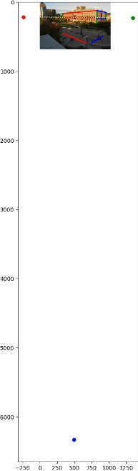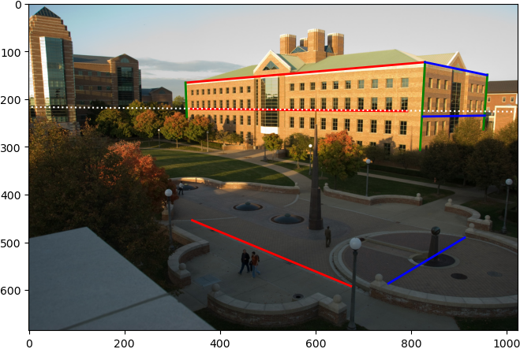

**Specify the VP pixel coordinates.**

(x, y) = **left** (-237.52, 214.21), **vertical** (493.85, 6330.22), **right** (1343.24, 229.17)

**Plot the ground horizon line and specify its parameters in the form a * x + b * y + c = 0. Normalize the parameters so that: a^2 + b^2 = 1.**

*Horizon plot in the first image.* **Line equation** -0.009458*x + 0.999955*y + -216.451659 = 0

**Using the fact that the vanishing directions are orthogonal, solve for the focal length and optical center (principal point) of the camera. Show all your work.  
Principal point** (x, y) = (550.65, 323.95), **Focal length** 783.77

**Compute the rotation matrix for the camera.**

Following the VPs order on website, (, , ) = (right, vertical, left)

**Estimate the heights of (a) the CSL building, (b) the spike statue, and (c) the lamp posts assuming that the person nearest to the spike is 5ft 6in tall. In the report, show all the lines and measurements used to perform the calculation.**

*Convert to metric so we can do height calculation easier.*

**Person** 1.6764 m; **CSL** 22.09 m; **Statue** 9.20 m; **Lamp post** 5.46 m

|  |  |
| --- | --- |
|  | Follow the convention in lecture slide, we first calculate the intersection from bottom points to horizon  Then we can derive the projected length of object of interest (statue, in this example),  From here, we can start to see the triangle similarity relationship  where is the reference height, and is what we want to calculate. |

**How do the answers change if you assume the person is 6ft tall?**

**Person** 1.8288 m; **CSL** 24.10 m; **Statue** 10.04 m; **Lamp post** 5.96 m

# Extra Credit

Don’t forget to include references, an explanation, and outputs to receive credit. Refer to the assignment for suggested outputs.

**Part 1**

**Extend homography estimation to work on multiple images**

Continue with previous description, my implementation can easily scale out to accommodate multiple images. In all following images, I choose to calculate matches by consecutive image pairs instead of reference with the first image, since Pier has non-overlapping images.

|  |  |
| --- | --- |
| **Hill** |  |
| **Ledge** |  |
| **Pier** |  |

**Register difficult image pairs**

*I accidentally implement Lowe’s ratio test, does this count as a point here?*

**Bundle adjustment**

**Image blending techniques**

**Part 2**

**Estimate fundamental matrices without ground-truth**

Using the same script from part 1, we can estimate matches that closely satisfy the homography, I think this is the reason that it yields a 0 residuals. All parameters are the same as part 1.

|  |  |
| --- | --- |
|  | **Inliers** 50  **Average residual** 0.242612  **Residual (point-epipolar line)** 0 px |

**Part 3**

**Perform additional measurements**

**Compute and display rectified views of the ground plane and the façades of the CSL**

**Attempt to fit lines to the image and estimate VP automagically**

**Find or take other images with 3 visible vanishing points**