**TCP Echo Server and Client Test Cases**

Liuyi Jin 225009797 Yinan Zhu 825008922

Case(1): as we input several strings, the server echoed it back

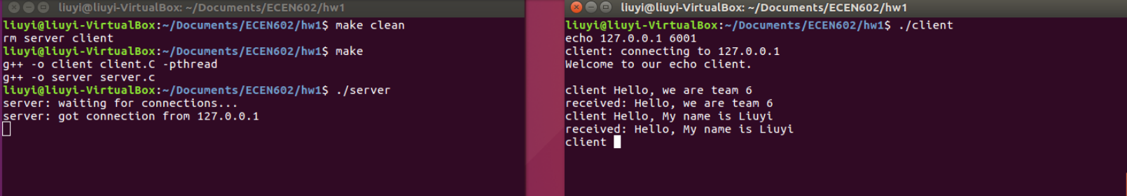

Case(2): if we have exceed the maximum length (we set it to 25), and we would return them separately.

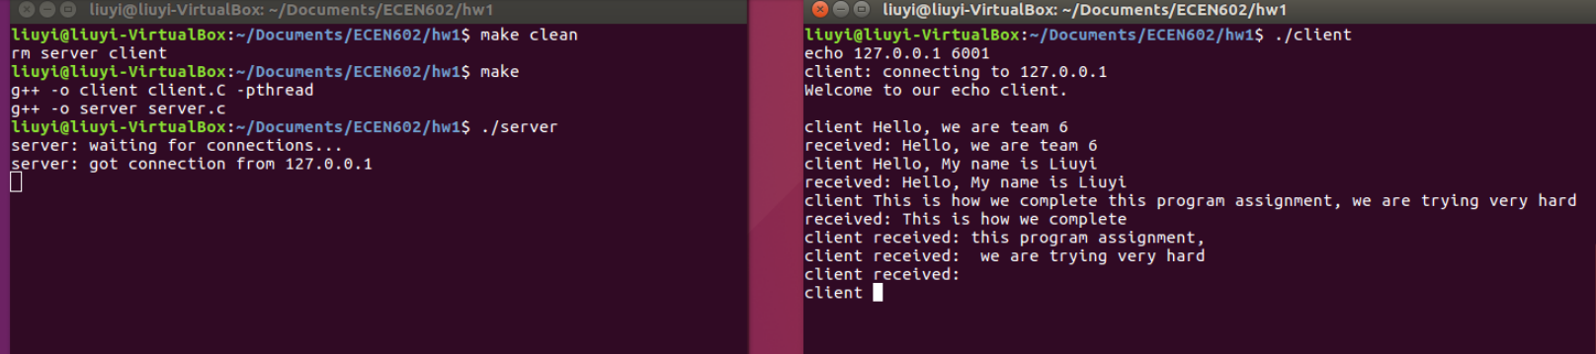

Case(3): if we enter nothing, we see it as “no characters” case; as for EOF case, we simply enter Control-D, the client should show “you ended echo”.

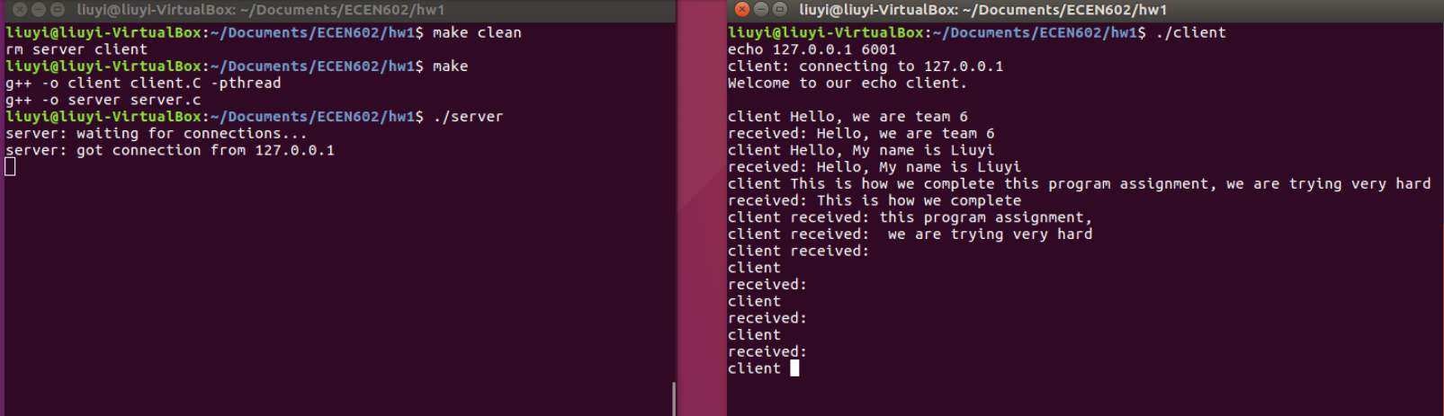

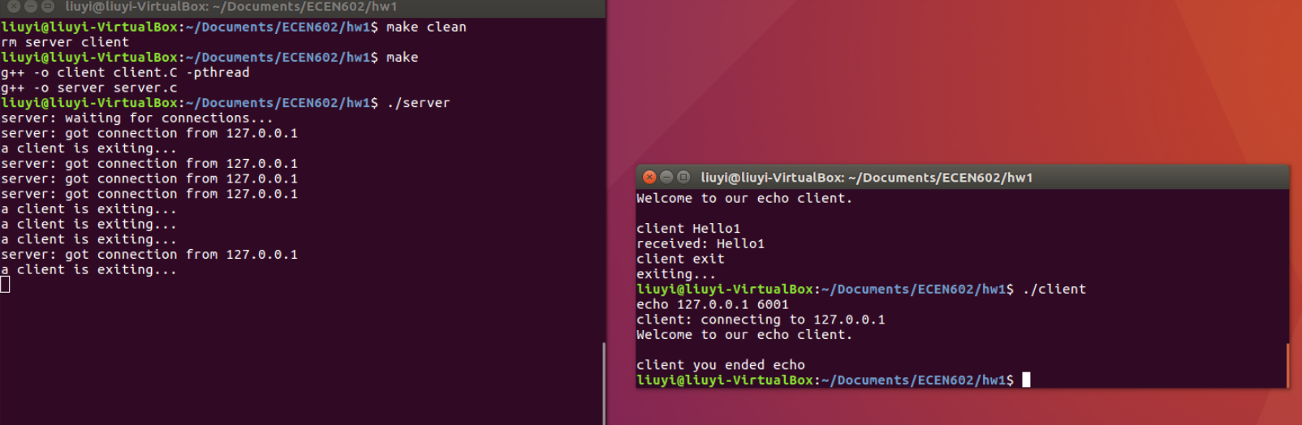

Case(4): we specified the text “exit” as the signal of exiting, this terminates the client and close the socket, so the server should receive a FIN to kill its child process

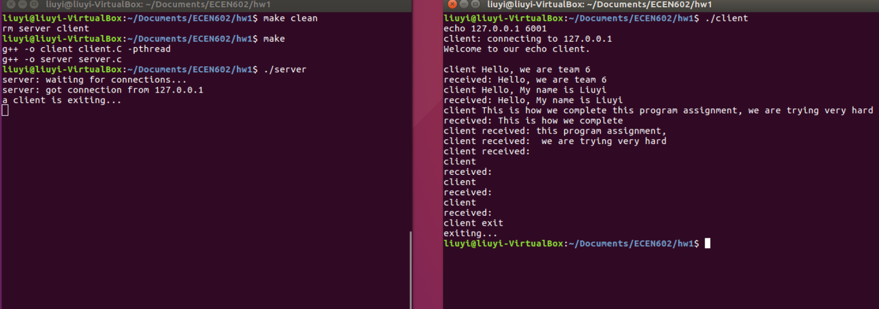

Case(5): 3 clients connect to the same server and the server echo their msgs.

