**TCP Simple Broadcast Chat Server and Client**

**ECEN 602 Network Programming Assignment 2**

Liuyi Jin 225009797 Yinan Zhu 825008922

Case (1): normal operation of the chat client with three clients connected

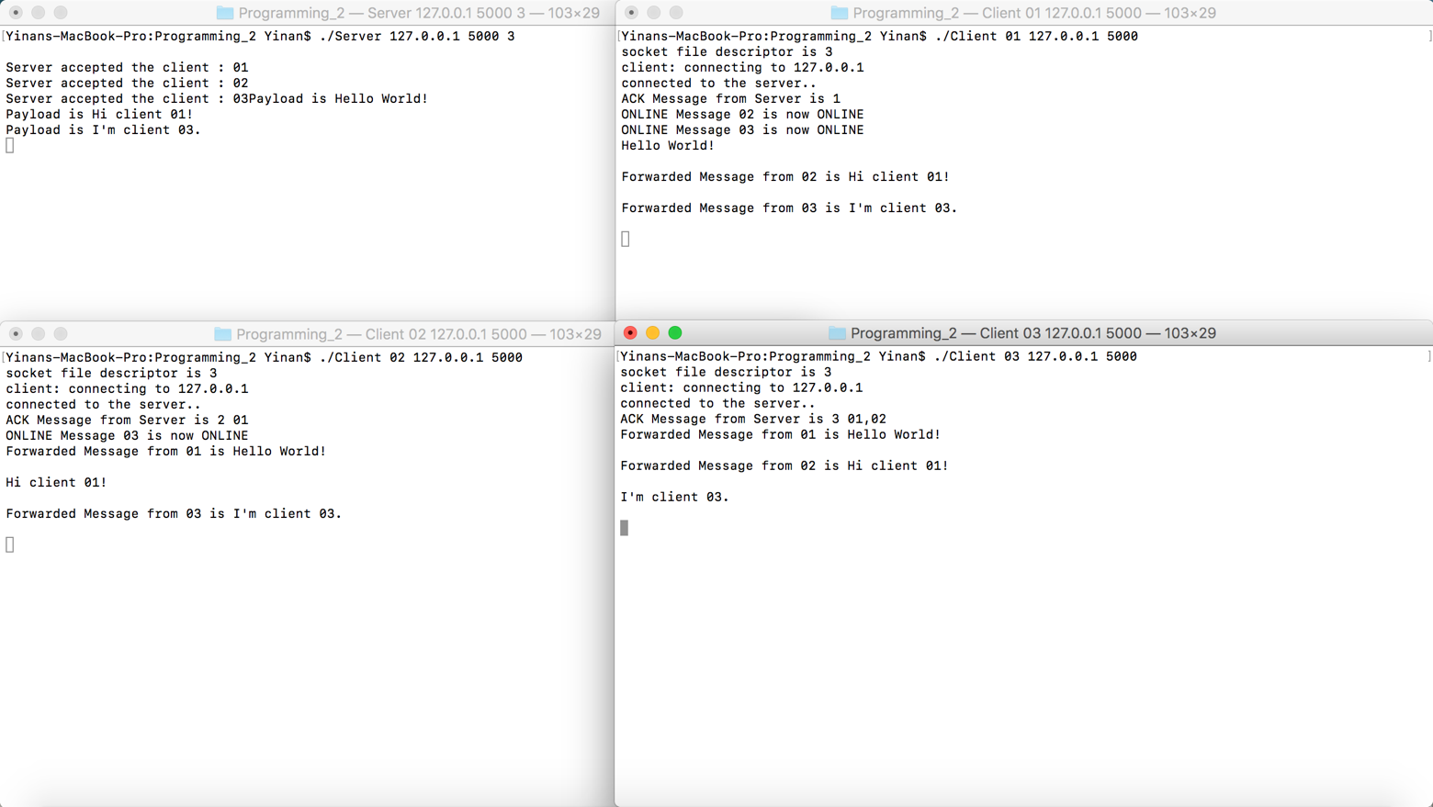

Case (2): server rejects a client with a duplicate username

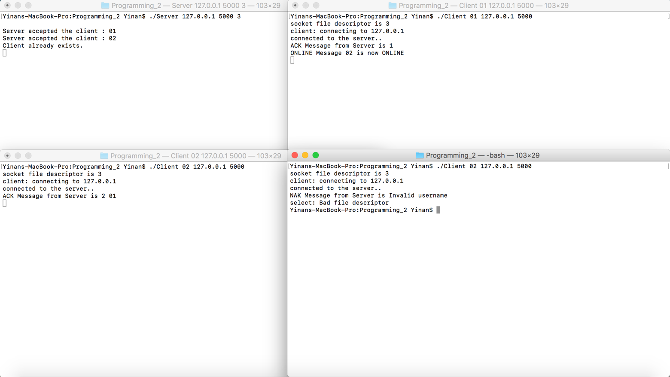

Case (3) server allows a previously used username to be reused

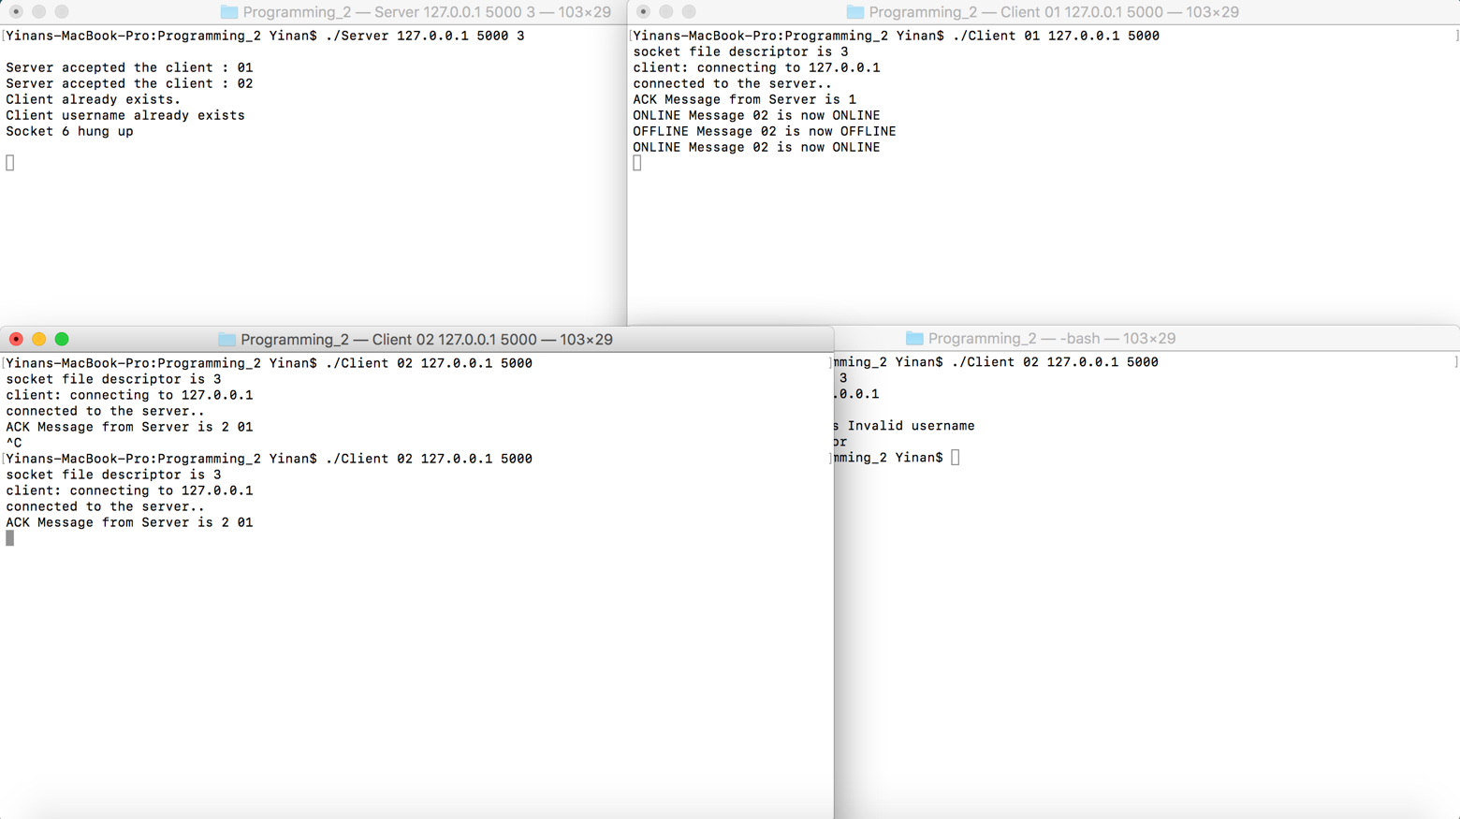

Case (4) server rejects the client because it exceeds the maximum number of clients allowed

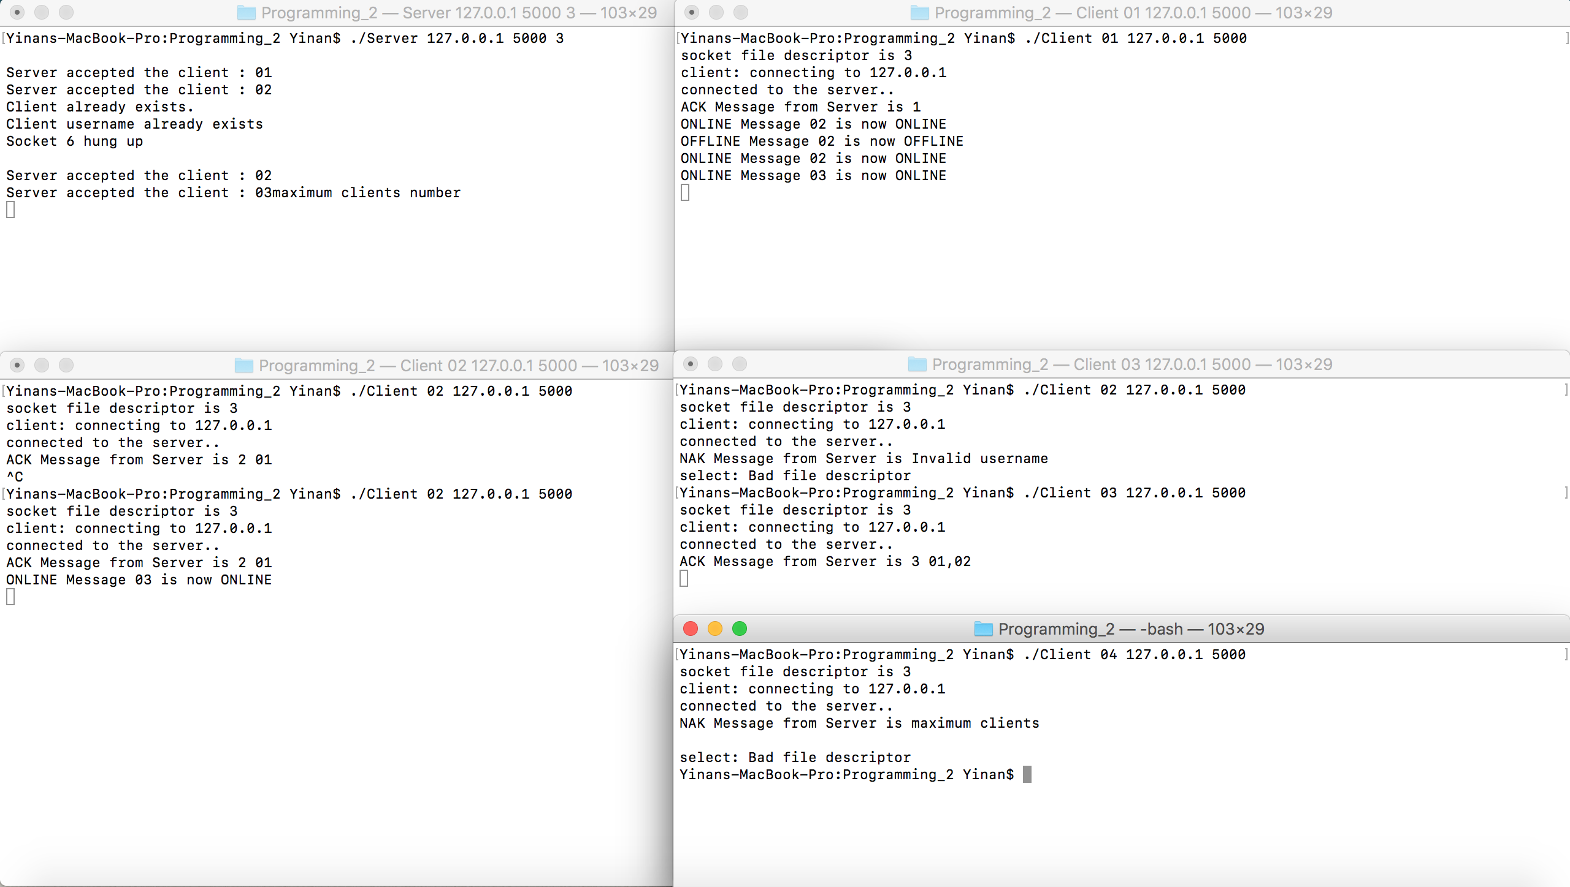

Case (5) separate test cases for any of the bonus features you implement.

Bonus 0: IPv4 and IPv6

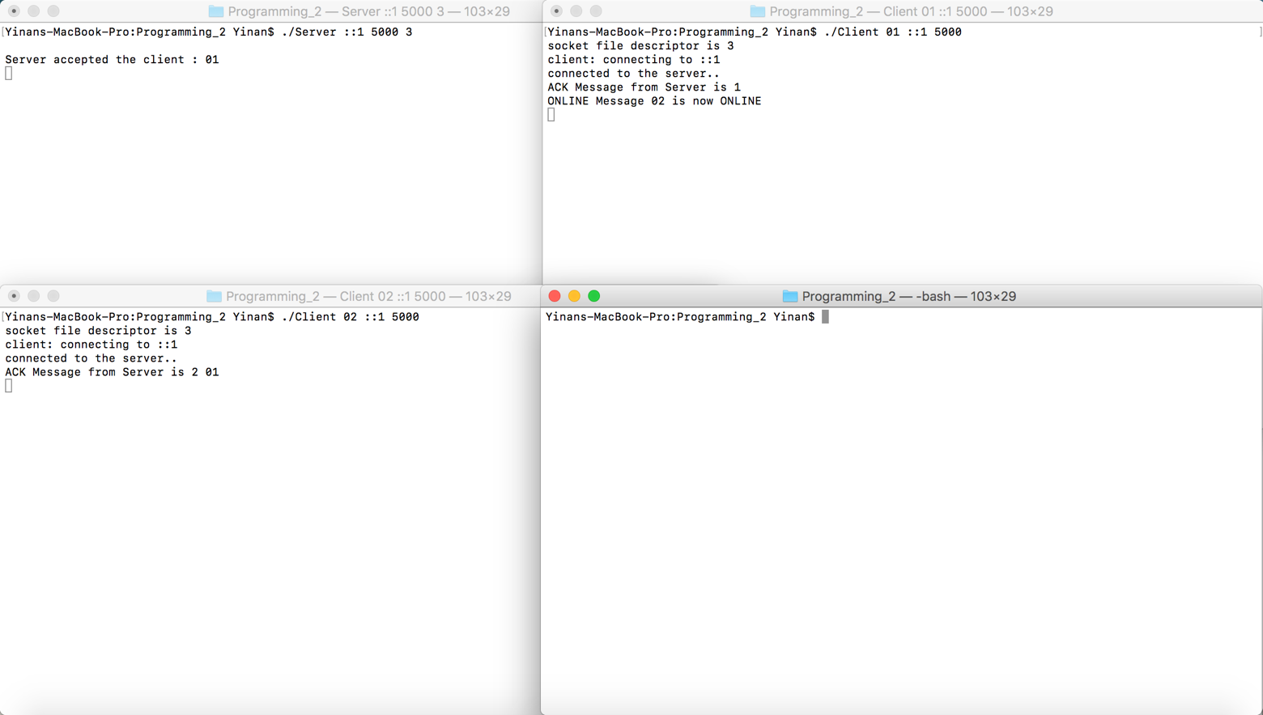

Bonus1: ACK, NAK, ONLINE, OFFLINE

ACK:

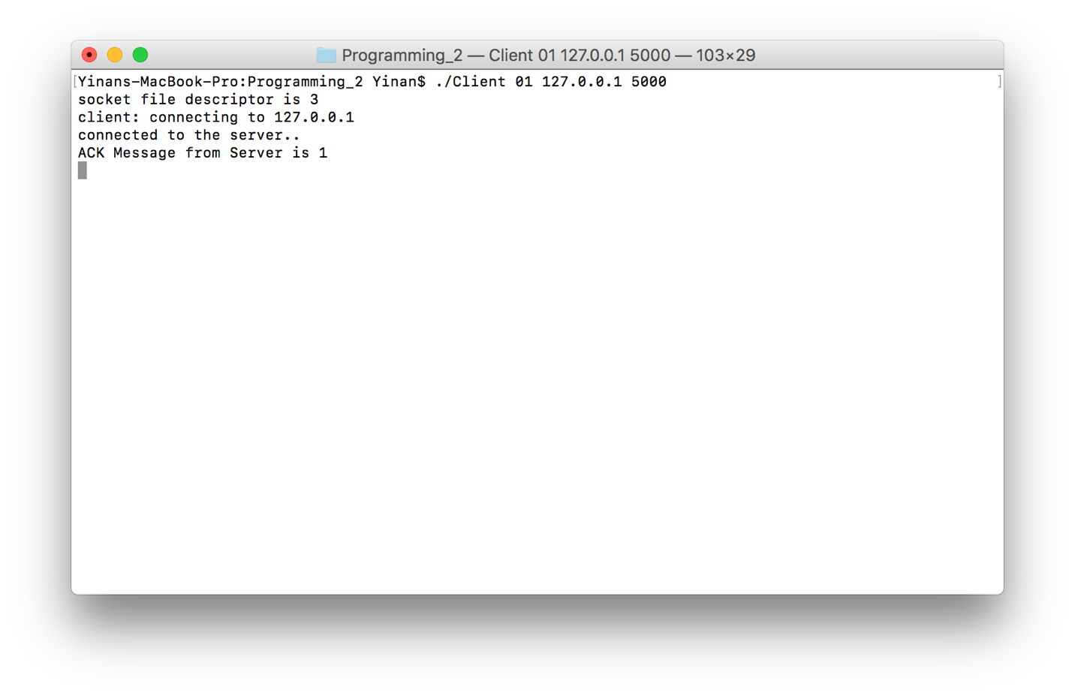

NAK:

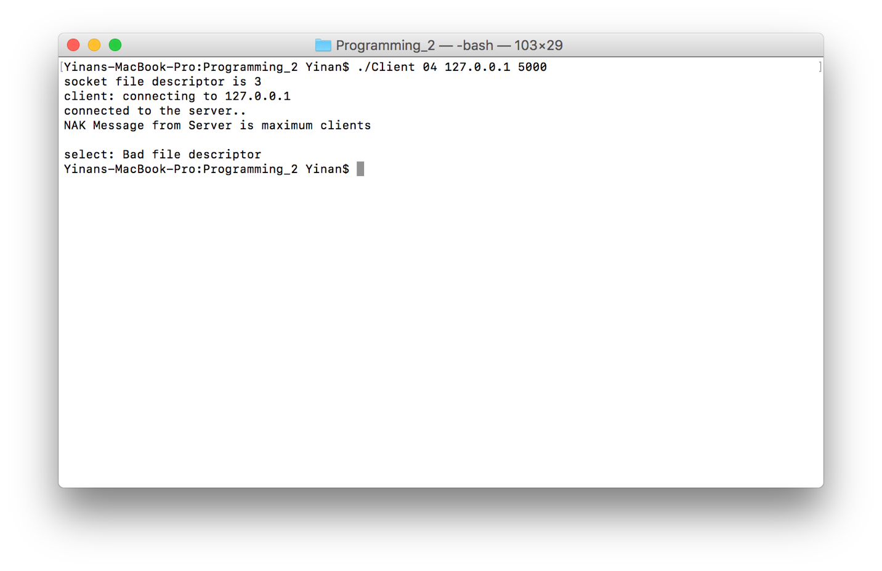

ONLINE, OFFLINE:

